**ASSIGNMENT-1**

**ELECTRICAL AND ELECTRONICS WORKSHOP(EEWS)**

**AIM:-**

**THEORY:**

**COMPUTER SYSTEM:-**

A computer is a complex system that consists of various hardware and software components working together to perform tasks.

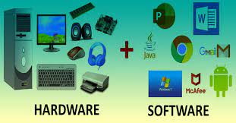

**HARDWARE:**

Now let us see some of the hardware components

1.Central processsing unit

2.Graphics processing unit

3.Mother board

4.Random Access Memory

5.Storage devices

6.Power supply unit

7.Peripheral devices

**Central processing Unit (CPU):** The Central Processing Unit (CPU) is a crucial component in a computer responsible for executing instructions from programs. Key aspects of a CPU which includes:

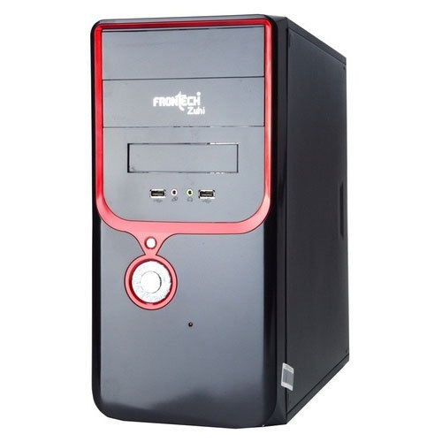

**1.Cache:** CPUs have various levels of cache memory (L1, L2, L3) for quick access to frequently used data, reducing latency.

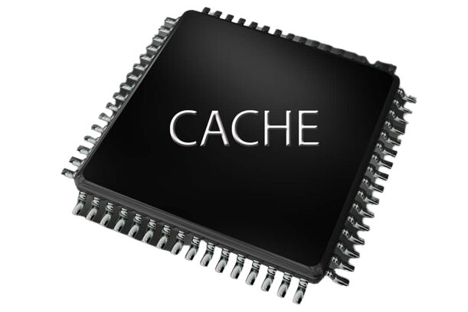

**2.Manufacturing Process:** The size of transistors on the CPU, measured in nanometers (nm), affects power efficiency and performance.

**3.Socket Type:** CPUs are designed to fit specific sockets on the motherboard, ensuring compatibility.

**4.Clock Speed:** Measured in gigahertz (GHz), it represents how many instructions a CPU can execute per second.

**5.Cores:** CPUs can have multiple cores, each capable of handling its own tasks simultaneously, enhancing multitasking performance.

**6.Threads:** CPUs may support multiple threads per core, allowing for better parallel processing.

**Graphics processing unit(GPU):**

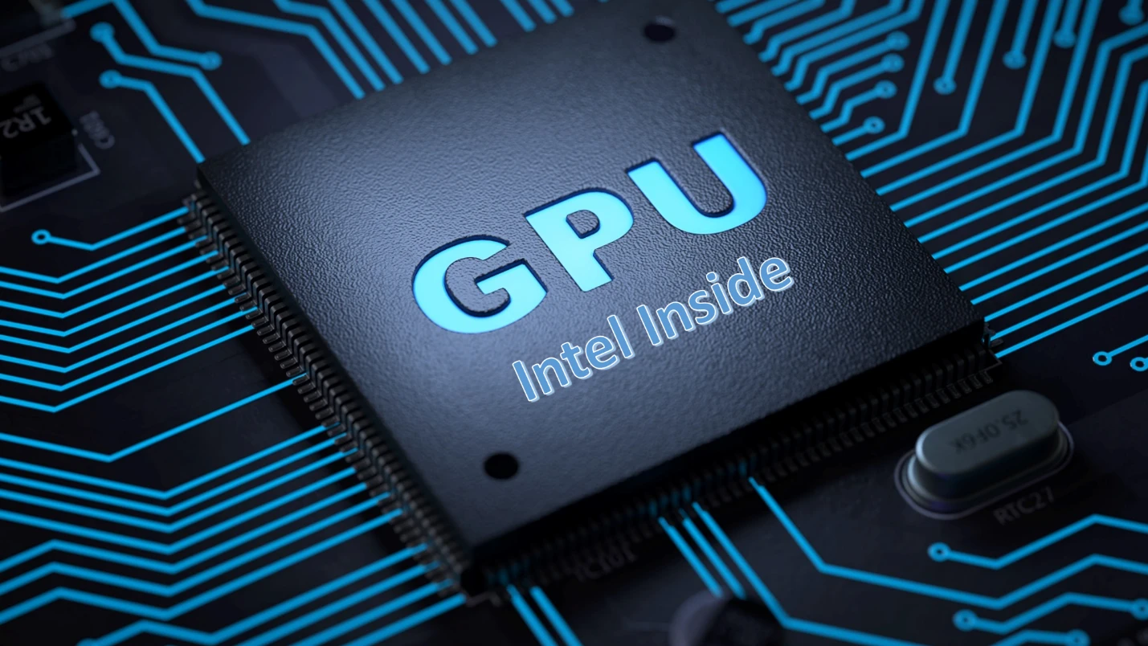

A Graphics Processing Unit (GPU) is a specialized electronic circuit designed to accelerate the rendering of images and videos for display. Its primary function is to handle graphics-related tasks, enhancing the performance of graphical applications, video games, and multimedia content.Modern GPUs consist of numerous shader cores responsible for tasks such as shading, lighting, and texture mapping. This parallel architecture enables the GPU to efficiently process large amounts of graphical data, making it well-suited for graphics rendering and computationally intensive applications.

Unlike the Central Processing Unit (CPU), which focuses on general-purpose computing tasks, the GPU is optimized for parallel processing, allowing it to handle multiple graphical calculations simultaneously.

There are two main types of GPUs: dedicated and integrated. Dedicated GPUs are separate cards that offer higher performance and are commonly used in gaming PCs and professional workstations.ntegrated GPUs, on the other hand, are integrated into the motherboard or CPU, providing basic graphics functionality suitable for everyday computing tasks.

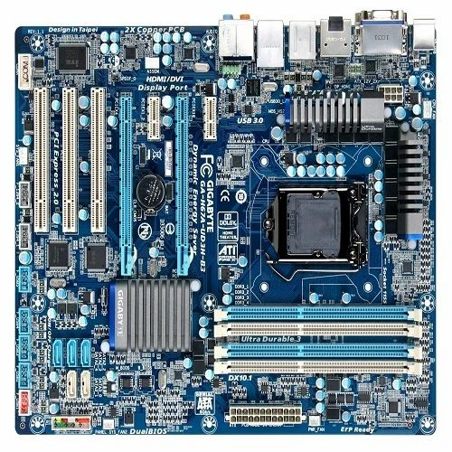**3.Mother board:**

A motherboard serves as the central and foundational component of a computer system, providing a platform for various hardware components to connect and communicate. Its significance lies in facilitating the interaction between the CPU, memory, storage devices, and other peripherals, making it a critical element for the overall functionality of a computer.

The chipset on the motherboard is a set of integrated circuits that manages communication between the CPU, memory, storage devices, peripherals. Different chipsets offer varying features and capabilities, influencing factors such data transfer speeds and support for advanced technologies. For instance, a high-end motherboard chipset might provide more PCIe lanes, allowing for better expansion capabilities.

Compatibility b/w the motherboard and other components crucial for building a stable and functional computer, making selection of suitable motherboard a fundamental step in the system-building process.

**4.Random Access Memory:**