Folder Structure:

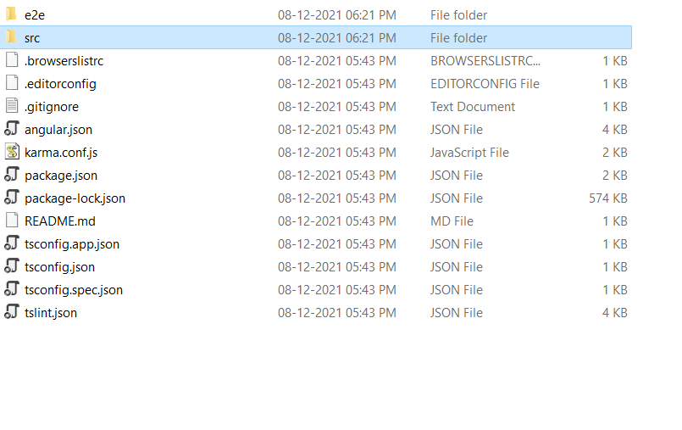

Source code:

*Aboutus.component.css*

background: linear-gradient(rgba(0,0,0,.7), rgba(0,0,0,.7)), url('/assets/images/aboutus.jpeg');

background-repeat: no-repeat;

background-size: cover;

background-position: center center;

color: #fff;

padding-top: 110px;

padding-bottom:110px;

}

.navbar{

background-color:rgb(114, 102, 192);

}

#anch

{

color:floralwhite;

font-size: 15px;

}

#anch:hover{

color:rgb(240, 187, 195);

}

p

{

font-family: 'Segoe UI';

}

h2{

color:rgb(54, 53, 53);

}

.container-fluid1 {

overflow: hidden;

margin-top: 50px;

background: #262626;

color: #627482 !important;

margin-bottom: 0;

padding-bottom: 0

}

small {

font-size: calc(12px + (15 - 12) * ((100vw - 360px) / (1600 - 360))) !important

}

.bold-text {

color: #989c9e !important

}

.mt-55 {

margin-top: calc(50px + (60 - 50) * ((100vw - 360px) / (1600 - 360))) !important

}

h3 {

font-size: calc(34px + (40 - 34) * ((100vw - 360px) / (1600 - 360))) !important

}

.social {

font-size: 21px !important

}

.rights {

font-size: calc(10px + (12 - 10) * ((100vw - 360px) / (1600 - 360))) !important

}

______________________________________________________________________________________



.navbar{

background-color:rgb(114, 102, 192);

}

#anch

{

color:floralwhite;

font-size: 15px;

}

#anch:hover{

color:rgb(240, 187, 195);

}

p

{

font-family: 'Segoe UI';

}

h2{

color:rgb(54, 53, 53);

}

App.component.css

a

{

color:floralwhite;

font-size: 15px;

}

a:hover{

color:rgb(240, 187, 195);

}

.navbar{

background-color:rgb(114, 102, 192);

}

cart.component.css

.navbar{

background-color:rgb(114, 102, 192);

}

#anch

{

color:floralwhite;

font-size: 15px;

}

#anch:hover{

color:rgb(240, 187, 195);

}

changepswd.component.css

.navbar{

background-color:rgb(114, 102, 192);

}

#anch

{

color:floralwhite;

font-size: 15px;

}

#anch:hover{

color:rgb(240, 187, 195);

}

Contactus.component.css

.navbar{

background-color:rgb(114, 102, 192);

}

#anch

{

color:floralwhite;

font-size: 15px;

}

#anch:hover{

color:rgb(240, 187, 195);

}

p

{

font-family: 'Segoe UI';

}

h2{

color:rgb(54, 53, 53);

}

.container-fluid1 {

overflow: hidden;

margin-top: 50px;

background: #262626;

color: #627482 !important;

margin-bottom: 0;

padding-bottom: 0

}

small {

font-size: calc(12px + (15 - 12) * ((100vw - 360px) / (1600 - 360))) !important

}

.bold-text {

color: #989c9e !important

}

.mt-55 {

margin-top: calc(50px + (60 - 50) * ((100vw - 360px) / (1600 - 360))) !important

}

h3 {

font-size: calc(34px + (40 - 34) * ((100vw - 360px) / (1600 - 360))) !important

}

.social {

font-size: 21px !important

}

.rights {

font-size: calc(10px + (12 - 10) * ((100vw - 360px) / (1600 - 360))) !important

}

[home.component.css](http://home.component.css)

.navbar{

background-color:rgb(114, 102, 192);

}

#anch

{

color:floralwhite;

font-size: 15px;

}

#anch:hover{

color:rgb(240, 187, 195);

}

p

{

font-family: 'Segoe UI';

}

h2{

color:rgb(54, 53, 53);

}

.container-fluid1 {

overflow: hidden;

margin-top: 50px;

background: #262626;

color: #627482 !important;

margin-bottom: 0;

padding-bottom: 0

}

small {

font-size: calc(12px + (15 - 12) * ((100vw - 360px) / (1600 - 360))) !important

}

.bold-text {

color: #989c9e !important

}

.mt-55 {

margin-top: calc(50px + (60 - 50) * ((100vw - 360px) / (1600 - 360))) !important

}

h3 {

font-size: calc(34px + (40 - 34) * ((100vw - 360px) / (1600 - 360))) !important

}

.social {

font-size: 21px !important

}

.rights {

font-size: calc(10px + (12 - 10) * ((100vw - 360px) / (1600 - 360))) !important

}

kitchenitems.component.css

.navbar{

background-color:rgb(114, 102, 192);

}

#anch

{

color:floralwhite;

font-size: 15px;

}

#anch:hover{

color:rgb(240, 187, 195);

}

kitchendetail.component.css

/* img

{

width:450px ;

height:350px;

} */

.navbar{

background-color:rgb(114, 102, 192);

}

#anch

{

color:floralwhite;

font-size: 15px;

}

#anch:hover{

color:rgb(240, 187, 195);

}

.firstdiv

{

width:50%;

height:100%;

float:left;

margin-left:20px;

}

/* p{

color:indianred;

text-size-adjust:"50px";

} */

.navbar{

background-color:rgb(114, 102, 192);

}

#anch

{

color:floralwhite;

font-size: 15px;

}

#anch:hover{

color:rgb(240, 187, 195);

}

p

{

font-family: 'Segoe UI';

}

h2{

color:rgb(54, 53, 53);

}

login.component.css

.navbar{

background-color:rgb(114, 102, 192);

}

#anch

{

color:floralwhite;

font-size: 15px;

}

#anch:hover{

color:rgb(240, 187, 195);

}

Payment.component.css

.submit-button {

margin-top: 10px;

}

.navbar{

background-color:rgb(114, 102, 192);

}

#anch

{

color:floralwhite;

font-size: 15px;

}

#anch:hover{

color:rgb(240, 187, 195);

}

register.component.css

a

{

color:floralwhite;

font-size: 15px;

}

a:hover{

color:rgb(240, 187, 195);

}

.navbar{

background-color:rgb(114, 102, 192);

}

Success.component.css

h3,p,h4{

color:floralwhite;

}

.submit-button {

margin-top: 10px;

}

body{

height:100%;

background: linear-gradient(rgba(0,0,0,.7), rgba(0,0,0,.7)), url('/assets/images/sucsessbg.jpeg');

background-repeat:no-repeat;

background-size: cover;

}

Viewitems. component.css

.navbar{

background-color:rgb(114, 102, 192);

}

#anch

{

color:floralwhite;

font-size: 15px;

}

#anch:hover{

color:rgb(240, 187, 195);

}

th{

color:darksalmon;

}