**Name :- Rushikesh Anil Mashidkar**

**Email Id :-** [**rishikeshmashidkar@gmail.com**](mailto:rishikeshmashidkar@gmail.com)

**Note :- The answer is in bullets ( 🡺 )**

**Basic Linux Commands Assignments part:-3**

**Assignment Part-3**

**Playing with files**

**1. Create a file like nano file.txt**

* **Edit some data and then save the file**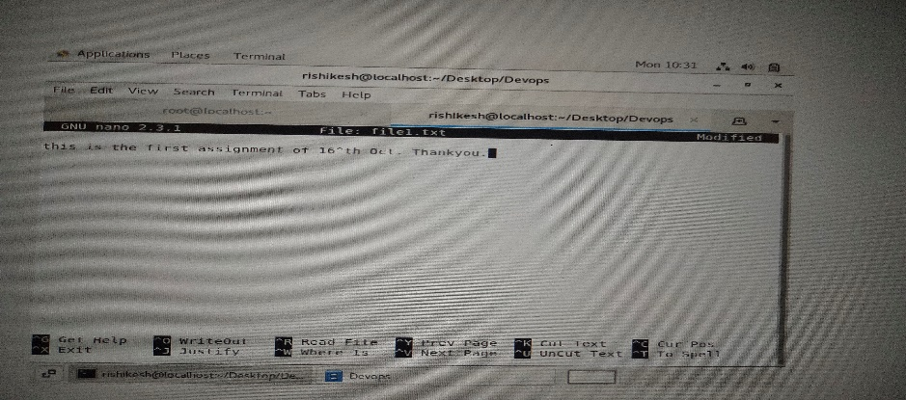

**2. Now we will copy date from file to new file**

* **cp file1.txt file2.txt**
* **Then see the output of file2.txt, cat file2 bit**
* **Give screenshot**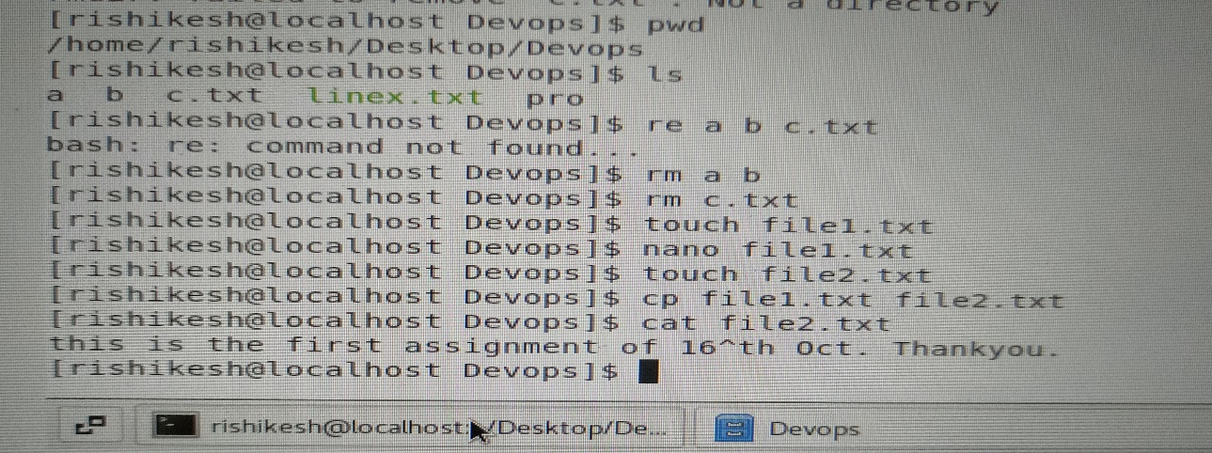

**Now we will move the file2.txt to new folder /home**

* **mv file2.txt/home**
* **Then go to home directory and check is, file exits or not?**
* 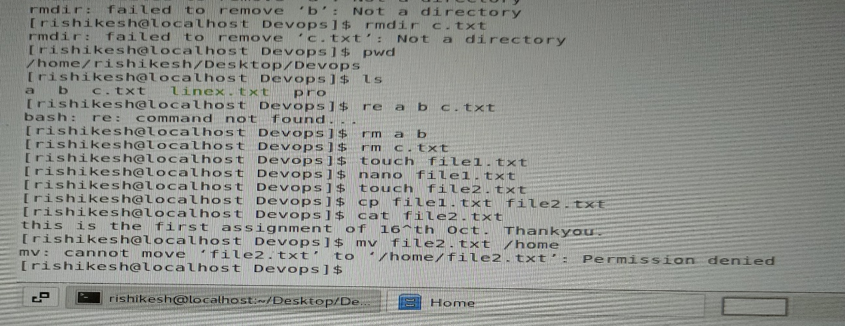**Given screenshot**
* 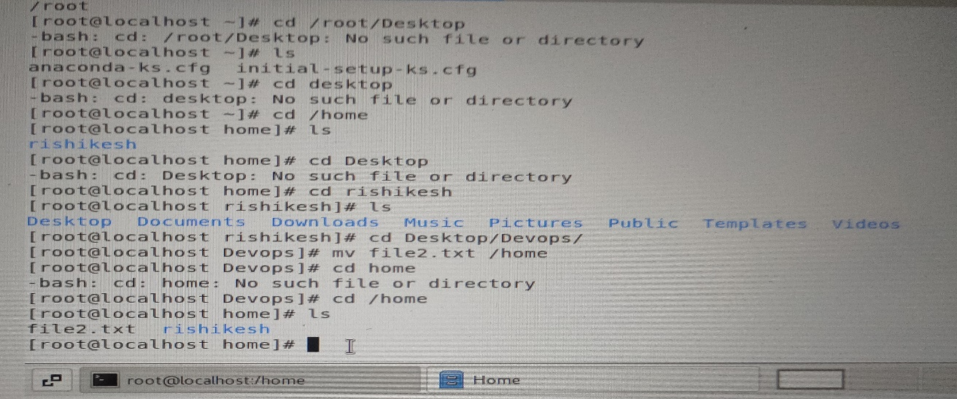

**🡺** In the first as a user it cannot move file to /home directory as see in the above 1st picture it says I had means the **user rishikesh** has not permission to move the file to /home directory. But when is switch as a root user **file moved in /home directory and it shows in there.**

**4. Then we create a new file.txt and file.txt in home directory and add content in it.**

* **Now do echo "Hello I am newline">file.txt and provide the output of file.txt**
* **Now do echo "Hello I am newline"> file.txt and provide the output of file.txt**
* **Tell the different between both step you follow and the reason behind it**

🡺 In first case **echo "Hello I am newline">file.txt** rewrite the file as “ **Hello I am newline”** and delet the existing text. But when we use the **echo** **"Hello I am newline"> file.txt** it will be write the **"Hello I am newline”** at ending of existing text means the command existing write in the file.

‘>’ :- Rewrite the file and delet the previous.

‘>>’ :- existing write the file.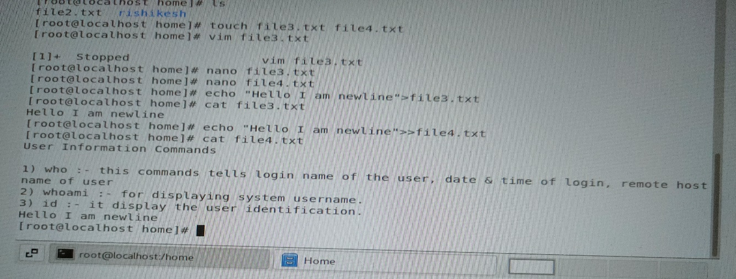

**5. For remove a file or directory you can use the below two commands**

* **To delete a file-rm <any filename>**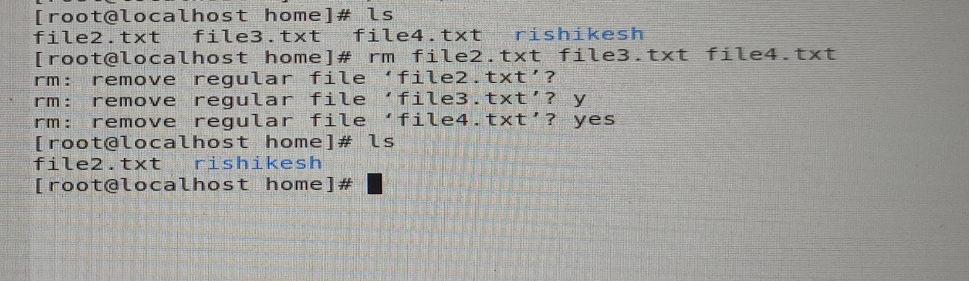
* **To delete a directory - rmdir <any directoryname>**