# **Experiment No.6**

**Aim:** To Study Quality of Service (QoS) in 802.11e based WLANs

**Prerequisite:**

1. Understanding of basics of WLAN

**Outcome:**

After successful completion of this experiment students will be able to

1. Understand how Quality of Service in 802.11e based WLANs vary

**Theory:**

IEEE 802.11e Medium Access Control (MAC) is a supplement to the IEEE 802.11 Wireless Local Area Network (WLAN) standard to support Quality-of-Service (QoS). When 802.11e is enabled high-priority traffic has a higher chance of being sent than low-priority traffic: an application with high priority traffic waits a little less before its packet is processed and compared to an application with low priority traffic. The various application traffic generated in NetSim have the following priority and QoS values:

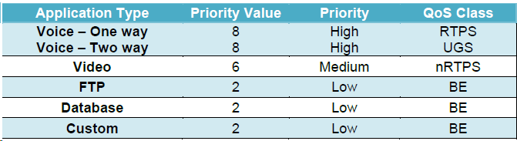

**Experiment No.6**

(PART B: TO BE COMPLETED BY STUDENTS)

**(Students must submit the soft copy as per following segments within two hours of the practical. The soft copy must be uploaded on the Blackboard or emailed to the concerned lab in charge faculties at the end of the practical in case the there is no Black board access available)**

|  |  |
| --- | --- |
| Roll No. C114 | Name: Rishikesh Vadodaria |
| Class: C | Batch: C2 |
| Date of Experiment: 1st March 2025 | Date of Submission: 1st March 2025 |
| Grade: |  |

## **B.1 Input**

**Include screenshots of the topology for every increase in the number of nodes ( atleast 3-4), parameter metrics of application created.**

**Sample 1:**

Topology Screenshot

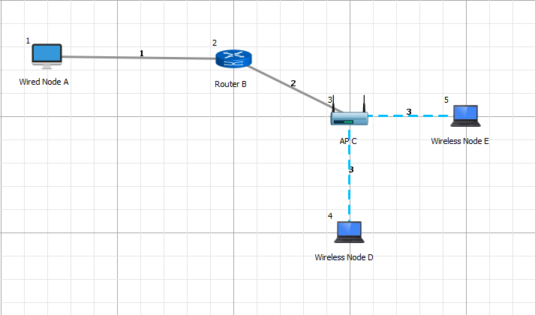

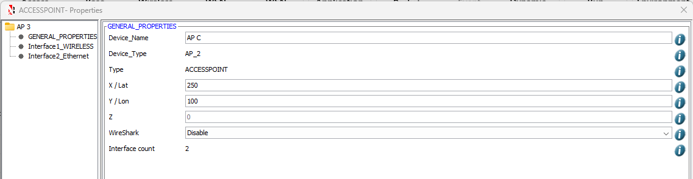

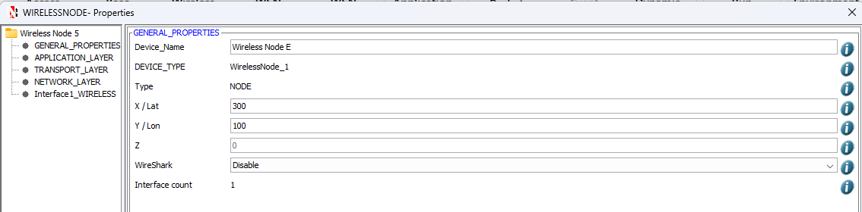

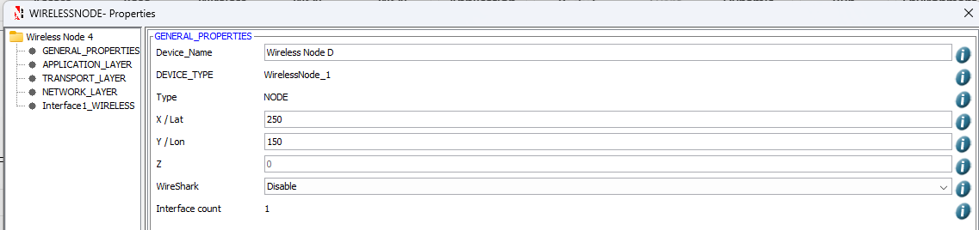

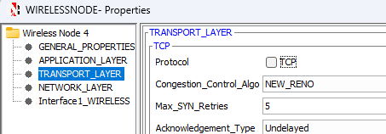

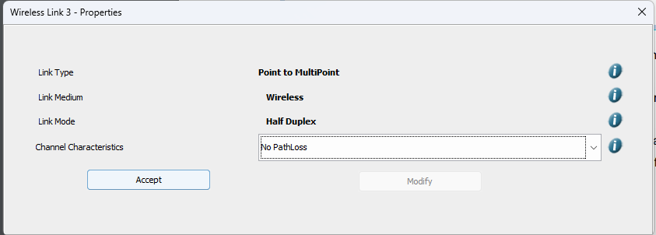

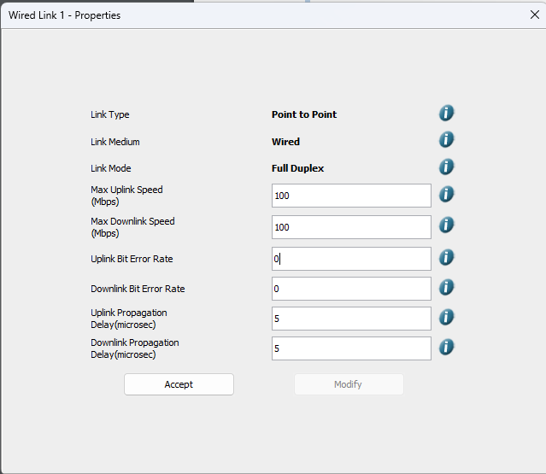

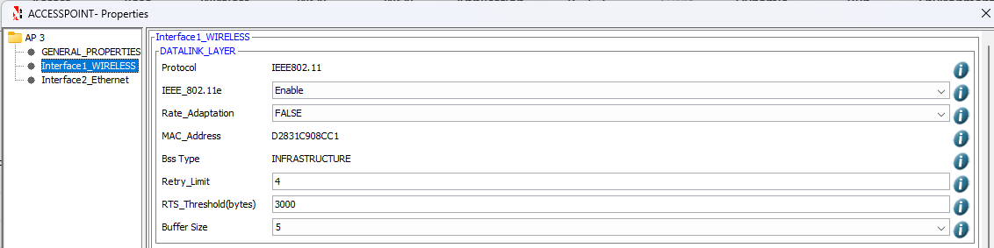

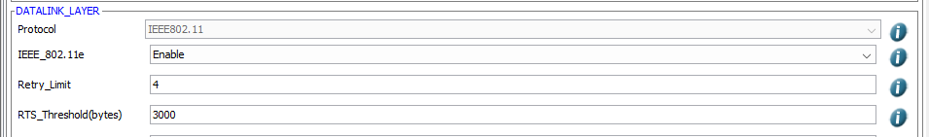

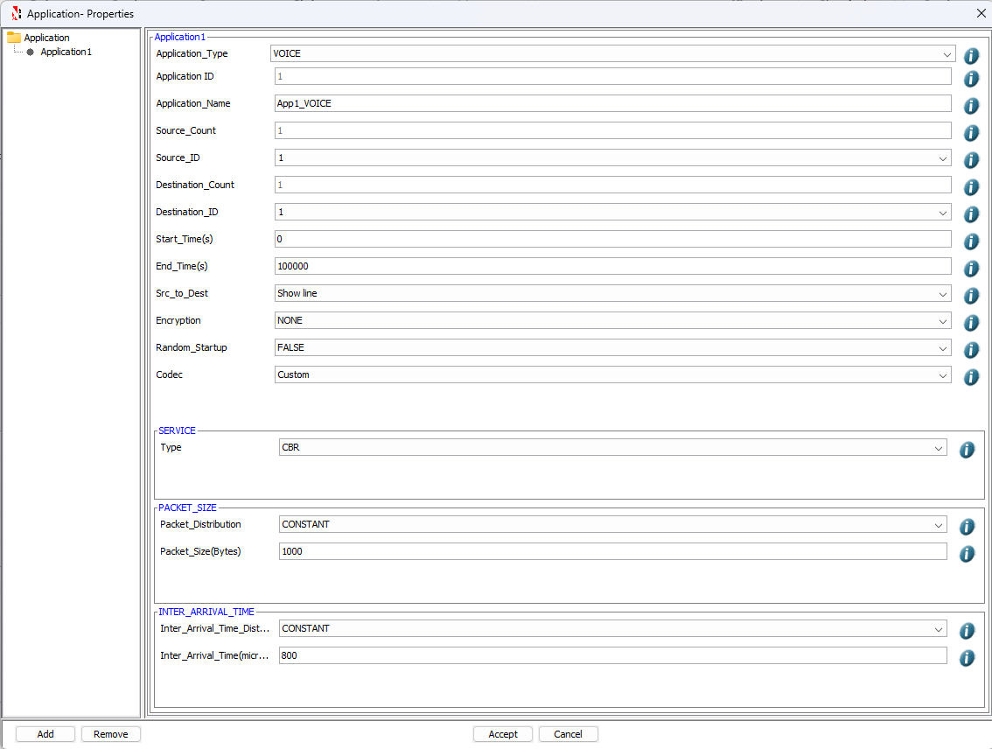

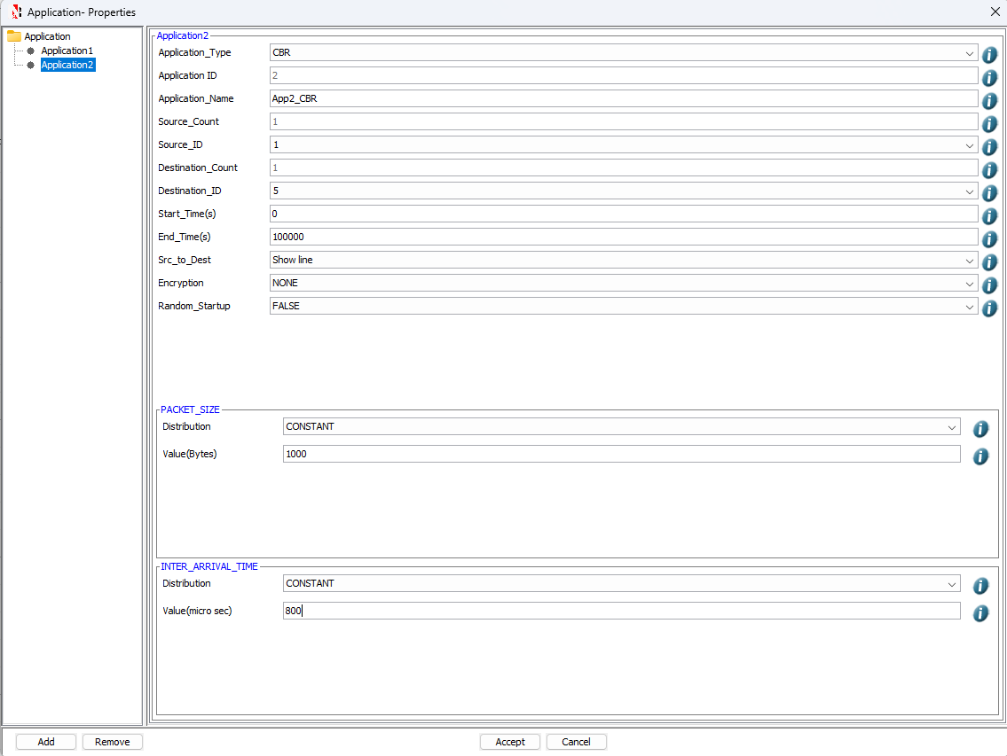

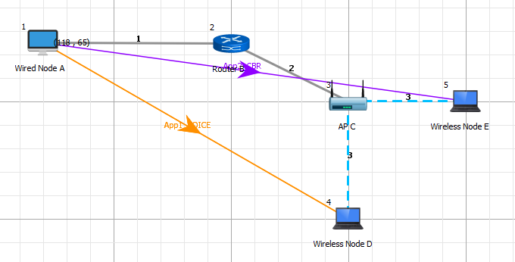

Application Metrics Screenshot

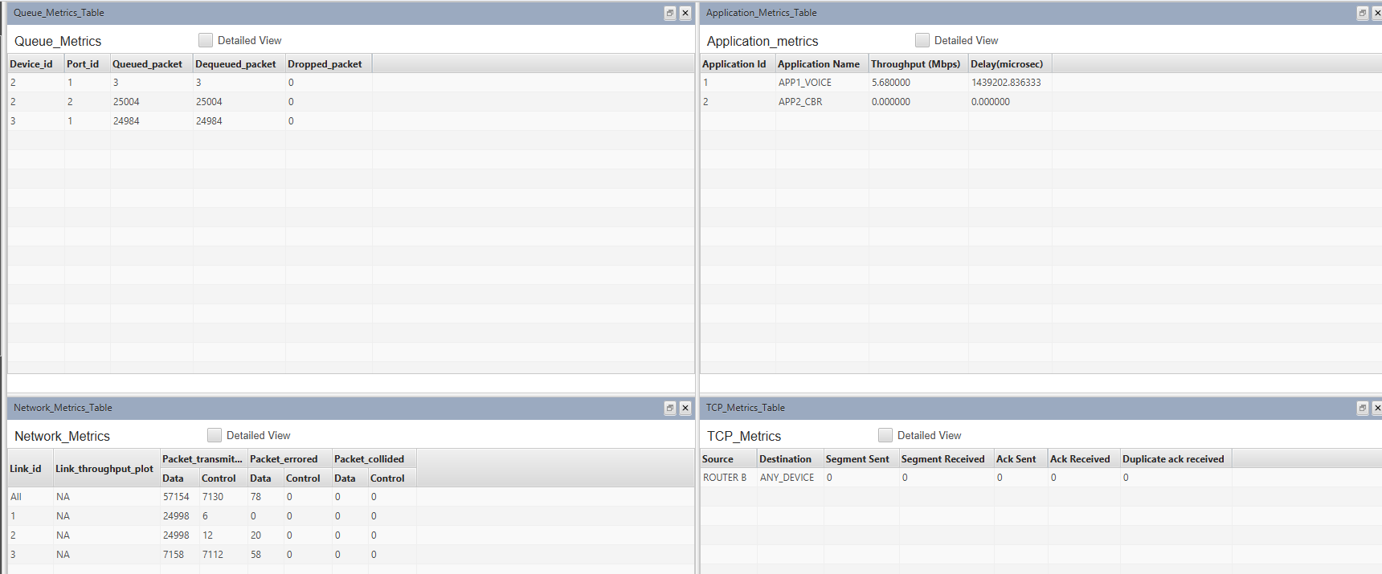

**Sample 2:**

Topology Screenshot

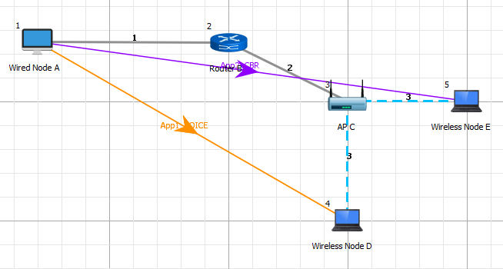

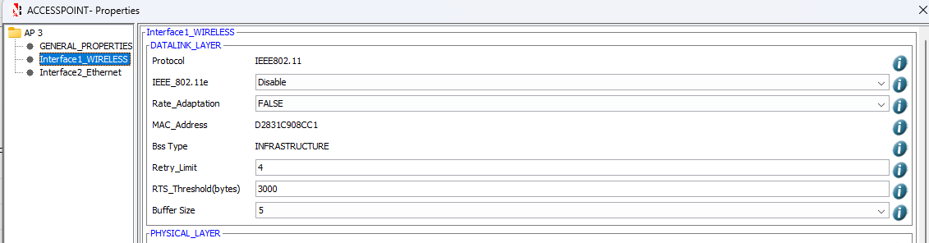

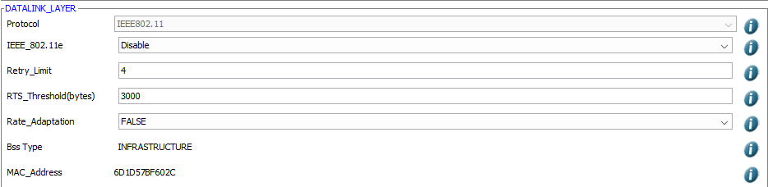

Application Metrics Screenshot

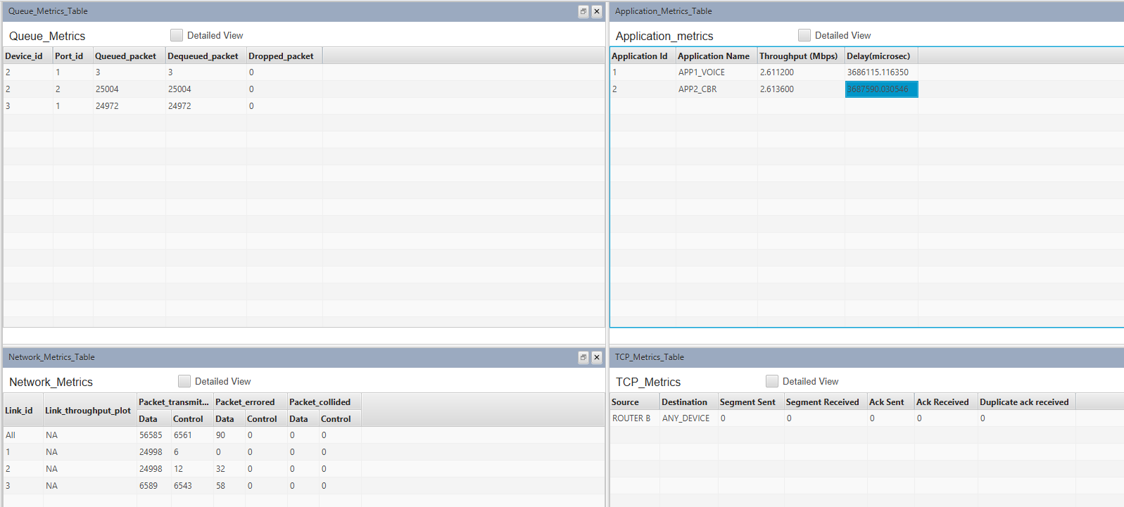

**Sample 3:**

Topology Screenshot (Enabled IEEE_802.11 4 Nodes and AP)

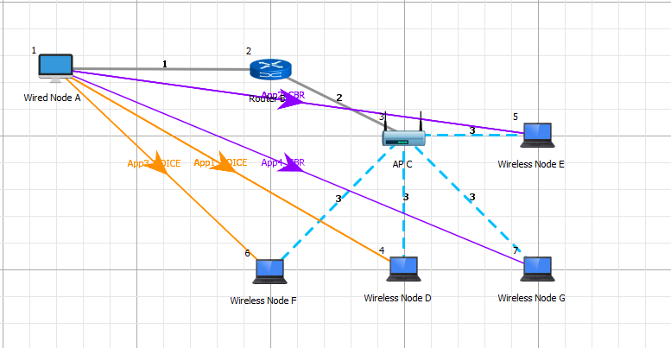

Application Metrics Screenshot

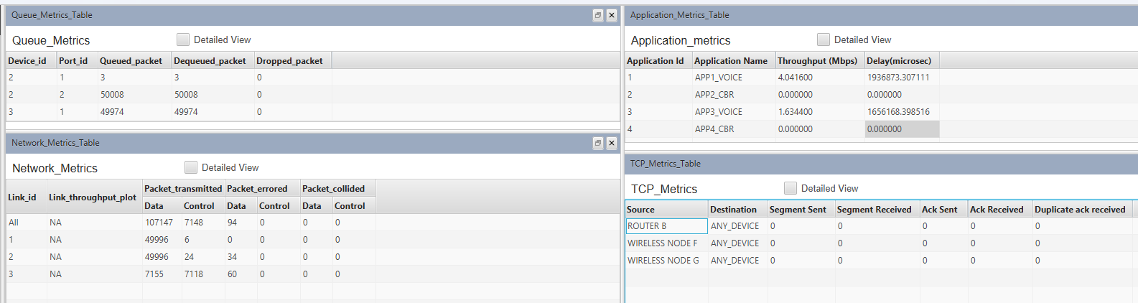

**Sample 4:**

Topology Screenshot (Disabled IEEE_802.11 4 Nodes and AP)

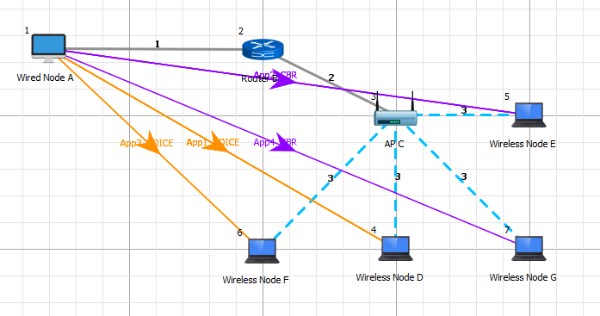

Application Metrics Screenshot

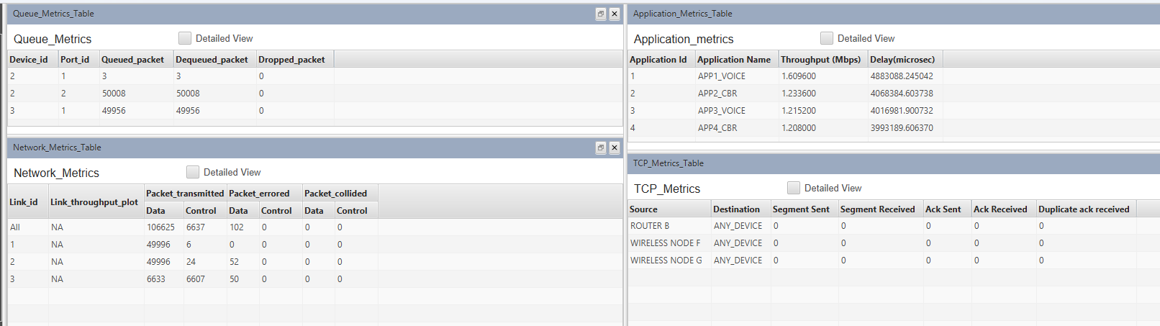

## **B.2 Simulation results**

|  |  |  |  |
| --- | --- | --- | --- |
| **IEEE 802.11e** | **Application** | **Throughput (Mbps)** | **Delay (Micro. Sec.)** |
| Enable  (Sample 2) | |  |  |  |  | | --- | --- | --- | --- | | Voice |  |  |  | |  | | | | | **5.68** | **1439202.8363** |
| CBR | **0.0** | **0.0** |
| **Disable**  **(Sample 1)** | |  |  |  |  | | --- | --- | --- | --- | | Voice |  |  |  | |  | | | | | **2.611200** | **3686115.116350** |
| CBR | **2.613600** | **3687590.030546** |

|  |  |  |  |
| --- | --- | --- | --- |
| **IEEE 802.11e** | **Application** | **Throughput (Mbps)** | **Delay (Micro. Sec.)** |
| Enable  (Sample 3) | |  |  |  |  |  | | --- | --- | --- | --- | --- | | Voice |  |  |  | | |  | | | | | **4.041600** | **1936873.307111** |
| CBR | **0.0** | **0.0** |
|  | |  |  |  |  | | --- | --- | --- | --- | | Voice |  |  |  | |  | | | | | **1.634400** | **1656168.398516** |
| CBR | **0.000000** | **0.000000** |

|  |  |  |  |
| --- | --- | --- | --- |
| **IEEE 802.11e** | **Application** | **Throughput (Mbps)** | **Delay (Micro. Sec.)** |
| Disable  (Sample 4) | |  |  |  |  |  | | --- | --- | --- | --- | --- | | Voice |  |  |  | | |  | | | | | **1.609600** | **4883088.245042** |
| CBR | **1.233600** | **4068384.603738** |
|  | |  |  |  |  | | --- | --- | --- | --- | | Voice |  |  |  | |  | | | | | **1.215200** | **4016981.900732** |
| CBR | **1.208000** | **3993189.606370** |

## **B.3 Conclusion and Inferences**

After successful completion of this experiment, I was able to understand how Quality of Service in 802.11e based vary on WLAN settings.

**B4. Questions of curiosity**

Q1. How does IEEE 802.11e handle the delivery of real-time traffic, such as voice and video, to ensure a satisfactory Quality of Service?

Ans: IEEE 802.11e introduces Quality of Service (QoS) enhancements through the Enhanced Distributed Channel Access (EDCA) mechanism. EDCA prioritizes traffic based on different access categories (ACs) such as voice, video, best effort, and background. Real-time traffic, like voice and video, is given higher priority by allocating shorter contention windows and faster access to the channel, thus reducing delay and ensuring a stable quality of service.

Q2. What is the primary motivation behind the introduction of QoS in IEEE 802.11e?

Ans: The primary motivation is to improve support for real-time applications (e.g., voice, video conferencing) in wireless networks. As WLANs were originally designed for data-oriented applications, the introduction of QoS ensures that time-sensitive traffic can be delivered with low latency, minimal jitter, and higher priority, ensuring a satisfactory user experience.

Q3. What mechanisms does IEEE 802.11e utilize to address the challenges associated with the wireless medium, such as channel access and fairness among different traffic types?

Ans: IEEE 802.11e addresses these challenges through:

* EDCA: Differentiates traffic using four access categories (ACs) with different priority levels and contention windows.
* Arbitration Interframe Space (AIFS): Assigns smaller AIFS values to high-priority traffic, allowing quicker access to the channel.
* Transmission Opportunity (TXOP): Provides a mechanism for burst transmission, which is crucial for time-sensitive traffic like video or voice. These mechanisms ensure fairness by regulating access and prioritizing high-priority traffic while maintaining fair channel access for all types.