# **Experiment No.2**

**Part I:**

**Aim: To understand and analyze the key components of cellular network architecture: Mobile Station (MS), Base Station (BS), Base Station Controller (BSC), and Mobile Switching Center (MSC)**

**Prerequisite:**

1. Basic Foundations of Mobile Technologies
2. Understanding of Wireless Communication

**Outcome:** After successful completion of this experiment students will be able to:

1. To understand the cellular network architecture components
2. Understand and compare functionalities of MS, BS, BSC, and MSC
3. Understand the interaction between different network components

**Theory:** Cellular network architecture refers to the foundational framework that enables mobile communication through a hierarchical network of components. Each component plays a vital role in establishing and maintaining wireless connections, managing resources, and ensuring seamless communication.

To explore following topics and summarise in your own words:

1. Definition of Mobile Station and its components
2. Base Station architecture and functionality
3. Role and responsibilities of Base Station Controller
4. Mobile Switching Center and its operations
5. Interaction between components
6. Cellular Network Architecture

**Experiment No.2**

(PART B: TO BE COMPLETED BY STUDENTS)

**(Students must submit the soft copy as per following segments within two hours of the practical. The soft copy must be uploaded on the Portal or emailed to the concerned lab in charge faculties at the end of the practical in case the there is no Black board access available)**

|  |  |
| --- | --- |
| Roll No. C114 | Name: Rishikesh Vadodaria |
| Class: C | Batch : C2 |
| Date of Experiment: 18-01-2024 | Date of Submission: 18-01-2024 |
| Grade : |  |

Include details from B1 to B5 as per theory

**B.1 Definition of Mobile Station and Components**

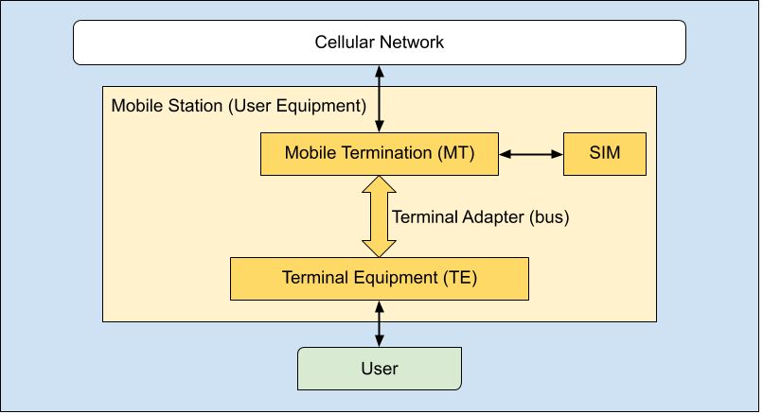

**Mobile Station (MS):**

* A Mobile Station (MS) is a user device in a cellular network that communicates wirelessly with the base station. It includes both the terminal equipment and mobile equipment.

**Terminal Equipment:**

* Terminal Equipment refers to the user interface of the mobile device, such as the display, keyboard, microphone, and speakers. It is responsible for user interaction with the mobile network.

**Mobile Equipment:**

* Mobile Equipment (ME) refers to the hardware responsible for handling wireless communication with the network, such as the radio module, processor, and antenna.

**MS Operations:**

* **Call Setup:** Initiates and receives calls.
* **Call Termination:** Ends a call.
* **Mobility Management:** Tracks user location and manages handovers.
* **Signal Transmission:** Sends and receives signals to/from the network.
* **Authentication:** Ensures the user is authorized to use the network.
* **Encryption:** Protects communication from eavesdropping.

**B.2 Base Station Architecture**

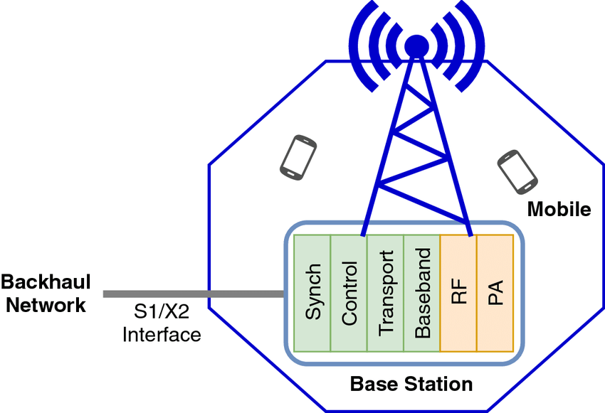

**Base Station (BS):**

* A Base Station (BS) is a fixed network component that connects mobile devices to the cellular network. It provides wireless communication for mobile stations in a specific geographic area.

**BS Components:**

* **Base Transceiver Station (BTS):** The radio equipment that transmits and receives signals to/from mobile stations.
* **Controller Interface:** Connects the BTS to the Base Station Controller (BSC).
* **Antenna System:** Handles the transmission and reception of radio signals.

**Coverage Concepts:**

* Coverage refers to the geographic area where the base station provides signal service. It is influenced by factors like power, antenna type, and environmental conditions.

**Frequency Allocation:**

* The allocation of specific frequencies to different base stations and channels to avoid interference and optimize capacity within the network.

**Power Management:**

* Power management in a base station ensures that the transmission power is optimized to maintain signal quality while minimizing energy consumption and interference.

**B.3 Base Station Controller**

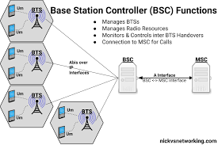

**BSC (Base Station Controller):**

* A Base Station Controller (BSC) manages multiple base stations and is responsible for tasks like handover, resource allocation, and power control in the network.

**Resource Management:**

* Manages radio resources like frequency channels, timeslots, and power levels to ensure efficient use of network capacity and optimal user experience.

**Handover Control:**

* Manages the transfer of calls or data sessions between different base stations to ensure seamless communication, especially when a mobile station moves across different coverage areas.

**BSC Responsibilities:**

* **Call Setup/Termination:** Manages call establishment and release.
* **Handover Management:** Controls handovers between different base stations.
* **Power Control:** Adjusts the transmission power to maintain optimal signal strength.
* **Resource Allocation:** Allocates radio channels and manages network traffic.
* **Traffic Balancing:** Distributes network load to avoid congestion.
* **Fault Management:** Monitors network performance and manages faults.

**B.4 Mobile Switching Center**

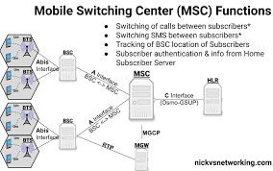

**MSC (Mobile Switching Center):**

* A Mobile Switching Center (MSC) is a central network node responsible for routing calls, managing location information, and handling mobility within the cellular network.

**Switching Operations:**

* The MSC routes calls between base stations, processes mobile-to-mobile calls, and connects mobile stations to external networks like PSTN (Public Switched Telephone Network).

**Location Management:**

* The MSC tracks the location of mobile stations, allowing for call delivery and handovers as the mobile user moves through different network areas.

**MSC Capabilities:**

* **Call Setup and Teardown:** Establishes and terminates calls.
* **Roaming Support:** Allows users to maintain service when traveling outside their home network.
* **Mobility Management:** Handles user location updates and handovers.
* **Short Message Service (SMS):** Facilitates text messaging.
* **Billing:** Tracks usage for billing purposes.
* **Inter-network Communication:** Manages connections with other networks.

**B.5 Cellular Network Architecture**

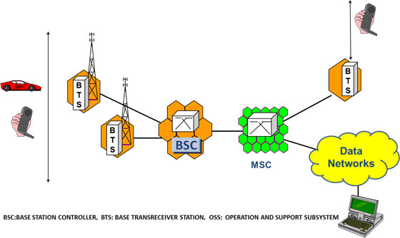

**Network Topology:**

* The cellular network consists of various components, such as Base Stations (BS), Base Station Controllers (BSC), Mobile Switching Centers (MSC), and gateways that interconnect to provide seamless mobile communication.

**User Plane:**

* The user plane refers to the part of the network responsible for the actual data transfer, including voice, text, and internet traffic. It transports user-generated content across the network.

**Architectural Principles:**

* **Scalability:** The network must support a large number of users and expand to accommodate future growth.
* **Flexibility:** The architecture should be adaptable to different technologies (e.g., 4G, 5G).
* **Reliability:** Ensures continuous service and fault tolerance.
* **Efficiency:** Optimizes resources to minimize congestion and power consumption.
* **Security:** Protects user data and network infrastructure from threats and breaches.

**Conclusion:** Cellular networks consist of interconnected components like Mobile Stations (MS), Base Stations (BS), Base Station Controllers (BSC), and Mobile Switching Centers (MSC). These work together to ensure seamless communication, manage resources, support mobility, and maintain network performance. Efficient management of resources, handovers, and mobility is crucial for reliable service.

**Learnings and Findings:**

* Interdependence: Network components rely on each other for smooth operation.
* Resource Efficiency: Proper allocation of radio resources is vital for quality service.
* Mobility Management: Handover management ensures uninterrupted service as users move.
* Scalability: Networks are designed to grow and adapt to new technologies.
* Security & Reliability: Network security and fault management are essential for stability.
* Technology Evolution: Newer technologies (like 5G) improve data speeds and user experiences.

**Questions of Curiosity:**

1. **Virtualized Networks and Cloud-Native Architectures:** With virtualization and cloud-native architectures, components like the Base Station Controller (BSC) and Mobile Switching Center (MSC) could be moved to the cloud, offering more flexibility, scalability, and easier management of resources without the need for dedicated physical hardware.
2. **Artificial Intelligence Integration:** AI could be integrated into these components to predict traffic patterns, optimize resource allocation, automate network management, and improve decision-making, leading to more efficient and responsive network operations.
3. **Support for Emerging Technologies:** To support IoT and machine-to-machine communication, these components will evolve to handle massive device connections, low-latency communication, and efficient data routing, ensuring that networks can manage a higher volume of devices and more diverse traffic.
4. **Security Challenges:** The distributed nature of these components increases vulnerability to cyberattacks and data breaches. Future implementations could address this by incorporating advanced encryption, real-time monitoring, and decentralized security protocols to ensure data integrity and network protection.