# **Experiment No.1**

**Aim: To understand and analyze the evolution of Mobile Computing through various generations.**

**Prerequisite:**

1. Basic Foundations of Mobile Technologies

**Outcome:**

After successful completion of this experiment students will be able to

1. To understand the evolution of Mobile computing
2. Understand and compare about 2G,3G,4G and 5G technologies.
3. Understand the mobile computing architecture, operation systems and its applications

**Theory:**

Mobile Computing refers a technology that allows transmission of data, voice and video via a computer or any other wireless enabled device. It is free from having a connection with a fixed physical link. It facilitates the users to move from one physical location to another during communication**.**

To explore following topics and summarise in your own words:

1. Definition of Mobile Computing
2. Types of Wireless Networks
3. Evolution of 1G,2G,3G , 4G and 5G
4. Comparison between 1G,2G,3G,4G AND 5G
5. Mobile Computing Applications
6. Mobile Computing Architecture

**Experiment No.1**

(PART B: TO BE COMPLETED BY STUDENTS)

**(Students must submit the soft copy as per following segments within two hours of the practical. The soft copy must be uploaded on the Portal or emailed to the concerned lab in charge faculties at the end of the practical in case the there is no Black board access available)**

|  |  |
| --- | --- |
| Roll No. C114 | Name: Rishikesh Vadodaria |
| Class: C | Batch: C2 |
| Date of Experiment: 11th January, 2025 | Date of Submission: 15th January, 2025 |
| Grade : |  |

**B.1 Definition of Mobile Computing**

Mobile Computing is a technology that provides an environment that enables users to transmit data from one device to another device without the use of any physical link or cables. Mobile computing allows transmission of data, voice and video via a computer or any other wireless-enabled device without being connected to a fixed physical link.

* Mobile computing involves mobile communication, mobile hardware, and mobile software.
* In this technology, data transmission is done wirelessly with the help of wireless devices such as mobiles, laptops etc.
* Wireless communication technologies like Wi-Fi, 4G/5G, and Bluetooth play a crucial role in enabling seamless connectivity for data transfer and communication.
* It provides a vast coverage diameter for communication. It is one of the fastest and most reliable sectors of the computing technology field.
* It allows users to access information and computational resources anytime and anywhere without being restricted to a specific location.

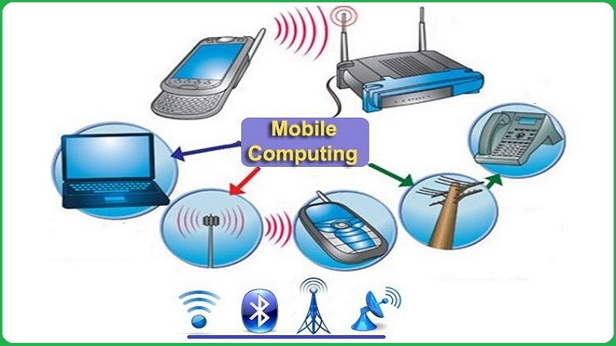

**B.2 Types of Wireless Networks**

Wireless networks allow devices to communicate with each other and access the internet or other network resources without using physical cables.

The most common types of wireless networks:

1. Wireless Personal Area Network (PAN):
   * Wireless personal area networks (PANs) connect devices within a relatively small area, that is generally within a person's reach.
   * They are common inside homes and small office buildings.
   * For example, both Bluetooth radio and invisible infrared light provides a WPAN for interconnecting a headset to a laptop.
2. Wireless Local Area Network (LAN)
   * A wireless local area network (LAN) links two or more devices over a short distance using a wireless distribution method, usually providing a connection through an access point for internet access.
   * The range can be confined to a single room or home or spread across an entire building.
   * For example, Wi-Fi is the most commonly known wireless LAN.
3. Wireless Metropolitan Area Network (MAN)
   * A metropolitan-area network is a computer network that spans across a city, small geographical area, or business or college campus.
   * Wireless metropolitan area networks are a type of wireless network that connects several wireless LANs
   * A MAN can cover several square miles, depending on the needs of the organization.
   * For example, WiMAX is a type of Wireless MAN for a wide coverage area.
4. Wireless Wide Area Network (WAN)
   * Wireless wide area networks are wireless networks that typically cover large areas, such as between neighboring towns and cities, or city and suburb.
   * These networks can be used to connect branch offices of business or as a public Internet access system.
   * Like the internet, a WAN can contain smaller networks, including LANs or MANs.
   * For example, Cellular services are the most commonly known wireless WANs.

**B3. Evolution of 1G,2G,3G,4G and 5G**

1. **1G**
   * 1G, or the first generation of Mobile Networks, was introduced in the 1980s.
   * It primarily supported analogue voice communication and was quite basic compared to modern standards.
   * Users could make voice calls, but no data services or internet connectivity were available on these networks.
2. **2G**
   * 2G was introduced in the early 1990s and significantly improved over 1G.
   * It introduced digital voice communication, which improved call quality and allowed for some basic data services like text messaging (SMS).
   * Internet access was still limited.
   * Data speeds were typically in the range of kilobits per second (Kbps).
3. **3G** 
   * 3G emerged in the early 2000s and brought substantial improvements in mobile communications.
   * It enabled faster data transfer rates, making accessing the internet on mobile devices possible.
   * With 3G, users could browse the web, send emails, and use more advanced data-based applications.
   * Data speeds improved to the range of megabits per second (Mbps)
4. **4G** 
   * 4G, rolled out in the late 2000s, represented a major leap in mobile technology.
   * It provided even faster data speeds and lower latency, making streaming high-definition videos, online gaming, and video conferencing smoother and more reliable.
   * Data speeds increased further to the range of tens of megabits per second (Mbps) to hundreds of megabits per second (Mbps).

1. **5G**:
   * 5G is the latest and most advanced mobile network technology.
   * It offers significantly faster data transfer rates, reduced latency, and increased network capacity.
   * It is designed to handle many connected devices and support advanced applications that require near-instantaneous data transmission.
   * Data speeds in 5G Networks can range from hundreds of megabits per second (Mbps) to multiple gigabits per second (Gbps).

**B4. Comparison**

|  |  |  |  |  |  |
| --- | --- | --- | --- | --- | --- |
| **Parameters** | **1G** | **2G** | **3G** | **4G** | **5G** |
| **Data Rate** | 2kbps | 14.4-64 kbps | 2 Mbps | 200 Mbps to 1 Gbps | 10 Gbps to 100 Gbps |
| **Base Technology** | Analog cellular technology | Digital Cellular Technology | Broad Bandwidth CDMA, IP Technology | Undefined IP and combination of broadband. | Undefined IP and combination of broadband. |
| **Types of Switching** | Circuit | Circuit | Packet | Packet | Packet |
| **Services offered** | Voice | Digital Voice, SMS | High quality audio, video and data | Dynamic information access, wearable devices | Dynamic information access, wearable devices with AI technologies |
| **Multiplexing** | FDMA | TDMA, CDMA | CDMA | CDMA | CDMA |
| **Frequency Bands** | Narrowband | Narrowband and Wideband | Wideband | Broadband | Broadband (mmWave, sub-6 GHz |

**B5. Mobile Computing Applications**

* **In Education Sector**
  1. E-Learning and Online Courses: Mobile devices allow students to access online courses and educational content on-the-go. Apps like Coursera, edX, and Khan Academy provide access to a wide range of courses and educational materials, including videos, quizzes, and interactive content.
  2. Virtual Classrooms and Collaboration: With mobile computing, teachers and students can connect in virtual classrooms via apps such as Zoom, Microsoft Teams, and Google Meet. These platforms allow for live sessions, sharing resources, and collaboration through discussion boards or group projects.
  3. Digital Textbooks and Learning Resources: E-books and educational apps are replacing traditional textbooks, offering students access to interactive, multimedia-rich content. Mobile applications like Kindle, and Google Books offer access to study guides, often at a lower cost than physical books.
  4. Campus Management Systems: Mobile computing allows educational institutions to streamline administrative tasks. Mobile apps for student information systems, such as Blackboard, Moodle, or university-specific apps, allow students and staff to access grades, assignments, attendance, and other academic resources.
* **Healthcare Sector**

1. Electronic Health Records (EHRs): Mobile access to EHRs enables healthcare providers to retrieve and update patient information in real-time, improving decision-making and coordination of care.
2. Telemedicine: Mobile platforms facilitate remote consultations, allowing patients to receive medical advice and treatment without visiting healthcare facilities, increasing accessibility and convenience.
3. Health Monitoring Apps: Applications track vital signs and health metrics, enabling patients to monitor their conditions and share data with healthcare providers for proactive management.

**B6. Mobile Computing Architecture**

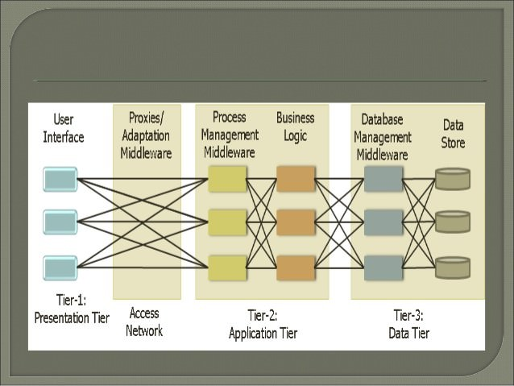

This diagram represents a three-tier architecture in mobile computing. Each tier has a specific role in the system's operation, providing modularity, scalability, and flexibility for mobile applications.

**Presentation Tier (Tier-1)**

* **User Interface**
  + It is the front-end component that provides users with an interactive platform to communicate with the system. It can include buttons, forms, menus, and other graphical elements.
  + Captures user input (e.g., touch, click, or typed commands).
  + Displays outputs from the application tier in a human-readable format.
  + Ensures usability, accessibility, and responsiveness of the system for diverse devices.

**Access Network**

* Represents the communication infrastructure that connects mobile devices to the system.
* It is the medium through which data flows between the presentation tier and the application tier.
* Facilitates secure and reliable data transmission.
* Adapts to changing network conditions (e.g., switching between 4G, 5G, or Wi-Fi).

**Application Tier (Tier-2)**

* **Proxies/Adaptation Middleware**
  + Proxies act as intermediaries between the user devices and the application logic, optimizing the interaction for different types of devices and network conditions.
  + Adaptation Middleware is responsible for handling the diversity of mobile devices (e.g., screen resolution, operating systems, hardware capabilities).
  + Adapts content (e.g., resizing images for smaller screens).
  + Balances requests across servers (load balancing).
  + Provides caching and session management for enhanced performance.
* **Process Management Middleware**
  + Coordinates the workflow of processes between the business logic and other layers.
  + Functions:
  + Manages authentication, session handling, and API calls.
  + Ensures smooth task execution, such as processing multiple user requests simultaneously.
* **Business Logic**
  + The core computational engine that contains the rules, algorithms, and functionality of the system.
  + Functions:
  + Executes operations requested by the user (e.g., retrieving account balance, booking tickets).
  + Implements validations and enforces system rules (e.g., ensuring a user has sufficient balance before making a transaction).

**Data Tier (Tier-3)**

* **Database Management Middleware**
  + This component acts as an interface between the application logic and the actual data store. It ensures efficient and secure access to stored data.
  + Handles database queries, transactions, and connection pooling.
  + Maintains data integrity, consistency, and security during interactions.
  + Provides features like indexing and optimization for fast data retrieval.
* **Data Store**
  + The data store is the backend storage system where all application data resides. It can include relational databases, NoSQL databases, or cloud-based storage.
  + Functions:
  + Permanently stores structured and unstructured data.
  + Ensures availability and redundancy to prevent data loss.

**Conclusion:**

* We researched about mobile computing in detail.
* Understood its architecture and the working of different layers.
* Researched about the real life applications of Mobile computing.

**Learnings and Findings:**

* Evolution of Mobile Networks: Mobile networks have transformed from 1G's analog communication to 5G's ultra-fast, high-capacity data services, with 6G poised to bring even greater advancements in speed, efficiency, and applications.
* Next-Generation Interfaces: Thought-based interaction through brain-computer interfaces and augmented reality will redefine how users interact with technology, offering seamless integration of the physical and digital worlds.
* Decentralized Networking: Technologies such as mesh networking, blockchain, and edge computing hold the potential for decentralized mobile networks, removing dependence on central infrastructure and enhancing resilience.
* Resilient Mobile Networks: Networks designed for disasters, underwater, and space environments rely on innovative approaches like deployable base stations, acoustic communication, and inter-satellite links.

**Questions of Curiosity:**

1. **How will user interfaces evolve beyond touch and voice? Could thought-based interaction become a reality? What role might have augmented reality play in the future of mobile computing interfaces?**

Thought-Based Interaction includes Brain-computer interfaces (BCIs) which are a promising area of research. Advances in neural decoding and wearable EEG devices suggest that thought-based interactions could become a reality, allowing users to control devices directly with their thoughts. Early applications might include accessibility tools for people with disabilities, gaming, and hands-free control in AR/VR environments.

Augmented Reality (AR) could revolutionize interfaces by overlaying contextual information onto the real world. With AR glasses and contact lenses, mobile computing might seamlessly blend physical and digital spaces, enabling hands-free interactions, holographic displays, and real-time guidance for tasks.

1. **Could we develop a truly decentralized mobile network that operates without any central infrastructure?**

A fully decentralized mobile network is conceivable using technologies like:

* Mesh Networking: Devices communicate directly with each other, forming a peer-to-peer network without relying on centralized infrastructure.
* Blockchain: Securely manage identity, transactions, and bandwidth sharing in a decentralized system.
* Edge Computing: Offload processing to local devices or micro-data centers, reducing dependence on centralized servers.

1. **How could mobile networks be designed to remain functional during major disasters or in extreme environments like underwater or in space?**

Mobile Networks for Extreme Conditions

* Disaster Scenarios: Networks like FirstNet and mesh-based systems can provide emergency communication during disasters. Deployable base stations and satellite uplinks are critical.
* Underwater Communication: Acoustic and optical communication technologies are being developed for underwater mobile networks, albeit with limited range and speed compared to terrestrial systems.
* Space Communication: Inter-satellite communication networks (ISL) and high-throughput satellites like Starlink can create reliable networks in space.

1. **How might 6G technology evolve beyond 5G, and what new applications could emerge from its potential capabilities?**

Beyond 5G, 6G aims to deliver terabit-level speeds, ultra-low latency (<1ms), and high energy efficiency. 6G could offer speeds up to 100 times faster than 5G.

Features like AI-driven network management and the integration of communication, sensing, and computation are anticipated.

Potential Applications:

* Holographic communications for immersive telepresence.
* High-precision IoT for smart cities and autonomous systems.
* Real-time, AI-driven decision-making in sectors like healthcare and finance.
* Advanced AR/VR experiences with tactile feedback and ultra-high-resolution visuals.

1. **What are the potential implications of mobile computing on personal privacy, and how can we balance convenience with security in future mobile technologies?**

Implications: Increased data collection by mobile devices raises concerns about surveillance, misuse of personal information, and identity theft.

Solutions:

* Privacy-by-Design: Embedding privacy principles into technology development.
* Decentralized Identity Systems: Users retain control over their digital identities.
* Encryption: End-to-end encryption for all communications and data storage.
* Regulation and Transparency: Stronger data protection laws and transparent policies on data usage.
* User Education: Empower users with tools and knowledge to manage their data and privacy settings effectively.

The future of mobile computing interfaces and networks will likely hinge on harmonizing technological innovation with ethical considerations and resilience to ensure accessibility and security for all users.