# **Experiment No.2**

**Aim: To understand and analyze call blocking probability with the increase in the number of mobile nodes.**

**Prerequisite:**

1. Understanding of basics of NetSim

**Outcome:**

After successful completion of this experiment students will be able to

1. Understand the GUI and controls available in the NetSim Simulator
2. Understand the relationship between call blocking probability and number of mobile nodes

**Theory:**

**NetSim** is a network simulation tool that allows you to create network scenarios, model traffic, and study performance metrics.

**What does NetSim provide?**

**Simulation:** NetSim provides simulation of various protocols working in various networks as follows: **Internetworks, Legacy Networks**, **BGP Networks, Advanced Wireless Networks, Cellular Networks, Wireless Sensor Networks, Personal Area Networks, LTE/LTE-A Networks, Cognitive Radio Networks, and Internet of Things**.

Users can open the experiments and save the experiments as desired. The different experiments can also be analyzed using the analytics option in the simulation menu.

**Programming**: NetSim covers various programming exercises along with concepts, algorithms, pseudo code and flowcharts. Users can also write their own source codes in C/C++ and can link them to NetSim.

Some of the programming concepts are Address resolution protocol (ARP), Classless inter domain routing (CIDR), Cryptography, Distance vector routing, shortest path, Subnetting etc.

**Refer NetSim experiment manual available in portal and follow the steps systematically.**

**Experiment No.2**

|  |  |
| --- | --- |
| Roll No. C11 | Name: Rishikesh Vadodaria |
| Class: C | Batch: C2 |
| Date of Experiment: 25th January 2025 | Date of Submission: 25th January 2025 |
| Grade: |  |

## **B.1 Input**

**8 Nodes**

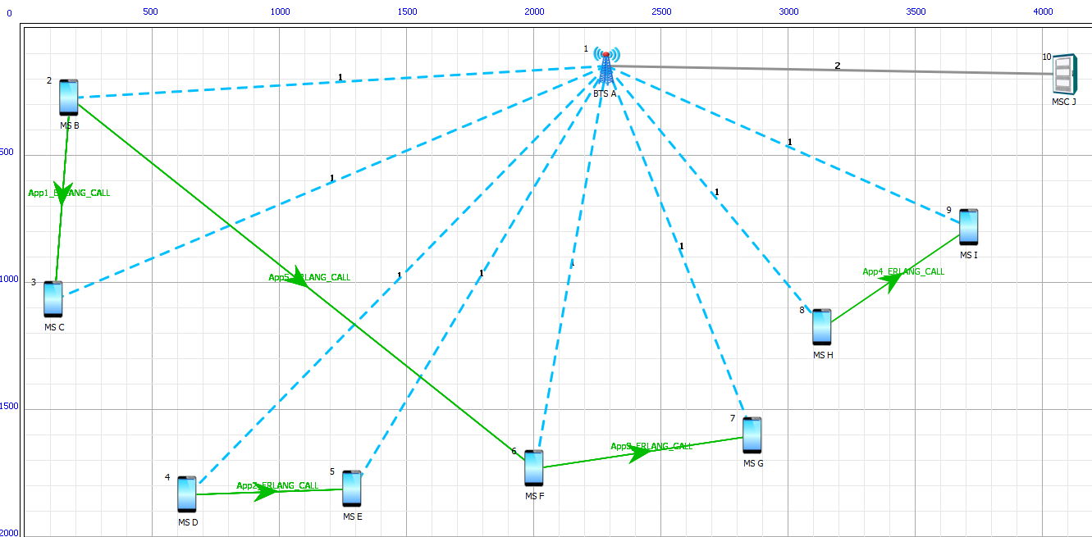

**10 Nodes**

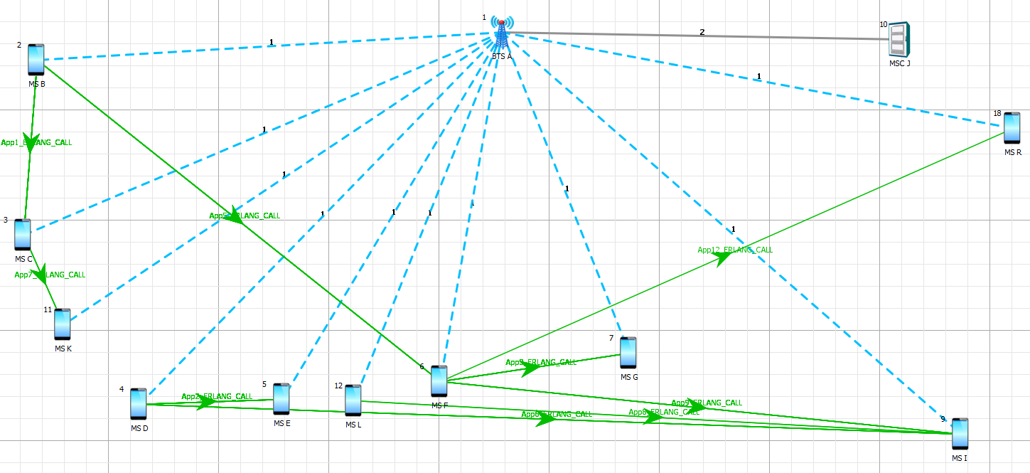

**12 Nodes**

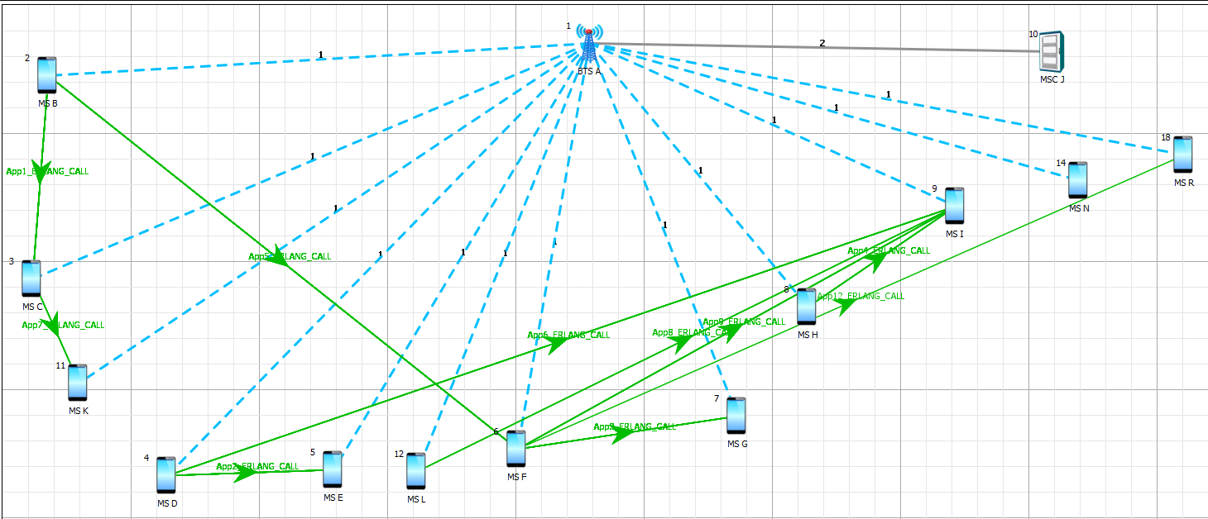

**16 Nodes**

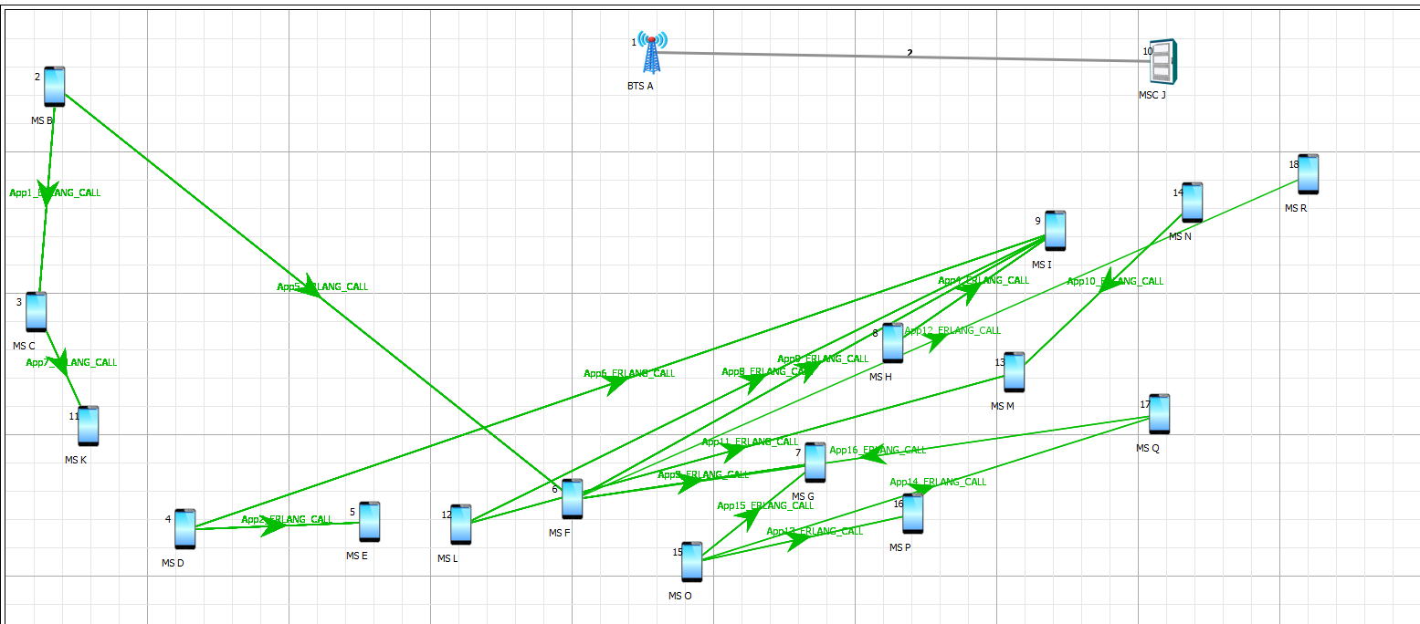

## **B.2 Simulation results**

**Include cellular metrics and call blocking probability**

**8 Nodes**

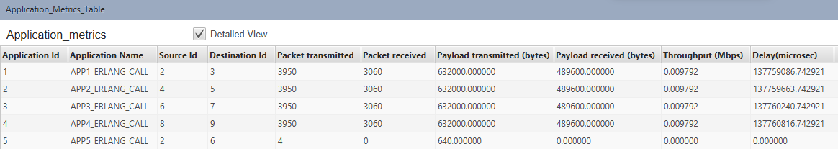

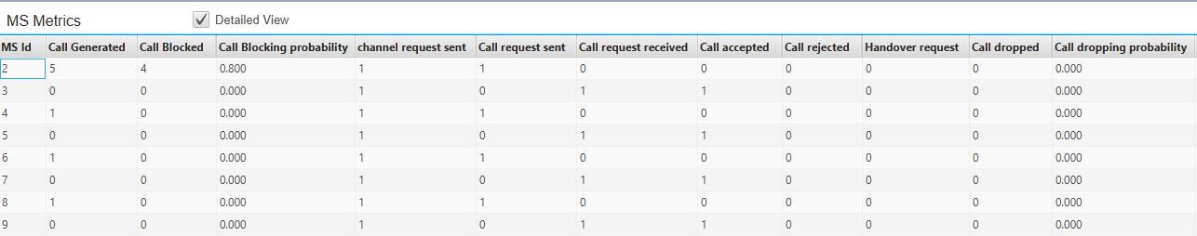

**10 Nodes**

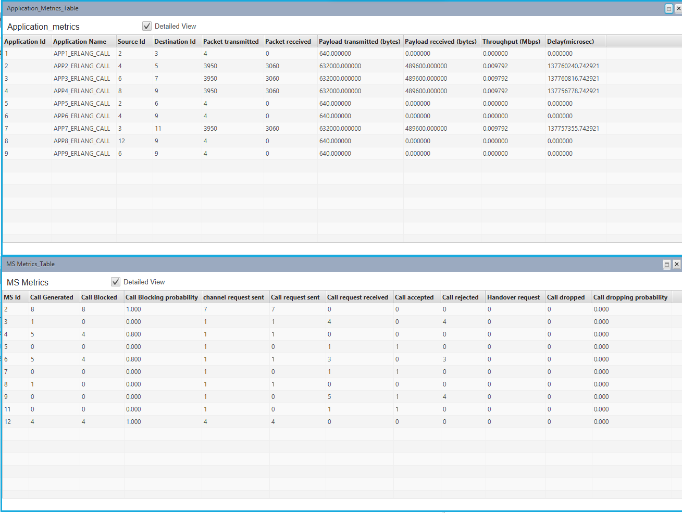

**12 Nodes**

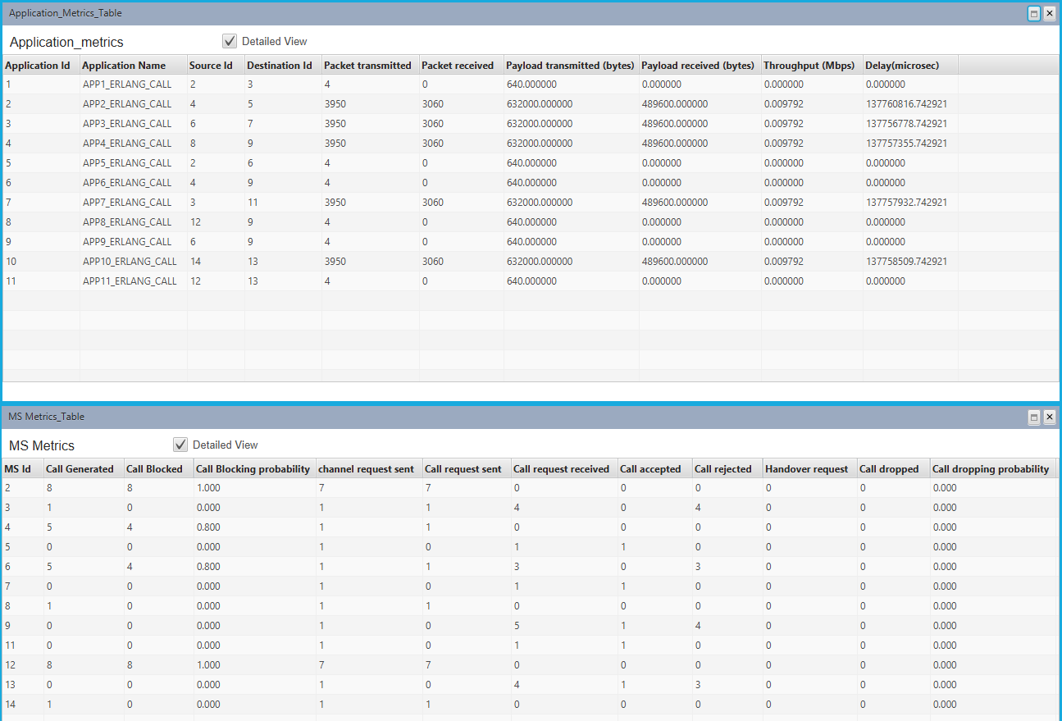

**16 Nodes**

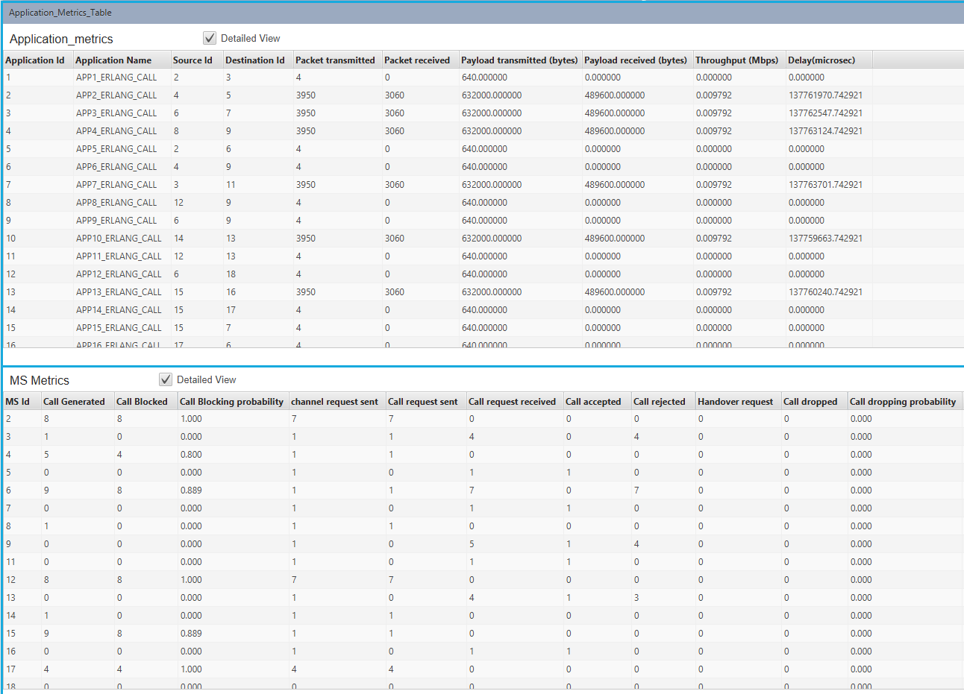

## **B.3 Conclusion**

After successful completion of this experiment, I was able to understand the GUI and controls available in the NetSim Simulator and understand the relationship between call blocking probability and number of mobile nodes.

**Questions of Curiosity**

1. What factors contribute to variations in call blocking probability in mobile networks?

Ans: Call blocking probability (CBP) in mobile networks is affected by several important factors. One major factor is the overall network load; when call volumes are high or data usage increases, congestion can occur, which raises the likelihood of call blocking. The availability of network resources, including radio spectrum, bandwidth, and cell capacity, is also crucial; insufficient resources can lead to a higher chance of call blocking. User density in certain areas significantly impacts CBP as well, with urban centers or crowded events facing a greater risk of call blocking due to high population concentrations. Additionally, traffic patterns play a role, as network congestion tends to be worse during peak hours or sudden spikes in usage. The efficiency of call setup times and handovers is another factor; delays in initiating calls or switching between cells can result in increased blocking rates. Lastly, mobility issues, especially poor handover management between different network cells, can lead to dropped or failed calls, further raising the overall blocking probability.

1. How do emerging technologies, such as network slicing, impact the dynamics of call blocking probability in next-generation networks?

Ans: Emerging technologies like network slicing significantly influence the call blocking probability in next-generation networks. Network slicing enables mobile operators to create virtual, isolated networks that cater to various use cases, including Internet of Things (IoT) devices, low-latency applications, and traditional voice services. This advancement helps lower the call blocking probability by optimizing how resources are allocated; for example, certain slices can be reserved for high-priority services such as voice calls, ensuring these services remain unaffected by congestion elsewhere in the network. Additionally, network slicing allows for more detailed quality of service (QoS) management, enabling operators to prioritize applications sensitive to latency and guarantee bandwidth, which reduces the chances of call blocking. By keeping traffic separate within each slice, operators can avoid congestion in one slice from impacting others, leading to a more reliable user experience and decreasing the likelihood of call failures.

1. Are there industry benchmarks or standards for acceptable call blocking probabilities in modern telecommunications networks?

Ans: In the field of modern telecommunications, there are several industry benchmarks and standards that help operators manage call blocking probability. The International Telecommunication Union (ITU) offers specific recommendations for acceptable levels of call blocking probability (CBP), usually setting thresholds for voice services at about 2% or lower to maintain satisfactory call quality. Furthermore, 3GPP standards outline performance targets for various generations of mobile networks, including 4G and 5G. For instance, these standards establish goals for call setup success rates and the maximum acceptable call blocking probabilities, all aimed at ensuring a high-quality user experience. Although benchmarks can differ by region and technology, operators typically aim to keep CBP below a certain level—often around 1% for 4G networks—to fulfill user expectations for dependable voice and data services. More stringent targets are generally set for newer technologies like 5G, where the focus on ultra-low latency and high reliability necessitates even lower blocking rates.

1. How does the geographical distribution of users affect call-blocking probability in a mobile communication system?

Ans: The geographical distribution of users greatly influences the likelihood of call blocking. In urban areas with high population density, the concentration of users can easily lead to network congestion, resulting in a higher call blocking probability (CBP). This is particularly evident during peak times, like morning and evening rush hours when traffic spikes. On the other hand, rural regions might have less traffic but can still experience significant CBP due to inadequate network coverage, where a lack of base stations or limited infrastructure leads to weak signals and dropped calls. The way users are distributed also impacts the density of network cells; if users are spread out over large areas with sparse cell coverage, or if there are physical barriers such as tall buildings or hilly landscapes, signal quality may decline, increasing the chances of call blocking. Furthermore, environments that obstruct radio signal propagation, like urban canyons or densely wooded areas, can worsen network problems, resulting in higher rates of call rejections.

1. What strategies can be employed to minimize call-blocking probability in congested cellular networks?

Ans: There are several strategies that mobile operators can employ to minimize call blocking probability in congested networks. One effective approach is cell load balancing, which involves dynamically redistributing traffic across cells to avoid overloading any single cell. This can be particularly useful in areas with high user concentrations. Additionally, improving spectrum efficiency through advanced technologies like carrier aggregation, MIMO (Multiple Input, Multiple Output), and high-order modulation schemes can increase network capacity and alleviate congestion. The deployment of small cells and heterogeneous networks (HetNets), which include femtocells, picocells, and microcells, can offload traffic from the macro network and enhance coverage in high-traffic areas, thus reducing the chances of call blocking. Offloading traffic to alternative networks, such as Wi-Fi or 5G for data-heavy applications, can also free up capacity in the 4G network, resulting in fewer blocked calls. Finally, network optimization through machine learning and artificial intelligence enables predictive management, allowing operators to foresee congestion patterns and adjust resources proactively to minimize call blocking, even in high-demand situations. These strategies, when combined, can significantly improve network performance and reduce the likelihood of call blocking in congested environments.