# **Experiment No.4**

**Aim: To Analyze the performance of 802.11g as the number of nodes are increased**

**Prerequisite:**

1. Understanding of basics of NetSim

**Outcome:**

After successful completion of this experiment students will be able to

1. Understand the GUI and controls available in the NetSim Simulator
2. Understand the relationship between call blocking probability and number of mobile nodes

**Theory:**

The 802.11g specification is a standard for wireless local area networks (WLANs) that offers transmission over relatively short distances at up to 54 megabits per second, Networks employing 802.11g operate at radio frequencies between 2.400 GHz and 2.4835 GHz, the same band as 802.11b. But the 802.11g specification employs orthogonal frequency division multiplexing (OFDM), the modulation scheme used in 802.11a, to obtain higher data speed.

**What does NetSim provide?**

**Simulation:** NetSim provides simulation of various protocols working in various networks as follows: **Internetworks, Legacy Networks**, **BGP Networks, Advanced Wireless Networks, Cellular Networks, Wireless Sensor Networks, Personal Area Networks, LTE/LTE-A Networks, Cognitive Radio Networks, and Internet of Things**.

Users can open the experiments and save the experiments as desired. The different experiments can also be analyzed using the analytics option in the simulation menu.

**Programming**: NetSim covers various programming exercises along with concepts, algorithms, pseudo code and flowcharts. Users can also write their own source codes in C/C++ and can link them to NetSim.

Some of the programming concepts are Address resolution protocol (ARP), Classless inter domain routing (CIDR), Cryptography, Distance vector routing, shortest path, Subnetting etc.

**Refer NetSim experiment manual available in portal and follow the steps systematically.**

**Experiment No.4**

|  |  |
| --- | --- |
| Roll No. C114 | Name: Rishikesh Vadodaria |
| Class: C | Batch: C2 |
| Date of Experiment: 15th February 2025 | Date of Submission: 15th February 2025 |
| Grade : |  |

## **B.1 Input**

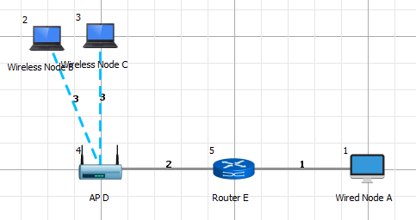

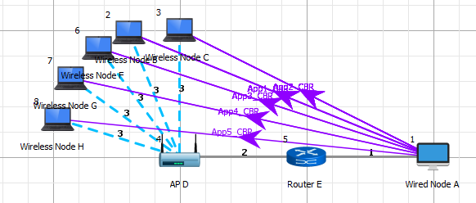

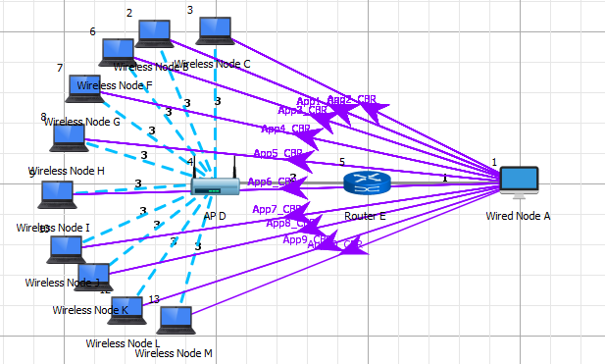

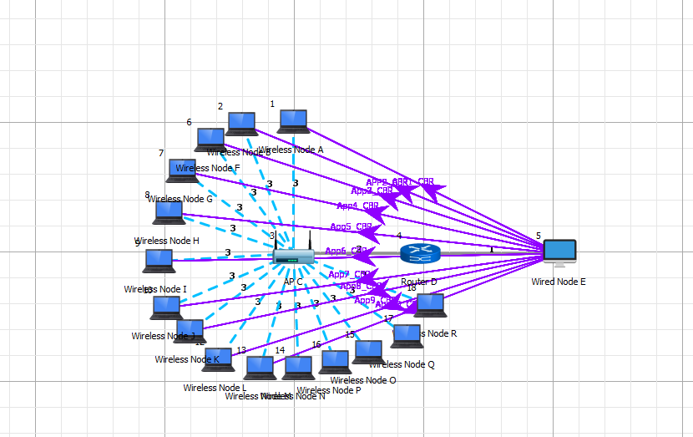

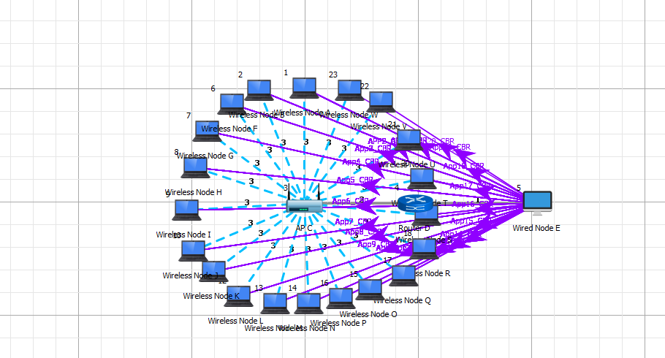

## **B.2 Simulation results**

**8.2 Procedure:**

**Sample 1**

**Step 1: Go to, New -> Internetworks**

**Step 2:**

**Create the network as per the screen shot.**

**Devices Required: 2 Wireless Nodes, 1 Access point, 1 Router and 1 Wired Node**



**Step 3:**

**Node properties:** Disable TCP in all nodes in Transport layer shown below:

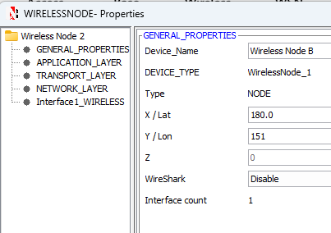

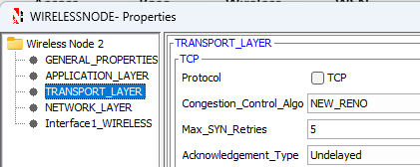

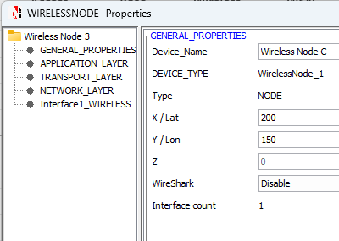

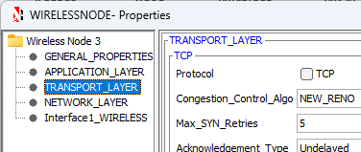

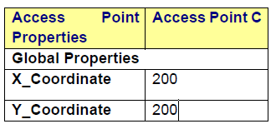

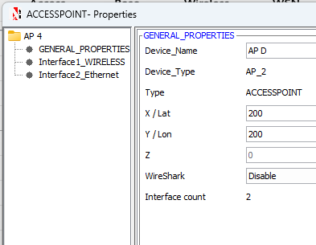

**Wireless Link Properties:**

Right click on Wireless Links and Change the channel characteristics as “No Path Loss”



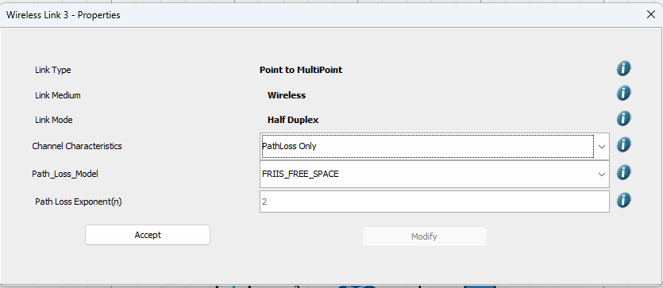

**Wireless Node Properties:**

Right click on Wireless Node and in Interface1_Wireless, Select the Physical Layer Standard as IEEE 802.11g.

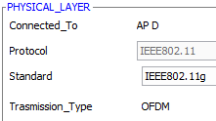

**Step 4:**

Select the Application Button and click on the gap between the Grid Environment and the ribbon. Now right click on Application and select Properties as shown below:

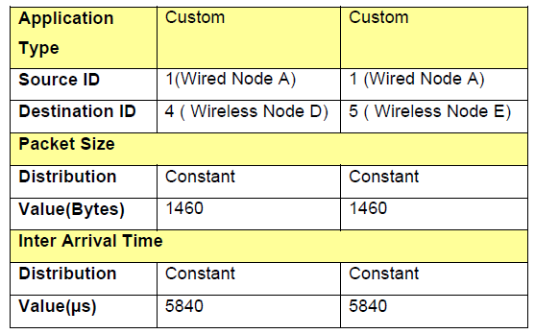

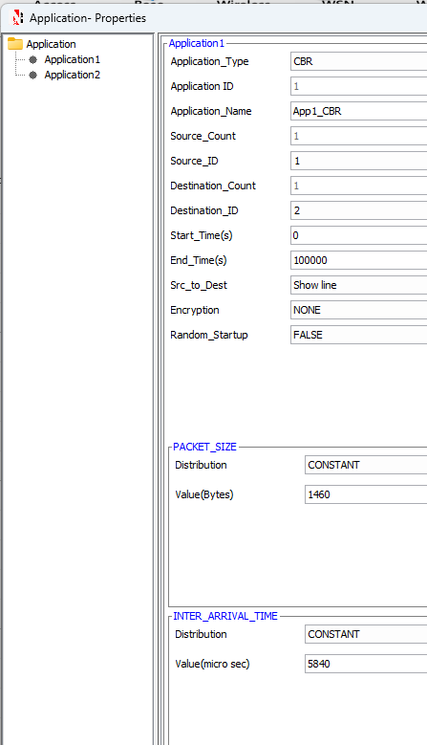

**NOTE:** The procedure to create multiple applications is as follows:

**Step**

**Step 1:** Click on the ADD button present in the bottom left corner to add a new application.

**Simulation Time – 10 sec**

Upon completion of simulation, “Save” the experiment.

**(Note:** *The Simulation Time can be selected only after doing the following two tasks,*

• *Set the properties of Node, Router& Link*

• *Then click on Run Simulation button)***.**

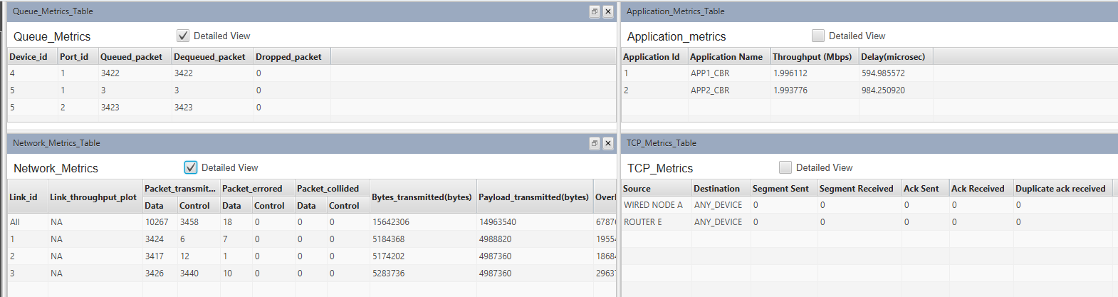

**Inputs for Sample 2**

Number of Wireless Nodes = 5

## Open Sample 1, Add 3 more Application and set the properties as above with Source_Id as 1 and Destination_Id as 6,7,8.

## 



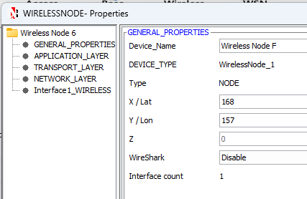

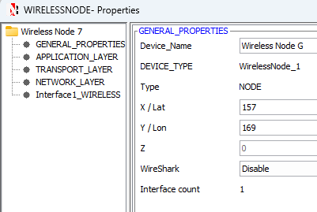

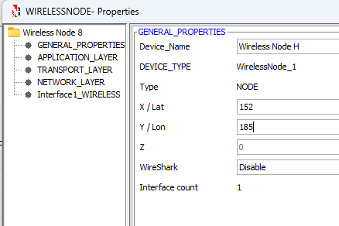

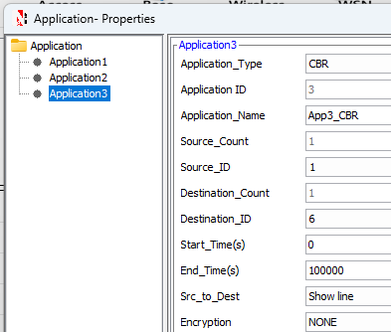

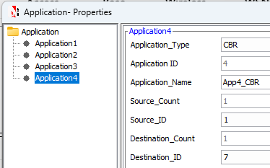

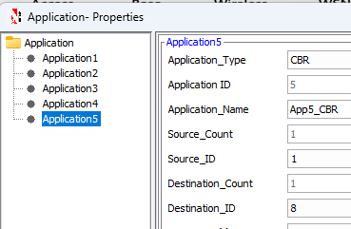

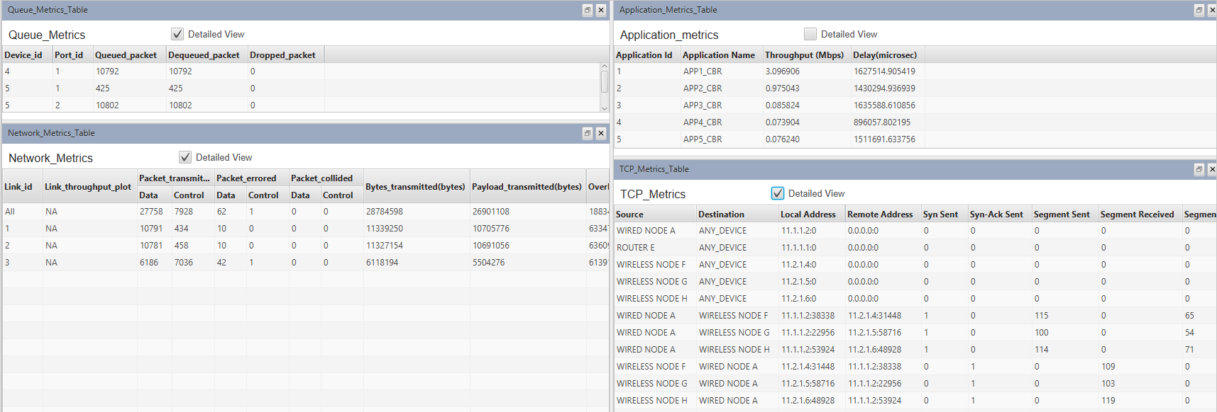

**Inputs for Sample 3**

Number of Wireless Nodes = 10

## Open Sample 2, Add 5 more Application and set the properties as above with Source_Id as 1 and Destination_Id as 9, 10,11,12,13 respectively.

## 



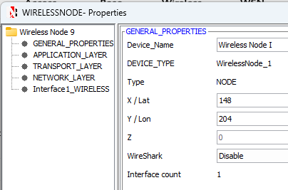

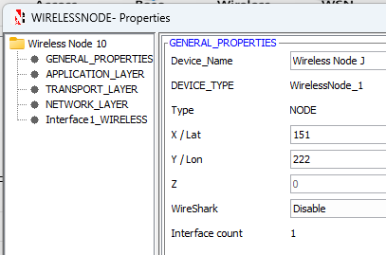

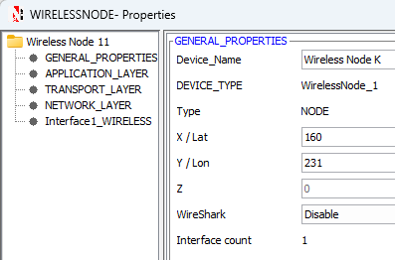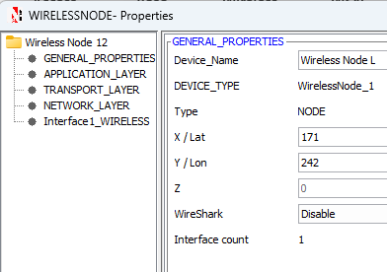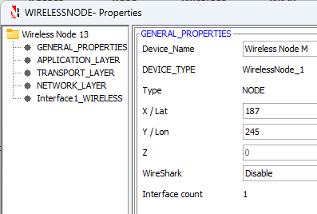

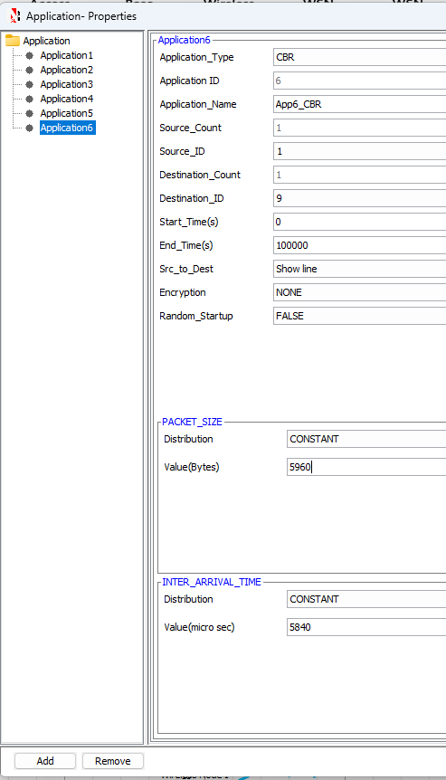

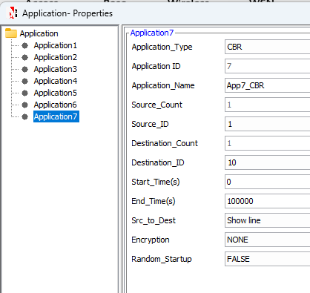

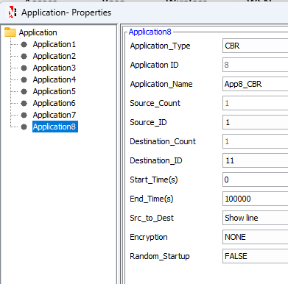

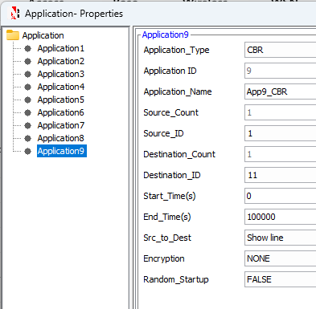

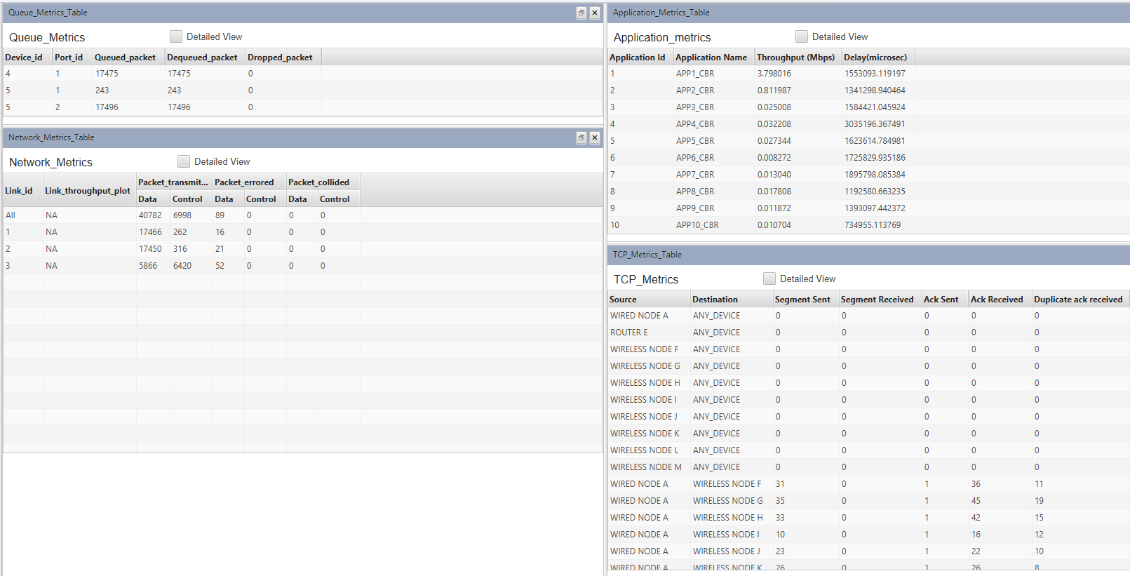

**Inputs for Sample 4**

Number of Wireless Nodes = 15

## Open Sample 3, Add 5 more Application and set the properties as above with Source_Id as 1 and Destination_Id as 14, 15,16,17,18 respectively.

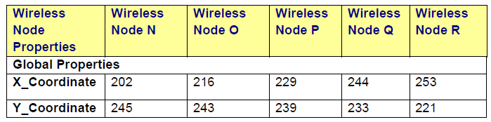



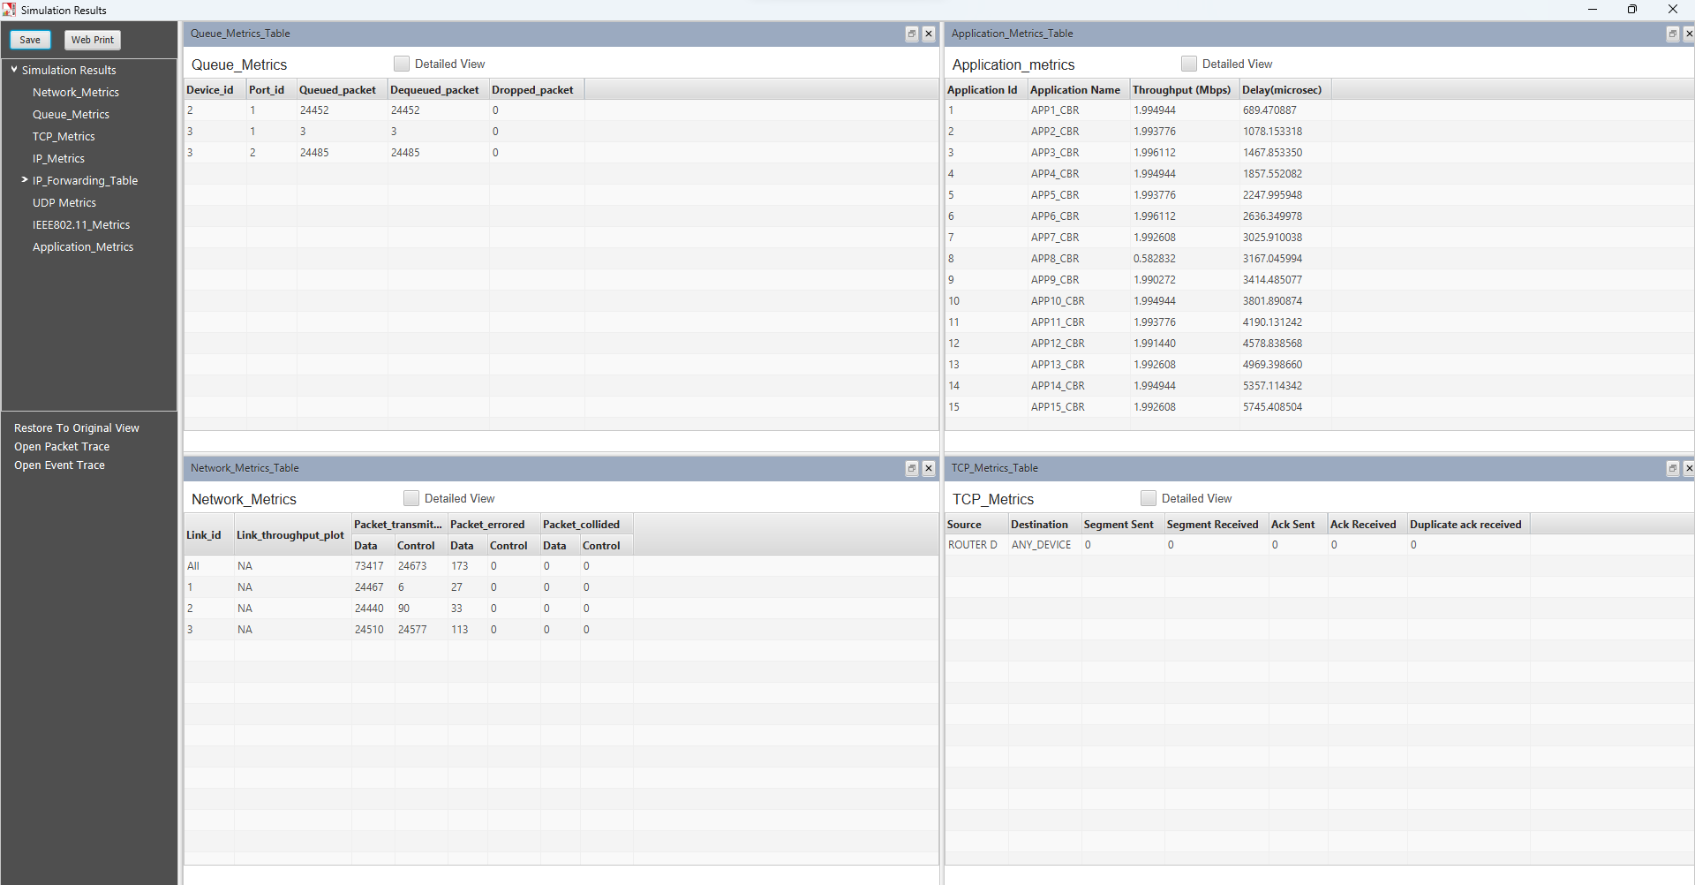

**Inputs for Sample 5**

Number of Wireless Nodes = 20

Open Sample 4, Add 5 more Application and set the properties as above with Source_Id as 1 and Destination_Id as 19, 20,21,22,23 respectively.

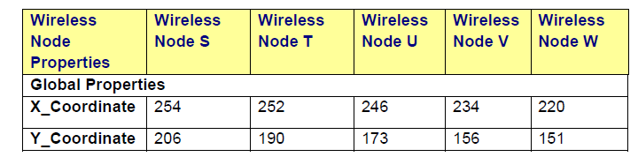



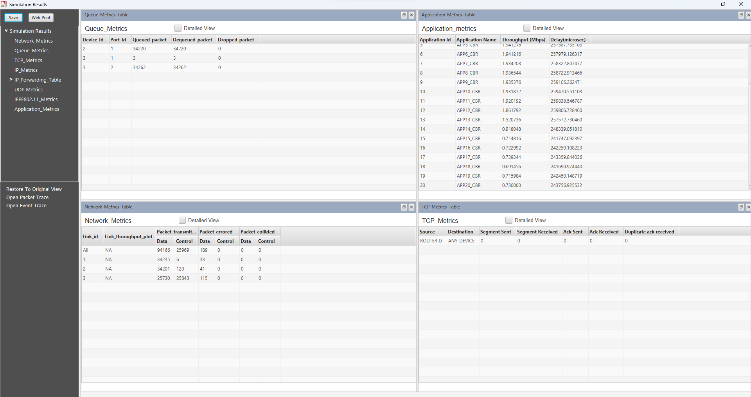

## **B.3 Conclusion**

Comparison Table :

|  |  |  |  |
| --- | --- | --- | --- |
| **No of Wireless nodes** | **Generation Rate (Mbps)** | **Throughput** | **Delay** |
| **2** | **4** | **3.983** | |  | | --- | | **1572.15** | |
| **5** | **10** | **9.964** | **6841.941** |
| **10** | **20** | **18.52** | **21039.8** |
| **15** | **30** | **29.48** | |  | | --- | | **110604.18** | |
| **20** | **40** | **30.15** | |  | | --- | | **5055615.72** | |

**Questions of Curiosity**

1. If we modified the simulation to include bidirectional traffic (where wireless nodes communicate with each other instead of just with Node 1), how would this affect network congestion and overall performance? Propose a test setup to compare unidirectional vs bidirectional communication patterns with the same number of nodes.

Ans:

**Effect:** Bidirectional traffic would increase network congestion due to the added communication paths between nodes, leading to higher contention for bandwidth. It could also introduce delays due to more frequent collisions or retransmissions.

**Test Setup:** Compare unidirectional vs. bidirectional traffic with the same number of nodes, measuring throughput, delay, and packet loss for both configurations. Use the same traffic load and node density in both setups to ensure a fair comparison.

1. How would implementing different packet sizes in the application properties affect network performance across the varying number of nodes? Design a test scenario to compare the impact of small (256 bytes) versus large (1500 bytes) packet sizes on throughput and delay.

Ans:

**Effect**: Larger packet sizes (1500 bytes) would typically result in higher throughput but could cause longer delays due to increased transmission time. Smaller packets (256 bytes) result in lower throughput but might offer better responsiveness with reduced latency.

**Test Scenario**: Set up two scenarios with varying packet sizes: one with 256-byte packets and the other with 1500-byte packets. Measure throughput and delay while increasing the number of nodes to observe the impact of packet size on network performance.

1. What impact would environmental factors (like walls, interference from other devices, or distance between nodes) have on the network performance if we had enabled path loss in the wireless link properties? How does this relate to real-world implementations?

Ans:

**Effect**: Environmental factors like walls, interference, or distance can significantly affect signal strength, leading to higher packet loss and reduced throughput. Path loss models simulate this by weakening the signal based on distance and obstacles.

**Real-world Relation**: This mimics real-world wireless networks, where physical obstructions and interference reduce communication quality and range, thus affecting performance (e.g., in offices, homes, or urban areas).

1. Why was TCP disabled in the transport layer for this experiment? How would the results differ if TCP was enabled, and what additional network characteristics would we be able to observe?

Ans:

**Reason for Disablement**: TCP was likely disabled to focus on the raw performance of the network layer without the influence of transport layer reliability (e.g., retransmissions, congestion control).

**Effect of Enabling TCP**: If TCP were enabled, we would see added overhead due to retransmissions and flow control, possibly lowering throughput but improving reliability and reducing packet loss. We could also observe network congestion more clearly.

1. If we enable path loss in wireless link properties, how would it affect the number of successful transmissions?

Ans:

**Impact:** Path loss would result in fewer successful transmissions as the signal strength diminishes with distance and obstacles. This would likely increase packet loss and require more retransmissions, reducing overall network efficiency.