1. **Simulate the effect of different discount factors (γ) on an RL agent’s decision-making in a simple reward-based environment. gamma_values = [0.1, 0.5, 0.9, 1.0], rewards = [10, 20, 30, 40]**
2. 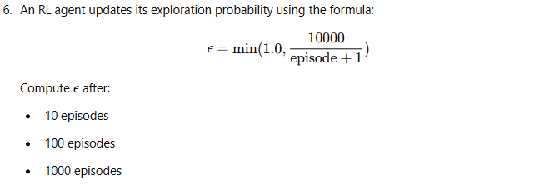
3. 