**Mukesh Patel School of Technology Management and Engineering**

Subject: Robotic Process Automation

**EXPERIMENT NO 8**

**Aim:** The objective of this experiment is to understand the capabilities of Microsoft Power Apps.

**Prerequisites:**

1. Power apps should be available on the browser.
2. Basic understanding of Power Apps

**Challenge Overview:**

**Leave Application form using cloud automation**

**Flow:**

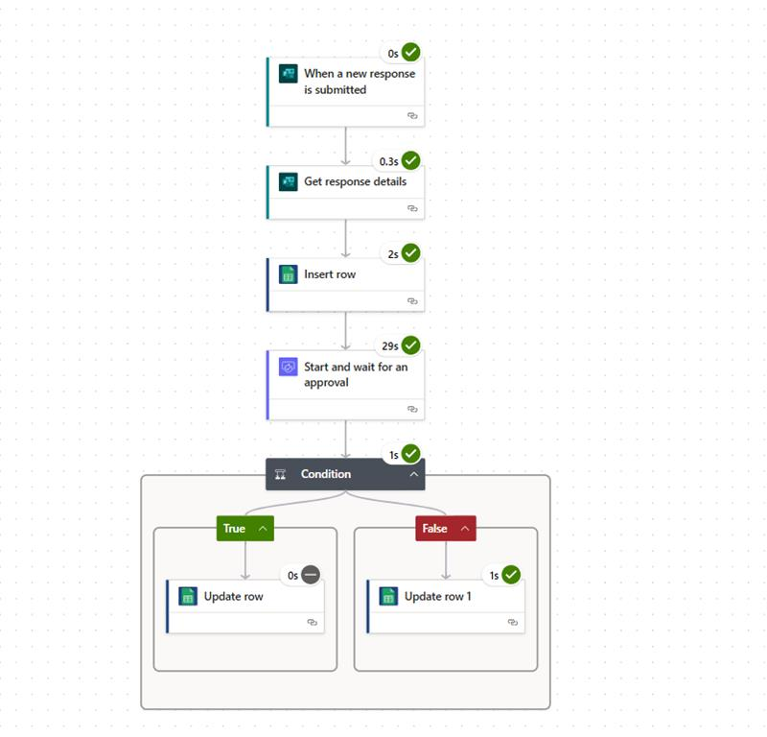

**Google sheets :**

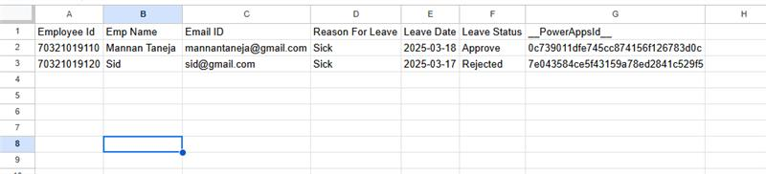

**Form Submission:**

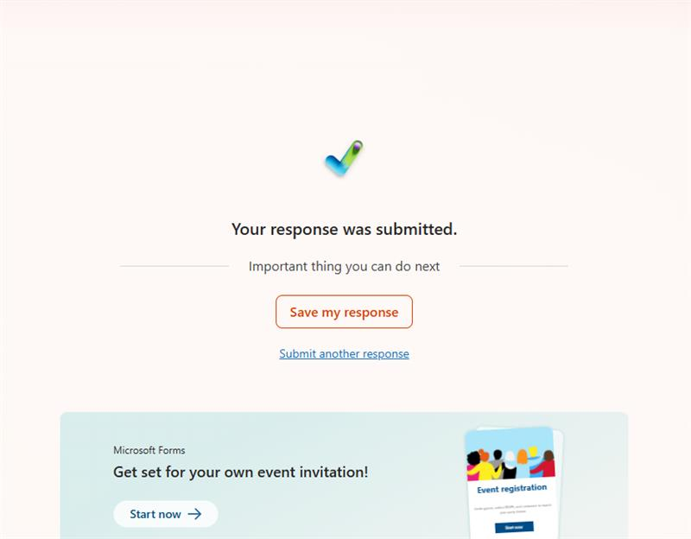

**Mail generated to grant permission:**

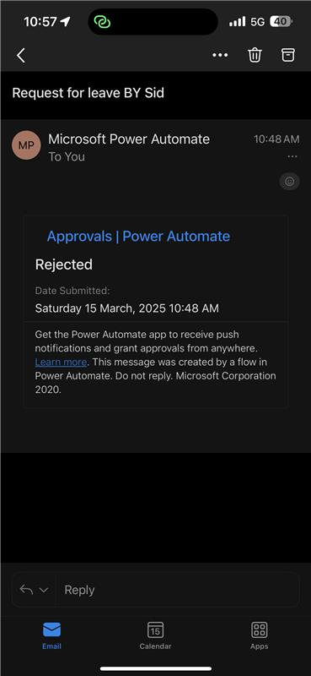

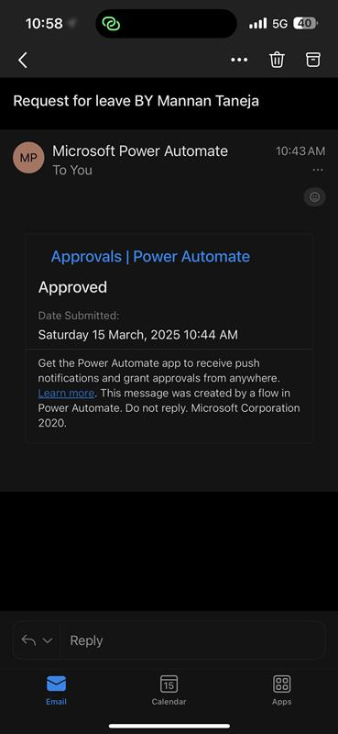

Mail generated to let the user know the result:

