### 1. Create a canvas app that shows the navigation functionality with personalization

### 2. Create a canvas app demonstrates the CRUD operation through sharepoint List.

**View Data**

**Delete Data**

**Edit Data:  
**

3. Create a PAD flow demonstrates scrapping (<https://www.youtube.com/watch?v=zMYp7nz3HyA&list=PLtS0QJFKl_Da-fdSNTZQFMwwgnykMhb3B>)

I

Output

### 4. Create a PAD flow to demonstrate Brower Desktop Automation

**Gym**

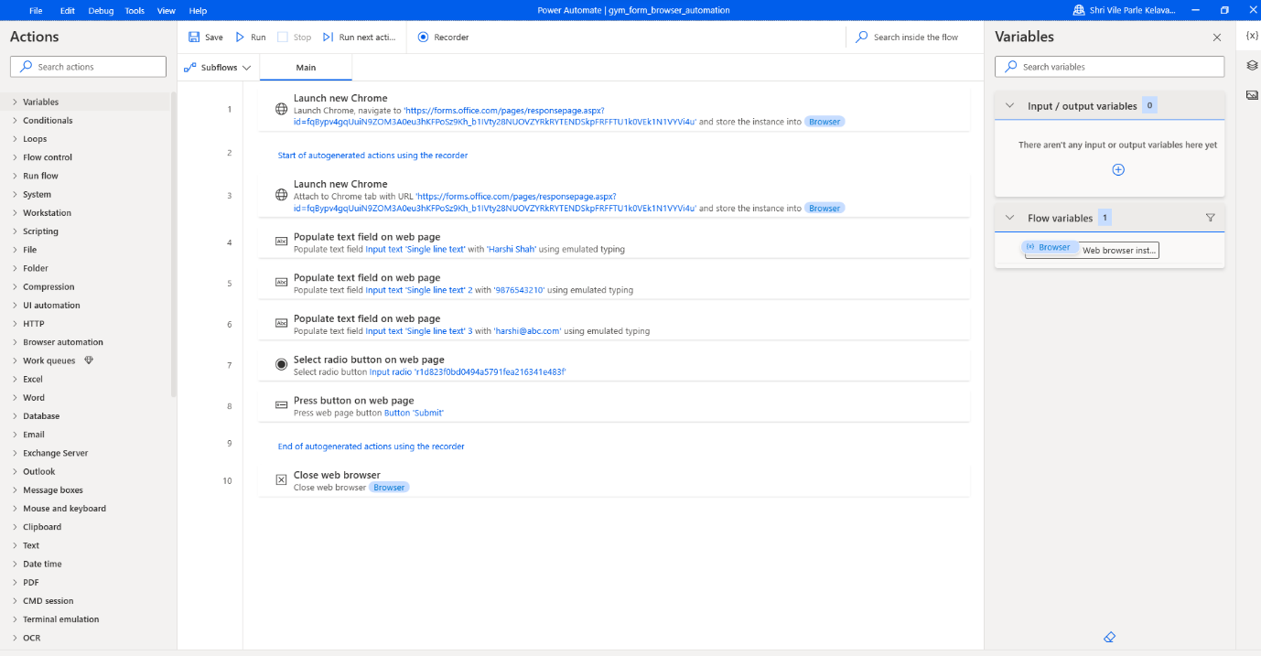

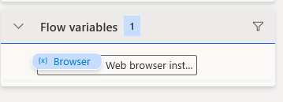

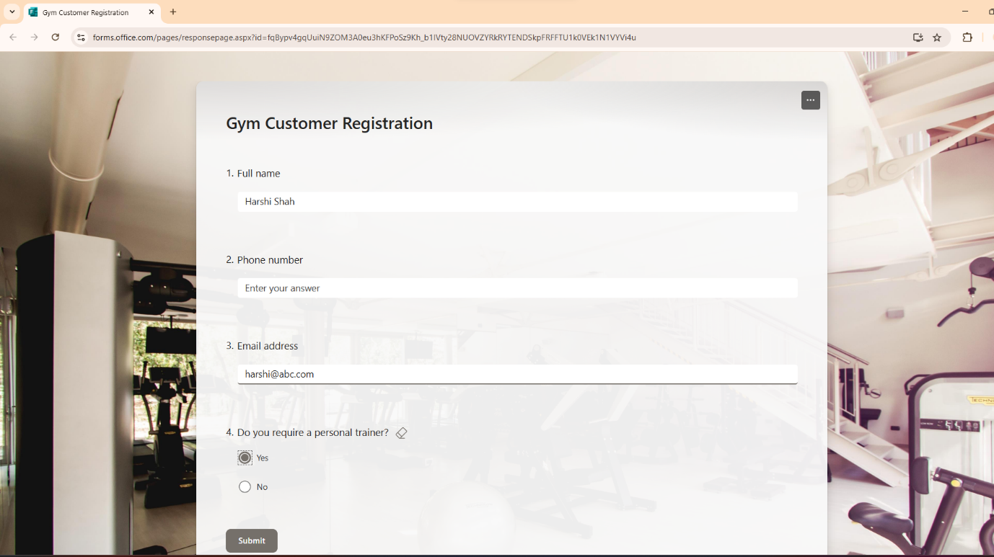

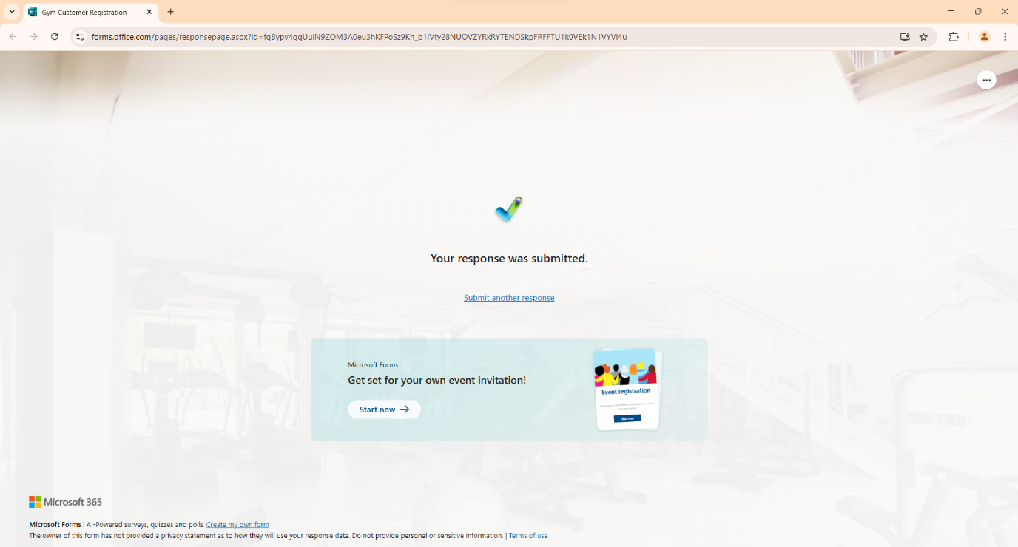

### 5. Create a PAD flow that demonstrate excel automation.

**Total Sales**

**Input:**

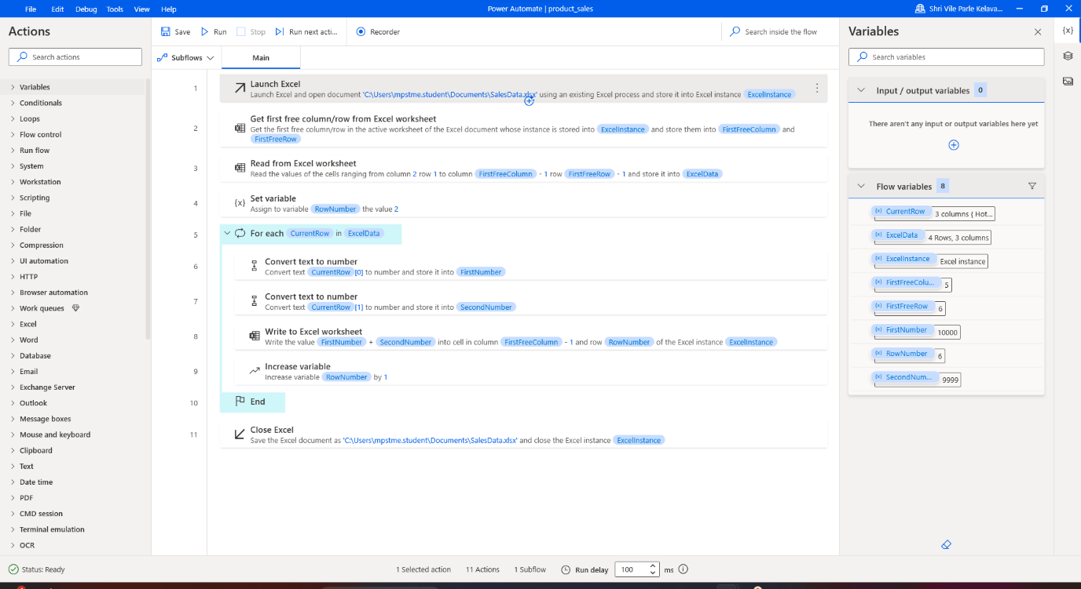

**Flow**

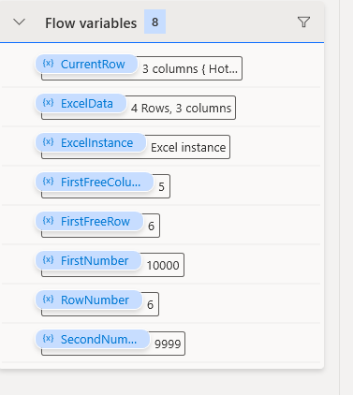

**Output:**

