**Date of Experiment:18/011/2025**

**Date of Submission:19/01/2025**

**C069**

**Manushi Patel**

**SVKM’S NMIMS**

**Mukesh Patel School of Technology Management & Engineering**

Department of Mechatronics Engineering

**AR-VR Lab**

Subject- Robotic Process Automation

**EXPERIMENT NO. 2A**

**Objective:**

This lab manual aims to reinforce your understanding of Power Automate Desktop, emphasizing variables for data manipulation and conditional actions for dynamic decision-making, ultimately enabling you to construct more flexible and efficient automation flows.

**Prerequisites:**

1. Power Automate Desktop installed on your computer.

2. Basic understanding of Power Automate Desktop interface.

**Challenge Overview:**

In this experiment, you will create 3 flows

1.Takes input for three subject marks, calculates their average.

2.Checks if the number is above the passing threshold

3.Assigns grades based on the number input from the user.

**Important Actions:**

**1. Input Dialog:**

- Use the "Input Dialog" action to prompt the user to enter marks for three subjects.

- Configure the input dialog to request numerical input for each subject.

**2. Calculate Average:**

- Utilize the "Set Variable" action to sum the three subject marks obtained from the user.

- Divide the sum by 3 to calculate the average.

**Hint:**enclose the calculation in “%%” any thing inside this will be evaluated.

**3. Decision:**

- Insert a "Decision" action to evaluate whether the average is above the passing threshold.

- Configure the decision to have two branches - one for passing and another for failing.

-You may use If-else or switch case here

**4. Assign Grades:**

- In the passing branch, use the "Set Variable" action to assign the appropriate grade based on the average.

- For example, if the average is above a certain value, assign 'A'; if it's between another range, assign 'B', and so on.

- In the failing branch, you may choose to assign an 'F' grade.

-You may use If-else ladder or switch case here

**5. Display Results:**

- Use the "Message Box" action to display the calculated average and assigned grade to the user.

**Tasks:**

1. Create a Power Automate Desktop flow that incorporates the described actions.

2. Test the flow by providing different sets of marks to ensure accurate calculation and grade assignment.

3. Debug and troubleshoot any errors that may arise during the execution of the flow.

4. Optimize the flow for efficiency, considering factors such as readability and simplicity. ￼

**Flow Screenshots:**

**Input Screenshots:**

**Output Screenshot:**

**Item Price Flow**

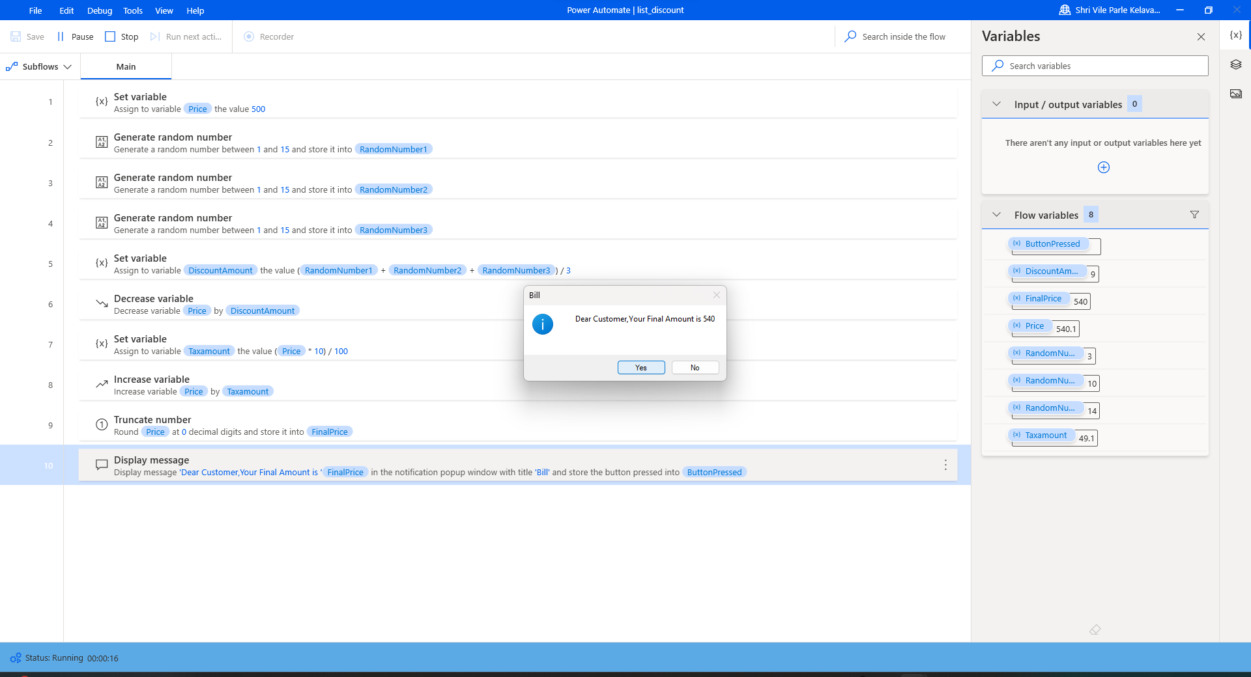

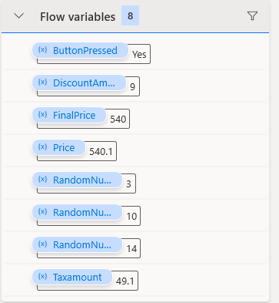

Output:

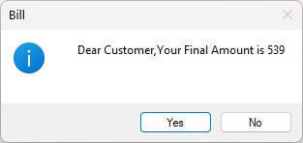

**Student Marks**

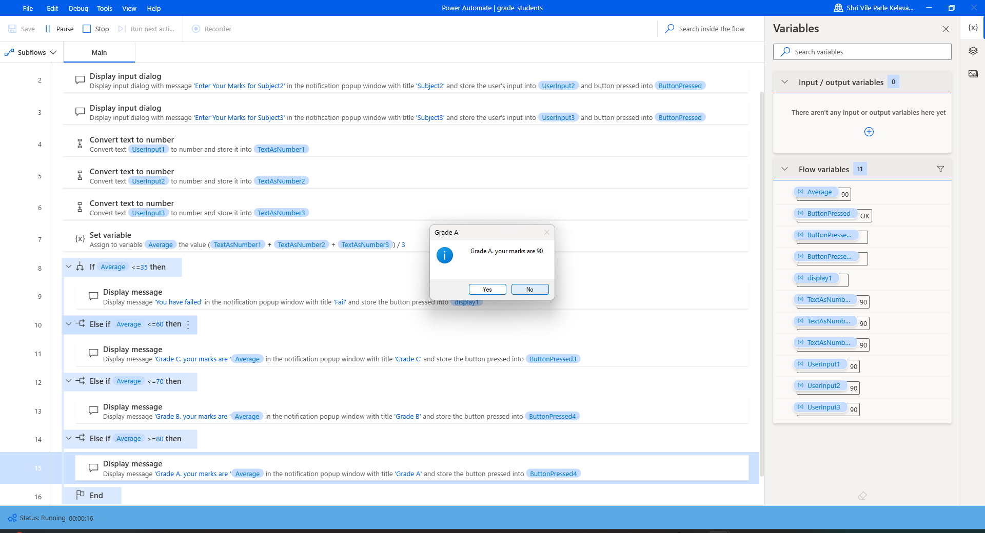

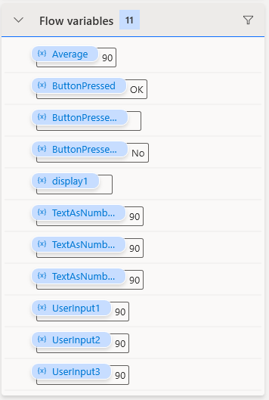

Output:

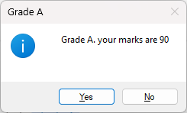

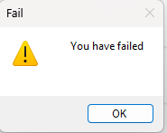

**Switch Case**

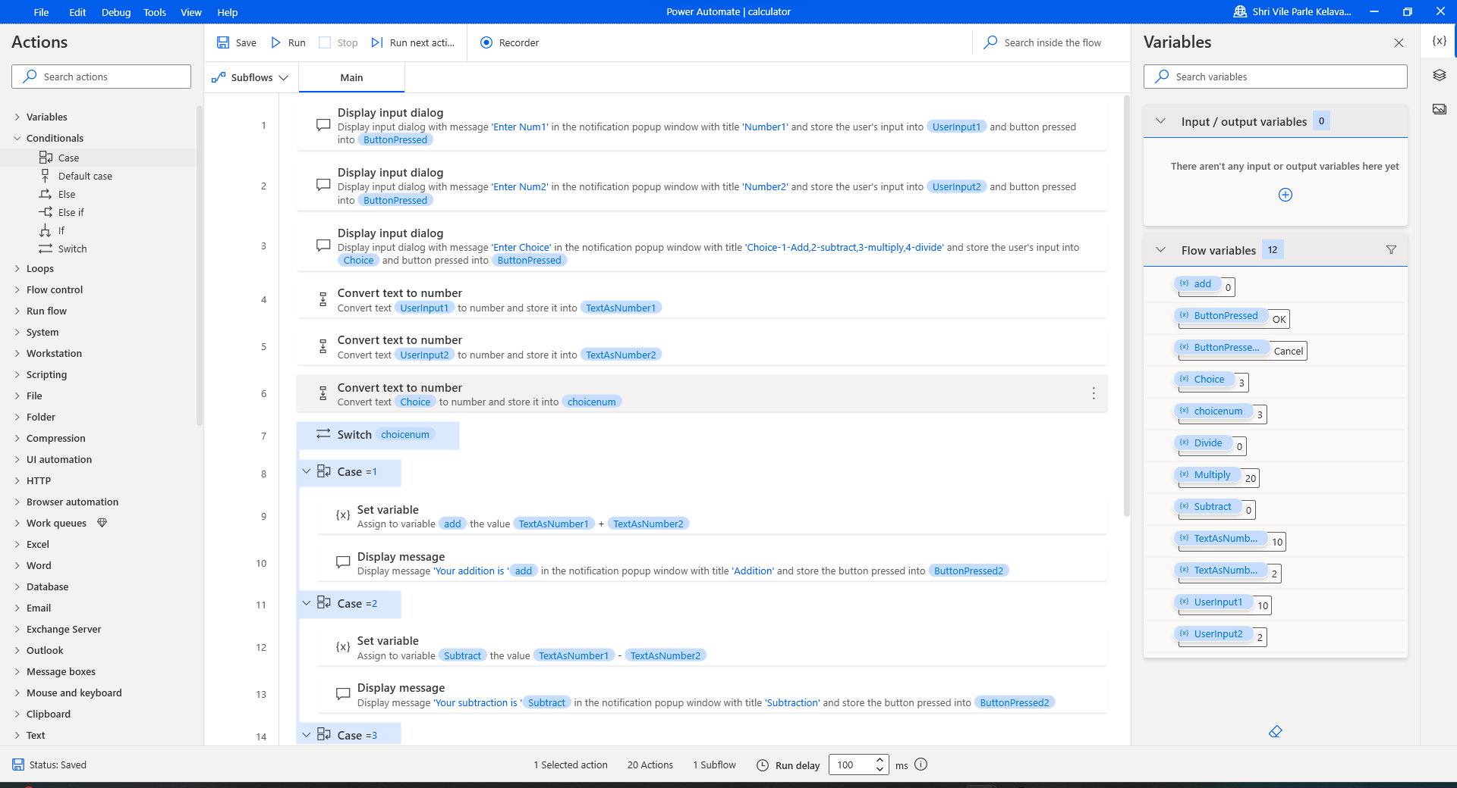

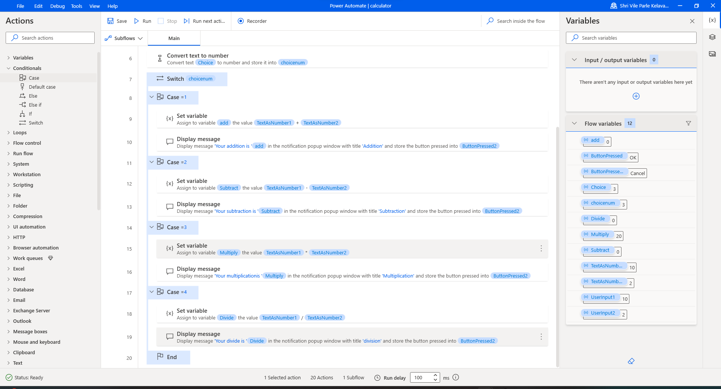

Output:

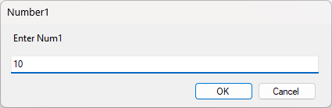

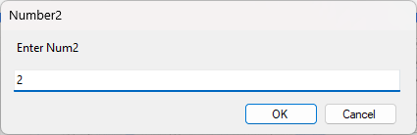

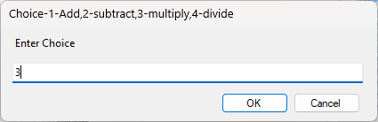

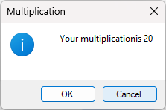

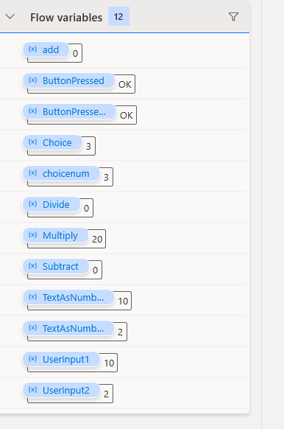

**Conclusion:** I gained hands-on experience in Power Automate by designing interactive flows for calculating bills and grades, enhancing my skills in handling user inputs, performing calculations, and generating dynamic outputs.

**Date of Experiment:23/12**

**Date of Submission:23/12**

**C069**

**Manushi Patel**

**SVKM’S NMIMS**

**Mukesh Patel School of Technology Management & Engineering**

Department of Mechatronics Engineering

**AR-VR Lab**

Subject- Robotic Process Automation

**EXPERIMENT NO. 2B**

**Objective:**

This lab is designed to deepen your understanding of loops in Power Automate Desktop. The objective is to learn how to utilize loops for repetitive tasks, enabling you to create more efficient and dynamic automation flows.

**Prerequisites:**

1. Power Automate Desktop installed on your computer.

2. Basic understanding of Power Automate Desktop interface.

**Challenge Overview:**

In this experiment, you will create 3 flows

1.Create a flow that checks whether a given input is a palindrome or not. A palindrome is a sequence that reads the same forwards and backward.

3.Build a flow that generates the multiplication table for a given number.

**Important Actions:**

1. **Input Dialog:**
   * **Purpose:** Captures user input during the flow execution.
   * **Usage:** Request information, such as text or numerical values, from the user.
2. **Message Box:**
   * **Purpose:** Displays messages, alerts, or results during the flow execution.
   * **Usage:** Communicate information to the user or provide feedback on the flow's progress.
3. **Set Variable:**
   * **Purpose:** Assigns a value to a variable.
   * **Usage:** Store and manipulate data within the flow.
4. **Decision:**
   * **Purpose:** Branches the flow based on a specified condition.
   * **Usage:** Enables dynamic decision-making within the flow.
5. **Loop (e.g., For Each, While, Do Until):**
   * **Purpose:** Repeats a set of actions multiple times based on a specified condition.
   * **Usage:** Efficiently handle repetitive tasks and iterate through collections of data.
6. **Log Message:**
   * **Purpose:** Records messages in the log for debugging and troubleshooting.
   * **Usage:** Assists in diagnosing issues and understanding the flow's behavior.

**Tasks:**

1. Create a Power Automate Desktop flow that incorporates the described actions.

2. Test the flow by providing different sets of Test cases

3. Debug and troubleshoot any errors that may arise during the execution of the flow.

4. Optimize the flow for efficiency, considering factors such as readability and simplicity.

**Output Screenshot:** Palindrome

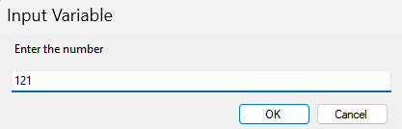

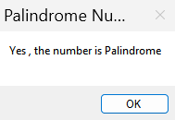

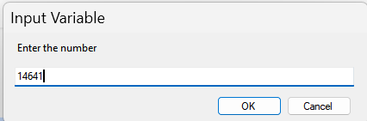

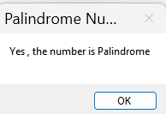

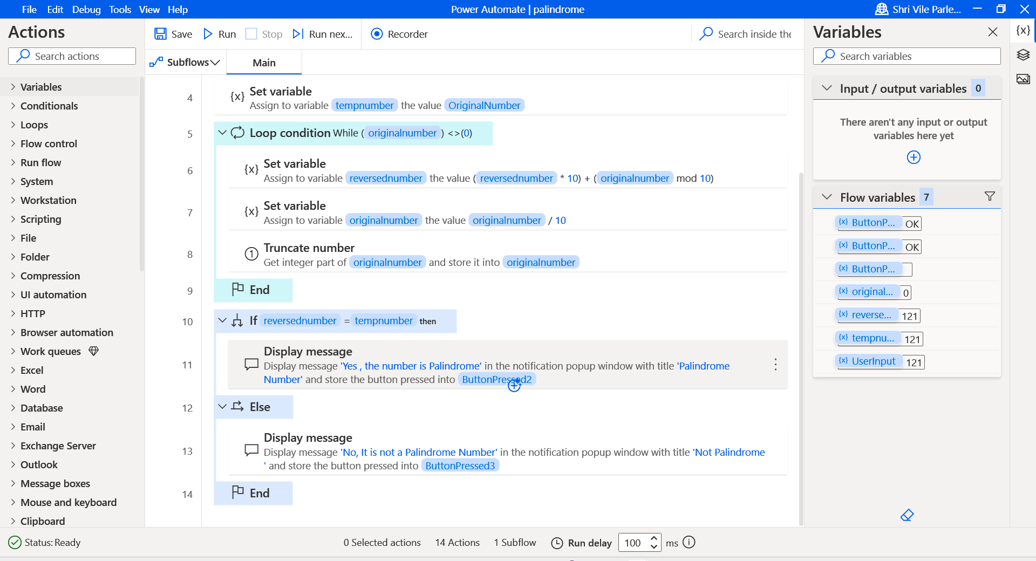

Multiplication table:

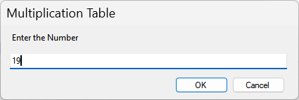

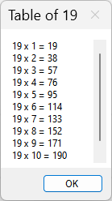

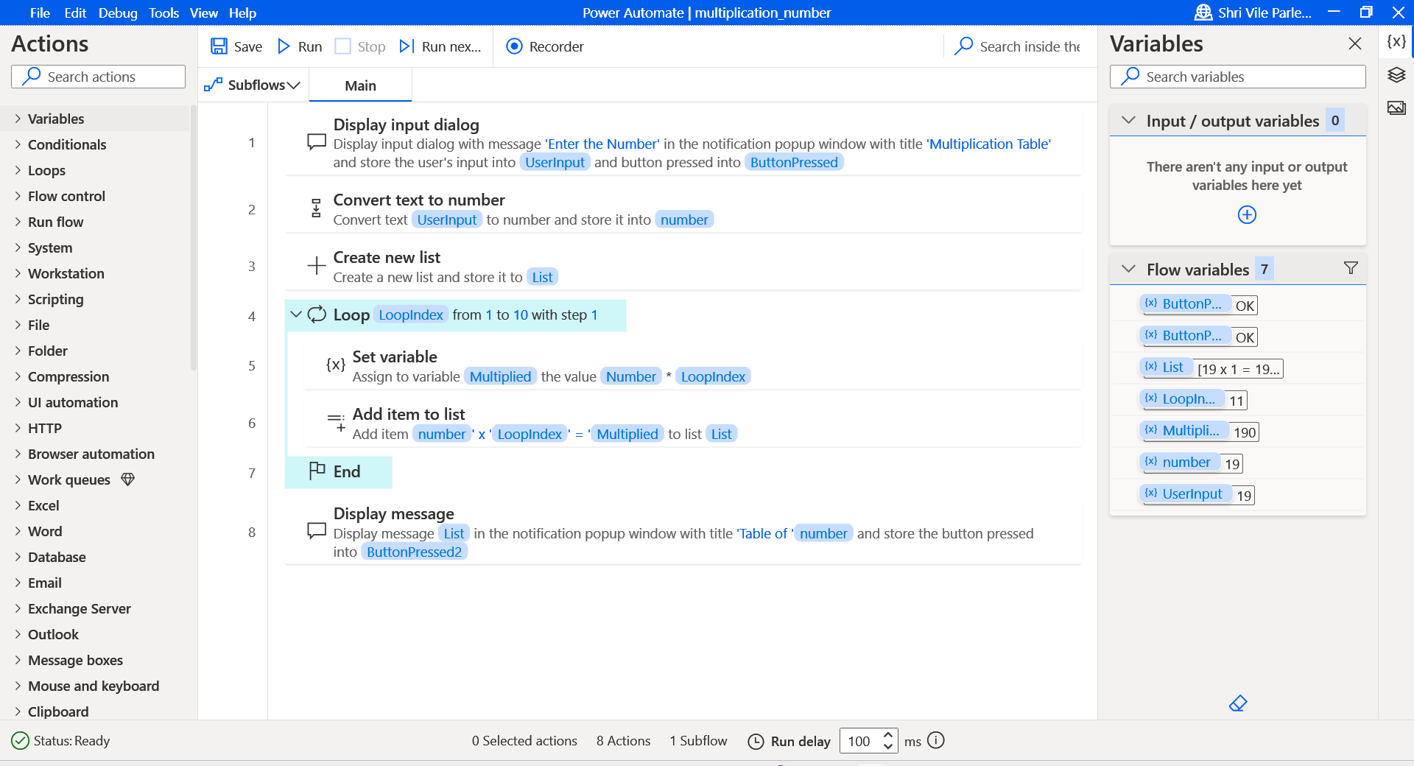

Armstrong validator:

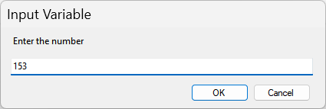

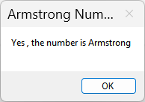

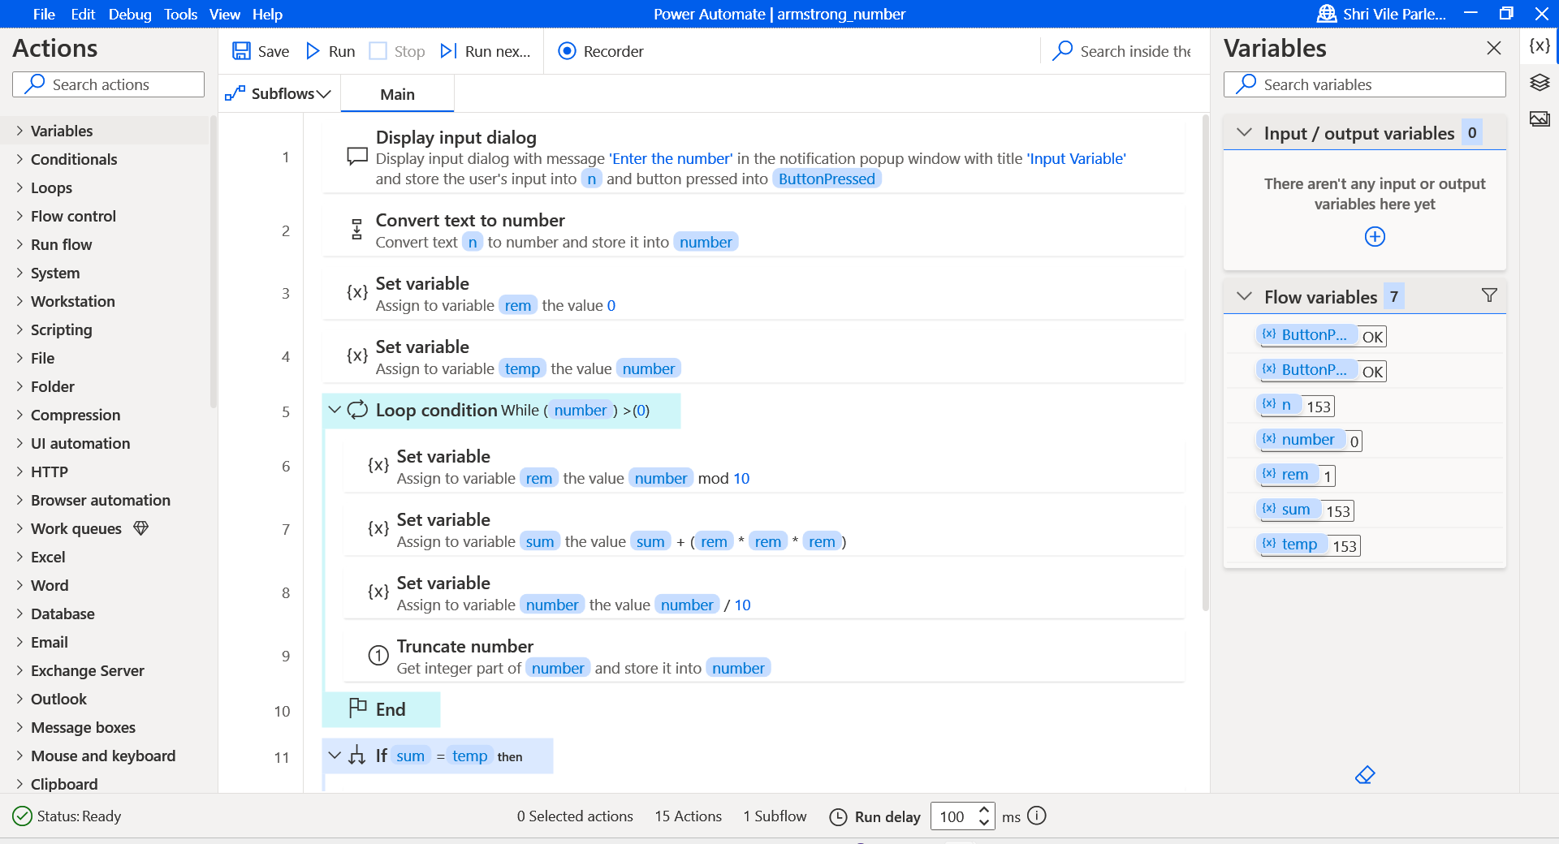

For each loop

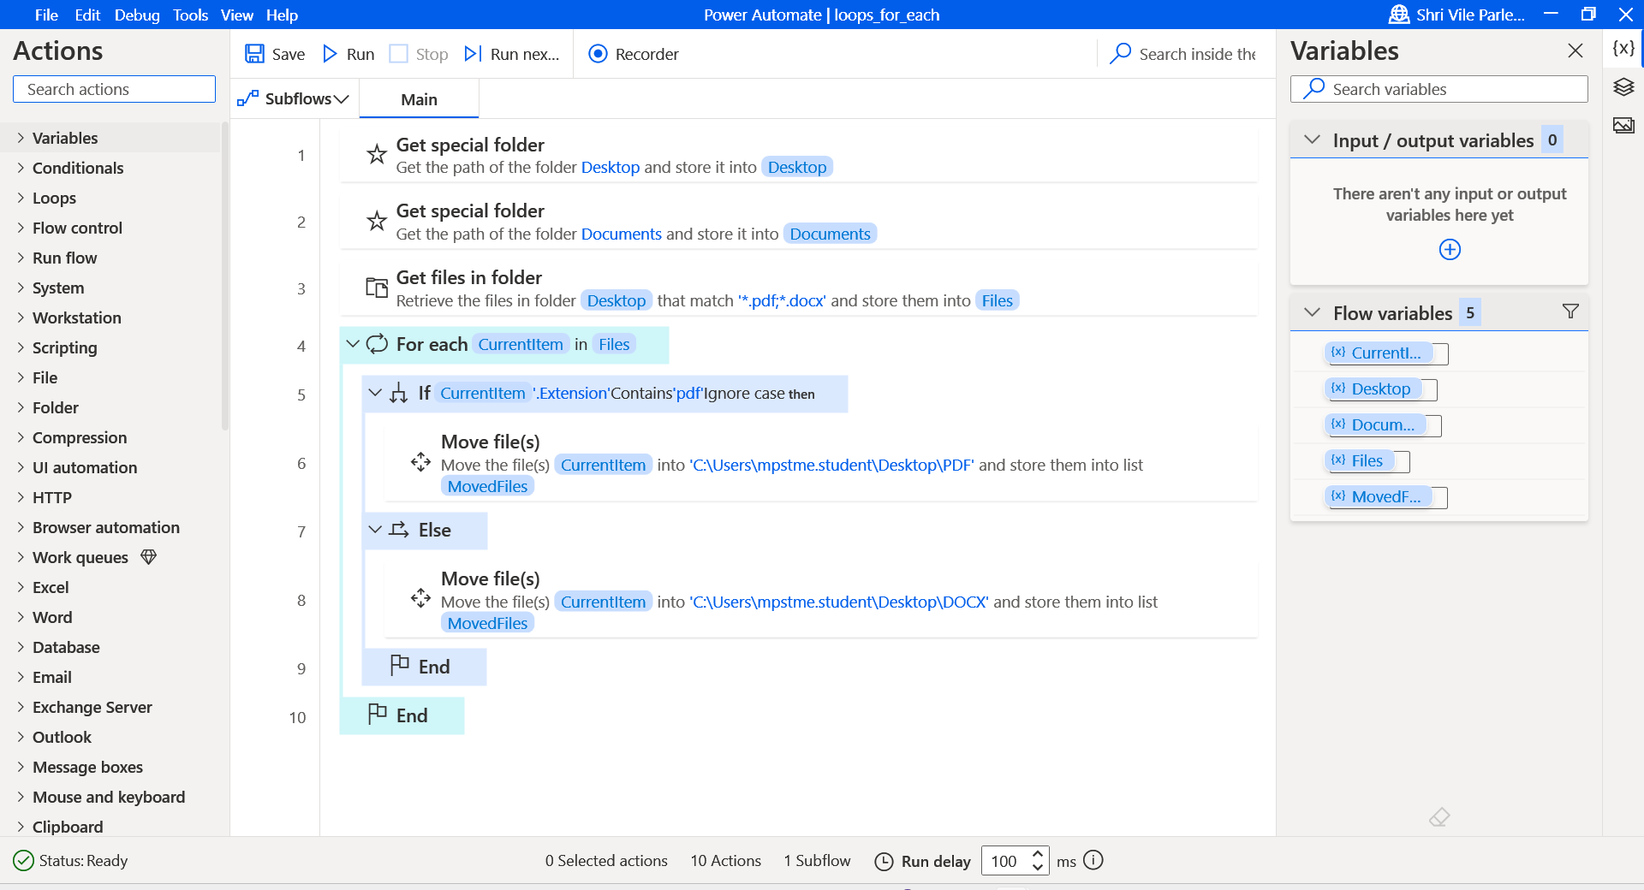

**Conclusion:**

**I understood loops-if,else,switch,for,for-each using Palindrome, Armstrong number, multiplication table. Hence, We successfully performed the experiment.**