**Mukesh Patel School of Technology Management and Engineering**

Subject: Robotic Process Automation

**EXPERIMENT NO 3A**

**Aim:**

This experiment aims to cultivate expertise in Excel automation through Power Automate Desktop, focusing on efficient data manipulation and task automation.

**Input Screenshot:**

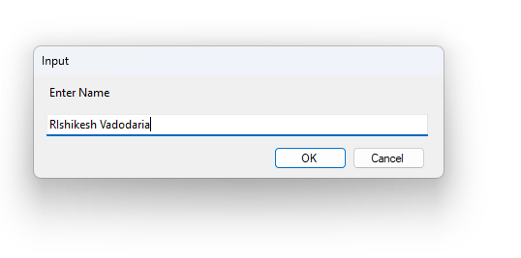

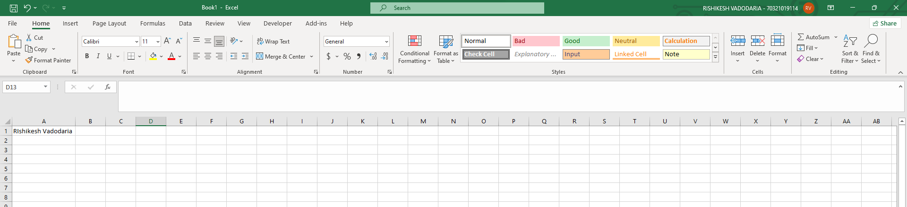

**Salary**

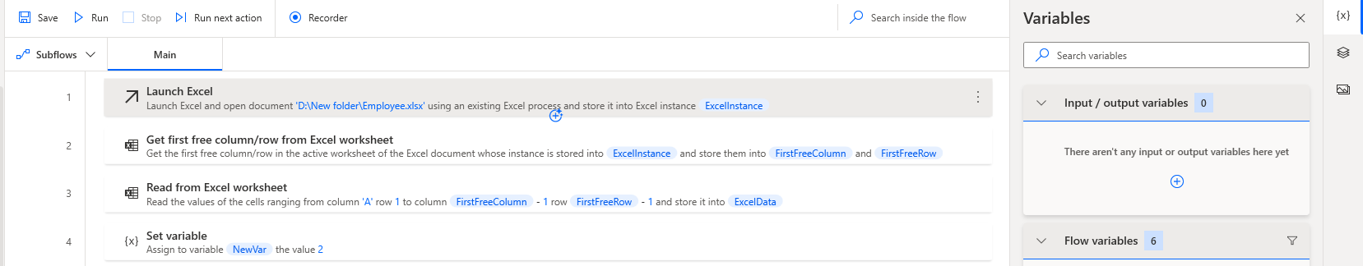

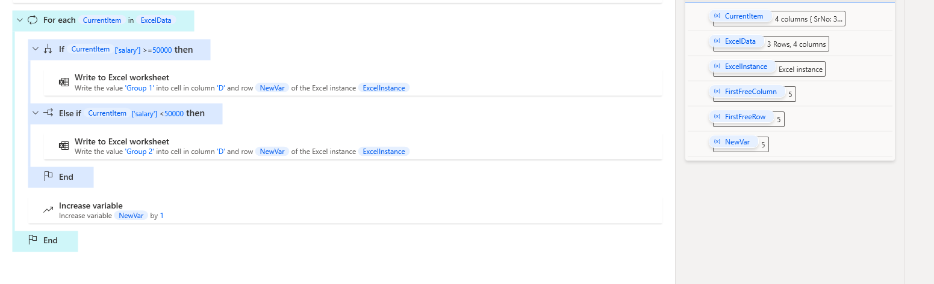

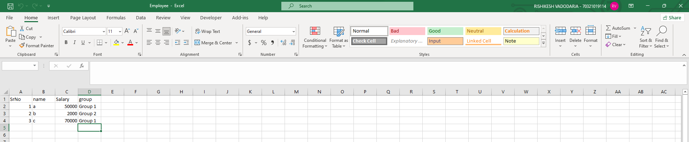

**Product Sale**

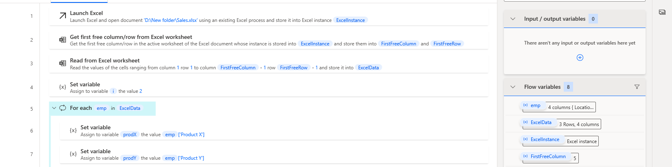

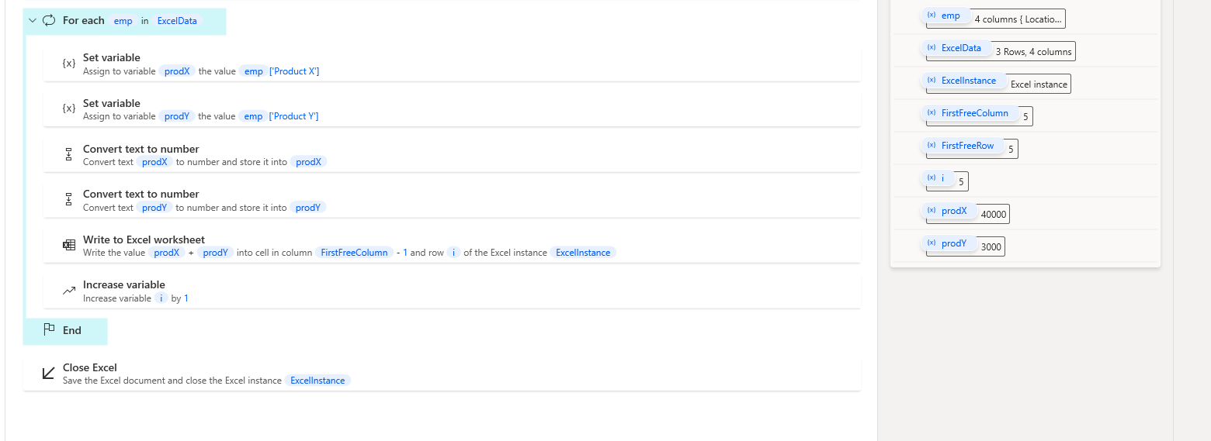

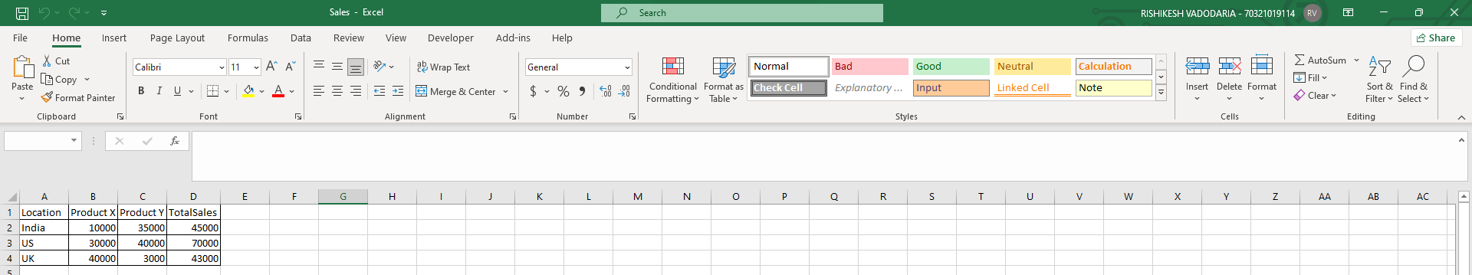

**Conclusion:**

**Hence we successfully performed the experiment where we learnt about Excel Automation**

Subject: Robotic Process Automation

**EXPERIMENT NO 3B**

**Aim:**

This experiment aims to cultivate expertise in Web Scraping for information manipulation in the browser.

**Pre-requisites:**

1. Power Automate Desktop installed on the computer.
2. Basic understanding of Power Automate Desktop interface.

**Challenge Overview:**

1. Implement Browser Automation by scrapping and displaying information to the user.

**Actions Taken:**

1. **Read Cell:**
   1. Purpose: Extract data from specific cells in an Excel sheet.
   2. Usage: Retrieve test cases for Armstrong number checking and student information for report card generation.
2. **Calculate:**
   1. Purpose: Perform arithmetic operations to evaluate Armstrong numbers and calculate grades.
   2. Usage: Utilize mathematical calculations within the flow for precise computations.
3. **Decision:**
   1. Purpose: Implement conditional branching based on specified criteria.
   2. Usage: Guide the flow to different paths for handling Armstrong number identification and grade assignment.
4. **Set Variable:**
   1. Purpose: Assign values to variables for storage and manipulation.
   2. Usage: Store interim results or information extracted from the Excel sheet for subsequent actions.
5. **Loop (e.g., For Each, While):**
   1. Purpose: Repeat a set of actions for each item in a collection or until a condition is met.
   2. Usage: Iterate through test cases and student records for efficient processing.
6. **Write Cell:**
   1. Purpose: Input data into specific cells in an Excel sheet.
   2. Usage: Update the Excel sheet with results, such as Armstrong number identification and generated report card details.
7. **Message Box:**
   1. Purpose: Display messages, alerts, or results during the flow execution.
   2. Usage: Communicate information to the user or provide feedback on the flow's progress.
8. **Open Workbook:**
   1. Purpose: Open a specified Excel workbook.
   2. Usage: Establish a connection with the Excel file to read and write data as needed.
9. **Log Message:**
   1. Purpose: Record messages in the log for debugging and troubleshooting.
   2. Usage: Assist in diagnosing issues and understanding the flow's behavior, especially during testing and development.

**Input Screenshot:**

**Web Scraping - Blogs Website**

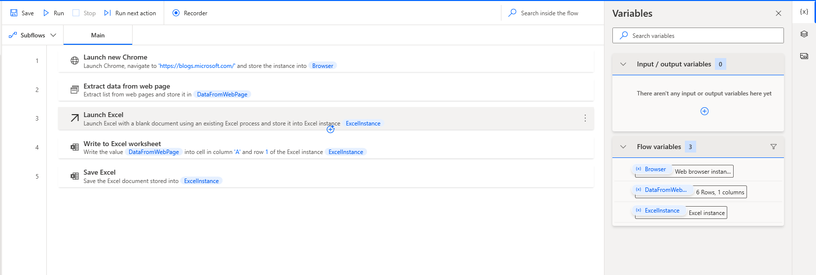

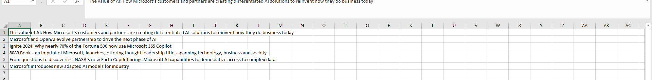

**Web Scraping- Extracting Titles and storing in excel sheet.**

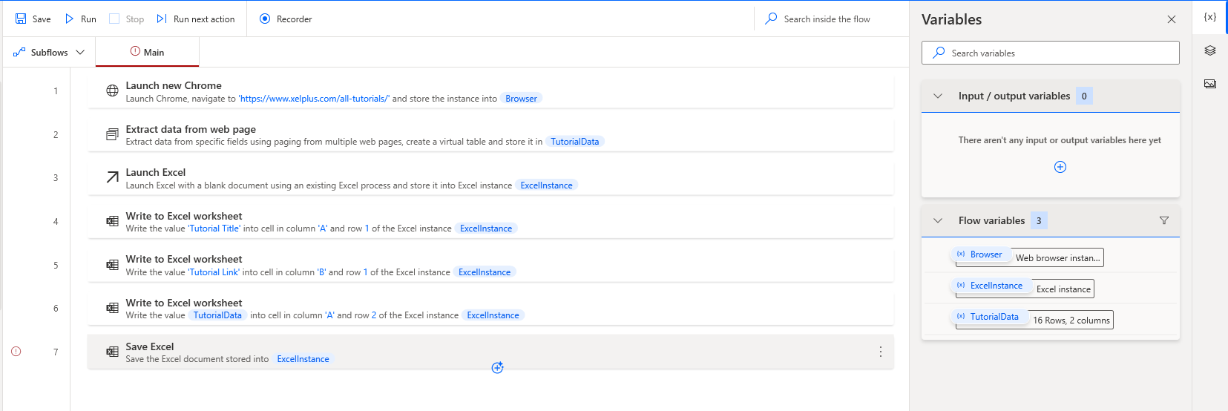

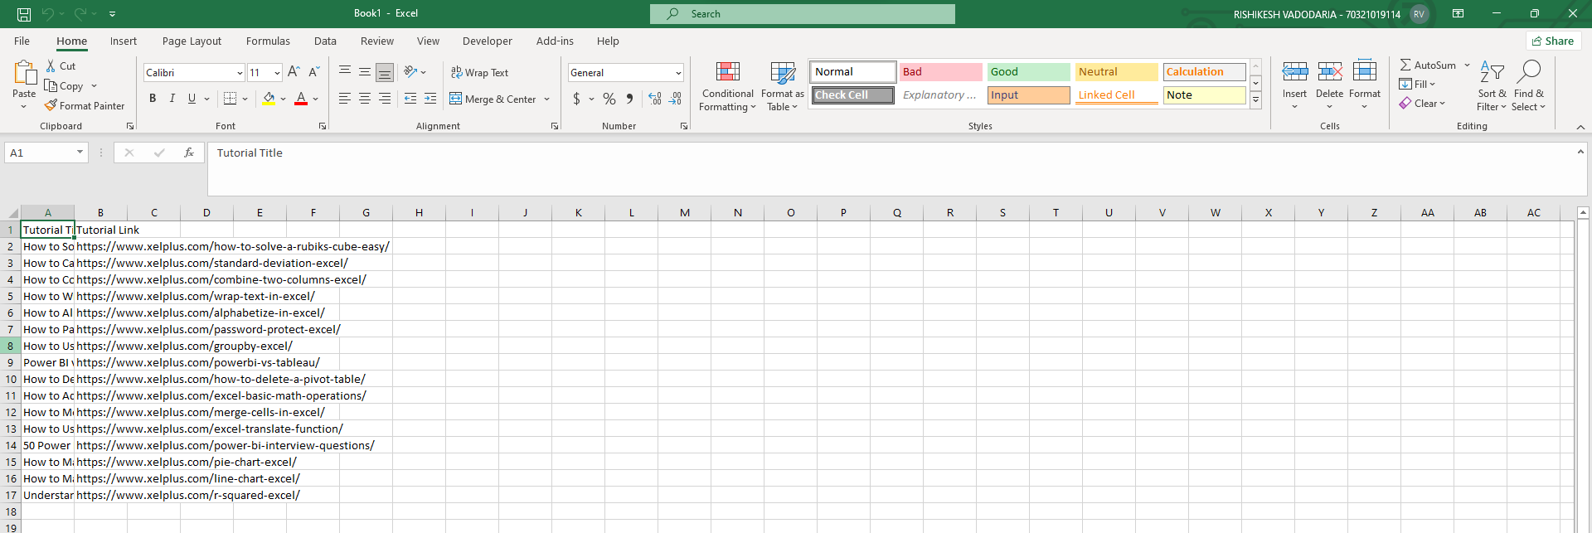

**Conclusion:**

In this experiment, we successfully learned how to use Power Automate Desktop to extract headlines from a website. By setting up a flow, we were able to automate the process of navigating to a specific webpage, identifying the elements containing the headlines, and then capturing them. Using the built-in web automation actions, we selected the appropriate HTML elements and extracted the text, which was then stored in an Excel file for further use. This hands-on exercise helped us understand how to interact with web data and efficiently automate the extraction of key information, demonstrating Power Automate's ability to simplify and speed up data collection tasks without requiring coding expertise.

s