**Mukesh Patel School of Technology Management and Engineering**

Subject: Robotic Process Automation

**EXPERIMENT NO 4**

**Aim:**

This experiment aims to cultivate expertise in Browser automation through Power Automate Desktop, focusing on web form filling using UI Elements.

**Pre-requisites:**

1. Power Automate Desktop installed on the computer.
2. Basic understanding of Power Automate Desktop interface.

**Challenge Overview:**

1. Automate Form Filling on an Online Website
2. Automate HR Onboarding Flow by generating Employee ID and Employee Email and mail them credentials to the candidate.

**Actions Taken:**

1. Input dialog:
   1. Use the “input dialog” action to prompt the user to enter marks for three subjects
   2. Configure the input dialog to request numerical input for each subject.
2. Calculate Average:
   1. Utilize the “Set Variable” action to sum the three subject marks obtained from the user.
   2. Divide the sum by 3 to calculate the average
   3. Hint: enclose the calculation in “%%” anything inside this will be evaluated.
3. Decision:
   1. Insert a “Decision” action to evaluate whether the average is above the passing threshold.
   2. Configure the decision to have two branches – one for passing and another for failing
   3. You may use if-else or switch case here
4. Assign grades:
   1. In the passing branch, use the “set variable” action to assign the appropriate grade based on the average.
   2. In the failing branch, you may choose to assign an ‘F’ grade.
   3. You may use if-else ladder or switch case here.
5. Display Results:
   1. Use the “Message Box” action to display the calculated average and assigned grade to the user

**Input Screenshots:**

**Task 1 - Form Filling (Admission or Gym form on teams)**

**ADMISSION:**

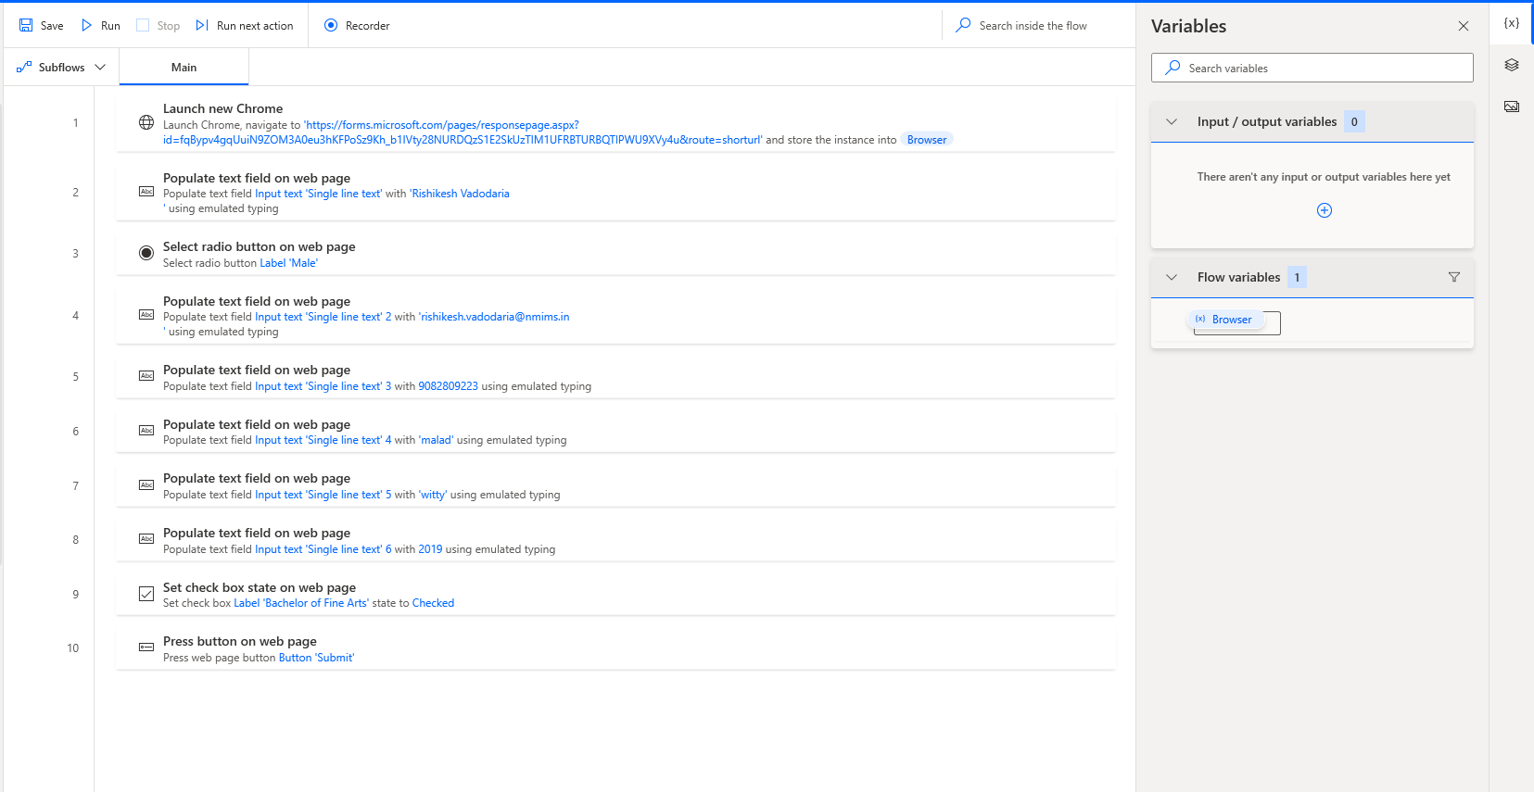

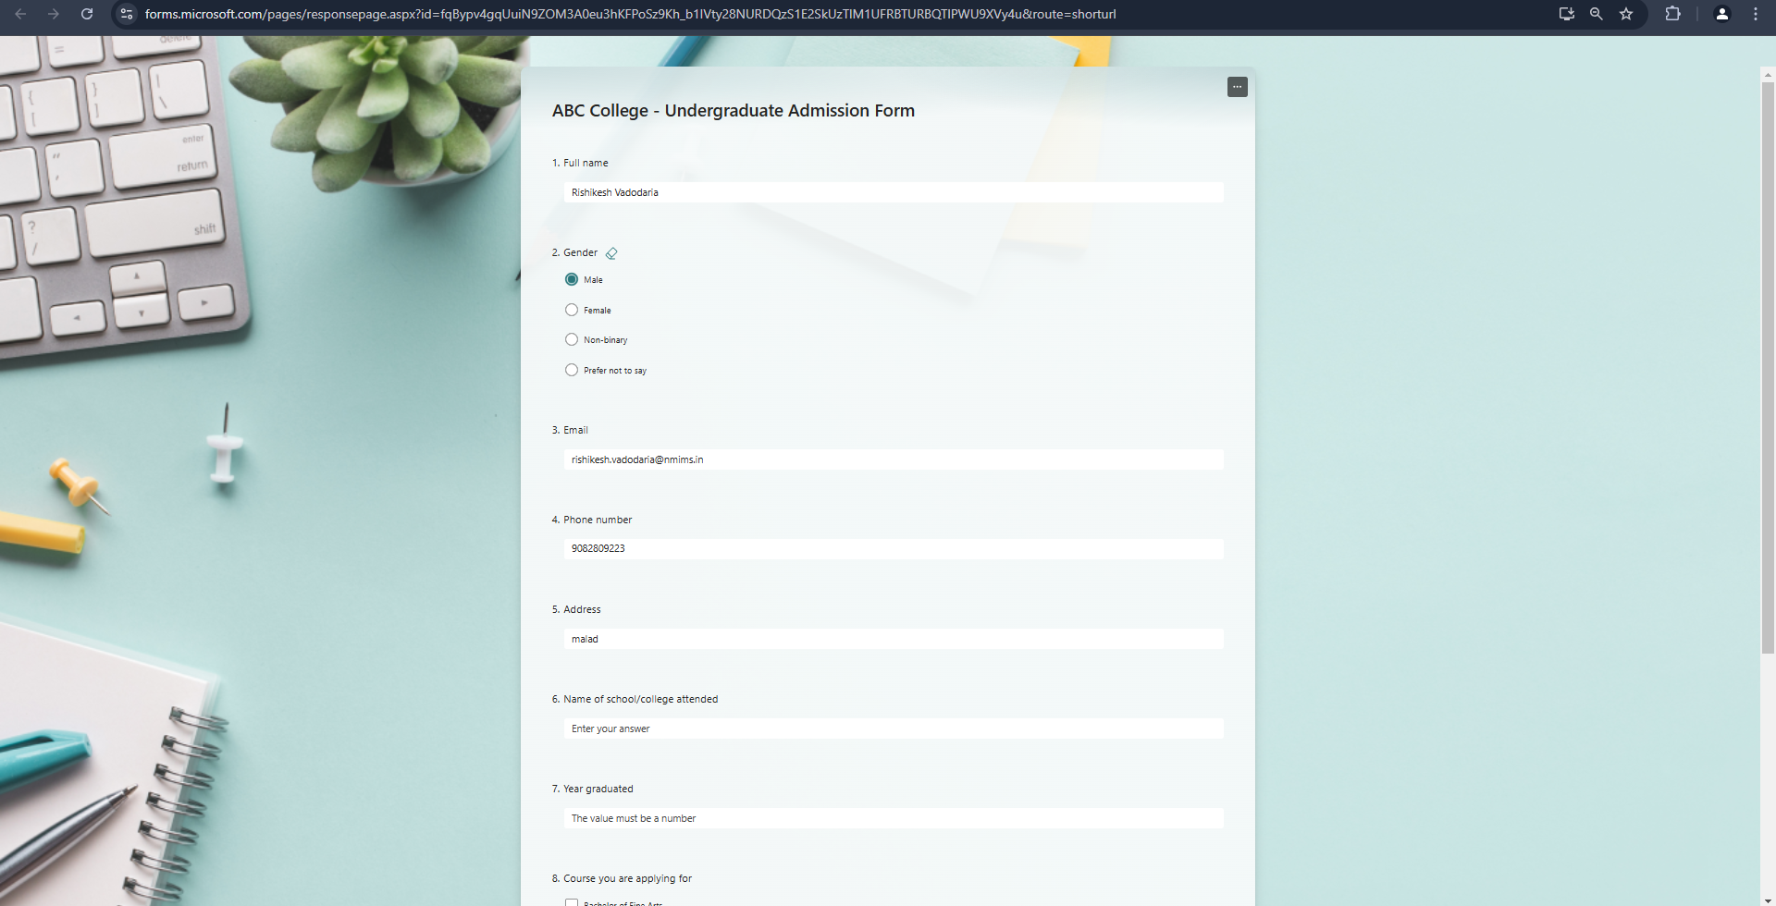

**GYM:**

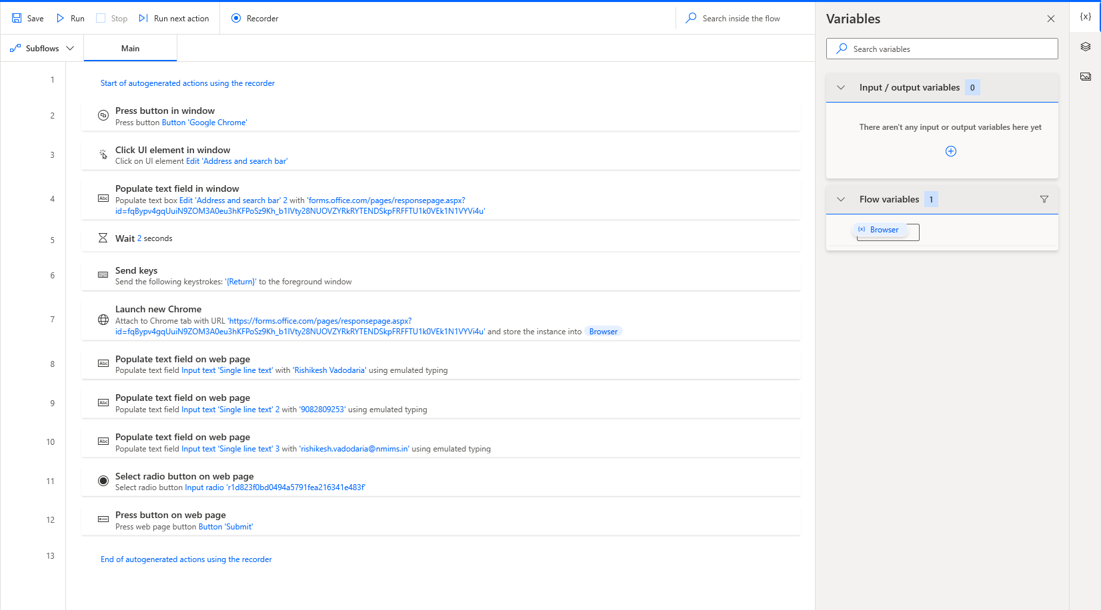

**Task 2 - HR Onboarding**

**Conclusion:**

Power Automate Desktop is a powerful tool by Microsoft that enables you to automate tasks on your desktop, including web automation and data extraction. With it, you can build workflows to interact with web forms, extract information, and automatically save the data to Excel. It provides a user-friendly interface with drag-and-drop actions, allowing you to automate tasks like filling out forms, clicking buttons, scraping data from web pages, and even working with Excel files. The process can be fully automated, reducing the need for manual data entry and streamlining repetitive tasks. This makes Power Automate Desktop a great choice for anyone looking to automate their workflows without needing advanced programming knowledge.