**Mukesh Patel School of Technology Management and Engineering**

Subject: Robotic Process Automation

**EXPERIMENT NO 5**

**Aim:** The objective of this experiment is to provide students with hands-on experience in creating a Power App

**Prerequisites:**

1. Power apps should be available on the browser.
2. Basic understanding of Power Apps

**Challenge Overview:**

**Task1: Navigation Example**

1. Create sample screens
2. Add button on the screen that would redirect from one screen to other

**Task2: Login**

1. Create a simple login page
2. Enter username and password and validate them
3. If authentication is successful, then redirect to welcome page.

**Task3: Search and Filter**

1. Create a excel with few columns
2. Import the excel in power app
3. Perform search and filter function on the excel using power app functions.

**Flow screenshots:**

**Task1: Navigation Example**

**Task2: Login**

**Task3: Search and Filter**

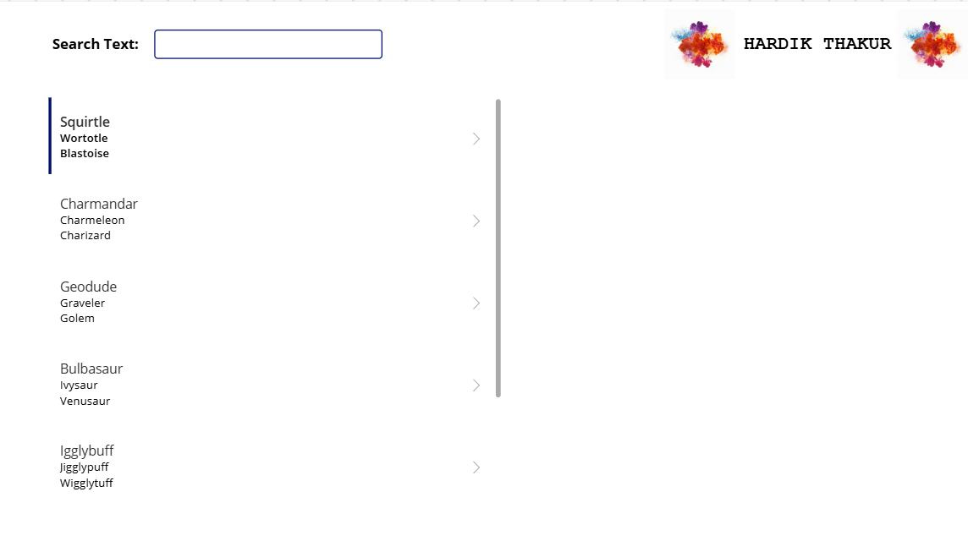

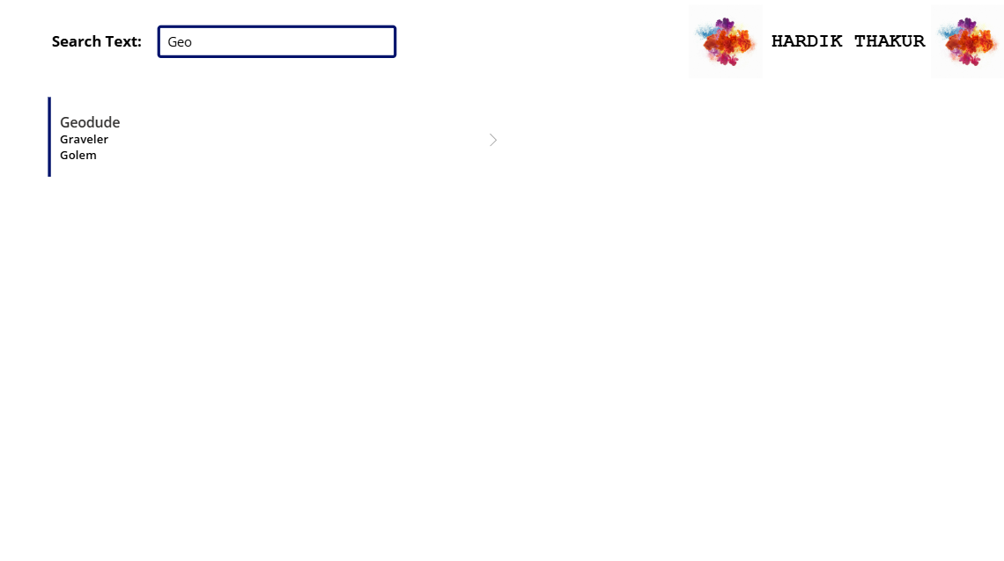

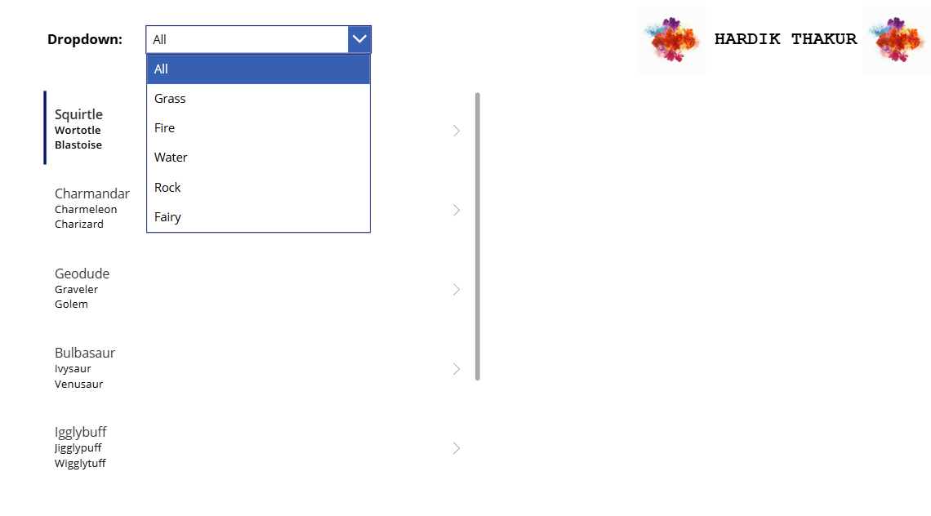

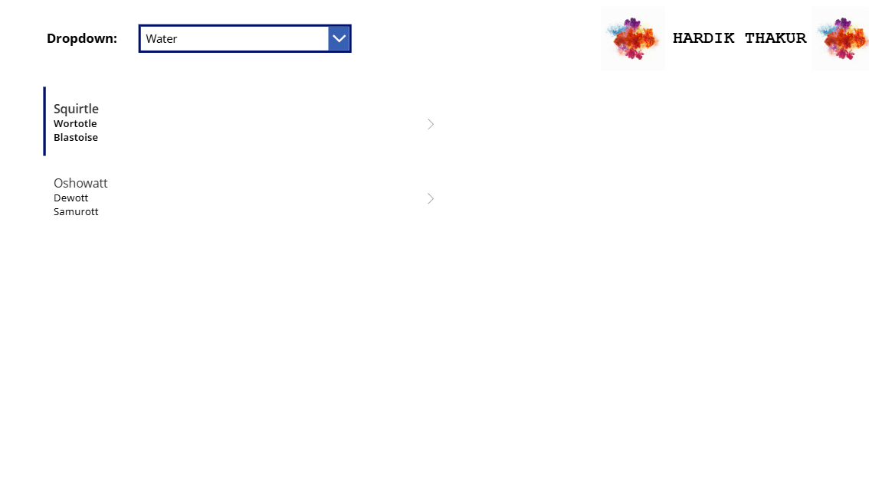

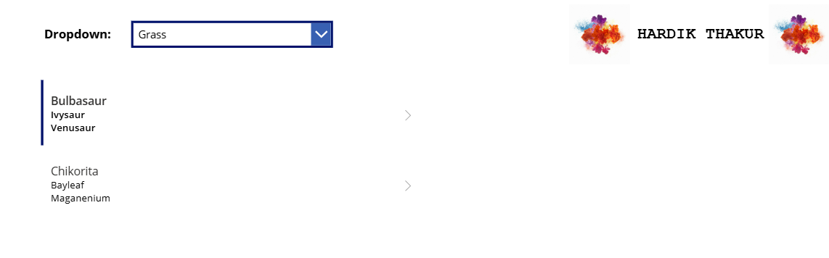

**Conclusion:**

* We successfully created our first app.
* Understood how to create excel and integrate with power app.
* Gained practical skills in building interactive Power Apps that integrate with SharePoint data sources.
* Also learned how to use formulas and navigation