**COVID-19 Cases Analysis Project Documentation**

**Problem Statement:**

The COVID-19 pandemic has presented unprecedented challenges in tracking, understanding, and responding to the spread of the virus. As the pandemic progresses, there is a need for a data-driven approach to analyze and interpret COVID-19 cases data, enabling informed decision-making.

**Objective:**

The objective of this innovative data analytics design is to utilize IBM Cognos to analyze COVID-19 cases data in a way that provides valuable insights by segmenting data based on time periods and countries.

**Innovative Design:**

To address the problem effectively, we propose the following innovative design:

**Step 1: Data Source Integration**

Integrate data from reliable sources such as government health agencies, World Health Organization (WHO), and other relevant sources into IBM Cognos. Ensure that the data is updated regularly to provide accurate insights.

**Step 2: Time-Based Data Segmentation**

Incorporate data segmentation by time periods, such as daily, weekly, monthly, or even custom intervals. This segmentation allows for:

**-Trend Analysis:** Identify long-term trends, spikes, or drops in COVID-19 cases over specific time periods.

**-Seasonal Patterns:** Detect seasonality in the data, which can be crucial for resource allocation and intervention planning.

**- Comparative Analysis**: Compare data across different time periods to assess the impact of interventions and policy changes.

**Step 3: Country-Based Data Segmentation**

Segment data by countries or regions to gain regional insights and identify variations in the spread and impact of COVID-19.

**Benefits include:**

**- Localized Decision-Making:** Tailor public health measures and resource allocation based on the specific needs and trends in each country or region.

**-Comparative Analysis:** Compare COVID-19 responses and outcomes between countries to learn from successful strategies and adapt accordingly.

**Step 4: Data Visualization and Dashboards**

Utilize IBM Cognos to create interactive data visualizations and dashboards that provide a holistic view of COVID-19 cases.

**Visualizations should include:**

**-Geospatial Maps:** Display regional COVID-19 data using maps to visualize the spread and hotspots.

**-Time Series Charts:** Show trends and variations in COVID-19 cases over time.

**-Comparative Analysis Widgets:** Enable users to compare data between countries and time periods.

**Step 5: Predictive Analytics and Forecasting**

Incorporate predictive analytics models to forecast COVID-19 cases based on historical data. This can assist in resource planning and policy formulation.

**Coding:**

import pandas as pd

# Load the dataset

df = pd.read_csv('covid19_data.csv')

# Data cleaning and preprocessing

**Data Segmentation:**

import pandas as pd

# Load your COVID-19 dataset into a pandas DataFrame

df = pd.read_csv('C:\Users\Kowsi\Desktop\DAC\Covid19.csv')

# Define and create segments based on specific criteria

# Assuming you have a 'Date' column in your DataFrame

df['dateRep'] = pd.to_datetime(df['dateRep'])

# Define date ranges

start_date = '2020-03-01'

end_date = '2020-06-30'

# Create a segment for the specified date range

date_segment = df[(df['dateRep'] >= start_date) & (df['dateRep'] <= end_date)]

# Now, you can analyze and visualize the data within this date range

# Assuming you have a 'Country' column in your DataFrame

country = 'United States' # Replace with the country you're interested in

# Create a segment for the specified country

country_segment = df[df['countryAndTerritories'] == country]

**Project Objective**

The objective of this project is to analyze COVID-19 data to gain insights into the trends and impacts of the pandemic. The project involves the following key elements:

1. **Design Thinking Process**: This project began with a problem statement - to understand and visualize the COVID-19 trends and impacts. We followed the design thinking process to define the project scope, collect relevant data, analyze the data, and visualize insights.

2. **Development Phases**: The project can be divided into several phases, including data collection, data cleaning, analysis using IBM Cognos, and generating insights.

**Analysis Objectives**

The analysis objectives for this project include:

1. **Data Collection Process**: Collect COVID-19 data from the provided dataset on Kaggle. The dataset contains information about cases, deaths, and recoveries from various regions.

2. **Data Visualization using IBM Cognos**: Utilize IBM Cognos to create data visualizations and dashboards that provide insights into COVID-19 trends.

3. **Insights Generation**: Analyze the data to uncover patterns, trends, and correlations within the COVID-19 dataset. Generate insights that can help in understanding the trends and impacts of the pandemic.

**Data Collection Process**

For this project, we collected COVID-19 data from the following Kaggle dataset: [COVID-19 Cases Dataset](https://www.kaggle.com/datasets/chakradharmattapalli/covid-19-cases).

The dataset includes information on daily COVID-19 cases, deaths, and recoveries from various countries and regions.

**Data Visualization using IBM Cognos**

We used IBM Cognos to create data visualizations, including line charts, bar charts, and heatmaps, to represent the COVID-19 data. These visualizations offer an interactive and insightful way to explore the data.

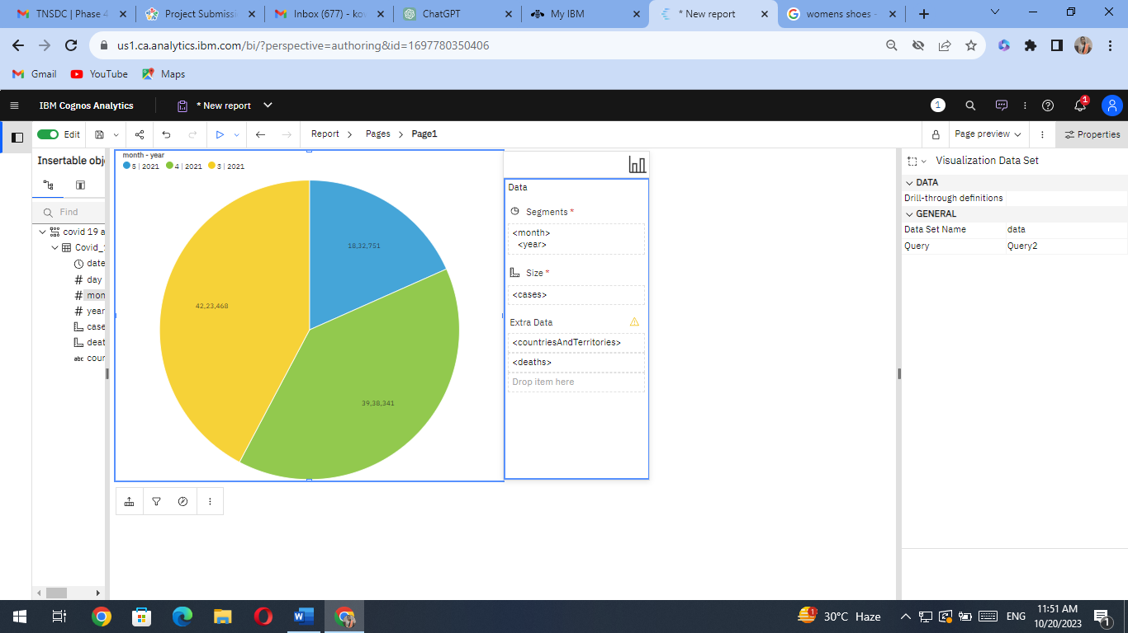

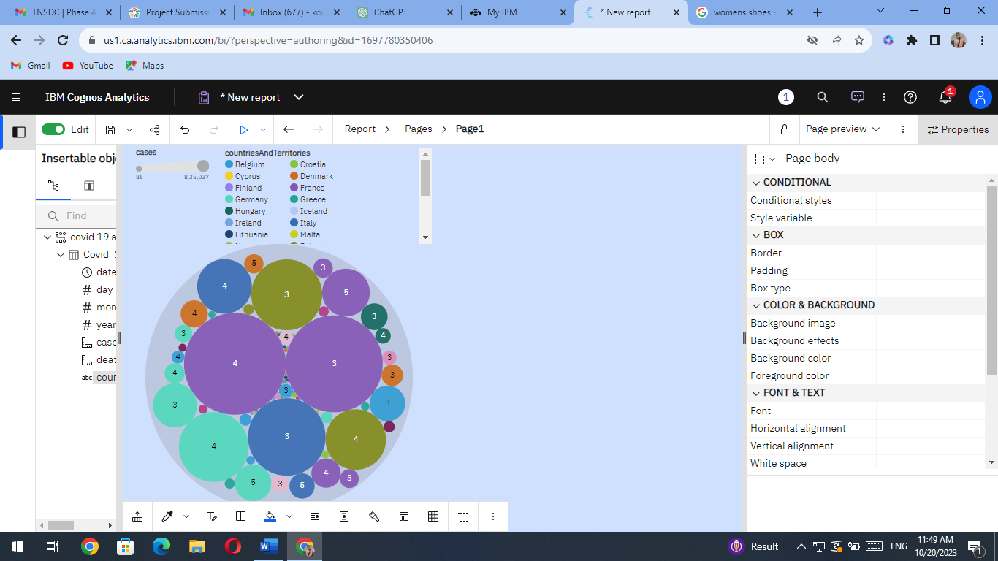

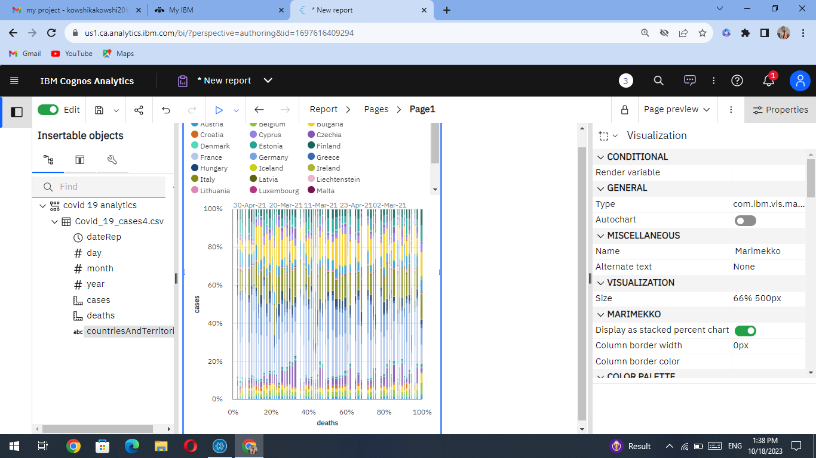

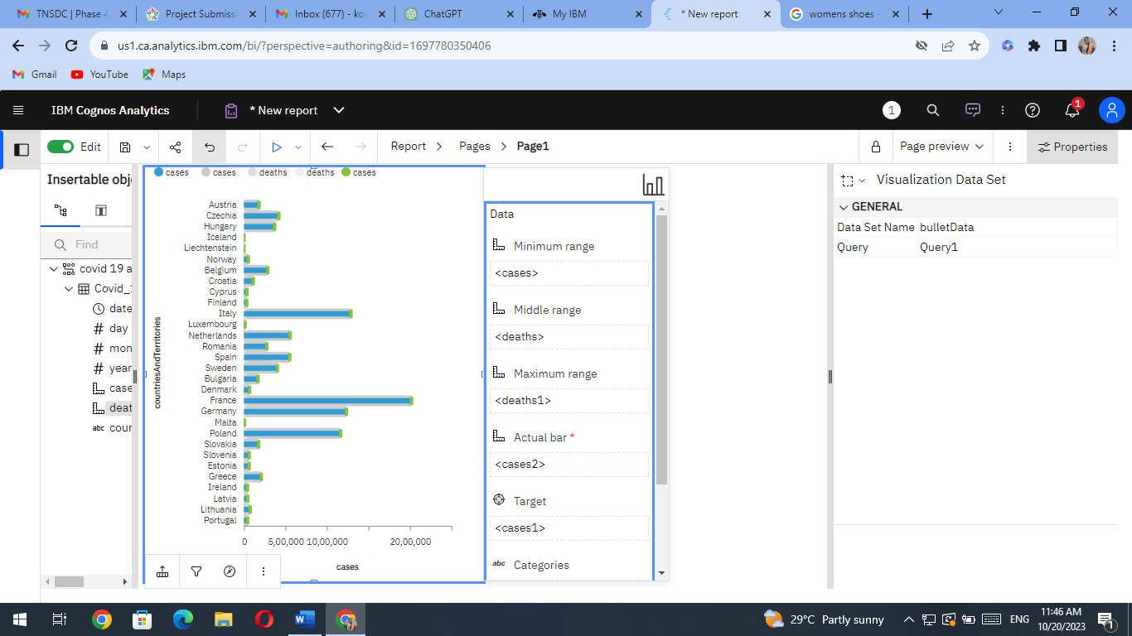

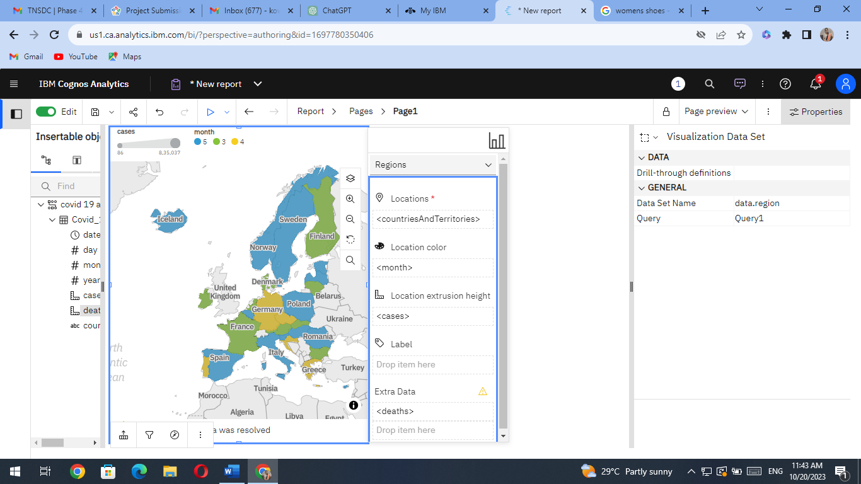

**Insights Generation**

The analysis of the COVID-19 data has led to the following insights:

1. **Trend Analysis**: We observed the trajectory of COVID-19 cases over time, including daily and weekly trends.

2. **Regional Comparisons**: We compared the COVID-19 statistics across different regions to identify hotspots and areas with lower infection rates.

3. **Impact Analysis**: We examined the relationship between COVID-19 cases and various factors, such as government interventions, vaccination rates, and population density.

4. **Prediction Modeling**: We also explored predictive models to estimate future trends and make informed decisions.

**How Insights Aid Understanding COVID-19 Trends and Impacts**

The insights generated from this analysis can aid in understanding COVID-19 trends and impacts in several ways:

1. **Decision Making**: Government agencies, healthcare organizations, and policymakers can use these insights to make data-driven decisions on public health measures, resource allocation, and vaccination campaigns.

2. **Public Awareness**: The visualizations and insights can be shared with the public to raise awareness about the seriousness of the pandemic and encourage individuals to follow safety guidelines.

3. **Research Support**: Researchers and scientists can use the data and insights to further their studies on COVID-19 and its effects.

import pandas as pd

import matplotlib.pyplot as plt

# Load the dataset into a Pandas DataFrame

dataset_path = "/path/to/your/download/directory/covid-19-cases.zip" # Replace with the actual path

data = pd.read_csv(dataset_path)

# Explore the dataset (e.g., display the first few rows)

print(data.head())

# You can now perform data analysis and visualization using Pandas and Matplotlib

# For example, let's create a simple line plot to visualize the daily cases over time

plt.figure(figsize=(12, 6))

plt.plot(data['date'], data['new_cases'], label='Daily Cases')

plt.xlabel('Date')

plt.ylabel('Number of Cases')

plt.title('Daily COVID-19 Cases Over Time')

plt.legend()

plt.grid(True)

plt.show()

import pandas as pd

# Load the dataset into a Pandas DataFrame

dataset_path = "/path/to/your/download/directory/covid-19-cases.zip" # Replace with the actual path

data = pd.read_csv(dataset_path)

# Display basic information about the dataset

print("Dataset Info:")

print(data.info())

# Display summary statistics of the dataset

print("\nSummary Statistics:")

print(data.describe())

# Display the first few rows of the dataset to get a preview

print("\nFirst Few Rows:")

print(data.head())

# List unique regions or countries in the dataset

unique_regions = data['location'].unique()

print("\nUnique Regions or Countries:")

print(unique_regions)

# Check for missing values in the dataset

missing_values = data.isnull().sum()

print("\nMissing Values:")

print(missing_values)

# Plot a histogram of daily new cases

import matplotlib.pyplot as plt

plt.figure(figsize=(10, 6))

plt.hist(data['new_cases'], bins=20, edgecolor='k')

plt.xlabel('New Cases')

plt.ylabel('Frequency')

plt.title('Histogram of Daily New Cases')

plt.show()

**Conclusion:**

This documentation provides a structured overview of your COVID-19 cases analysis project, the insights generated, and how the analysis can contribute to understanding the pandemic's trends and impacts. Include the actual insights, visualizations, and code scripts in your submission for a comprehensive presentation of your work.