🟢 Le vel 1 – Basic Loop Logic
1. Sum of 10 numbers
2. Find factorial of a given number (n!)
3. Print sum series 1 + 4 + 9 + 16 + … + n
4. Print digits of a number in reverse order
5. Print sum of digits of a given number
6. Perform multiplication without using * operator
7. Calculate x^y without using power operator
________________________________________
🟡 Level 2 – Loops with Conditional Logic (if inside loop)
8. Print numbers divisible by 2 between two numbers
9. Find factors of a given number
10. Find the sum of all divisors of a number
11. Find the GCD (Greatest Common Divisor) of two numbers
12. Find the LCM (Least Common Multiple) of two numbers
13. Check whether a number is a Perfect Number.
(A perfect number is a positive integer that is equal to the sum of its positive divisors, excluding the number itself. A divisor of an integer x is an integer that can divide x evenly.)
14. Check whether a number is a Harshad Number.
(An integer num which is divisible by the sum of its digits is said to be a Harshad number.)
15. Check whether a number is Prime or Not
16. Print the Fibonacci Series
17. Find the sum of series 1 – 2 + 3 – 4 + 5 – 6 + … ± n,

Check if given number is a Happy Number or not
Check if given number is a Ugly Number or not.
(a n ugly number is a positive integer which does not have a prime factor other than 2, 3, and 5.)

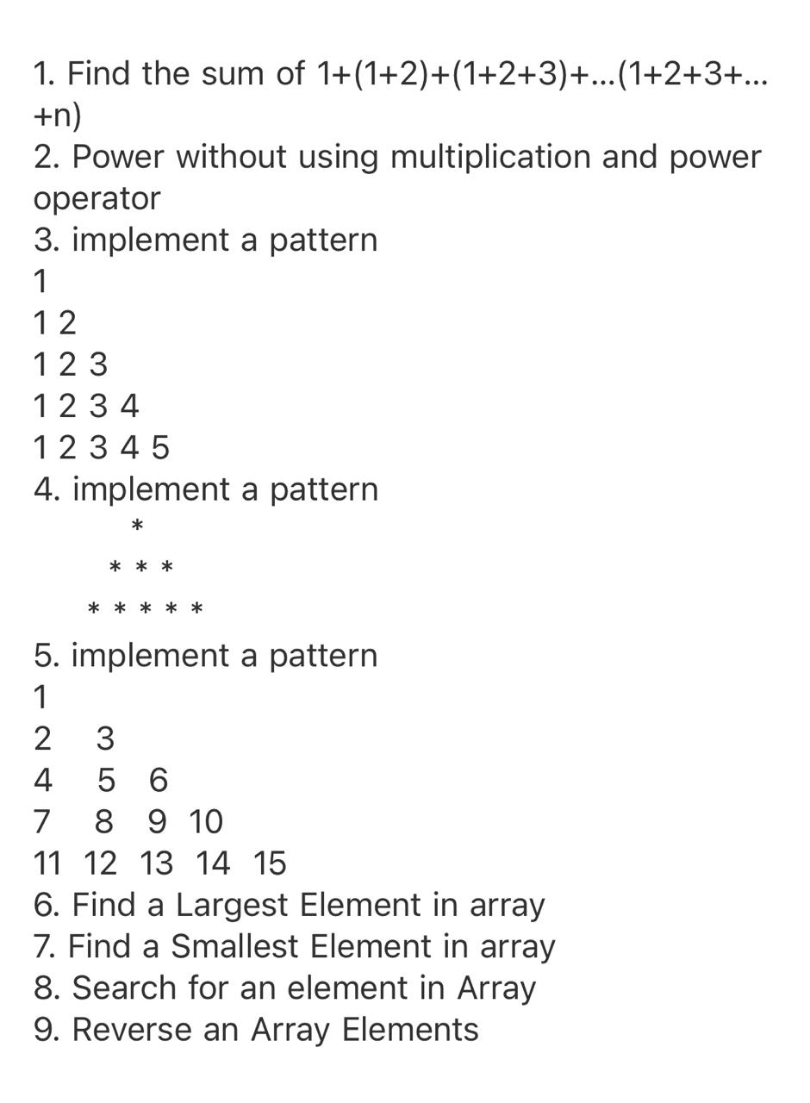

27.

*
* *
* * *
* * * *
* * * * *

28.
1
1 2
1 2 3
1 2 3 4
1 2 3 4 5

29.
A
B B
C C C
D D D D
E E E E E

30.
* * * * *
* * * *
* * *
* *
*

31.
1 2 3 4 5
1 2 3 4
1 2 3
1 2
1

32.
*
* * *
* * * * *
* * * * * * *
* * * * * * * * *

33.
1
2 3 2
3 4 5 4 3
4 5 6 7 6 5 4
5 6 7 8 9 8 7 6 5

34.
* * * * * * * * *
* * * * * * *
* * * * *
* * *
*

35.
1
1 1
1 2 1
1 3 3 1
1 4 6 4 1
1 5 10 10 5 1

36.
1
2 3
4 5 6
7 8 9 10

37.
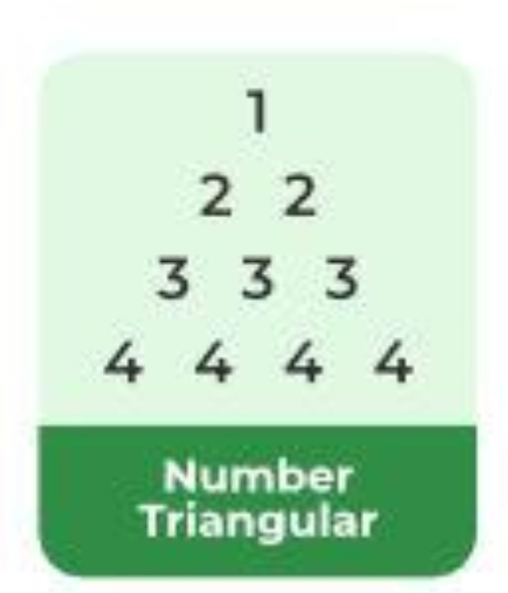
38.
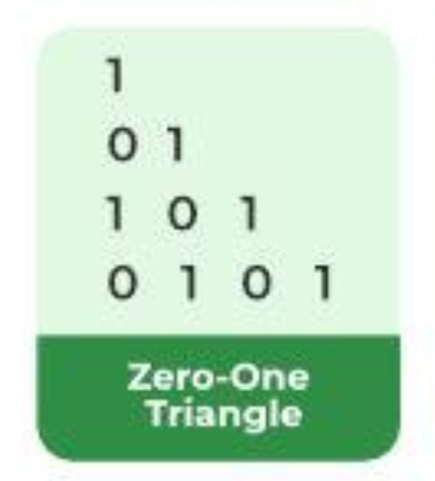
39.
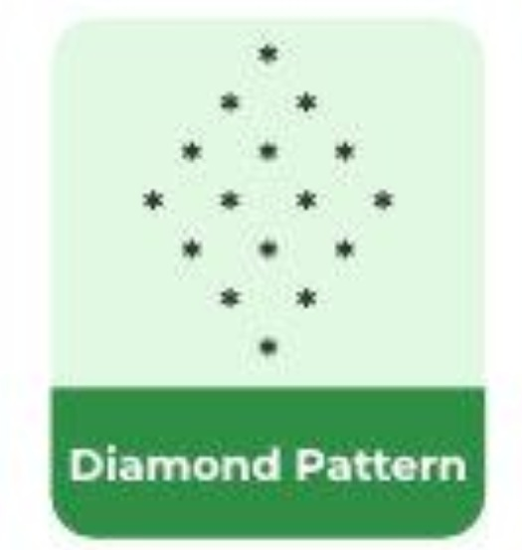
40.
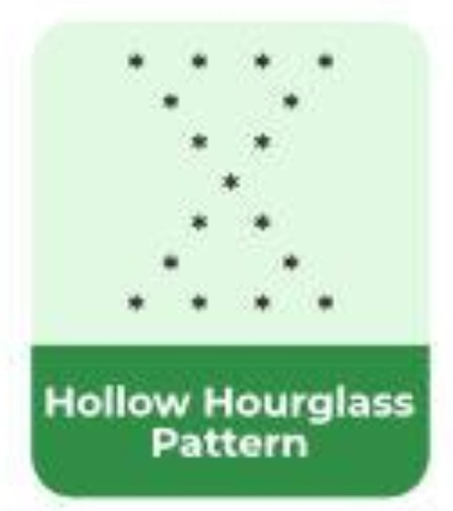
41.
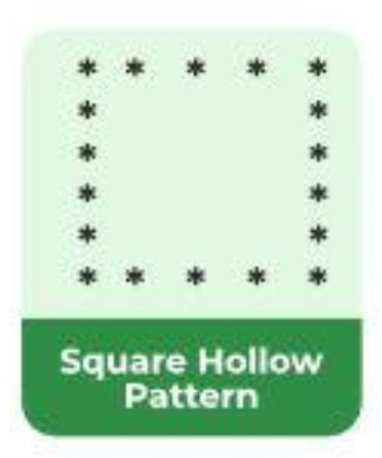

42.

43.
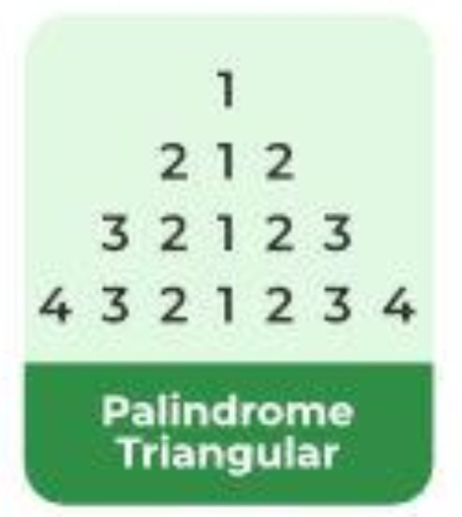

https://github.com/RishilJani/logic-develepment.git
i\j | 1 | 2 | 3 | 4
1 | * | * | * | *
2 |  |  | *
3
4
5

