DealerConnect
Dealer Relationship Management & Auditing Platform
Capstone Project Report
Java Full Stack (Angular + Spring Boot Microservices)

Field | Details
Student Name | Rishiraj Sarkar
Guide / Mentor | Mr. Thaneshwara
Submission Date | 17/06/26

1. Introduction
Automotive organizations manage a large network of dealers, dealer contacts and business relationships. Existing systems often lack governance controls, auditing capabilities and centralized dealer visibility. DealerConnect addresses this gap by providing a secure Dealer Relationship Management platform built on a microservices architecture, with complete audit trails, role-based access control, soft-delete governance and a personalized dealer-favorites feature.
The platform is delivered as an Angular single-page application backed by six independent Spring Boot services that communicate through an API Gateway and a Eureka service registry.

2. Objectives & Scope
- Provide secure authentication and role-based authorization (Admin, Relationship Manager).
- Enable full CRUD management of dealers and their contacts.
- Support dealer search, activation/deactivation and soft-delete governance.
- Allow Relationship Managers to manage and filter personal dealer favorites.
- Maintain a complete, queryable audit trail of all key business events.
- Demonstrate microservice patterns: service discovery, API gateway and inter-service calls.

3. Technology Stack
Layer | Technology
Frontend | Angular 19 (standalone components, signals), Tailwind CSS, TypeScript
Backend | Java 21, Spring Boot 4.1, Spring Web, Spring Data JPA
Microservices | Spring Cloud Gateway, Netflix Eureka, OpenFeign
Security | Spring Security, JWT (HS512), BCrypt
Database | MySQL 8 (one schema per service)
Build / Tools | Maven, Node.js, npm

4. System Architecture
The system follows a database-per-service microservice design. All client traffic enters through the API Gateway, which is the single point of authentication and authorization. The gateway validates the JWT, enforces role rules and forwards the caller identity downstream so the protected services can trust it without re-validating tokens. Services register with Eureka and resolve each other by name; inter-service calls use OpenFeign.
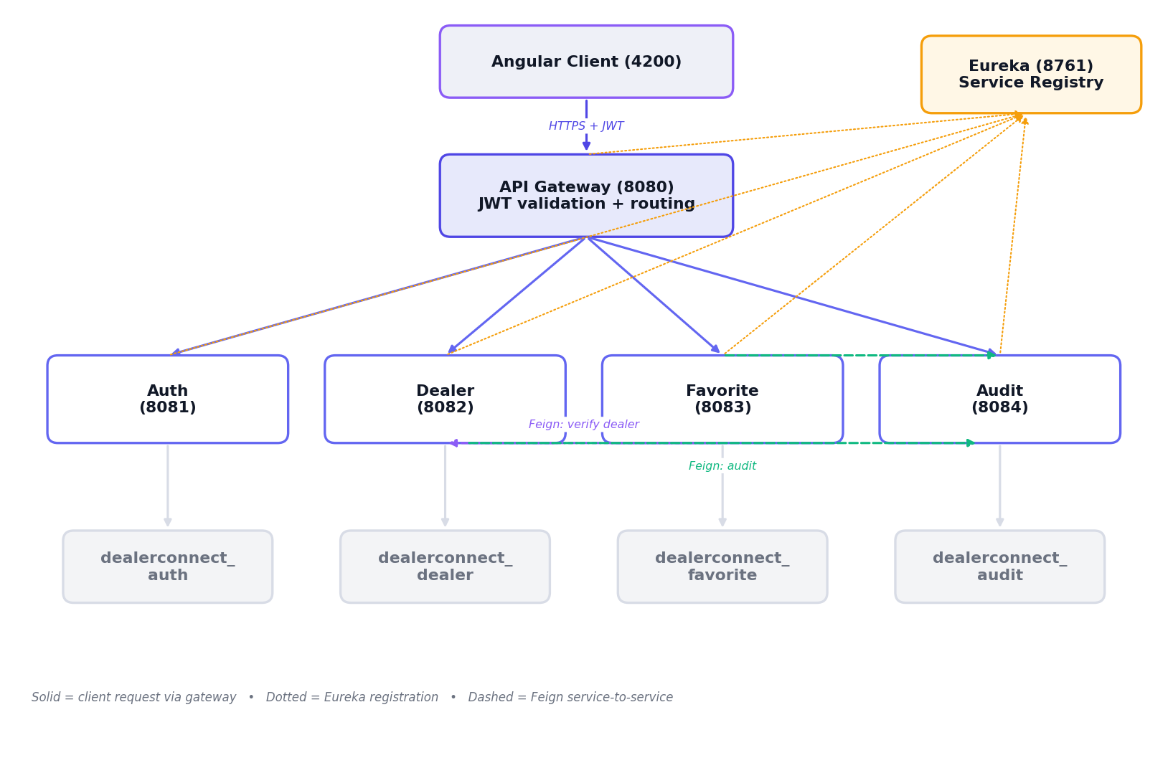
Figure 1. DealerConnect microservice architecture

Service | Port | Responsibility
Eureka Server | 8761 | Service registry / discovery
API Gateway | 8080 | Routing, JWT validation, role authorization
Auth Service | 8081 | Registration, login, JWT issuing
Dealer Service | 8082 | Dealer & contact management, search, soft delete
Favorite Service | 8083 | Dealer favorites (verifies dealers via Feign)
Audit Service | 8084 | Stores and serves audit history

5. Database Design
Each service owns a dedicated MySQL schema. Relationships within a single database are enforced with foreign keys (dealers to dealer_contacts); references that span services, such as a favorite pointing to a dealer, are logical references resolved at runtime through Feign.
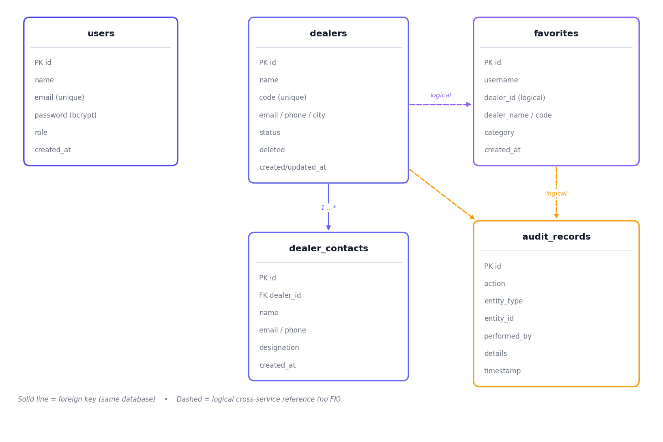
Figure 2. Entity-Relationship diagram across the four databases

6. Security & Authentication
Authentication is centralized at the gateway. On login the Auth Service verifies the BCrypt password and returns a signed JWT carrying the user email and role. Every subsequent request must present this token; the gateway validates the signature and expiry, checks the role against the route rules, and injects X-Auth-User and X-Auth-Role headers before forwarding.
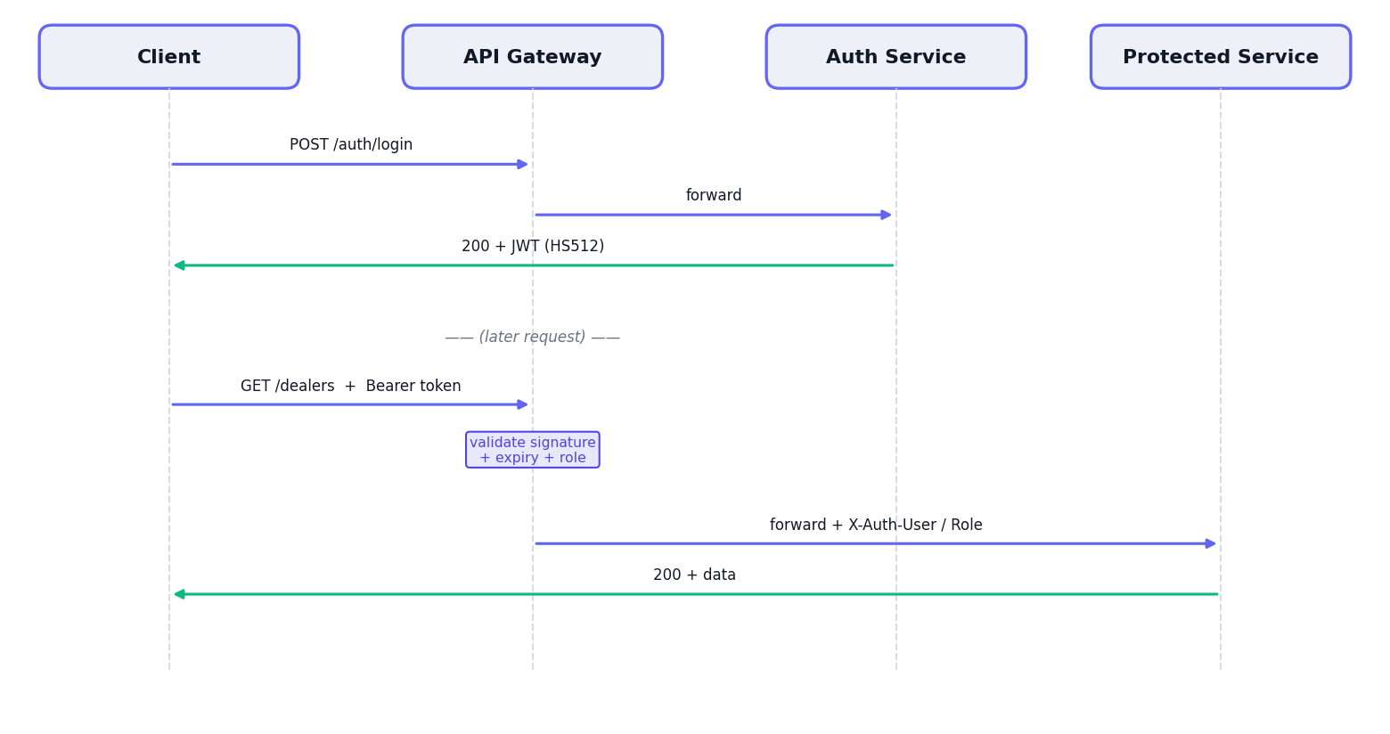
Figure 3. JWT authentication and request authorization flow

Route | Method | Allowed Role
/auth/login, /auth/register | any | Public
/dealers, /contacts | GET | Admin, Relationship Manager
/dealers, /contacts | Write | Admin
/favorites | any | Admin, Relationship Manager
/audit | any | Admin

7. Application Walkthrough
The following screens demonstrate the application. Replace each placeholder with a screenshot captured by following the instructions in its caption (start all backend services, then run the Angular app and open http://localhost:4200).

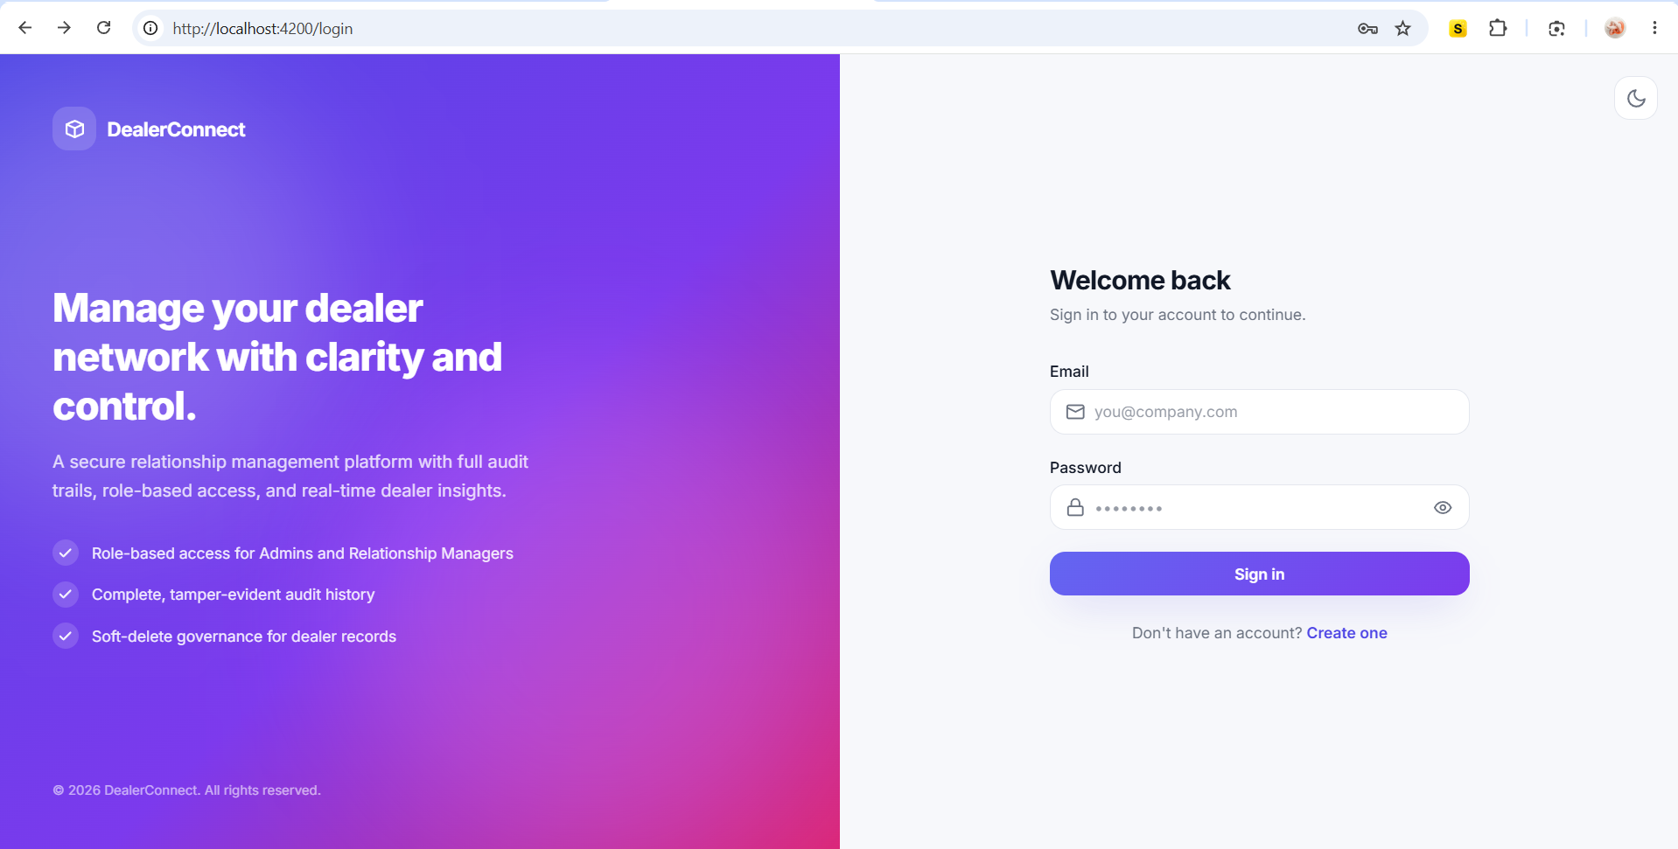
Figure 4. Login page

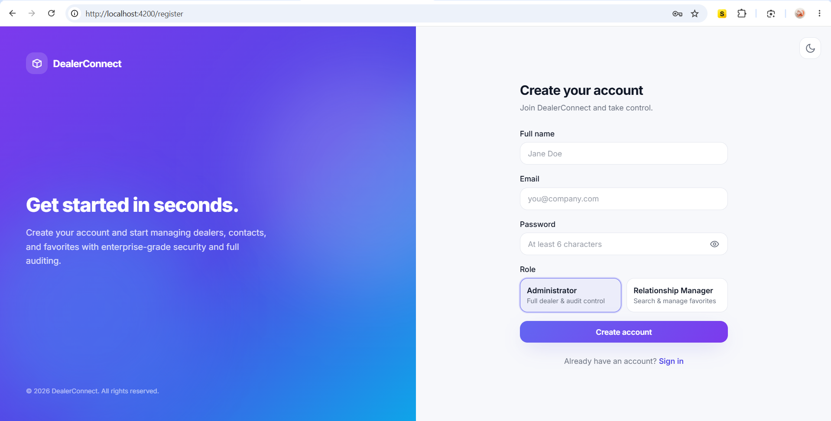
Figure 5. Registration page
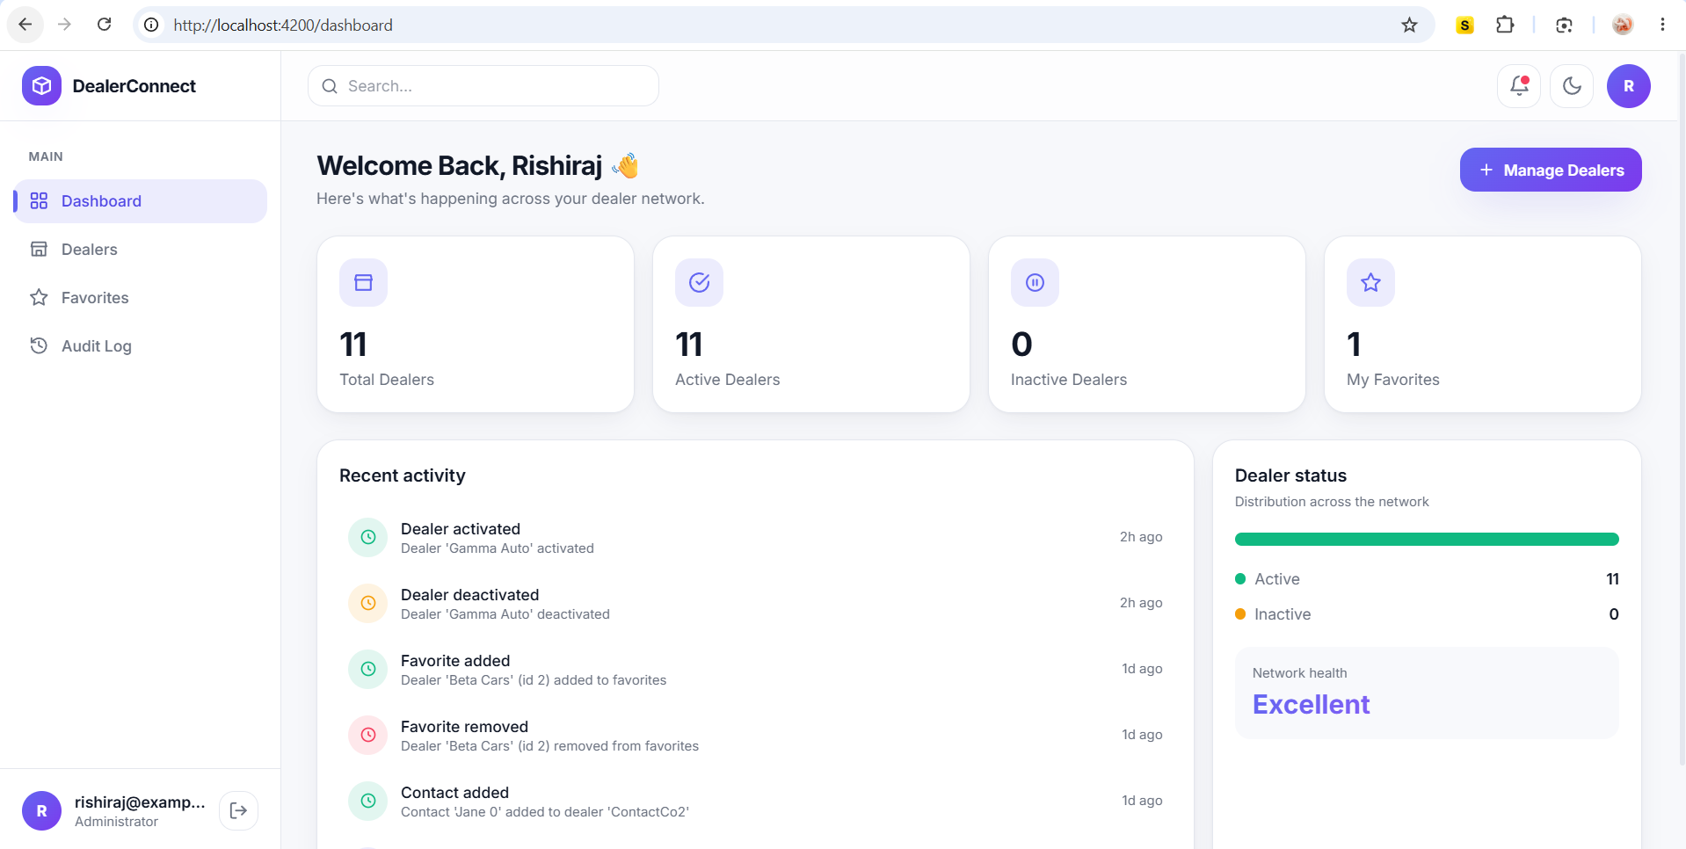
Figure 6. Dashboard (light mode)

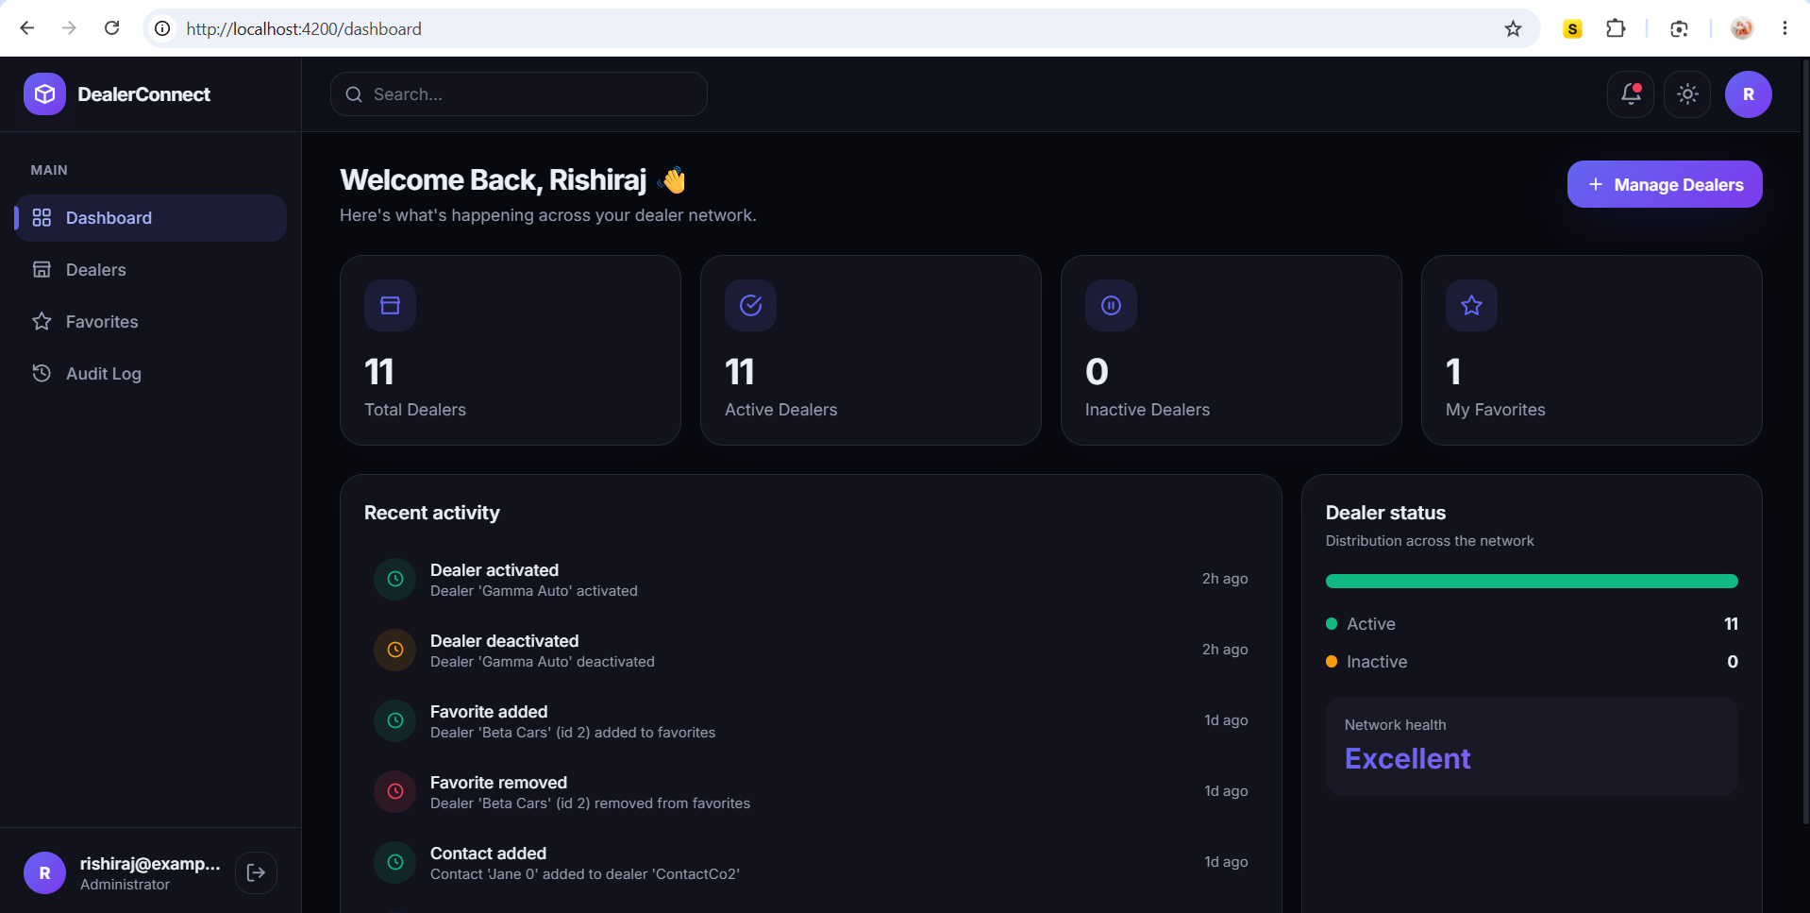
Figure 7. Dashboard (dark mode)
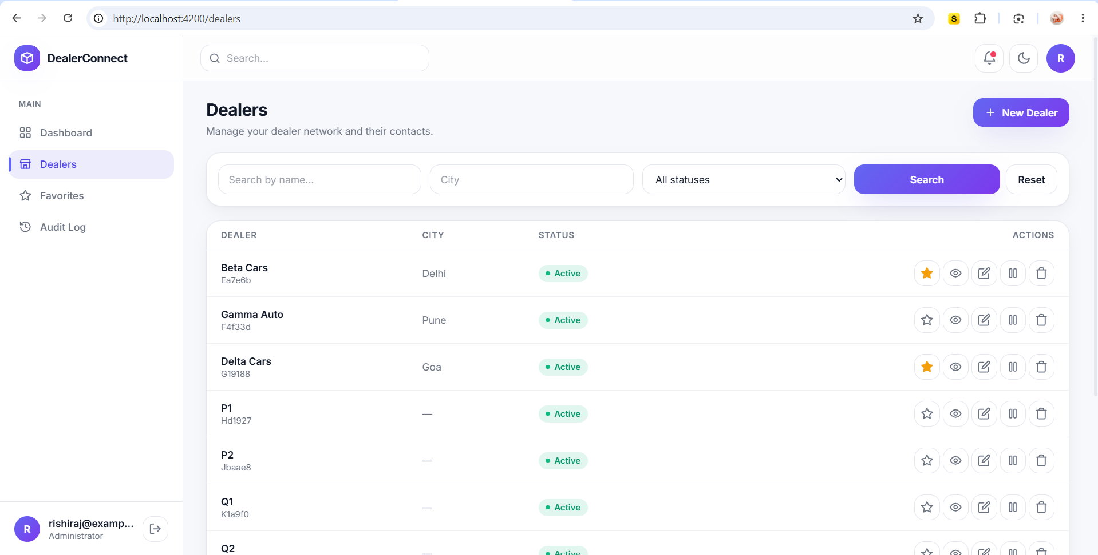
Figure 8. Dealers list

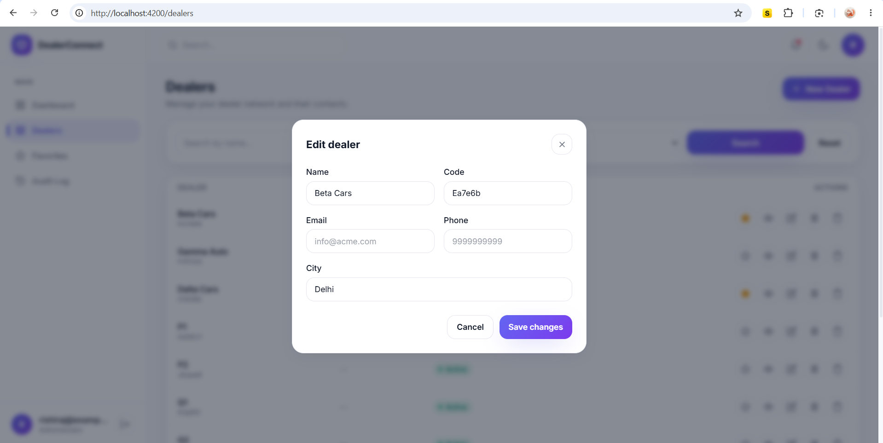
Figure 9. New / Edit Dealer form
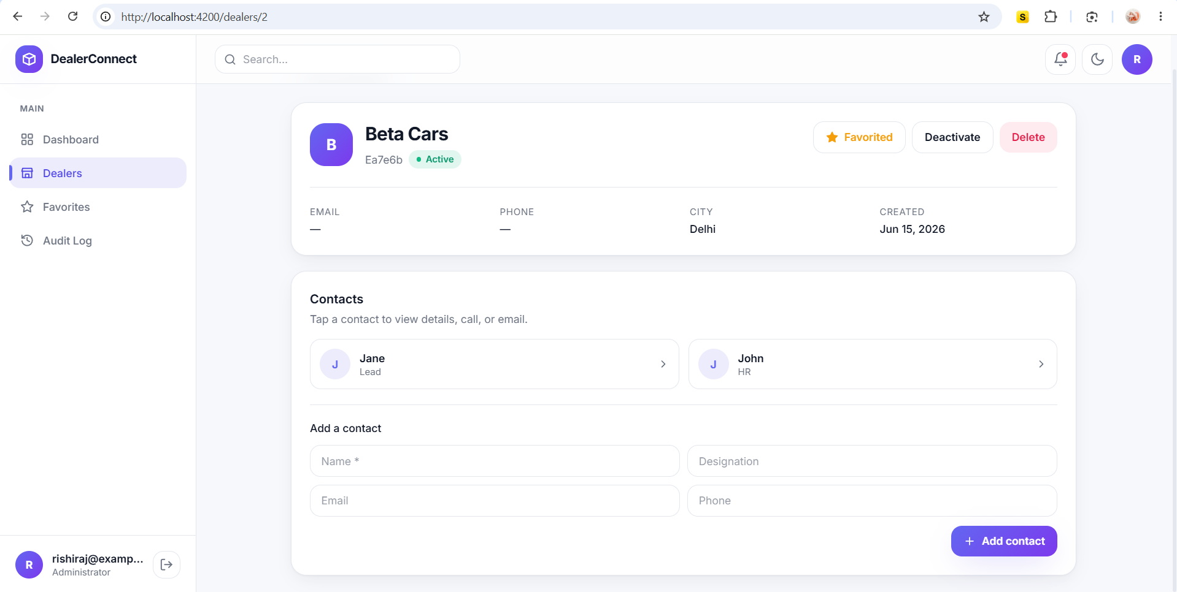
Figure 10. Dealer detail with contacts

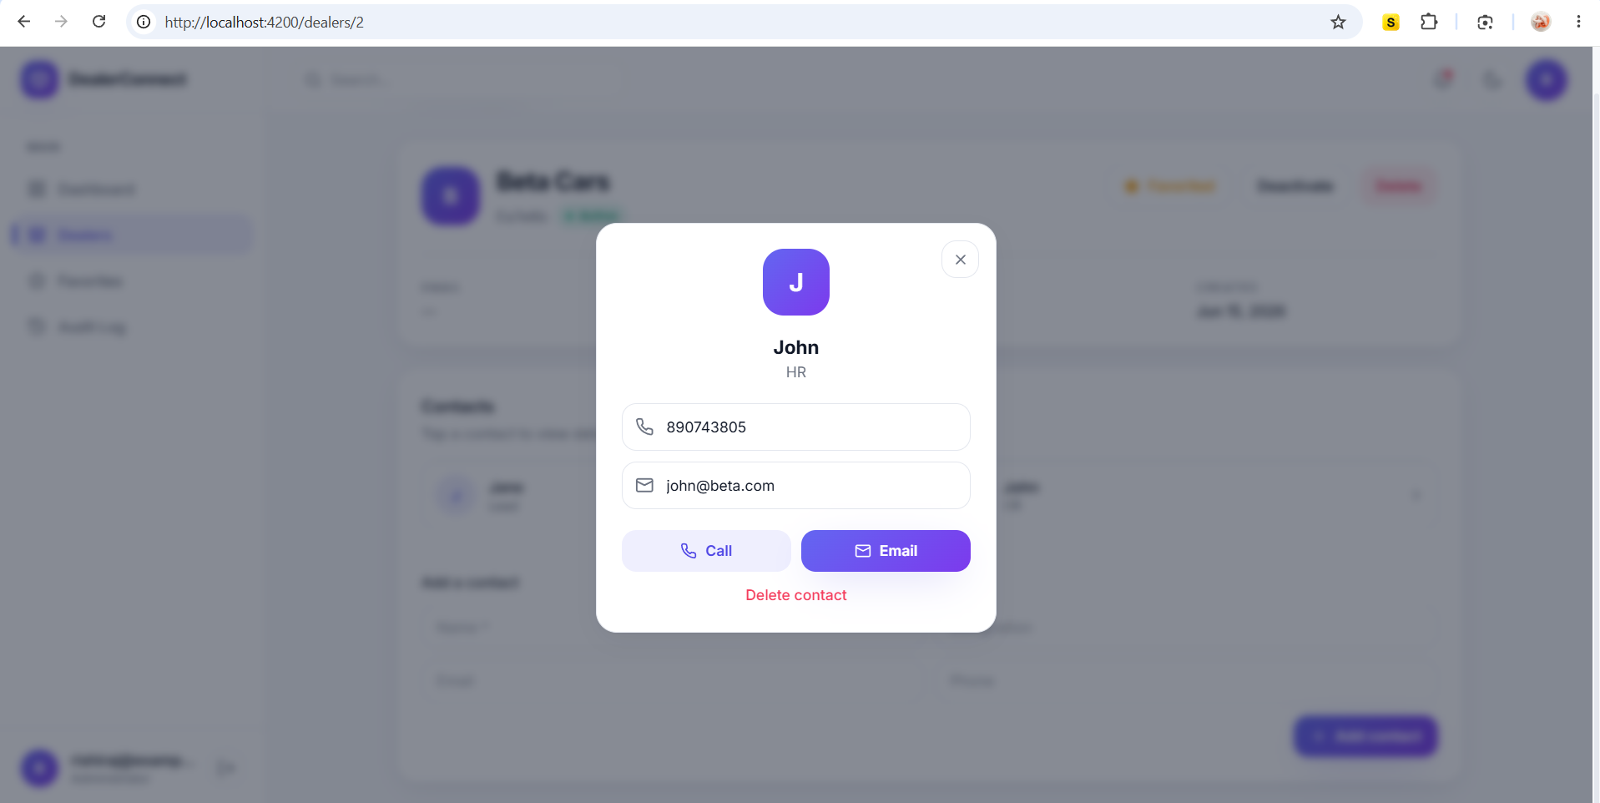
Figure 11. Contact detail (call / email)
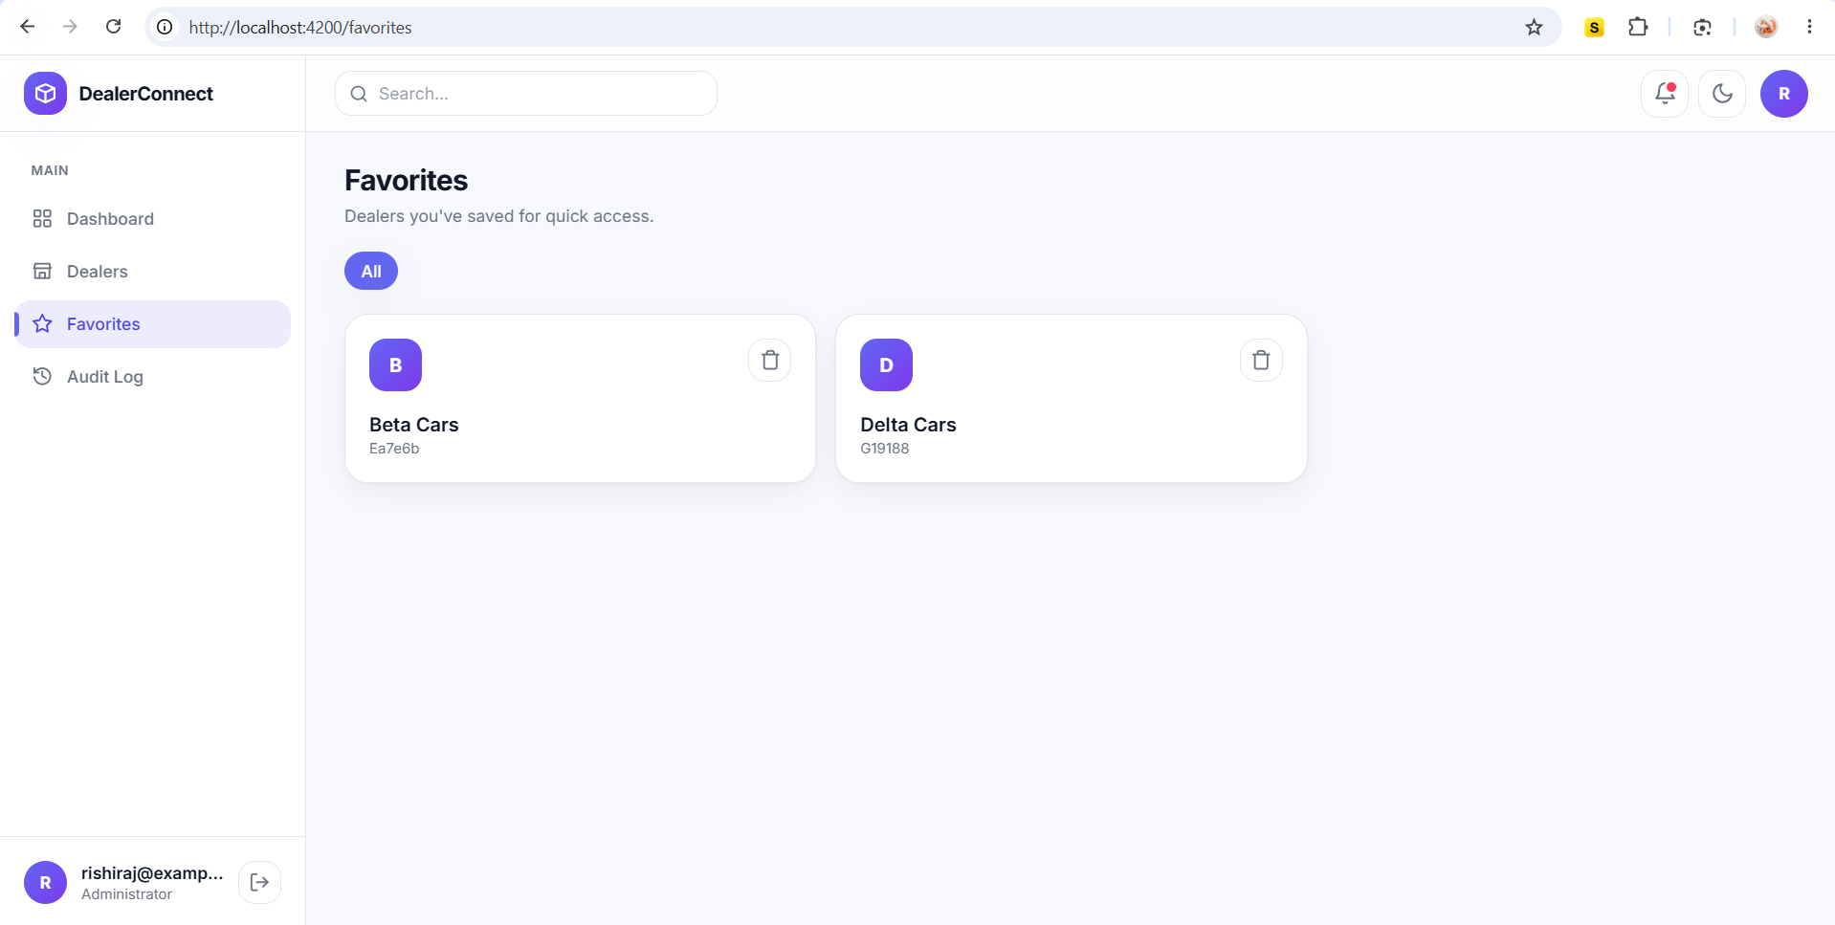
Figure 12. Favorites with category filter

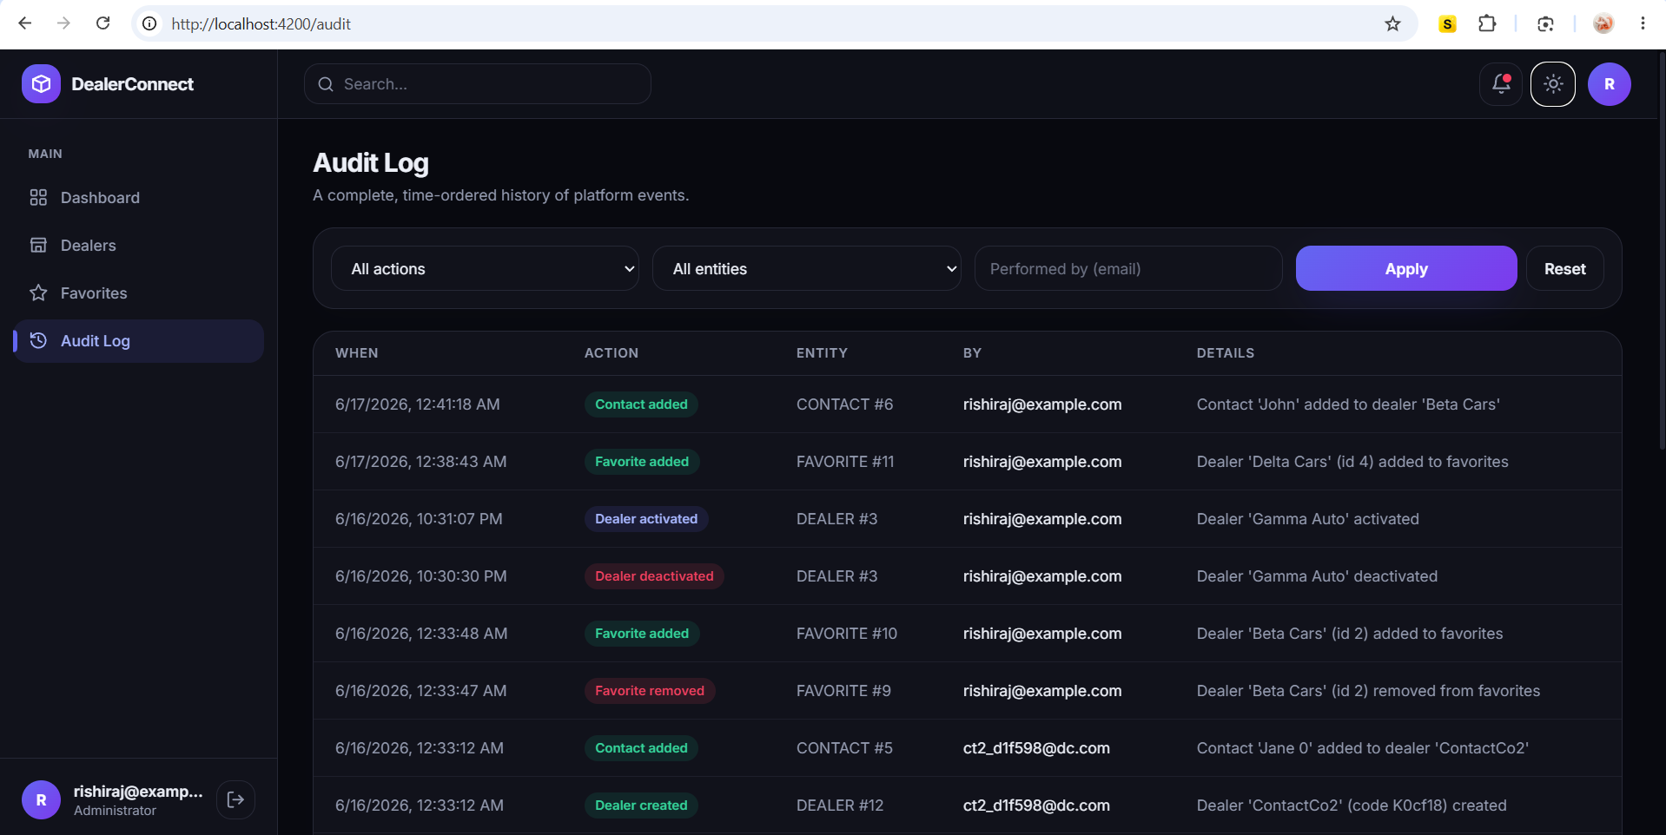
Figure 13. Audit log

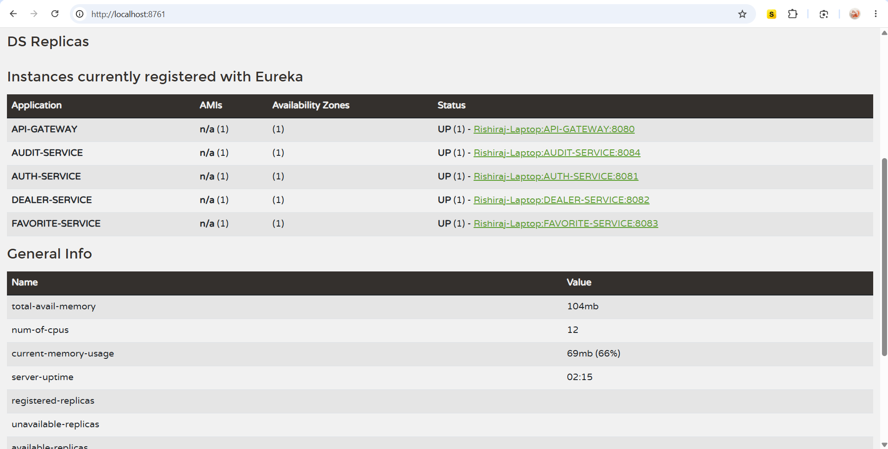
Figure 14. Eureka dashboard

8. API Summary
Method & Path | Description
POST /auth/register | Create a user account
POST /auth/login | Authenticate and receive a JWT
GET /dealers, /dealers/search | List / search dealers
POST/PUT /dealers | Create / update a dealer (Admin)
PATCH /dealers/{id}/activate|deactivate | Change dealer status (Admin)
DELETE /dealers/{id} | Soft-delete a dealer (Admin)
GET/POST/DELETE /contacts | Manage dealer contacts
GET/POST/DELETE /favorites | View / add / remove favorites
GET /audit | View audit history (Admin)

9. Testing & Validation
The platform was validated end-to-end: Eureka registration of all services, gateway routing, the full JWT flow (public vs protected routes, role enforcement returning 401/403), CRUD and soft-delete on dealers, the Feign dealer-existence check before creating a favorite, and audit records produced for dealer, contact and favorite events. Input validation and a global exception handler return consistent error responses (400/401/403/404/409/503).

10. Conclusion
DealerConnect demonstrates a complete, secure and well-structured full-stack microservice application. It applies enterprise patterns - centralized security, service discovery, inter-service communication and auditing - behind a modern, responsive Angular interface with light and dark themes. The layered architecture and clear separation of concerns make the system maintainable and straightforward to extend.

