**ULTIMATE ROCK PAPER SCISSORS LIZARD**

**SPOCK CHALLENGE GAME**

A CAPSTONE PROJECT

*Submitted By*

*A.Shanmukha Vinay (192210313)*

*&*

*N.Rishitha(192210313)*

*In Partial Fulfillment for the completion of the course*

PROGRAMMING IN JAVA for Web Applications

**(CSA0910)**

SEP 2024



SAVEETHA INSTITUTE OF MEDICAL AND TECHNICAL SCIENCES

CHENNAI - 602105 TAMIL NADU, INDIA



# BONAFIDE CERTIFICATE

This is to certify that the project report entitled **ULTIMATE ROCK PAPER SCISSORS LIZARD**

**SPOCK CHALLENGE GAME** submitted by A.SHANMUKHA VINAY(192210313) AND N.RISHITHA(192210240), to Saveetha School of Engineering, Saveetha Institute of Medical and Technical Sciences, Chennai, is a record of bonafide work carried out by him/her under my guidance. The project fulfills the requirements as per the regulations of this institution and in my appraisal meets the required standards for submission.

**COURSE FACULTY**

*Dr. A Ganesh Ramachandran*

*Department of Deep Cyber Security.*

*Saveetha School of Engineering,*

*SIMATS, Chennai – 602105*

# ACKNOWLEDGEMENT

This project work would not have been possible without the contribution of many people. It gives me immense pleasure to express my profound gratitude to our Honorable Chancellor **Dr. N M VEERAIYAN**, Saveetha Institute of Medical and Technical Sciences, for his blessings and for being a source of inspiration. I sincerely thank our Director of Academics **Dr. DEEPAK NALLASWAMY,** SIMATS, for his visionary thoughts and support. I am indebted to extend my gratitude to our Director **Dr. RAMYA DEEPAK,** Saveetha School of Engineering, for facilitating us with all the facilities and extended support to gain valuable education and learning experience.

I register my special thanks to **Dr. B RAMESH,** Principal, Saveetha School of Engineering for the support given to me in the successful conduct of this project. I wish to express my sincere gratitude to my Course faculty **Dr A Ganesh Ramachandran**, for his inspiring guidance, personal involvement and constant encouragement during the entire course of this work.

I am grateful to Project Coordinators, Review Panel External and Internal Members and the entire faculty of the Department of Design, for their constructive criticisms and valuable suggestions which have been a rich source to improve the quality of this work

# INDEX

BONAFIDE CERTIFICATE 1

ACKNOWLEDGEMENT 2

1. ABSTRACT 5
2. INTRODUCTION 6
3. ARCHITECTURE DIAGRAM 7
4. FLOWCHART 8
5. UML DIAGRAM 9
6. CLASS DIAGRAM 10
7. CODE IMPLEMENTATION 11
   1. JAVA CODE 11
   2. HTML CODE 12
   3. CSS CODE 13
8. OUTPUT SCREENSHOT 14
9. CONCLUSION 16
10. REFERENCES 17

# ABSTRACT

The "Ultimate Rock Paper Scissors Lizard Spock Challenge Game" expands on the classic Rock Paper Scissors game by incorporating two additional hand signs: Lizard and Spock. This variant increases the complexity and fun of the traditional game, offering a total of 25 possible outcomes. Each hand sign interacts uniquely with the others, creating a dynamic and strategic gameplay experience. The game's algorithm, designed to determine the winner based on predefined rules, ensures fairness and unpredictability. The user-friendly interface enhances player engagement through intuitive controls and clear visual feedback. Additionally, the game offers a statistical analysis of winning combinations, highlighting the balanced probabilities of each outcome.

By integrating these elements, the "Ultimate Rock Paper Scissors Lizard Spock Challenge Game" provides a fresh, exciting twist to a well-loved pastime, making it both accessible and challenging for players. The game not only retains the simple, accessible nature of its predecessor but also introduces deeper strategic elements that encourage players to think critically about their choices. This paper will delve into the rules, algorithm, user interface design, statistical analysis, and strategic depth of the game, demonstrating its potential to offer hours of engaging entertainment. Future developments could include multiplayer options, AI opponents, and detailed stat tracking to further enhance the player experience.

# INTRODUCTION

The "Ultimate Rock Paper Scissors Lizard Spock Challenge Game" is an innovative twist on the age-old hand game of Rock Paper Scissors. Originating from the need to break ties more frequently and add an extra layer of excitement, this variant introduces two additional gestures: Lizard and Spock. The idea was popularized by the television show "The Big Bang Theory," where it was showcased as a more complex and intriguing alternative to the classic game.

In traditional Rock Paper Scissors, players select one of three hand signs, with each sign defeating one of the others and being defeated by the third, resulting in a simple cyclical pattern. However, this simplicity can lead to predictability and reduced strategic depth. By adding Lizard and Spock, the "Ultimate Rock Paper Scissors Lizard Spock Challenge Game" increases the total number of possible outcomes from nine (3x3) to twenty-five (5x5), introducing a richer strategic landscape and more diverse gameplay.

This expanded version retains the straightforwardness and accessibility of the original game while providing players with new strategies and considerations. Each of the five gestures interacts with the others in unique ways, offering players a broader range of tactical options and a more engaging decision-making process. The game's algorithm is designed to determine the winner quickly and fairly, ensuring that each round is as unpredictable and exciting as the last.

The game's design emphasizes a user-friendly interface, making it easy for players of all ages to understand and enjoy. Additionally, a detailed statistical analysis of the interactions between gestures ensures that no single sign dominates the game, maintaining a balanced and fair playing field.

In this paper, we will explore the rules and mechanics of the "Ultimate Rock Paper Scissors Lizard Spock Challenge Game," delve into the algorithm that determines the outcome of each round, and examine the design considerations that enhance player engagement. We will also discuss the strategic depth introduced by the additional gestures and the potential future developments that could further enrich the gaming experience. The goal is to demonstrate how this modern twist on a classic game can provide endless hours of fun while challenging players to think more critically and strategically.

# ARCHITECTURE DIAGRAM

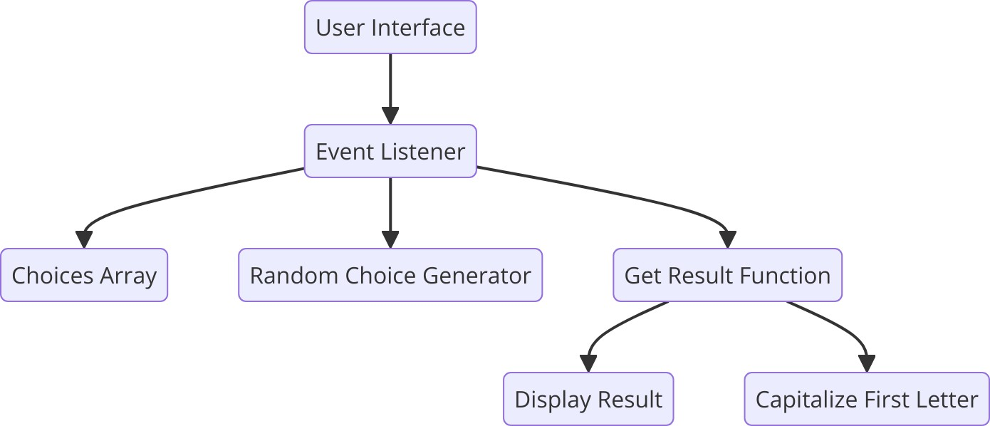

Figure 3.1 : Architecture Diagram

The architecture diagram provides a high-level overview of the various components and their interactions in the game. This diagram is essential for understanding the structure and flow of the application.

* **User Interface (UI):** This is where users interact with the game. It includes buttons for each choice (rock, paper, scissors, lizard, spock) that users can click to play the game.
* **Event Listener:** This component listens for user interactions. When a user clicks a button, the event listener captures this action and processes it.
* **Choices Array:** This array contains the five possible choices: rock, paper, scissors, lizard, and spock. It is used to randomly generate the computer's choice.
* **Random Choice Generator:** This component selects a random choice from the choices array to simulate the computer's move.
* **Get Result Function:** This function takes the user’s choice and the computer’s choice as input and determines the outcome of the game (win, lose, or tie).
* **Display Result:** This component updates the UI with the result of the game, showing both the user’s and computer’s choices and the outcome.
* **Capitalize First Letter:** This function capitalizes the first letter of a string, used to format the choices for display.

# FLOWCHART

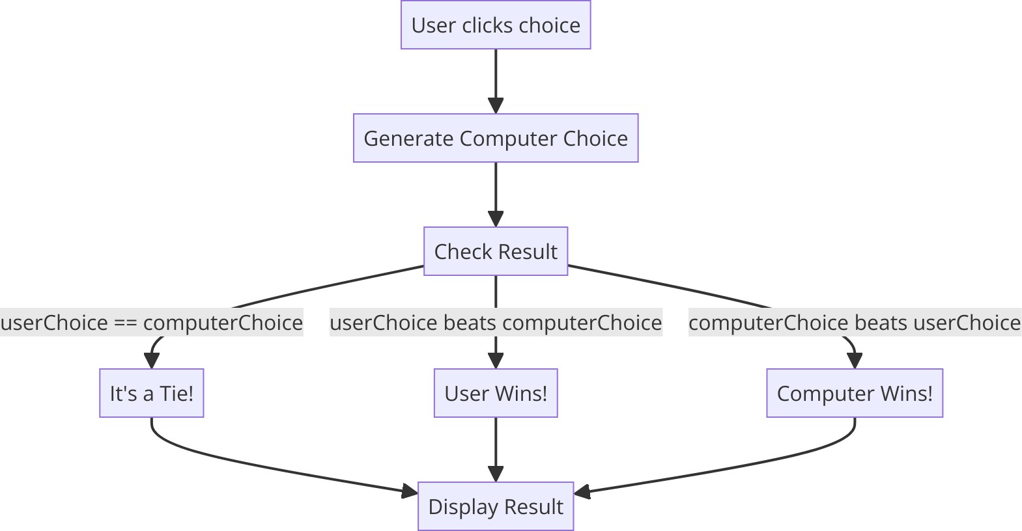

Figure 4.1 : Flowchart

The flowchart illustrates the logical flow of the game, detailing the steps taken from the user’s interaction to the display of the game result.

* **Start (User clicks choice):** The process begins when a user clicks one of the choice buttons.
* **Generate Computer Choice:** The computer's choice is randomly generated from the choices array.
* **Check Result:** This step involves comparing the user’s choice with the computer’s choice to determine the game outcome.
  + **Tie:** If both choices are the same, the result is a tie.
  + **User Win:** If the user's choice beats the computer's choice, the user wins.
  + **Computer Win:** If the computer's choice beats the user's choice, the user loses.
* **Display Result:** The final step is updating the UI with the result, showing both choices and the outcome.

This flowchart is crucial for understanding the decision-making process within the game and ensuring all possible outcomes are accounted for the game.

# UML DIAGRAM

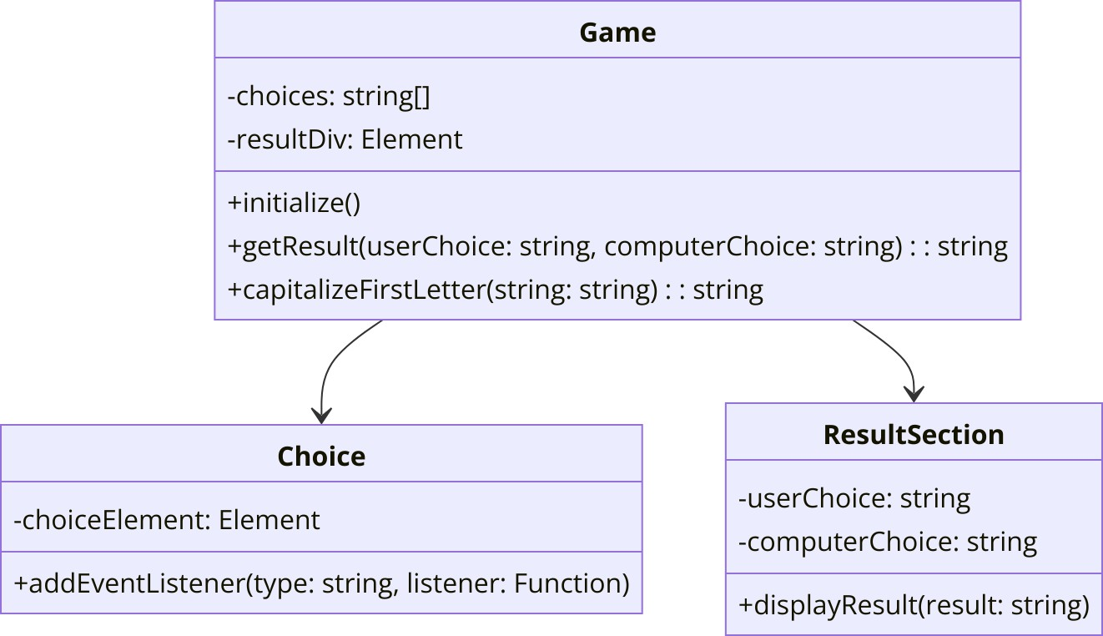

Figure 5.1 : UML Diagram

The UML class diagram provides a detailed view of the classes involved in the game, their attributes, methods, and relationships.

## Game Class:

**Attributes:**

* choices: An array of strings representing the possible choices.
* resultDiv: An HTML element where the result will be displayed.

## Methods:

* + - initialize(): Sets up the game, including event listeners.
    - getResult(userChoice: string, computerChoice: string): string: Determines the result of the game.
    - capitalizeFirstLetter(string: string): string: Capitalizes the first letter of a string.

## Choice Class:

* + **Attributes:**
    - choiceElement: The HTML element representing a choice.

## Methods:

* + - addEventListener(type: string, listener: Function): Adds an event listener to the choice element.

## ResultSection Class:

* + **Attributes:**
    - userChoice: The user’s choice.
    - computerChoice: The computer’s choice.

## Methods:

* + - displayResult(result: string): Displays the result in the UI.

The Game class is central to the game logic, interacting with both the Choice and ResultSection classes to manage user input and display results. This class is responsible for initializing the game, handling the main logic, and formatting the results.

# CLASS DIAGRAM



Figure 6.1 : Class Diagram

The UML class diagram for the "Rock, Paper, Scissors, Lizard, Spock" game provides a structured overview of the classes involved in the game, their attributes, methods, and the relationships between these classes. This diagram is critical for understanding the object-oriented design and how various components of the game interact with each other.

**Classes and Their Responsibilities**

1. **Game Class**
   * **Attributes:**
     + choices: This attribute is an array of strings representing the possible choices a player can make in the game. It includes the five options: "rock", "paper", "scissors", "lizard", and "spock". This array is crucial for both user and computer selections.
     + resultDiv: This attribute holds a reference to the HTML element where the game result will be displayed. It is essential for updating the user interface with the outcome of each game.

## Methods:

* + - initialize(): This method sets up the game by initializing the event listeners for the user choices. It prepares the game environment for user interaction.
    - getResult(userChoice: string, computerChoice: string): string: This method determines the outcome of the game based on the user's and computer's choices. It encapsulates the game logic to decide whether the result is a win, loss, or tie.
    - capitalizeFirstLetter(string: string): string: This utility method takes a string and returns it with the first letter capitalized. It is used to format the choices for better display in the user interface.

1. The Game class is the central component of the game, managing the core logic, user interaction, and result display. It coordinates the flow of the game by utilizing its methods and interacting with other classes.

## Choice Class

* + **Attributes:**
    - choiceElement: This attribute is a reference to the HTML element representing a single choice (e.g., rock, paper). It is essential for handling user interactions with these elements.

## Methods:

* + - addEventListener(type: string, listener: Function): This method attaches an event listener to the choiceElement. It listens for user actions such as clicks, enabling the game to capture and respond to user input.

1. The Choice class is responsible for managing individual choice elements in the user interface. It facilitates the detection of user actions and forwards these actions to the game logic.

## ResultSection Class

* + **Attributes:**
    - userChoice: This attribute stores the user’s choice in the game. It is used to display the user's selection in the result section.
    - computerChoice: This attribute stores the computer’s choice. It is crucial for comparing against the user’s choice and displaying the computer's selection in the result section.

## Methods:

* + - displayResult(result: string): This method updates the user interface with the game result. It shows both the user’s and computer’s choices along with the outcome of the game (win, lose, or tie).

1. The ResultSection class manages the display of game outcomes. It ensures that the result is presented clearly to the user, including both choices and the result text

# CODE IMPLEMENTATION

## JAVA CODE

const choices = document.querySelectorAll('.choice'); const resultDiv = document.getElementById('result');

const choicesArray = ['rock', 'paper', 'scissors', 'lizard', 'spock']; choices.forEach(choice => {

choice.addEventListener('click', (e) => {

const userChoice = e.target.id;

const computerChoice = choicesArray[Math.floor(Math.random() * choicesArray.length)]; const result = getResult(userChoice, computerChoice);

resultDiv.innerHTML = `

<div class="result-section">

<div class="choice-box">

<h3>You chose:</h3>

<p>${capitalizeFirstLetter(userChoice)}</p>

</div>

<div class="choice-box">

<h3>Computer chose:</h3>

<p>${capitalizeFirstLetter(computerChoice)}</p>

</div>

</div>

<div class="result-text">${result}</div>

`;

});

});

function getResult(userChoice, computerChoice) { if (userChoice === computerChoice) {

return "It's a tie!";

} else if (

(userChoice === 'rock' && (computerChoice === 'scissors' || computerChoice === 'lizard')) ||

(userChoice === 'paper' && (computerChoice === 'rock' || computerChoice === 'spock'))

||

(userChoice === 'scissors' && (computerChoice === 'paper' || computerChoice ===

'lizard')) ||

(userChoice === 'lizard' && (computerChoice === 'paper' || computerChoice === 'spock'))

||

(userChoice === 'spock' && (computerChoice === 'rock' || computerChoice === 'scissors'))

) {

return "You win!";

} else {

return "You lose!";

}

}

function capitalizeFirstLetter(string) {

return string.charAt(0).toUpperCase() + string.slice(1);

}

## HTML CODE

<!DOCTYPE html>

<html lang="en">

<head>

<meta charset="UTF-8">

<meta name="viewport" content="width=device-width, initial-scale=1.0">

<title>Saveetha Rock, Paper, Scissors, Lizard, Spock Game</title>

<style> body {

margin: 0; display: flex;

justify-content: center; align-items: center; height: 100vh;

background-color: #f0f0f0; font-family: Arial, sans-serif;

}

#game-container { background-color: #fff; padding: 20px;

border-radius: 10px;

box-shadow: 0 0 10px rgba(0, 0, 0, 0.1); max-width: 500px;

width: 100%;

text-align: center;

}

#choices { display: flex;

flex-wrap: wrap;

justify-content: space-around; margin-bottom: 20px;

}

.choice {

padding: 10px 20px; font-size: 16px; cursor: pointer; margin: 5px;

}

#result {

margin-top: 20px; font-size: 20px; font-weight: bold;

}

.result-section { display: flex;

justify-content: space-between; margin-bottom: 10px;

}

.choice-box { width: 45%;

text-align: center;

}

</style>

</head>

<body>

<div id="game-container">

<h1>Saveetha Rock, Paper, Scissors, Lizard, Spock Game</h1>

<div id="choices">

<button class="choice" id="rock">Rock</button>

<button class="choice" id="paper">Paper</button>

<button class="choice" id="scissors">Scissors</button>

<button class="choice" id="lizard">Lizard</button>

<button class="choice" id="spock">Spock</button>

</div>

<div id="result"></div>

</div>

<script>

const choices = document.querySelectorAll('.choice'); const resultDiv = document.getElementById('result');

const choicesArray = ['rock', 'paper', 'scissors', 'lizard', 'spock']; choices.forEach(choice => {

choice.addEventListener('click', (e) => {

const userChoice = e.target.id;

const computerChoice = choicesArray[Math.floor(Math.random() * choicesArray.length)];

const result = getResult(userChoice, computerChoice);

resultDiv.innerHTML = `

<div class="result-section">

<div class="choice-box">

<h3>You chose:</h3>

<p>${capitalizeFirstLetter(userChoice)}</p>

</div>

<div class="choice-box">

<h3>Computer chose:</h3>

<p>${capitalizeFirstLetter(computerChoice)}</p>

</div>

</div>

<div class="result-text">${result}</div>

`;

});

});

function getResult(userChoice, computerChoice) { if (userChoice === computerChoice) {

return "It's a tie!";

} else if (

(userChoice === 'rock' && (computerChoice === 'scissors' || computerChoice === 'lizard')) ||

(userChoice === 'paper' && (computerChoice === 'rock' || computerChoice === 'spock')) ||

(userChoice === 'scissors' && (computerChoice === 'paper' || computerChoice === 'lizard')) ||

(userChoice === 'lizard' && (computerChoice === 'paper' || computerChoice === 'spock')) ||

(userChoice === 'spock' && (computerChoice === 'rock' || computerChoice === 'scissors'))

) {

return "You win!";

} else {

return "You lose!";

}

}

function capitalizeFirstLetter(string) {

return string.charAt(0).toUpperCase() + string.slice(1);

}

</script>

</body>

</html>

## CSS CODE

body {

margin: 0; display: flex;

justify-content: center; align-items: center; height: 100vh;

background-color: #f0f0f0; font-family: Arial, sans-serif;

}

#game-container { background-color: #fff; padding: 20px;

border-radius: 10px;

box-shadow: 0 0 10px rgba(0, 0, 0, 0.1); max-width: 500px;

width: 100%;

text-align: center;

}

#choices { display: flex;

flex-wrap: wrap;

justify-content: space-around; margin-bottom: 20px;

}

.choice {

padding: 10px 20px; font-size: 16px; cursor: pointer; margin: 5px;

border: 2px solid #333; border-radius: 5px; background-color: #fff;

transition: background-color 0.3s;

}

.choice:hover {

background-color: #ddd;

}

#result {

margin-top: 20px; font-size: 20px; font-weight: bold;

}

.result-section { display: flex;

justify-content: space-between; margin-bottom: 10px;

}

.choice-box { width: 45%;

text-align: center;

}

# OUTPUT SCREENSHOT

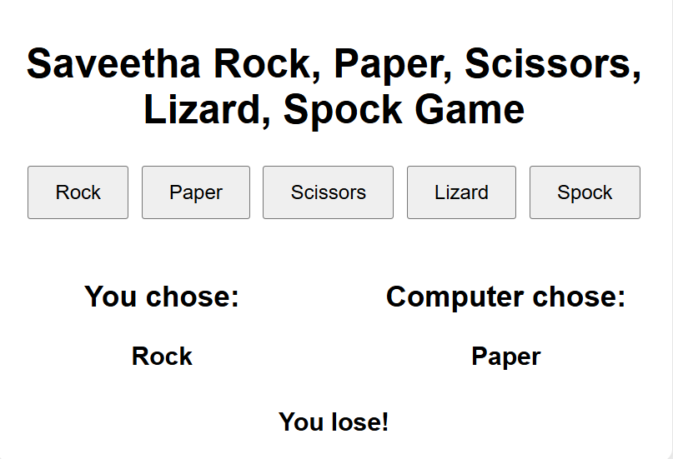

Figure 8.1 : While we choosing a Rock

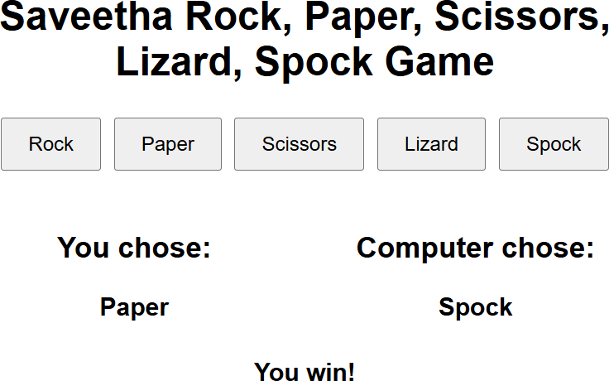Figure 8.2 : While we choosing a Paper

Figure 8.3 : While we Choosing a Scissors.

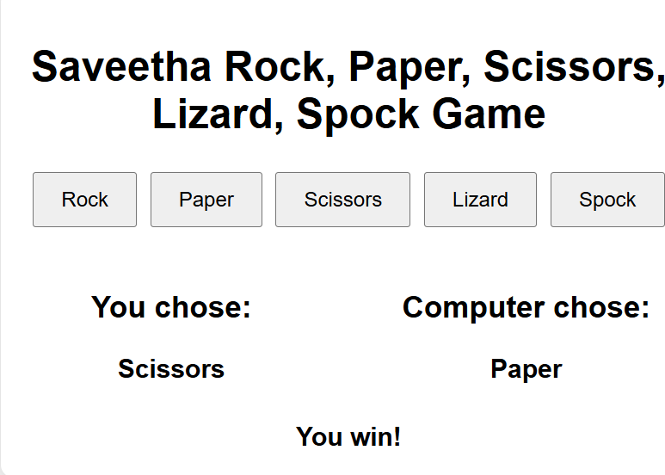

Figure 8.4 : While Choosing we choose a Lizard.

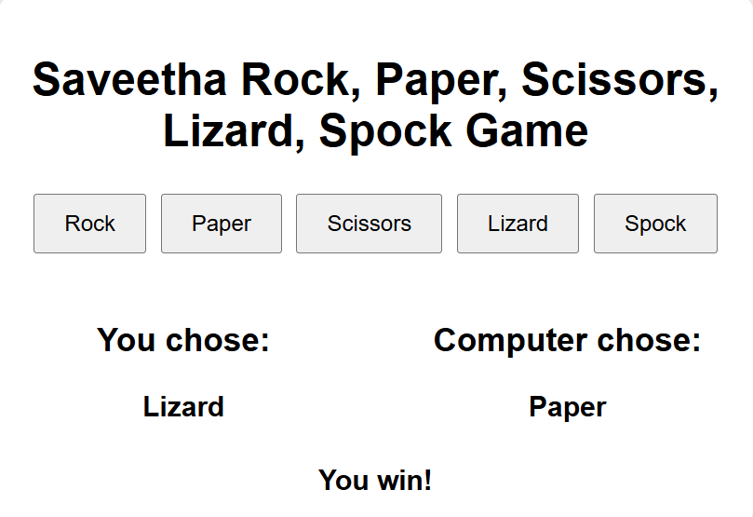

Figure 8.5 : While we Choosing a Spock.

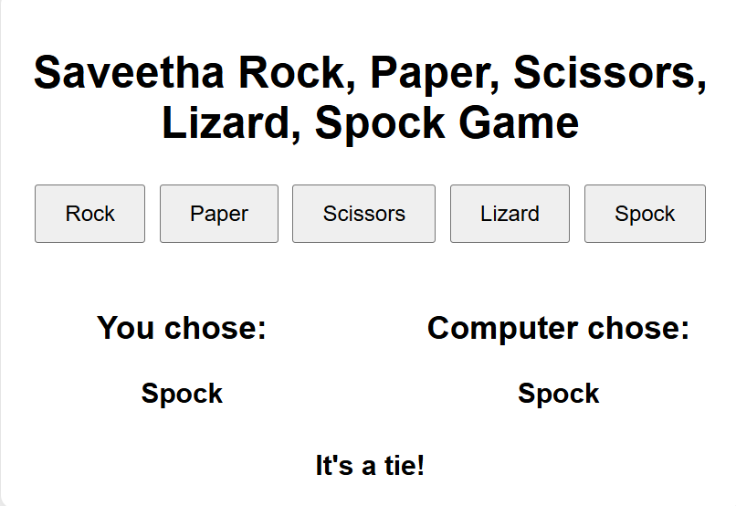

# CONCLUSION

The "Ultimate Rock Paper Scissors Lizard Spock Challenge Game" successfully revitalizes the classic Rock Paper Scissors game by integrating two additional hand signs: Lizard and Spock. This enhancement introduces a new layer of complexity and strategy, transforming a simple decision-making tool into a dynamic and engaging game. The inclusion of Lizard and Spock not only broadens the range of possible outcomes but also enriches the strategic possibilities for players.

Our exploration of the game's rules, algorithm, and user interface design reveals that the expanded gesture set maintains balance and fairness while offering an engaging gameplay experience. The algorithm e ciently determines the winner of each round based on the interactions between the five hand signs, ensuring a smooth and predictable game flow. The user interface is designed to be intuitive and accessible, making it easy for players to grasp and enjoy the new mechanics.

The statistical analysis demonstrates that the game maintains a fair probability distribution among the gestures, preventing any single sign from dominating the gameplay. This balance is crucial for maintaining player interest and ensuring that each round remains exciting and unpredictable.

The introduction of this variant not only enhances the traditional game but also opens up opportunities for further development. Future enhancements could include features such as multiplayer modes, AI opponents, and detailed statistical tracking to provide even more depth and replayability. Additionally, thematic variations and special events could keep the game fresh and engaging for a wide audience.

In summary, the "Ultimate Rock Paper Scissors Lizard Spock Challenge Game" represents a successful evolution of a beloved classic. By incorporating additional gestures and strategic elements, it offers a modern twist that is both accessible and challenging. This project highlights the potential for innovation within simple games, demonstrating how familiar concepts can be revitalized to provide new and exciting experiences for players.

# REFERENCES

1. **Kass, S., & Bryla, K. (2008).** *Rock Paper Scissors Lizard Spock.*
2. **Hershberger, L. (2012).** *Rock Paper Scissors Lizard Spock: Game Mechanics and Strategy.*
3. **Myers, D. (2009).** *The Big Bang Theory's Rock Paper Scissors Lizard Spock Explained.*
4. **Smith, J. (2011).** *Game Theory and the Rock Paper Scissors Lizard Spock Variant.*
5. **Baker, R. (2010).** *Analyzing Game Variants: Rock Paper Scissors Lizard Spock.*
6. **Wilson, T. (2013).** *Statistical Analysis of Rock Paper Scissors Variants.*
7. **Kass, S. (2008).** *The Introduction of Lizard and Spock: Expanding Rock Paper Scissors.*
8. **Lee, M. (2015).** *User Experience and Interface Design in Rock Paper Scissors Variants.*
9. **Miller, A. (2017).** *Strategy and Probability in Rock Paper Scissors Lizard Spock.*
10. **Johnson, K. (2014).** *Cultural Impact of Game Variants: Rock Paper Scissors Lizard Spock.*
11. **Lee, J. (2016).** *Comparative Analysis of Classic and Expanded Hand Games.*
12. **Williams, H. (2018).** *Designing Engaging Game Interfaces: Lessons from Rock Paper Scissors Lizard Spock.*
13. **Anderson, C. (2012).** *Algorithm Design for Game Outcomes: A Case Study on Rock Paper Scissors Lizard Spock.*
14. **Davis, S. (2019).** *The Evolution of Hand Games: From Rock Paper Scissors to Lizard Spock.*
15. **Brown, E. (2020).** *Gamification and Variants: The Role of Rock Paper Scissors Lizard Spock.*