ADAPTIVE MARKET INTELLIGENCE
Indian Index F&O Research, Decision & Execution Platform
FINAL ARCHITECTURE + HLD + LLD + STEP-BY-STEP BUILD ROADMAP
Architecture principle: Parallel intelligence, centralized capital/risk/execution. Stable platform contracts; expandable trading intelligence.

Scope: NIFTY • BANKNIFTY • SENSEX | CE/PE option buying first | Research → Replay → Paper → Shadow → Controlled Live
Version 2.0 — Architecture Freeze Candidate

1. Executive Summary
We are building a production-grade, AI-assisted quantitative F&O platform for Indian index options. The platform continuously observes NIFTY, BANKNIFTY and SENSEX, evaluates both CE and PE opportunities across relevant expiries/strikes, compares opportunities globally, applies independent capital/risk/safety controls, executes through broker adapters, reconciles broker truth, and learns through a controlled research lifecycle. It is deliberately not a simple indicator bot and not an autonomous self-modifying live trader.
Primary objective: Discover and exploit durable, repeatable edge only when it survives realistic costs, temporal validation, replay and live paper/shadow evidence. Profit is an outcome; reproducibility, safety and decision quality are engineering requirements.

What the platform should do during market hours
- Process market and option-chain events continuously rather than waiting for sequential chart analysis.
- Maintain simultaneous multi-timeframe state for each monitored index and its relevant CE/PE contracts.
- Run cheap filtering first, then deep analysis only on serious option candidates.
- Compare NIFTY, BANKNIFTY and SENSEX opportunities using remaining move, option economics, liquidity, correlation and portfolio impact.
- Produce BUY CE, BUY PE, WAIT, NO TRADE, REDUCE, EXIT or UNCERTAIN decisions with reason codes.
- Allow independent risk and a minimal Safety Kernel to veto any trade regardless of strategy confidence.
- Persist enough lineage to reproduce why every trade, skip, rejection and exit happened.

Document Map
Section | Purpose
2 | Non-negotiable design principles
3 | High-Level Architecture
4 | Real-time parallel market scanning
5 | Low-Level component design
6 | Domain contracts and state machines
7 | Data architecture and point-in-time correctness
8 | Performance and efficiency architecture
9 | Risk, safety and execution
10 | Research, validation and continuous improvement
11 | Testing and fault architecture
12 | AWS V1 and production evolution
13 | Security, compliance and operations
14 | Step-by-step build roadmap P0–P19
15 | Immediate next actions and architecture freeze checklist

2. Non-Negotiable Design Principles
Principle | Meaning
No future information | Every decision is valid only from information available at its as_of timestamp. No look-ahead, future option snapshots or hidden forward-fill leakage.
Parallel intelligence, centralized control | Multiple markets/timeframes/options are analysed concurrently, but capital, risk and execution remain coordinated in one portfolio brain.
Raw data is immutable | Original market events are append-only. Normalized/features/models are versioned derivatives.
Risk is independent | Strategies propose opportunities; risk may approve, resize, reject, reduce, exit or halt.
Safety is simpler than intelligence | The Safety Kernel contains hard deterministic checks only. No ML/LLM or adaptive relaxation of hard limits.
NO TRADE is first-class | Doing nothing is correct when edge, data quality, option economics or risk are insufficient.
Research never directly trades | LLMs, notebooks and research agents can create candidate artifacts only. Promotion to live requires explicit gates.
Broker/cloud are adapters | Domain logic must not depend directly on one broker SDK or cloud provider.
Idempotent execution | A timeout is UNKNOWN, not an invitation to blindly resend. Reconcile before retrying.
Same core logic across modes | Backtest/replay/paper/live should share domain logic; clocks, feeds and execution adapters change.
Complexity is earned | Add strategies, features, services, ML or HA only when measured value justifies complexity.
Architecture stable; intelligence expandable | Freeze contracts/state machines/safety boundaries, not trading hypotheses or feature choices.

3. High-Level Architecture (HLD)
The platform is organized as logical planes. These are architectural boundaries, not necessarily separate microservices. In V1 the latency-critical path should remain in one process where practical.
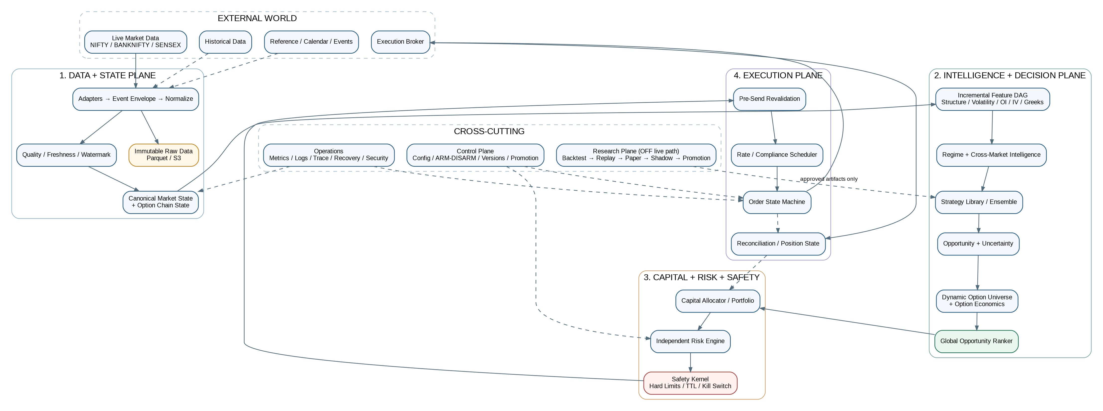
Figure 1 — Overall platform HLD: data/state → intelligence/decision → capital/risk/safety → execution, surrounded by control, operations and research.

Logical planes
Plane | Owns
Data + State | Adapters, event envelope, normalization, quality, freshness, watermark, reference data, raw recording, canonical market and option state.
Intelligence | Incremental features, market structure, swings/SR, volatility, OI/IV/Greeks, time-of-day, events, regimes and cross-market state.
Decision | Strategies, ensemble/conflict resolution, opportunity/uncertainty, expected value, option intelligence and global opportunity ranking.
Capital + Risk + Safety | Capital budget, portfolio exposure, correlation/Greeks, risk decision, hard safety kernel and kill-switch hierarchy.
Execution | Pre-send validation, regulatory/API scheduling, order state machine, fills, positions, reconciliation and transaction-cost analysis.
Control + Operations | Config/version authority, environment, ARM/DISARM, releases, audit, observability, recovery, credentials, compliance and security.
Research + Learning | Experiments, backtests, walk-forward, holdout, replay, paper, shadow, counterfactual analysis, TCA and champion/challenger evaluation.

4. Real-Time Parallel Market Scanning
The runtime does not finish NIFTY analysis and then move to BANKNIFTY and SENSEX. It maintains all monitored markets continuously, updates only affected state/features, evaluates CE and PE candidates in parallel, then sends the best risk-adjusted opportunities to one centralized portfolio/risk brain.
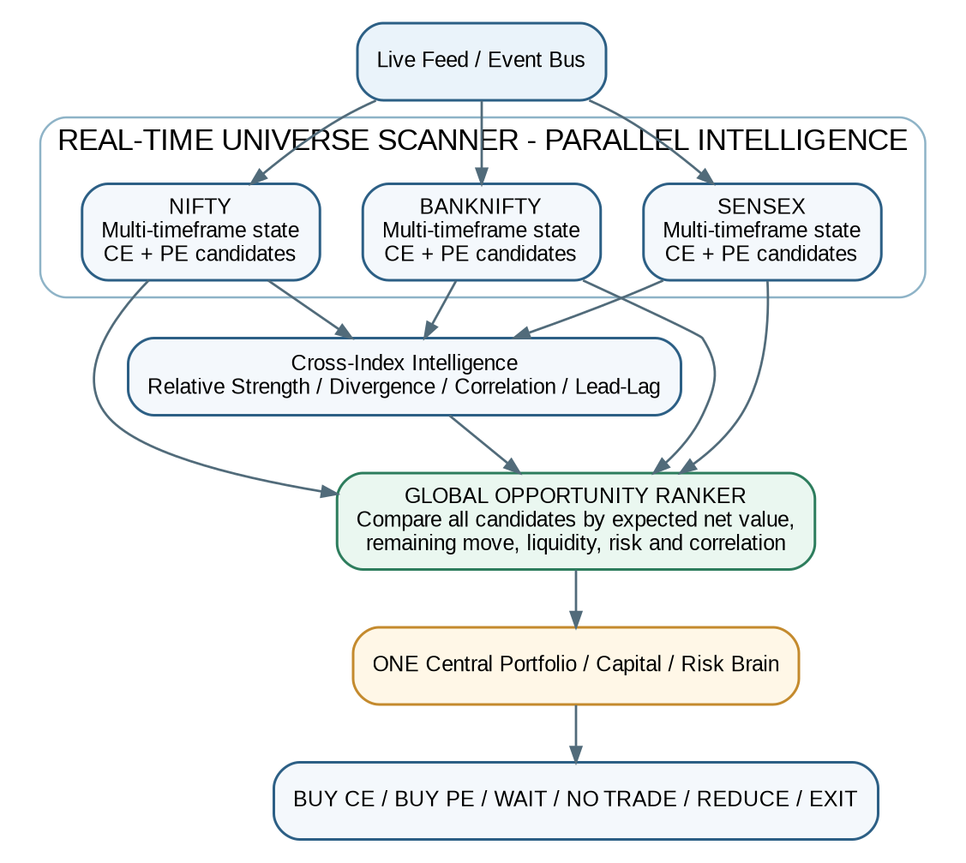
Figure 2 — Parallel intelligence across NIFTY, BANKNIFTY and SENSEX with centralized opportunity ranking and risk.

RealTimeUniverseScanner
- Maintains current multi-timeframe state for each index.
- Maintains bullish and bearish opportunity context without assuming direction first.
- Tracks a dynamically reduced option universe: relevant expiries, strike windows, delta/moneyness ranges and liquidity constraints.
- Publishes MarketOpportunitySnapshot updates only when relevant state changes.
- Separates data confidence from signal confidence and can mark a market temporarily untradable.

GlobalOpportunityRanker
The ranker compares candidates across indices and option sides. It does not simply select the largest signal score. It considers expected remaining move, move already travelled, regime compatibility, option response, IV/theta, spread/slippage, liquidity, expiry/time-of-day, current portfolio, correlation and confidence. A globally strong signal may still be rejected if all available options have poor economics.

5. Low-Level Design — Core Components
Component | Input | Output | State | Can transmit order?
MarketDataAdapter | Provider feed / subscriptions | Canonical market events | Connection/feed health | No
ReferenceDataAdapter | Instrument/calendar source | Effective-dated reference records | Reference cache | No
Normalizer | Provider events | Canonical event envelope | Minimal mapping | No
DataQualityEngine | Canonical events | Quality verdict + reason codes | Quality state | No
WatermarkEngine | Timestamped market state | Freshness/completeness state | Yes | No
MarketStateEngine | Validated events | Immutable-as-of snapshots | Hot state | No
FeatureEngine | Market state + dependency DAG | FeatureVector | Incremental caches | No
Structure/Regime | Features + state | StructureState / RegimeState | Transition state | No
StrategyEngine | Decision context | SignalCandidate(s) | Strategy state | No
EnsembleResolver | Signals + strategy health | Consolidated hypothesis | Weights/health | No
OpportunityEngine | Hypothesis + market state | OpportunityDecision | Move lifecycle | No
OptionUniverseManager | Spot/expiry/liquidity state | Eligible contracts | Subscription universe | No
OptionIntelligence | Opportunity + chain | OptionCandidate(s) | Chain analytics | No
GlobalOpportunityRanker | Cross-index candidates | Ranked opportunities | Minimal | No
CapitalAllocator | Portfolio + candidates | Trade risk budget | Allocation state | No
RiskEngine | Candidate + portfolio + limits | RiskDecision | Risk state | No
SafetyKernel | Approved risk + live safety state | ALLOW / REJECT / EXIT_ONLY / HALT | Hard state | No
ExecutionPlanner | Approved candidate | Executable intent | Minimal | No
OrderManager | Executable intent | Order lifecycle | Durable | YES
Reconciler | Internal + broker truth | ReconciliationResult | Durable | No
TCA/PnL Attribution | Decision/order/fill history | Execution + edge attribution | Analytical | No

Critical rule: Only OrderManager through ExecutionBrokerAdapter can transmit a broker order. Strategy, opportunity, option, capital, risk, LLM and research code cannot.

6. Domain Contracts and State Machines

6.1 Canonical Event Envelope
Field group | Required fields
Identity | event_id, event_type, schema_version, source, source_instance
Instrument | instrument_id, underlying, exchange/segment when applicable
Causality | correlation_id, causation_id, sequence_number
Time | ts_exchange, ts_broker (if available), ts_received, ts_processed, monotonic_receive_ns
Quality | quality_state, freshness, completeness flags
Payload | payload, payload_hash, provider-specific raw reference
Environment | dev/backtest/replay/paper/shadow/live

6.2 Core immutable decision contracts
Contract | Minimum content
MarketStateSnapshot | snapshot_id, as_of, watermark, quotes, candles, option state, structure, regime context, data quality, versions
FeatureVector | feature_version, as_of, values, input state ID, lineage metadata
SignalCandidate | signal_id, strategy/version, direction, setup, horizon, expected-move distribution, invalidation, confidence, reasons
OpportunityDecision | BUY_CE/BUY_PE/WAIT/NO_TRADE/UNCERTAIN, expected move, remaining move, stage, EV before/after cost, chasing/exhaustion risk
OptionCandidate | contract, expiry/strike/type, Greeks, IV, spread/depth, OI/volume, expected response, estimated costs, net EV
CapitalAllocation | portfolio risk budget, strategy/index allocation, requested trade budget, correlation adjustment
RiskDecision | APPROVE/RESIZE/REJECT/REDUCE/EXIT/HALT, approved quantity, estimated loss, exposures, hard-limit results, risk config version
OrderIntent | intent_id, client_order_id/idempotency key, contract, qty, type, price/trigger, decision TTL, versions
DecisionRecord | trace from raw state → signal → opportunity → option → risk → execution with reason codes and timing

6.3 System lifecycle
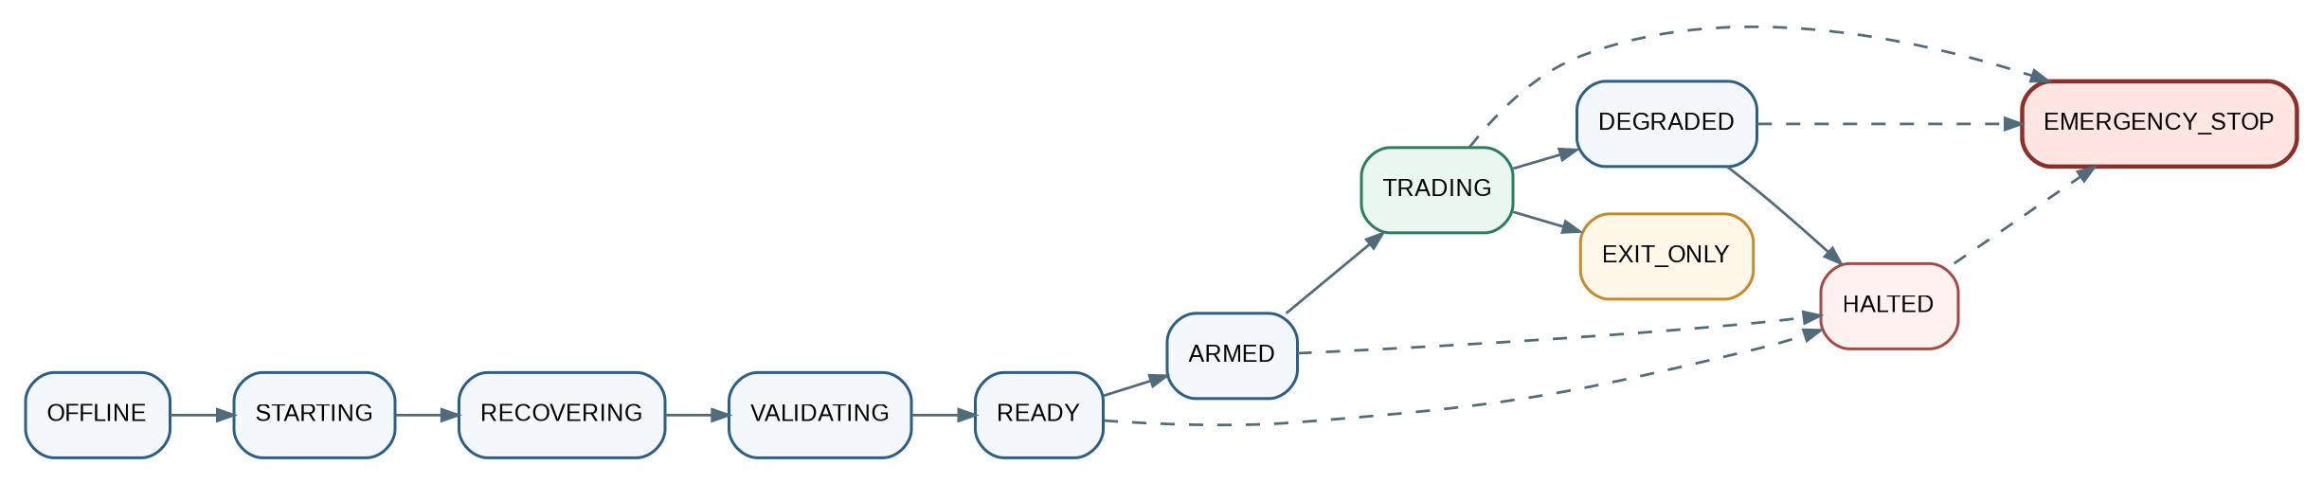
Figure 3 — Runtime lifecycle. Trading is never enabled directly from process start.

6.4 Order lifecycle
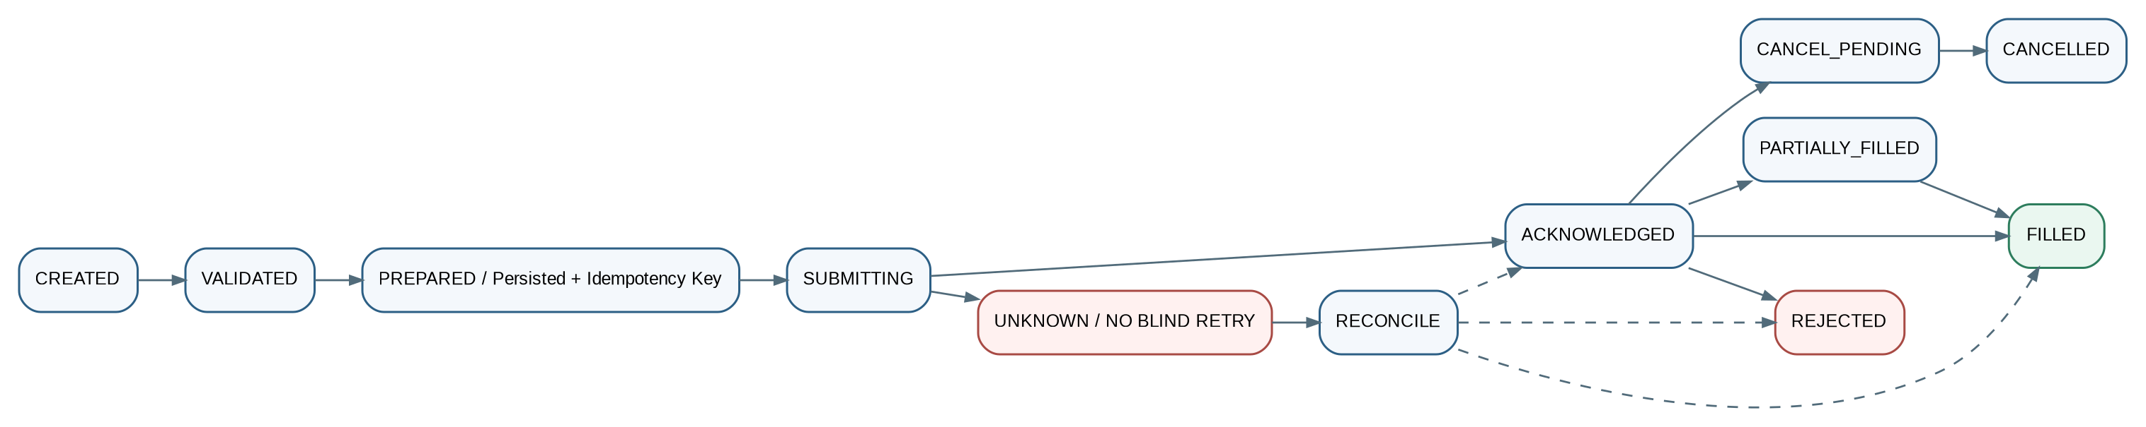
Figure 4 — Idempotent order lifecycle. UNKNOWN requires reconciliation before any retry.

7. Data Architecture and Point-in-Time Correctness

7.1 Storage tiers
Tier | Technology | Purpose
Raw immutable | Parquet on local/S3 | Original market/option/broker events, append-only, checksummed.
Analytical | Parquet + DuckDB | Historical scans, joins, feature research, backtests and reports.
Transactional | PostgreSQL | Configs, versions, experiments, decisions, orders, fills, positions, audit, reconciliation.
Hot state | In-memory + Redis | Latest quotes, state snapshots, idempotency keys, locks, ephemeral runtime state.
Metrics | Prometheus | Latency, freshness, queues, broker health, risk/system gauges.
Dashboard | Grafana | Operational and trading observability only; never a dependency of the hot path.

7.2 Point-in-time option-chain reconstruction
Full option snapshots on every tick are wasteful. The preferred design is periodic full checkpoints plus incremental quote/OI/IV/Greeks deltas. Replay reconstructs the chain state valid at time T from the latest checkpoint plus only deltas received by T.
Invariant: A decision at time T must never use an option-chain value that arrived after T, even if that later value belongs to the same exchange timestamp.

7.3 Watermark and freshness state
- Track age of required quotes by instrument/contract rather than one global feed age.
- Record oldest required event, newest event, chain completeness and source divergence.
- Allow high signal confidence + low data confidence to resolve to NO TRADE.
- Use monotonic time for latency durations and wall/exchange time for event chronology.
- Reference data, fees, lot sizes, expiry calendars and compliance rules must be effective-dated.

7.4 Feature lineage
Every material feature should be traceable to implementation/version, dataset/reference version, instrument, exact input timestamps and source. A live trade should be reconstructable backwards: Trade → RiskDecision → OptionCandidate → Opportunity → Signal → Regime/Structure → FeatureVector → MarketState → Raw Events.

8. Performance and Efficiency Architecture
Figure 5 — Hot path: lean event-driven processing, incremental state and only affected computations.

8.1 Hot / warm / cold paths
Path | Examples | Rule
HOT | quotes, state, incremental features, signal, option economics, risk, execution | Low latency; bounded work; no large DB queries/LLM/training.
WARM | structure enrichment, strategy health, TCA, PnL attribution, noncritical analytics | May lag modestly; cannot block execution.
COLD | backtests, ML training, large DuckDB scans, reports, LLM research | Completely off live order path.

8.2 Feature Dependency DAG
New events invalidate only dependent nodes. A tick updates quote/current candle; a 1-minute close updates 1-minute features; a swing change updates structure/Fibonacci; deep option ranking runs only when an underlying opportunity is viable. This avoids recalculating every timeframe and indicator on every tick.

8.3 Dynamic option universe
- Start from complete instrument master, but subscribe/analyse deeply only relevant expiries and strike windows.
- Use cheap liquidity/moneyness/delta filters before expensive Greeks/EV/ranking logic.
- Adapt the candidate window as spot, volatility and expiry conditions change.
- Record why a contract was excluded so research can detect over-filtering.

8.4 Backpressure
Queues must be bounded. Intermediate market quote updates may be coalesced when safe, but order, fill, risk, kill-switch and reconciliation events are never dropped. Monitor queue depth, event lag, processing lag and coalesced/dropped market updates.

9. Capital, Risk, Safety and Execution

9.1 Capital hierarchy
Capital allocation is separate from signal generation: Total Capital → Portfolio Risk Budget → Index/Strategy Allocation → Opportunity Budget → Position Size. Correlated NIFTY/BANKNIFTY/SENSEX signals are treated as shared directional exposure, not three independent bets.

9.2 Safety Kernel — final gate
- Trading/system state permits new risk.
- Decision has not exceeded valid_until / market-age TTL.
- Required data is fresh and complete.
- No unresolved broker/internal mismatch or UNKNOWN order risk.
- Hard quantity/notional/daily loss/portfolio limits pass.
- Credentials/broker session are valid.
- Regulatory/broker rate budget is available.
- Kill-switch hierarchy allows this instrument/strategy/order.
Pre-send revalidation: Immediately before transmission, re-check current option bid/ask, spread, liquidity, underlying movement, remaining opportunity, portfolio exposure, open orders, risk limits, TTL and kill switches. If economics changed materially, cancel the intent.

9.3 Kill-switch hierarchy and degradation
Layer / mode | Examples
Hierarchy | GLOBAL → ENVIRONMENT → BROKER → PORTFOLIO → STRATEGY → INSTRUMENT → ORDER
HEALTHY | Full capability.
DEGRADED | Reduced features/capability but safety intact.
EXIT_ONLY | No new risk; manage/close existing positions.
HALTED | No automated trading until investigation/recovery.
EMERGENCY | Cancel/close according to predefined emergency policy.

9.4 Execution semantics
Use PREPARE → PERSIST → SEND → ACK/UNKNOWN → RECONCILE semantics. Exactly-once execution across PostgreSQL and an external broker is not assumed. Idempotency keys and reconciliation provide safety. Partial fills immediately update real position/risk state.

10. Research, Validation and Continuous Improvement
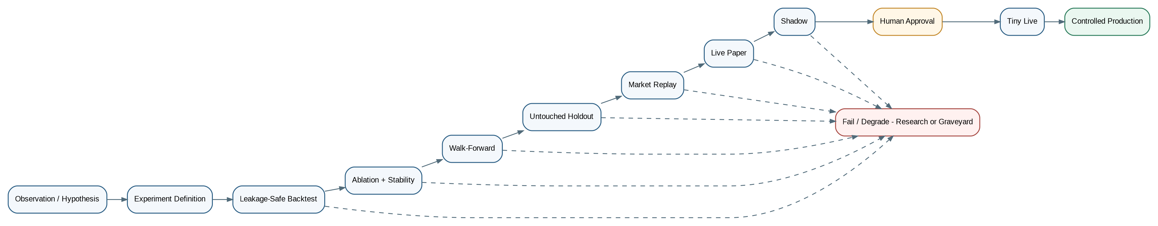
Figure 6 — Promotion ladder. Research artifacts can reach capital only through validation and explicit approval gates.

10.1 Baseline first
EMA 14/20 + RSI 14/20 with the original multi-timeframe idea is Strategy Baseline V0, not a belief. Fibonacci, volume profile, OI, Greeks, breadth, futures basis, ML and every other feature remain research hypotheses until they add stable out-of-sample value after realistic costs.

10.2 Experiment discipline
- Every experiment gets ID, hypothesis, allowed parameter space, code/data/feature/model/config versions and train/validation/holdout periods.
- No random cross-validation for time series by default; use temporal splits, walk-forward and gaps/embargo where relevant.
- Use ablation to prove incremental value, not just total strategy profitability.
- Protect final holdout from repeated tuning and record failed strategies in a Strategy Graveyard.
- Track calibration/Brier score for probabilistic outputs and distinguish data drift from concept drift.
- Use future-mutation leakage tests: alter all data after decision time; the earlier decision must not change.

10.3 Champion / Challenger
The approved champion may trade. Challengers consume the same live data in paper/shadow, producing hypothetical decisions for comparison. Neither research agents nor challengers may automatically replace the champion or increase live risk.

10.4 Edge and P&L decomposition
Attribute results to direction/timing edge, option selection, IV effect, theta, spread, slippage, execution delay, fees and exit timing. This tells us which subsystem adds value and prevents optimizing the wrong component.

11. Testing, Fault Injection and Recovery

11.1 Test pyramid
Layer | Examples | Blocking?
Unit | Indicators, fees, swings, sizing, state transitions | YES
Property / invariants | No negative qty; no risk bypass; no future read; idempotent duplicate intent | YES
Contract | Broker/data adapter schemas and capability behavior | YES
Integration | PostgreSQL/Redis/object store/mock broker/WebSocket reconnect | YES
Regression / golden | Known day produces identical decisions for frozen code/data/config | YES
Backtest correctness | time ordering, costs, fills, holdout/walk-forward | YES
Replay | historical event stream through production-like interfaces | YES
Fault / chaos | disconnects, timeouts, partial fills, restart, DB/cache/disk/network faults | YES
Full-session paper/shadow | normal market day without manual intervention | YES

11.2 Required fault scenarios
- WebSocket disconnect/reconnect, duplicate/missing/out-of-order ticks and stale/incomplete option chains.
- Broker timeout, slow acknowledgement, reject, partial fill, cancel/modify failure and rate-limit exhaustion.
- Database unavailable, Redis unavailable, disk full, S3 unavailable, network partition and process/VM restart.
- Wrong system clock, expired/invalid credentials, unexpected broker position/order and internal/broker mismatch.
- Future HA: two execution nodes attempting leadership; fencing must prevent split-brain execution.

11.3 Recovery architecture
Figure 7 — Recovery is checkpoint + durable events + broker truth + reconciliation, never blind resume.

12. AWS V1 Deployment and Production Evolution
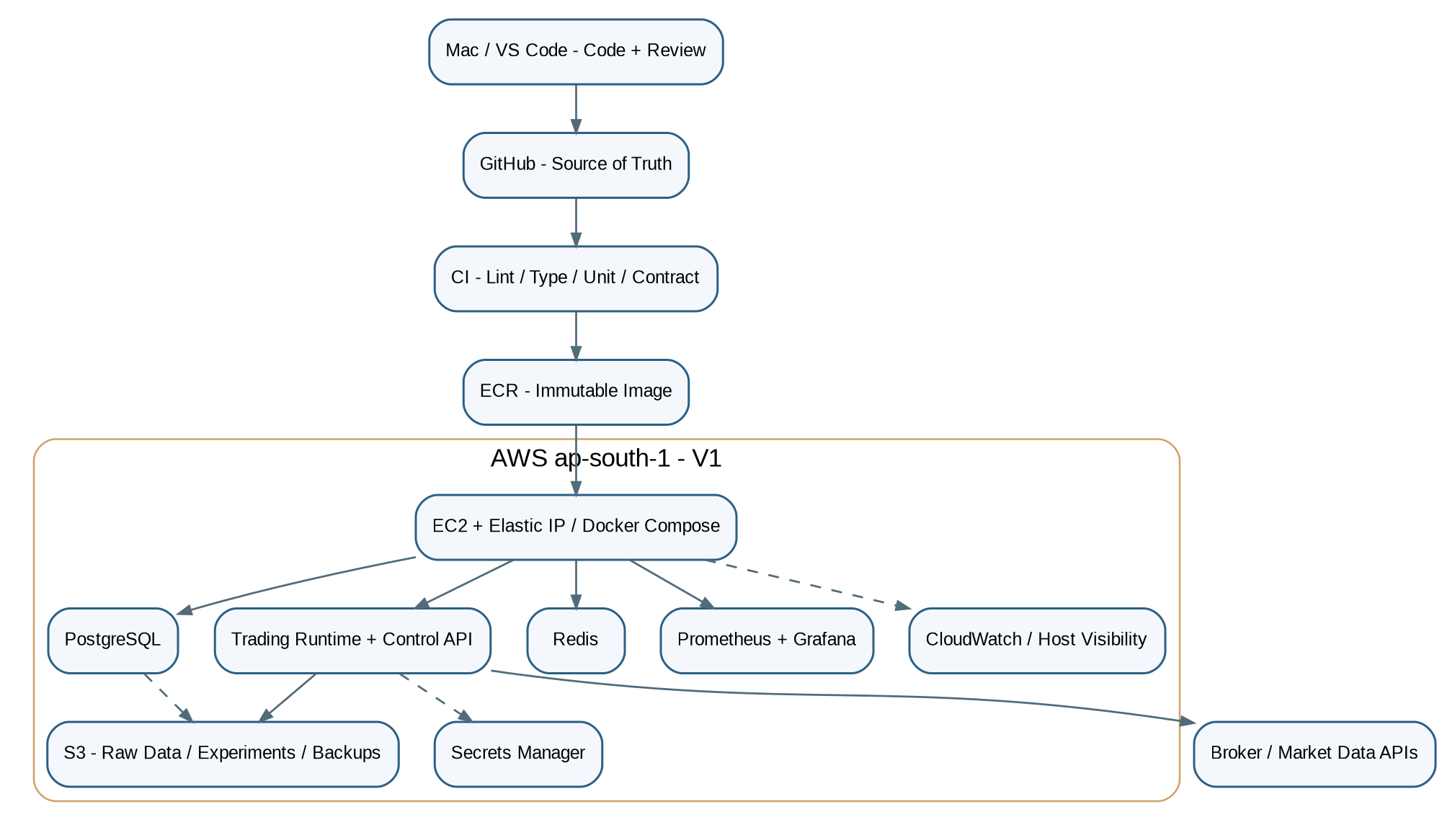
Figure 8 — Lean AWS V1: one start/stop-capable EC2 runtime, ECR, S3, Secrets Manager and basic visibility.

12.1 V1 rules
- Mac is the development/control machine; GitHub is source of truth; no manual live file edits on EC2.
- Build immutable container images and deploy by digest/tag through a controlled release path.
- Use EC2 + EBS + S3 + ECR + Secrets Manager + CloudWatch first; PostgreSQL/Redis may initially run in Docker Compose.
- Use a stable outbound/public IP design when broker/exchange API requirements require it.
- Do not add Kubernetes, Kafka, RDS, ElastiCache, ALB, NAT Gateway or multi-region HA until measured need justifies cost/complexity.

12.2 Future HA rule
Redundant execution must be leader/standby with fencing. A standby never starts trading merely because the leader disappeared; it first acquires leadership, queries broker truth, reconstructs/reconciles state, passes readiness checks, then execution may be armed.

13. Security, Compliance and Operations

13.1 Environment and credential boundaries
Environment | Real orders? | Credentials / purpose
dev | NO | Synthetic fixtures, unit/integration only
backtest | NO | Historical datasets only
replay | NO | Historical event stream through live-like contracts
paper | NO | Real-time data + simulated fills
shadow | NO | Complete live decisions/order intents but never transmitted
live | YES | Separate production credentials; explicit ARM required

13.2 Compliance and broker capability profile
Do not hardcode current broker/exchange rules into strategy code. Maintain effective-dated capability/compliance metadata: supported order types, API/session rules, rate limits/order budgets, static-IP requirements if applicable, algo/order identifiers, audit retention and reference source. Execution validates the active profile before transmission.

13.3 Operator controls
- ARM, DISARM, EXIT_ONLY, HALT, CANCEL_PENDING and FLATTEN are privileged, authenticated and audited.
- Dangerous changes such as ENABLE_LIVE, increasing hard limits or disabling a safety rule require explicit confirmation and old/new-value audit.
- Pre-market readiness validates clock, calendar, instruments, feed, option chain, broker, reconciliation, capital, config, risk, data recorder and alerts before ARM.
- Post-market disables new entries, reconciles, flushes data, generates quality/TCA/risk/strategy-health reports, backs up and DISARMs.

14. Step-by-Step Build Roadmap — What We Build From Now
This is the implementation order. Do not skip ahead to advanced strategy tuning or live broker execution. Each phase has an exit gate; the next phase starts only when the previous gate is satisfied.
Phase | Build inside this phase | Deliverable | Exit gate
P0 — Architecture Freeze | Finalize HLD/LLD, contracts, state machines, invariants, configuration/version rules and phase gates. | One canonical architecture document; component/contract checklist; no unresolved critical design question. | Architecture approved enough to code.
P1 — Repository & Engineering Foundation | Minimal Python project, pyproject/lock, config loader, structured logging, IDs/time helpers, test framework, CI, Docker Compose skeleton. | Fresh clone runs lint/type/unit tests with one command. | Clean CI; reproducible local environment.
P2 — Core Domain + Time / Session / Reference | Implement enums/models for Instrument, EventEnvelope, session/calendar, effective-dated lot/tick/expiry/fees, environment and version metadata. | Domain models + instrument master + trading calendar + synthetic fixtures. | Point-in-time instrument/session correctness tests pass.
P3 — Historical / Live Data Adapters + Raw Recorder | MarketDataAdapter, HistoricalDataAdapter, one provider first, normalizer, append-only Parquet writer, checksums/manifests. | Historical downloader + live recorder + canonical raw schema. | Can ingest/replay a small market day reproducibly.
P4 — Data Quality + Watermark + Canonical Market State | Duplicate/gap/stale/crossed quote checks, source timestamps, watermarks, option chain checkpoint/delta state, bounded hot state. | DataQualityState + MarketStateSnapshot + quarantine path. | Bad/stale data cannot silently enter decisions.
P5 — Real-Time Universe Scanner + Multi-Timeframe Aggregation | Parallel NIFTY/BANKNIFTY/SENSEX state, candle aggregation, dynamic option subscription/candidate universe, cross-index state. | RealTimeUniverseScanner emits synchronized snapshots. | All monitored markets update concurrently within performance budget.
P6 — Baseline Features + Baseline Strategy V0 | TA-Lib/verified indicators, EMA14/20 + RSI14/20, simple multi-timeframe context, deterministic SignalCandidate. | Known-value indicator tests + frozen baseline outputs. | Baseline reproducible; no broker code involved.
P7 — Event-Driven Backtest Engine | Historical clock, event ordering, fill simulator, fees/taxes/spread/slippage/latency, ledger, MAE/MFE, experiment registry. | First baseline experiment with lineage and report. | Leakage/cost/regression tests pass.
P8 — Market Intelligence | Structure, swings, HH/HL/LH/LL, BOS/CHoCH, SR, VWAP, volume profile, volatility, Fibonacci, time-of-day, events, regime transitions/hysteresis. | Versioned feature families with ablation reports. | Only evidence-backed features remain candidates.
P9 — Options Intelligence | Point-in-time chain analytics, IV/Greeks/OI/volume/spread/depth, dynamic strike/expiry selection, expected option response/cost. | OptionCandidate + contract-selection report. | No strong underlying signal can bypass poor option economics.
P10 — Opportunity / Uncertainty / Global Ranking | Move stage, remaining move, chasing/exhaustion, expected value, CE/PE/WAIT/NO_TRADE/UNCERTAIN, cross-index ranking. | OpportunityDecision + GlobalOpportunityRanker. | Deterministic decisions and reason codes for frozen inputs.
P11 — Portfolio / Capital / Risk / Safety / Exit | Capital hierarchy, correlation/Greeks, hard limits, adaptive sizing within limits, Safety Kernel, decision TTL, pre-send rules, exits. | RiskDecision, SafetyDecision, portfolio state and stress tests. | Risk can veto independently; safety invariants cannot be bypassed.
P12 — Broker Execution / Orders / Positions / Reconciliation | ExecutionBrokerAdapter, capabilities, rate scheduler, PREPARE→SEND semantics, order/position state machines, reconciliation and idempotency. | Mock/sandbox/paper adapter first; durable execution ledger. | Timeout/partial/reject/duplicate/restart tests pass.
P13 — Replay / Counterfactual / TCA / Attribution | Production-like market replay, skipped/late/alternate decision logging, transaction-cost analysis, P&L/edge decomposition. | Replay reports + execution model feedback artifacts. | Replay decisions match expected deterministic state.
P14 — Live Paper Trading | Wire live data through full stack with simulated fills; dashboards/alerts; full-session operation. | Paper deployment + daily readiness/post-market reports. | Multiple full sessions stable without manual intervention.
P15 — Reliability / Fault / Recovery / Performance | Fault injection, checkpoint/journal recovery, restart/reconnect, backpressure, latency p50/p95/p99, memory/disk growth, security scans. | Production-readiness report. | Critical failure scenarios fail closed and recover deterministically.
P16 — AWS V1 Deployment | Terraform/minimal infra, EC2/EBS/S3/ECR/IAM/Secrets/CloudWatch, immutable release workflow and rollback. | Reproducible cloud environment. | Fresh deployment from code; no manual server patching.
P17 — Shadow + Champion/Challenger | Approved champion and new challenger consume same live feed; challenger generates decisions only. | Shadow comparison, drift/calibration/latency reports. | Stable live evidence and no unresolved critical discrepancies.
P18 — Tiny Controlled Live | Explicit compliance/broker/current-rule review, small hard-capped capital, operator runbook, monitoring/on-call procedures. | Human-approved tiny-live release. | Observed execution/risk behavior consistent with paper/shadow assumptions.
P19 — Controlled Production / HA When Earned | Scale capital slowly; add managed DB/cache, standby execution, stronger HA/backup only after measured need. | Production SLOs and capacity plan. | Scale based on evidence, not architecture ambition.

15. Immediate Execution Plan — Exact Order From Today
The roadmap above is the full program. The following is the concrete sequence to execute now. We stop at each checkpoint, review, commit, and only then continue.
Step 1 — Freeze architecture (P0)
Approve this document as the design baseline. Convert the key contracts/state machines into the repository master specification. Do not create dozens of docs; keep one canonical architecture/design document plus the existing master spec/roadmap.
Step 2 — Minimal project bootstrap (P1)
Create pyproject.toml + lock strategy, src package, tests, config skeleton, Docker Compose placeholder, CI workflow, Makefile/task commands, .env.example. Keep folders minimal and create new modules only when a phase starts.
Step 3 — Engineering primitives
Implement typed IDs, UTC/exchange time helpers, monotonic timer helper, structured logging, error taxonomy, environment enum, version metadata and configuration validation. These become dependencies for every later component.
Step 4 — Domain contracts
Implement EventEnvelope, Instrument, TradingSession, DataQualityState, MarketStateSnapshot, FeatureVector, SignalCandidate, OpportunityDecision, OptionCandidate, CapitalAllocation, RiskDecision, OrderIntent, Fill, PositionState, ReconciliationResult, Experiment and ReleaseManifest.
Step 5 — Synthetic fixtures first
Build a deterministic synthetic market generator for trends, ranges, gaps, bad ticks, stale quotes and partial option chains. This lets us test architecture before broker data is trusted.
Step 6 — Reference/time subsystem (P2)
Instrument master, expiry/lot/tick metadata, exchange calendar, session state machine, effective-dated fee/reference records, as-of lookups and tests.
Step 7 — One data provider only (P3)
Choose one provider/broker for the first adapter. Implement historical retrieval, live WebSocket recorder, canonical normalization, raw Parquet writer and dataset manifest. Do not implement four brokers at once.
Step 8 — Quality/watermark/state (P4)
Create duplicate/gap/stale checks, option chain checkpoint+delta representation, watermarks, market-state snapshots and fail-closed behavior.
Step 9 — Parallel universe scanner (P5)
Wire NIFTY/BANKNIFTY/SENSEX concurrent state, multi-timeframe aggregation, dynamic option universe and cross-index state. Measure processing latency before adding more intelligence.
Step 10 — Baseline strategy (P6)
Implement only the simple EMA/RSI benchmark and deterministic signal contract. No ML or complex discretionary rules yet.
Step 11 — Trustworthy backtest (P7)
Build the event-driven simulator, costs, fills, ledger, MAE/MFE, experiment registry and leakage tests before optimizing strategy.
Step 12 — Continue P8 onward only after evidence
Add structure/regimes/options/opportunity/risk/execution in roadmap order, with tests and phase gates. Each strategy-affecting change must have measurable evidence and rollback/version lineage.

16. Architecture Freeze Checklist
- Can every decision be reproduced from data/config/code/model/feature/risk versions?
- Can a future-data mutation after decision time leave the earlier decision unchanged?
- Can the platform analyse NIFTY, BANKNIFTY and SENSEX simultaneously without sequential blocking?
- Can CE and PE option economics reject an otherwise strong directional signal?
- Can data confidence veto high signal confidence?
- Can risk veto/resize without strategy override?
- Can the Safety Kernel reject stale/expired decisions immediately before send?
- Can duplicate/timeout broker responses avoid duplicate risk through UNKNOWN + reconciliation?
- Can restart recovery reconstruct state and compare it with broker truth before ARM?
- Can the platform run backtest/replay/paper/shadow using the same core decision contracts?
- Can a challenger observe the same live feed without transmitting orders?
- Can a new software release be compared and rolled back without manual server edits?
- Can we measure end-to-end and stage-level latency (p50/p95/p99)?
- Can the system degrade to EXIT_ONLY/HALTED safely when critical dependencies fail?
- Can an operator explain every trade and every skipped/rejected opportunity after the fact?
- Can we add/remove features/strategies without redesigning risk, execution or data contracts?
Architecture freeze decision: Once this checklist is accepted, stop adding speculative components. Start P1. New architecture changes require a concrete measured need or a discovered correctness/safety gap.

Final Build Principle
SOPHISTICATED RESEARCH + SIMPLE LIVE PATH + HARD SAFETY BOUNDARIES
The platform wins by making better measurable decisions consistently — not by maximizing indicators, models, services or trades.

