**Project Title : LearnHub: Your Centre for Skill Enhancement**

## **Institution Name** **:** Seshadri Rao gudlavalleru Engineering College

**Team ID : LTVIP2025TMID55205**

**Team Members:**

1.Team Leader: Akhila Gunde

2.Team Member: Jalandhara Devi Kondeboina

3.Team Member: Rishi sai Guvvabathina

**Introduction**

LearnHub is an education-based web platform developed as a mini project to facilitate students in learning programming languages and technical courses through a centralized system. This project is tailored for skill centers where students can enroll, access, and track progress through interactive learning modules and coding tutorials.

**Project Overview**

* **Objective:** To build an online learning system for students of a skill center to access and learn courses like Python, Java, HTML, etc.
* **Features:**
  + Course browsing and enrollment
  + Interactive UI for learning modules
  + Student login and course progress tracking
  + Responsive design

**Technology Stack**

* **Frontend:** React.js
* **Backend:** Node.js / Express.js (if used)
* **Database:** MongoDB / Firebase (if used)
* **Hosting:** Render (Link: <https://learnhub-frontend-4dsc.onrender.com/>)

**Images with Explanations**

Paste each UI screenshot and write a description below. Here's a sample format

**Image 1: Home Page**

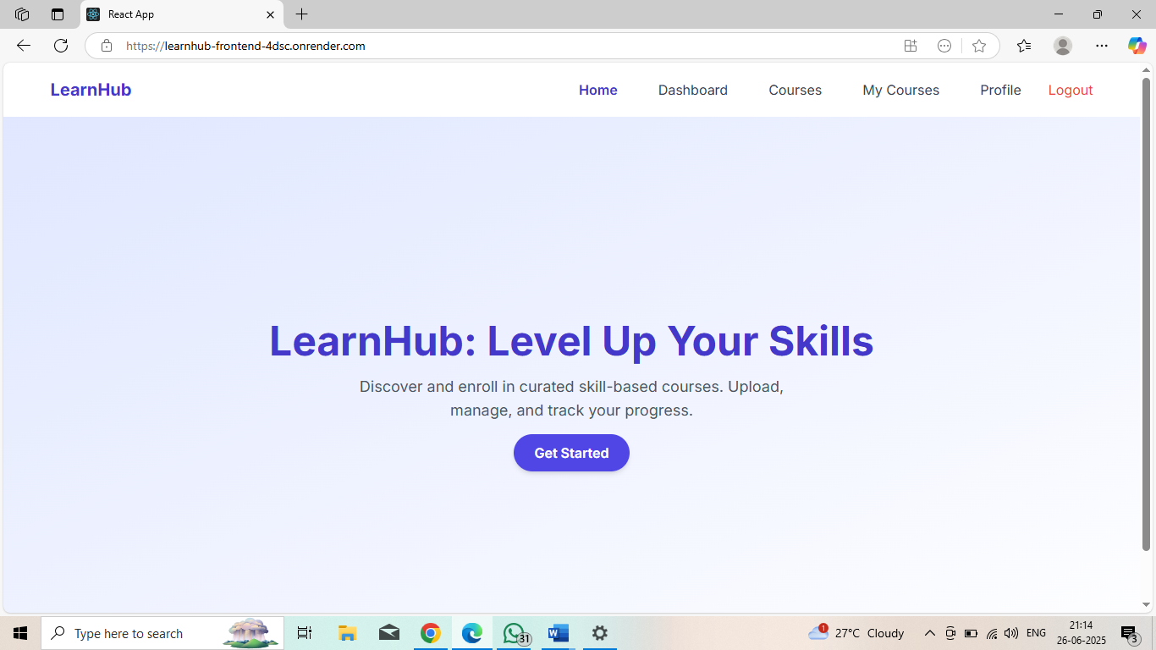

This image displays the Home Page of the LearnHub educational platform. It is designed to welcome users and introduce them to the platform’s purpose.

* The header includes a navigation menu with the following links:
  + Home (highlighted to show it's the current page)
  + Dashboard
  + Courses
  + My Courses
  + Profile
  + Logout (in red to clearly indicate its function)
* The main content section showcases the platform’s tagline and call to action:
  + Heading: “LearnHub: Level Up Your Skills” – emphasizing the platform’s goal of helping users improve through skill-based learning.
  + Subtext: “Discover and enroll in curated skill-based courses. Upload, manage, and track your progress.” – briefly explaining what users can do on the platform.
  + Button: A prominently displayed “Get Started” button in purple invites users to begin exploring and enrolling in courses.
* The color scheme uses a calming light blue background with bold purple elements, maintaining a professional yet approachable design aesthetic.

This starting point page serves as the entry point for users, offering them an overview of the platform and an easy to explore educational content**.**

**Top of Form**

**Bottom of Form**

**Image 2: Sign up Page**

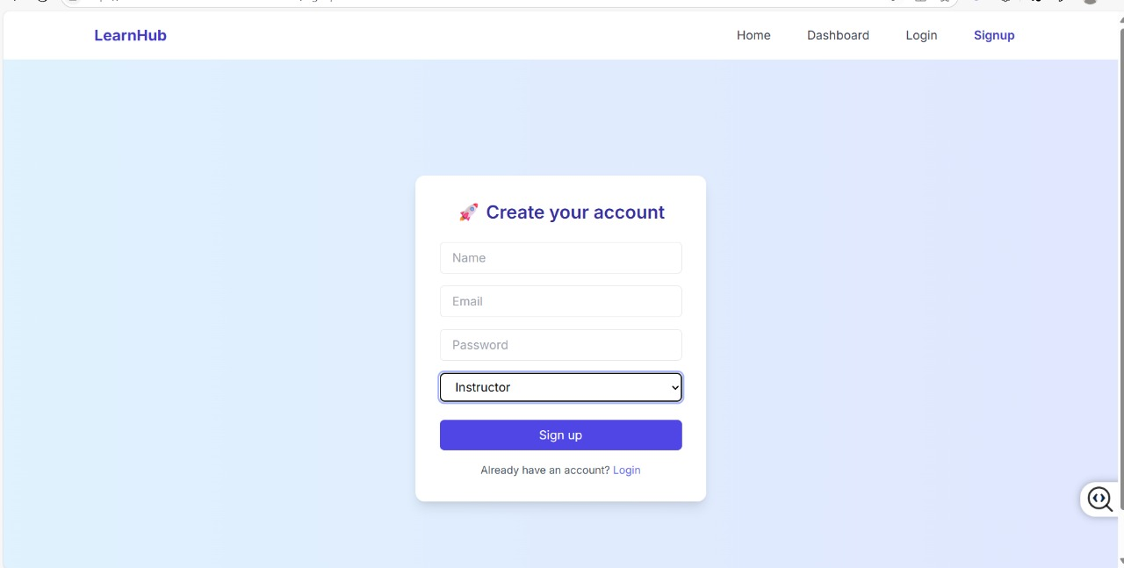

**Description:**

**📸 Image Description – Signup Page (LearnHub)**

* **Title/Header:**At the center of the page, there is a card with the title "🚀 Create your account" indicating that this is the registration form for new users.
* **Input Fields:**  
  The form consists of the following input fields:
  1. Name – Text input for the user's full name.
  2. Email – Input for the user's email address.
  3. Password – Input to securely set a password.
  4. Role Dropdown – A dropdown selection box that allows the user to choose between roles, such as:
     + Instructor
     + (Presumably the other option is Student, though not visible in the image)
* **Button:**  
  A "Sign up" button in a purple shade is placed below the form for submitting the registration details.
* **Link:**  
  Below the signup button, a small text reads:  
  *"Already have an account? Login"*  
  This is a navigation link that likely redirects users to the login page if they already have an account.
* **Navigation Bar (Top):**
  1. The header of the page includes:
     + Website title/logo: LearnHub
     + Menu options: Home, Dashboard, Login, and Signup
* **Background:**The background is a soft gradient of light blue shades, giving a clean and user-friendly aesthetic.

🔐 **Functionality Overview**

This page enables new users to:

* Register as either a **Student** or **Instructor**
* Enter credentials securely
* Navigate easily to the login page if they already have an account

**Top of Form**

**Bottom of Form**

**Image 3: Login Page**

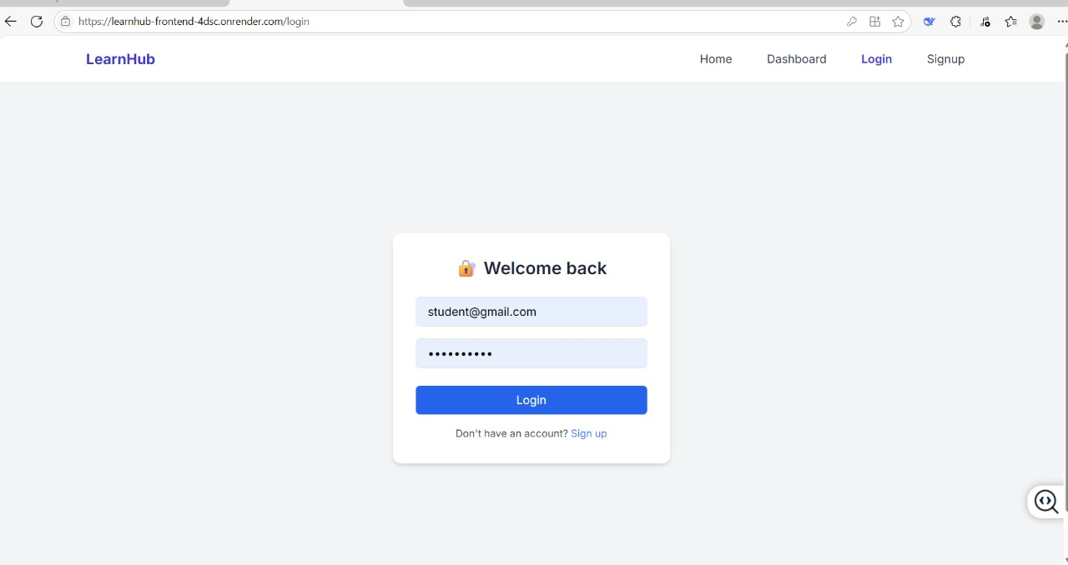

**Description:**

**📸 Image Description – Login Page (LearnHub)**

* **Header Section:**
  + LearnHub logo/title is placed at the top-left.
  + Navigation menu includes:
    - Home
    - Dashboard
    - Login (currently highlighted)
    - Signup
* **Login Form:**
  + Centered on the page within a white card with rounded corners.
  + Title: "🔐 Welcome back" – indicating this is a returning user login interface.
* Input Fields:
  + Email Field: Pre-filled with the text: student@gmail.com
  + Password Field: Contains hidden characters (dots), representing the password input.
* Action Button:
  + A solid blue "Login" button is displayed below the fields.
* Additional Navigation:
  + Below the login button, a sentence reads:

"Don't have an account? Sign up"

* + The Sign up text is hyperlinked, allowing new users to register.
* Background:
  + The background is light grey, giving a clean, modern UI look with focus on the login form.

**🔐 Functionality Overview**

This page enables existing users (students or instructors) to:

* Log in securely with email and password.
* Get redirected to their dashboard upon successful authentication.
* Navigate easily to the signup page if they are new users.

**Image 4: Student DashBoard Page**

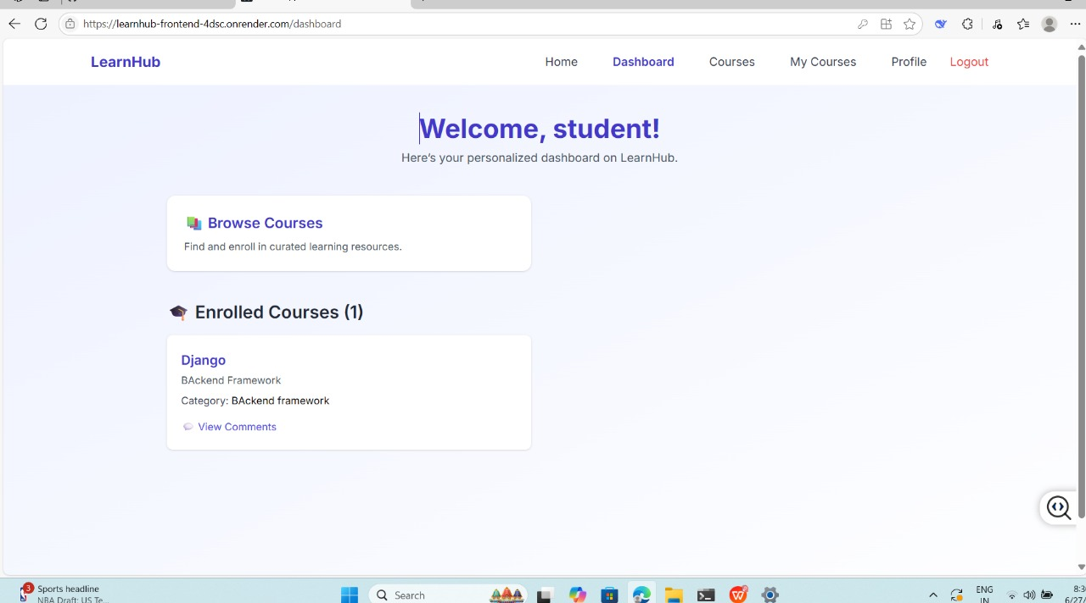

**Descrption:**

**📸 Image Description – Student Dashboard (LearnHub)**

* **Header Section:**
  + Top navigation bar includes:
    - **Home**
    - **Dashboard** (highlighted)
    - **Courses**
    - **My Courses**
    - **Profile**
    - **Logout** (in red, indicating an active session)
* **Welcome Message:**
  + The top center of the screen displays a friendly greeting:
    - **“Welcome, student!”**
    - Followed by a subheading: *"Here's your personalized dashboard on LearnHub."*
* **Main Dashboard Cards:**
  + **📚 Browse Courses**
    - A clickable card encouraging users to explore and enroll in more learning resources.
    - Text: *"Find and enroll in curated learning resources."*
  + **🎓 Enrolled Courses (1)**
    - Section title indicates that the student is currently enrolled in one course.
    - **Course Card:**
      * **Course Name:** Django
      * **Type:** Backend Framework
      * **Category:** BAckend framework (note: case inconsistency)
      * **Link:** "View Comments" – leads to the comment section for that specific course.
* **Background:**
  + Clean, soft light-blue gradient background.
  + Simple and professional UI design, enhancing readability and usability.

**🧑‍🎓 Functionality Overview**

The **dashboard page** provides students with:

* A personalized welcome and overview.
* A clear path to explore more courses via **"Browse Courses."**
* A quick view of **currently enrolled courses**.
* Easy access to **course-specific actions** like viewing feedback/comments.

**Image 5: Corses Enrolled By Students(My Corses) Page**

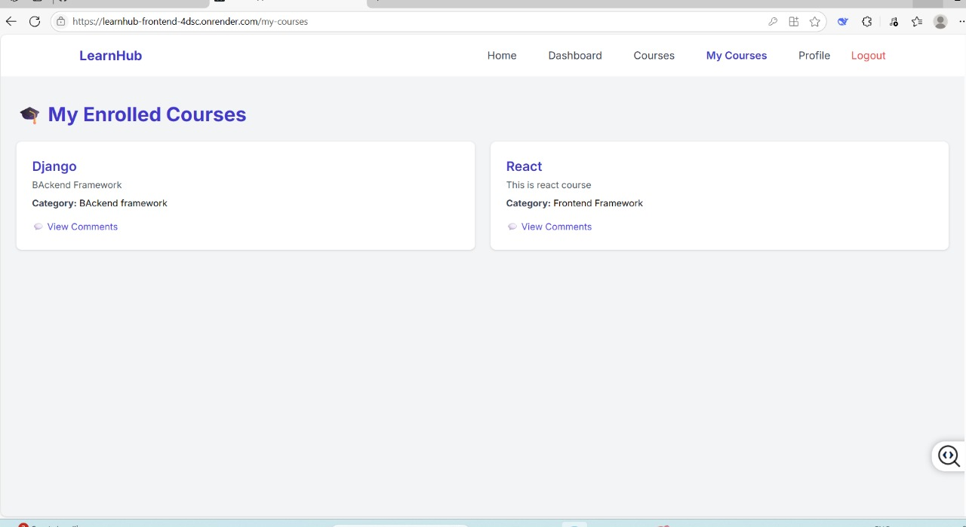

**Description:**

This image shows the **“My Courses” Page** of the **LearnHub** web application, where users can view the courses they are currently enrolled in. Below is a detailed description:

**📸 Image Description – My Enrolled Courses Page (LearnHub)**

* **Header Section:**
  + Top navigation bar includes:
    - **Home**
    - **Dashboard**
    - **Courses**
    - **My Courses** (highlighted)
    - **Profile**
    - **Logout** (in red)
* **Page Title:**
  + Large heading at the top-left: **🎓 My Enrolled Courses**
  + Indicates this section displays the user's active learning modules.
* **Course Cards:**
  + Two rectangular cards represent enrolled courses:
    - **Django**
      * Description: **Backend Framework**
      * Category: *BAckend framework* (note: inconsistent casing)
      * Option: **View Comments** (text with speech-bubble icon)
    - **React**
      * Description: *This is react course*
      * Category: *Frontend Framework*
      * Option: **View Comments**
* **Background & Layout:**
  + Simple and clean light grey background.
  + Cards are equally spaced and designed for clarity.
  + Minimalistic design for easy navigation.

**🧑‍🎓 Functionality Overview**

The **“My Courses”** page allows students to:

* See all the courses they are currently enrolled in.
* Check course descriptions and categories.
* **Click "View Comments" to read or add course-related feedback or discussions.**

**Image 6: Profile Page**

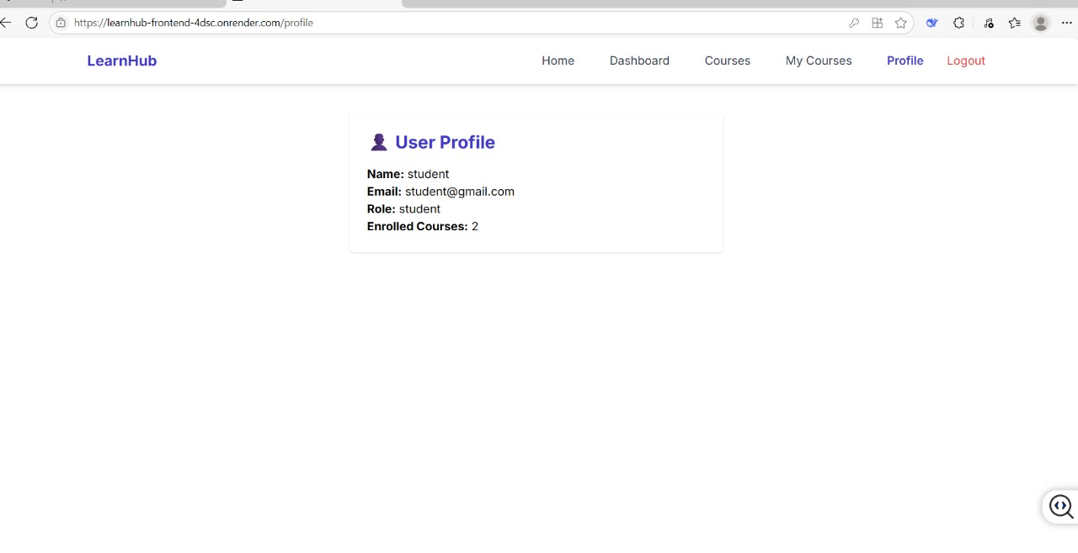**Description:**

This image shows the **User Profile Page** of the **LearnHub** web application. Here's a detailed description:

**📸 Image Description – User Profile Page (LearnHub)**

* **Header Section:**
  + Standard navigation bar at the top includes:
    - **Home**
    - **Dashboard**
    - **Courses**
    - **My Courses**
    - **Profile** (highlighted in blue)
    - **Logout** (highlighted in red)
* **Main Content – User Profile Card:**
  + The center of the page displays a white card containing the user’s profile information.
  + The card includes:
    - **👤 User Profile** (header with an icon)
    - **Name:** student
    - **Email:** student@gmail.com
    - **Role:** student
    - **Enrolled Courses:** 2
* **Design & Layout:**
  + The background is plain white with a minimalistic layout.
  + The profile card is centered for clarity and focus.

**👤 Functionality Overview**

The **User Profile Page** provides:

* A quick summary of the logged-in user's details.
* Visibility into how many courses the user is enrolled in.
* Simple and clean UI for checking profile status.

**Image 7: Courses Page**

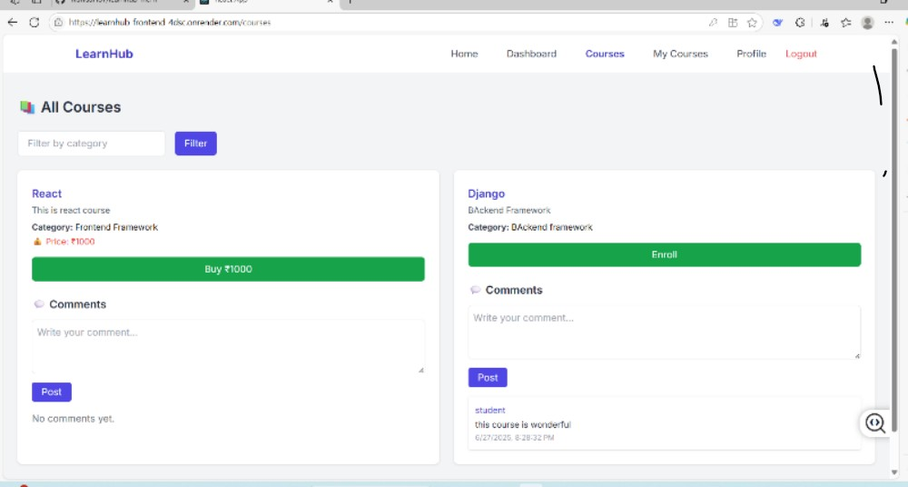

**Description:**

This image shows the **"All Courses" Page** of the **LearnHub** web application, where users can browse and interact with available courses. Here's a detailed description:

**📸 Image Description – All Courses Page (LearnHub)**

* **Header Section:**
  + Top navigation bar with the following links:
    - **Home**
    - **Dashboard**
    - **Courses** (currently selected)
    - **My Courses**
    - **Profile**
    - **Logout** (highlighted in red)
* **Page Title:**
  + **📚 All Courses** – Indicates that this section displays all available courses on the platform.
* **Filter Feature:**
  + Input field with placeholder text: “Filter by category”
  + A **Filter** button in purple to apply category-based filtering.

**🧾 Course Cards Displayed:**

1. **React Course**
   * **Description:** This is a React course.
   * **Category:** Frontend Framework
   * **Price:** ₹1000 (displayed with a price tag icon)
   * **Action Button:** Green **Buy ₹1000** button for purchasing the course.
   * **Comments Section:**
     + A comment box with a “Post” button.
     + No comments yet ("No comments yet." displayed).
2. **Django Course**
   * **Description:** Backend Framework
   * **Category:** BAcKend framework (note: casing inconsistency)
   * **Action Button:** Green **Enroll** button (free course).
   * **Comments Section:**
     + Comment box with a “Post” button.
     + One posted comment:

“**student:** this course is wonderful”  
Timestamp: 6/27/2025, 8:28:32 PM

**💡 Functionality Overview**

This page allows users to:

* View all courses offered on LearnHub.
* Use category filters to narrow down results.
* Buy or enroll in courses.
* Add and read comments for each course.

**Image 8: Admin Page**

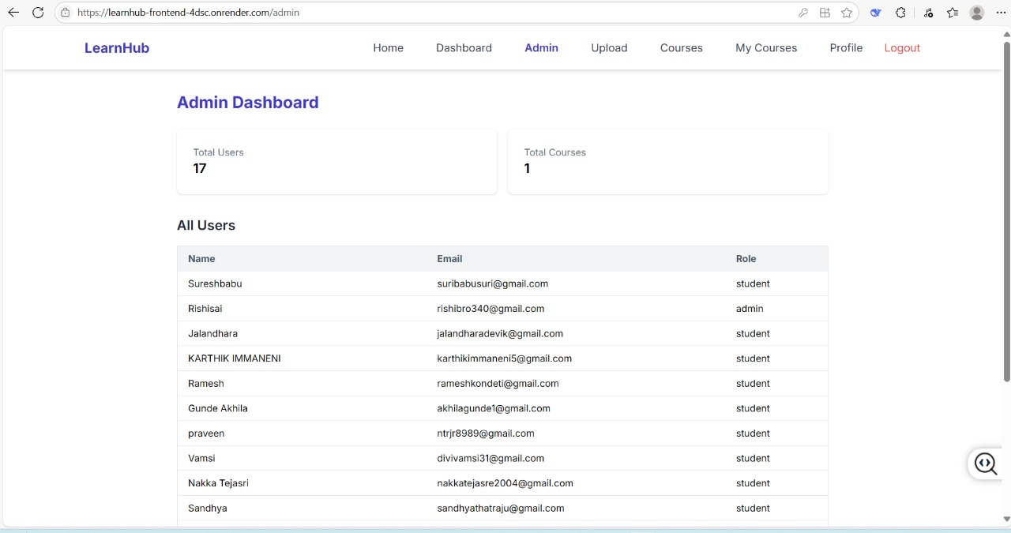

**Description:**

This image shows the **Admin Dashboard Page** of the **LearnHub** web application. It is intended for administrators to view user and course data. Here's a detailed description:

**📸 Image Description – Admin Dashboard Page (LearnHub)**

* **Header Section:**
  + Navigation bar includes:
    - **Home**
    - **Dashboard**
    - **Admin** (currently active)
    - **Upload**
    - **Courses**
    - **My Courses**
    - **Profile**
    - **Logout** (highlighted in red)

**🧑‍💼 Main Section – Admin Dashboard:**

* **Dashboard Title:**
  + Heading: **Admin Dashboard** in bold blue text.
* **Summary Cards (Top):**
  + **Total Users:** 17
  + **Total Courses:** 1  
    These cards give a quick overview of the platform statistics.
* **User Table (All Users):**
  + Displays a list of all registered users.
  + **Columns:**
    - **Name**
    - **Email**
    - **Role**
  + The list includes users like:
    - *Sureshbabu* – student
    - *Rishisai* – admin
    - *Jalandhara* – student
    - Others (e.g., Karthik, Ramesh, Akhila, Praveen, etc.)

**🧩 Functionality Overview**

This **Admin Page** allows the administrator to:

* View a complete list of users with their names, emails, and roles (admin or student).
* Monitor overall user count and course availability.
* Ensure proper user-role management and platform tracking.

Top of Form

Bottom of Form

Top of Form

Bottom of Form

**System Top of Form**

**Bottom of Form**

**Architecture**

* **ER Diagram:** (Entity-Relationship diagram showing tables/entities like Student, Course, Enrollment, etc.)

**DIAGRAM:**

* User
* ├── UserID (PK)
* ├── Name
* ├── Email
* ├── Password
* └── Role
* │
* │ 1 M
* ▼ ▲
* Enrollment
* ├── EnrollmentID (PK)
* ├── UserID (FK)
* ├── CourseID (FK)
* ├── EnrollmentDate
* └── Progress
* │
* │ M 1
* ▼ ▲
* Course
* ├── CourseID (PK)
* ├── Title
* ├── Description
* ├── Category
* ├── Language
* └── CreatedBy (FK → User)
* │
* │ 1 M
* ▼ ▲
* Lesson
* ├── LessonID (PK)
* ├── CourseID (FK)
* ├── Title
* ├── Content
* └── OrderNumber
* Feedback
* ├── FeedbackID (PK)
* ├── UserID (FK)
* ├── CourseID (FK)
* ├── Comment
* └── Rating

Data Flow Diagram :

At Level 0:

+---------------------+

| Student |

+---------------------+

|

| Register/Login, View Courses, Enroll

v

+---------------------+

| LearnHub |

| System |

+---------------------+

|

+---------------+---------------+

| |

v v

+---------------+ +------------------+

| User DB | | Course DB |

+---------------+ +------------------+

**Explanation:**

* Student interacts with the LearnHub system.
* The system reads/writes to the **User database** (registration, login, enrollments).
* It also reads from the **Course database** (course listings, enrollments).

**At level 1:**

+--------------------+ +----------------------+

| Student | | Admin |

+--------------------+ +----------------------+

| |

| Register/Login | Add/Update Courses

v v

+-------------------------+ View/Enroll in Courses +-------------------------+

| 1. User Management | <---------------------------- | 3. Course Management |

+-------------------------+ +-------------------------+

| |

| Create/Retrieve/Update User Info | Save Courses

v v

+-------------------------+ +-------------------------+

| User DB | | Course DB |

+-------------------------+ +-------------------------+

\_________________________________/

|

+------------------------------+

| 2. Enrollment Management |

+------------------------------+

|

Store Enrollments in both User & Course DB

**🧩 Components & Processes**

| **#** | **Process** | **Description** |
| --- | --- | --- |
| 1 | **User Management** | Handles student registration, login, profile updates. |
| 2 | **Enrollment Management** | Manages student enrollment into courses, updates both user and course records. |
| 3 | **Course Management** | Admin or instructor can add, update, or delete course information. |

**🗂 External Entities**

* **Student**: End-user who registers and enrolls in courses.
* **Admin**: Adds or manages available courses.

**🧱 Data Stores**

| **Data Store** | **Description** |
| --- | --- |
| **User DB** | Stores user details like name, email, password, role, enrolled courses. |
| **Course DB** | Stores course title, description, duration, and enrolled students. |

Top of Form

Bottom of Form

**Prerequisites:**

* Node.js installed
* React environment set up (create-react-app or Vite)
* MongoDB account (if using database)
* Code editor (VS Code recommended)
* Internet connection

**Installation and Setup Instructions**

bash

CopyEdit

# Clone frontend repo

git clone https://github.com/yourusername/learnhub-frontend

# Install dependencies

cd learnhub-frontend

npm install

# Start the app

npm start

(Include backend setup if applicable.)

**Conclusion**

The LearnHub mini project successfully provides an accessible and intuitive platform for skill center students to learn programming courses online. It lays a strong foundation for scalable, real-world e-learning platforms.

**Future Scope**

* Add quizzes and assessments
* Integrate certification
* Admin panel for course management
* Chat-based doubt resolution

**12. References**

* React.js Documentation
* MongoDB Docs
* Render Deployment Guide
* Any tutorials/resources you referred to

**Project site:** https://learnhub-frontend-4dsc.onrender.com/