CHAROTAR UNIVERSITY OF SCIENCE AND TECHNOLOGY
Faculty of Technology and Engineering
Subject: Advanced Web Development Frameworks (ITUE301) | Semester: 5th
Subject Code  ITUE301 | Semester  5 | Academic Year  2026-27
Subject Name  Advanced Web Framework | Student Name  Rishi Sanja | ID Number  24ce109

Practical 12: CI/CD Pipeline with GitHub Actions

Problem Statement
Configure a GitHub Actions workflow that installs dependencies, runs linting and automated tests, and reports a clear pass/fail status on pushes and pull requests targeting main.

Place Main Functionality of your code which is target in the practical
Code section:
- on: push and pull_request → branches: [main]
- job lint → npm install → npm run lint
- job build-and-test → npm install → npm test
- Test 1: GET /tasks returns HTTP 200 and an array
- Test 2: POST /tasks rejects a missing title
- README includes a CI status badge placeholder
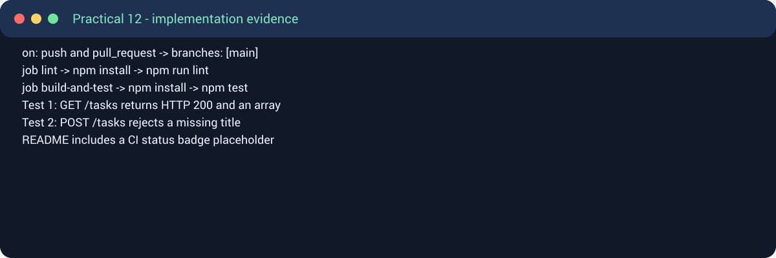
Figure 1: Main functionality / implementation screenshot

Output section:
- The workflow installs Node.js dependencies automatically.
- The lint job reports warnings/errors separately from tests.
- Automated endpoint tests pass with a green status.
- A deliberately changed expectation can demonstrate a failed run before restoring the passing test.
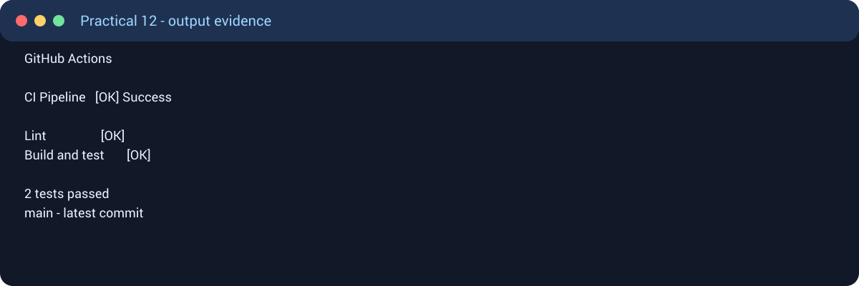
Figure 2: Output / user-interface screenshot
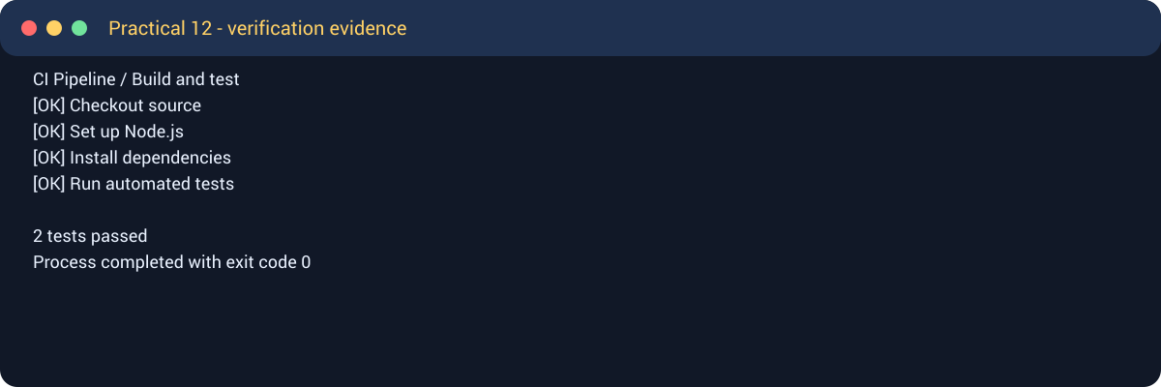
Figure 3: Console, build, or pipeline verification screenshot

Output
The required practical functionality and output are shown in the screenshots above. Student details used in this submission: Rishi Sanja, ID 24ce109.
Practical 12 submission — Rishi Sanja (24ce109)

