ML
Math foundation
1. Understanding data spread (VERY IMPORTANT)
Age distribution tells you:
- Are ages tightly grouped?
- Or widely spread?
Example:
- Low variance → passengers are similar age (e.g., mostly adults)
- High variance → mixed ages (kids + adults + elderly)
👉 This helps you understand dataset structure

2. Detecting outliers
Standard deviation helps you find unusual values:
mean ± 2 * std
If Age is outside this range → potential outlier
Why it matters:
Outliers can:
- distort models
- affect mean heavily
- mislead regression models

3. Feature scaling decision (VERY IMPORTANT FOR ML)
Variance tells you:
“Do I need scaling?”
If features have different variance:
- Age (small range)
- Fare (large range)
👉 You MUST scale before ML models like:
- Logistic Regression
- SVM
- KNN

4. Data quality check
If variance is:
❌ too low:
- Feature is almost constant → useless
❌ too high:
- possible noise or errors

5. ML intuition (most important part)
Variance is NOT a feature you directly use.
It helps you answer:
“Is this feature stable, useful, or noisy?”

Probability
- best way to to represent probabily to calculate is the wenn diagram or true table
- 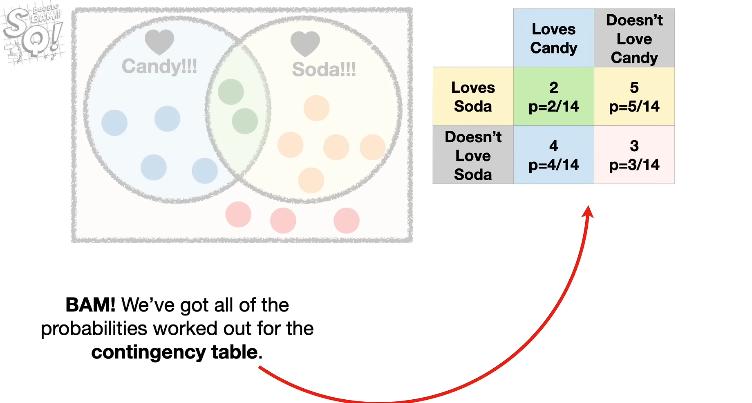
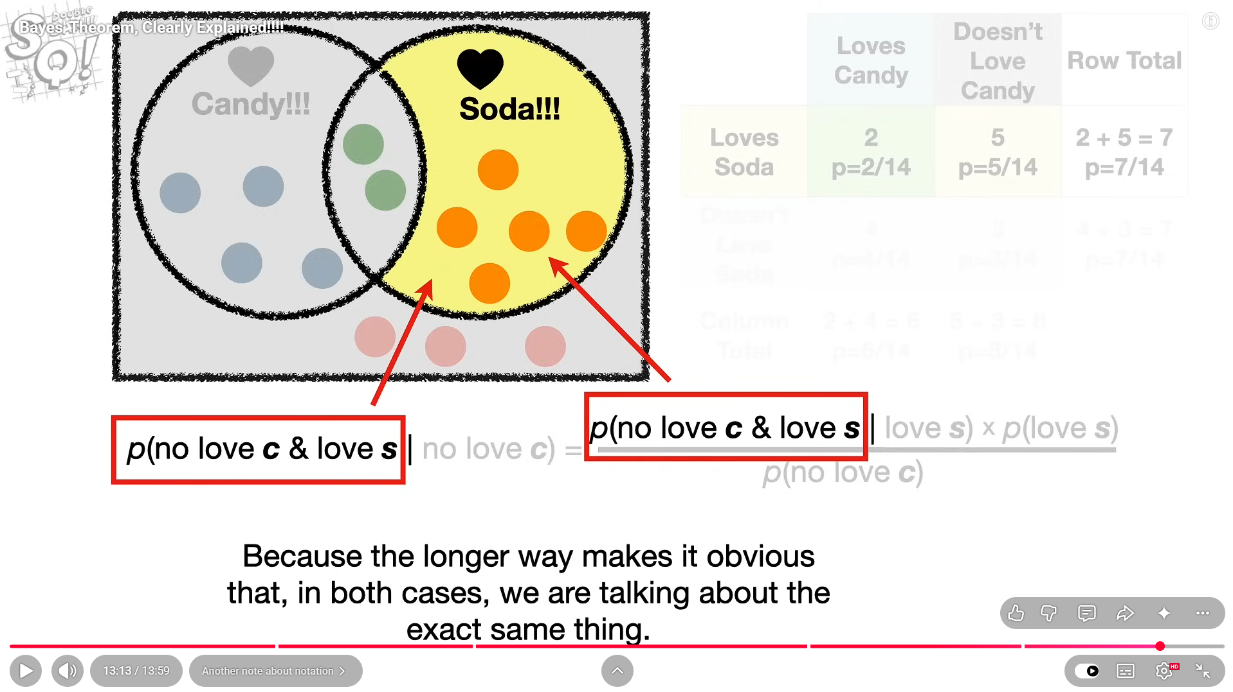
- Writing it in long way like this is very crucial an the best practice so follow this itself. Don’t write like this p(love s)|(no love c) this is more confuing and not good presentation as well while solving

- Very important
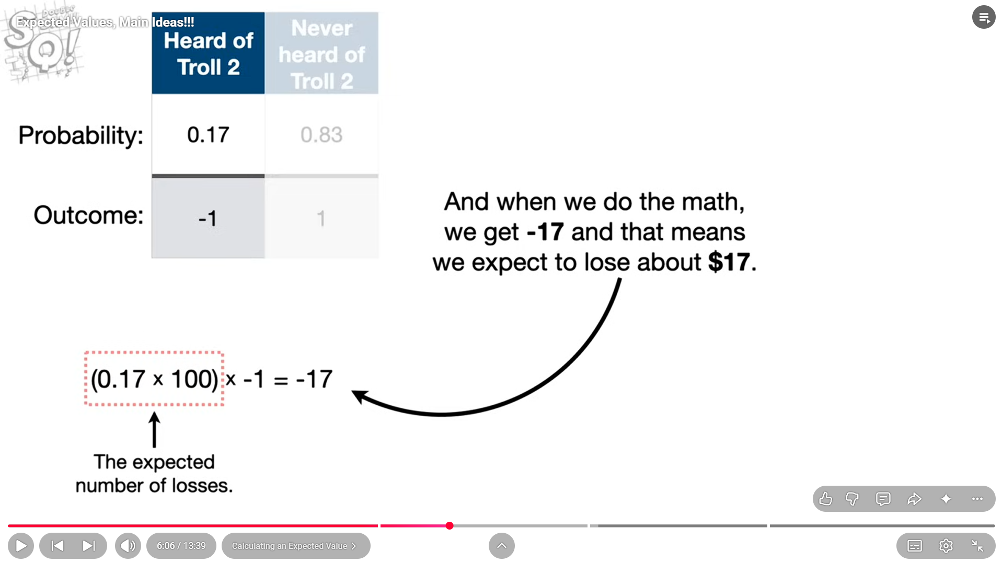

- This following one is for contineuous values of variables and above was descrete values
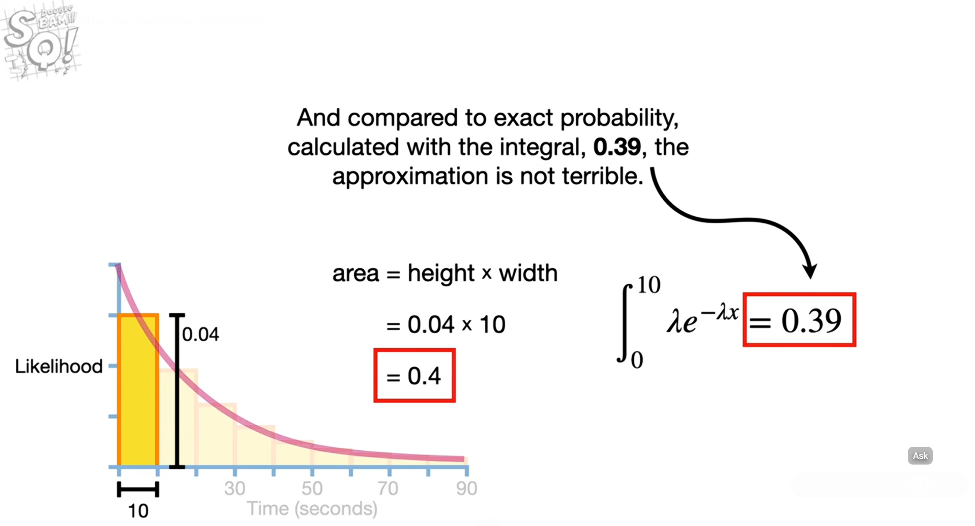
The curve is used for continueous but in case we assume it is discrete also then we can find it and it is accurate , see the integration formula there on the right and the left one is area of the rectangle they found where height came up to be 0.04
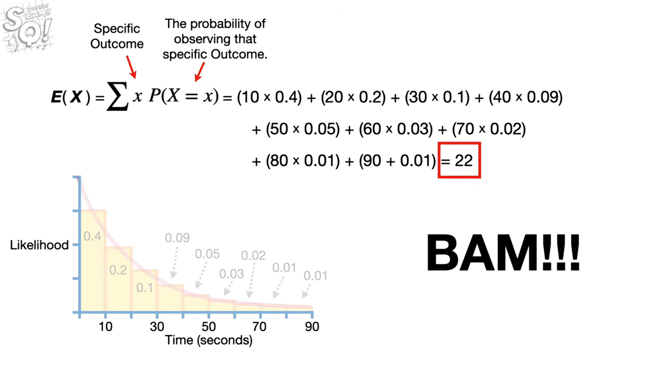
- Here we can reduce width so rectangle increase but value will add up to be same and so if we keep reducing the size of the rectangle then at one point the width is 0 and num of rectangles is infinite so that is where we stop approximating the value and becomes exact calculation
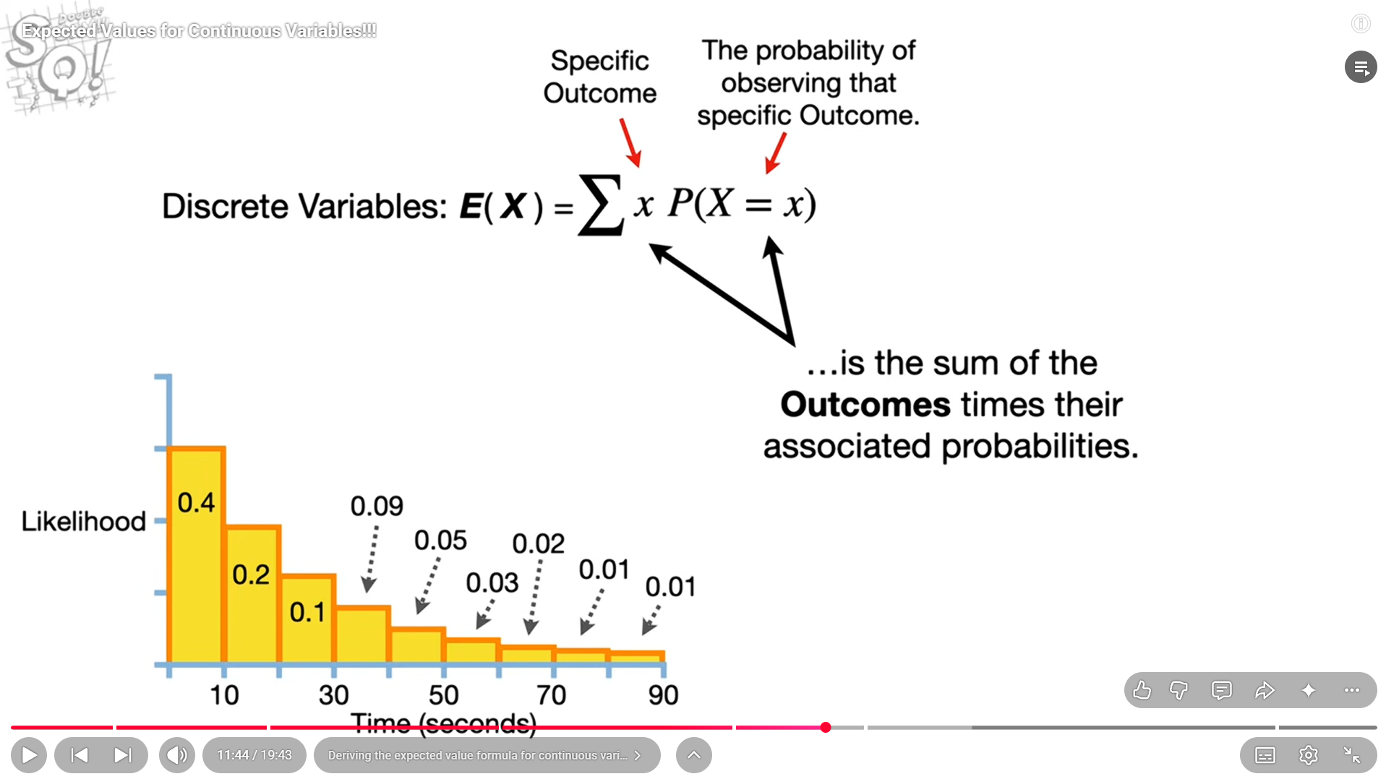
- This is what we did for discrete
- Now for cont
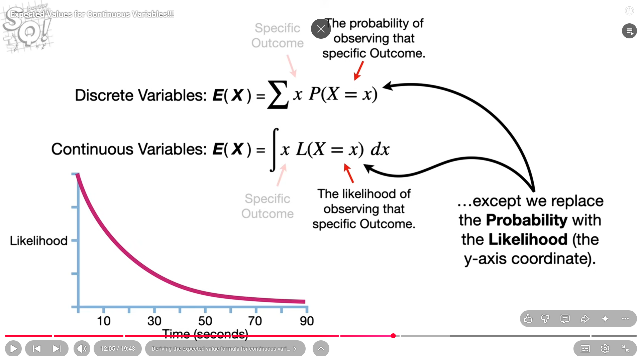

CLT – central limit theorem
- It tells us that the data distribution might not be normal but they should be uniform, exponential or other distribution but their mean is normal for samples

