CASCADE '26 · THEME 4: INFORMATION ASYMMETRY · PROBLEM 1
DAOGuard
Governance intelligence and execution assurance for DAO proposals
Understand the decision. Verify the execution. Preserve the evidence.
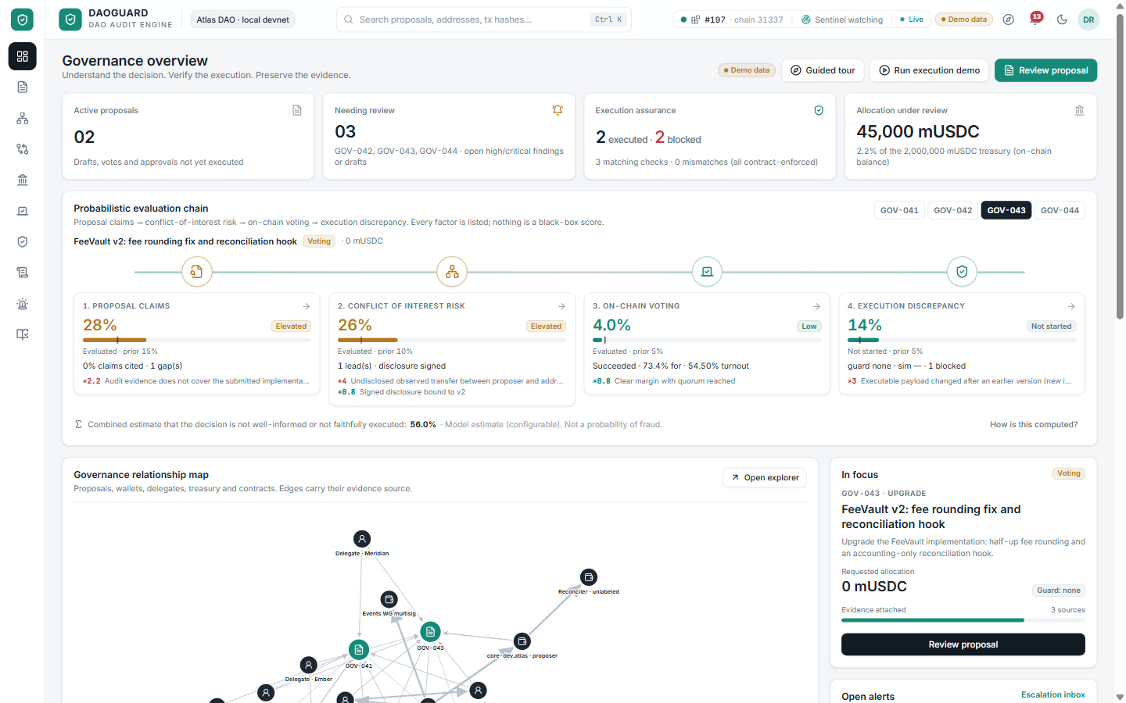
Figure 1. DAOGuard overview: the four-stage evaluation chain, relationship map, open alerts and sentinel status (working prototype, demo data).
4  evaluation stages | 11  product modules | 82  automated tests | 0  unverified approvals executed

Document | Details
Problem statement | The Governance Illusion: voters approve proposals they cannot verify, and what executes may differ from what was approved.
Deliverable | Working prototype: Solidity contracts on a local Hardhat chain, FastAPI backend, React web app. All entities and amounts are fictional demo data.
Contents | 0 Executive summary · 1 Problem · 2 Who is affected · 3 Case studies · 4 Existing solutions & gaps · 5 Research · 6 Our approach · 7 Features & UI/UX · 8 USP & moat · 9 Technical deep-dive · 10 Architecture & flows · 11 Testing · 12 Impact · 13 Feasibility & viability · 14 Business

0. Executive summary
The problem. DAO voters approve proposals they cannot realistically verify. Claims are uncited, conflicts are hidden in on-chain history, and the payload that finally executes can differ from the text voters read, or change after the vote. Public incidents (Beanstalk, Tornado Cash governance, Compound Proposal 62) show the cost: hundreds of millions of dollars moved with full formal legitimacy.
The solution. DAOGuard is a governance intelligence workspace joined to an on-chain execution guard. It explains each proposal with cited evidence and explicit gaps, maps conflicts of interest from chain data, quantifies treasury impact, lets reviewers question proposers with signed answers, simulates every approved payload, and executes only the exact cryptographic manifest that governance approved.
Pillar | Capability | Proof in the prototype
Understand | Cited brief, 11 missing-information rules, contradiction and injection detection, conflict graph, proposer Q&A, treasury model. | GOV-042: 520k vs 500k contradiction and an undisclosed proposer → recipient transfer are surfaced automatically.
Verify | EIP-712 manifest digest, 18 deterministic payload rules, preflight, snapshot simulation, sentinel auto-halt, implementation comparison. | Recipient swap reverts with ManifestMismatch; GOV-043's hidden vault drain is halted before execution.
Preserve | Hash-chained audit ledger anchored on-chain, signed disclosures and answers, verifiable reports. | Editing one stored event or one signed answer is detected on verification.

Why now | Why us | What we ask
DAO treasuries and grant programmes keep growing while voter attention does not; AI summaries add speed but also new injection and hallucination risks. | A working end-to-end prototype: contracts, backend, UI, 82 automated tests, and a design grounded in incident research. | Pilot partners among DAO grant programmes and delegate teams; feedback on the manifest standard; security review of the guard contract.

1. The problem: the governance illusion
Decentralised Autonomous Organisations (DAOs) govern treasuries worth tens of billions of dollars through token votes. On paper every holder decides; in practice most voters approve proposals they cannot realistically verify. The result is an illusion of governance: legitimacy without understanding, and approval without assurance about what will actually execute.
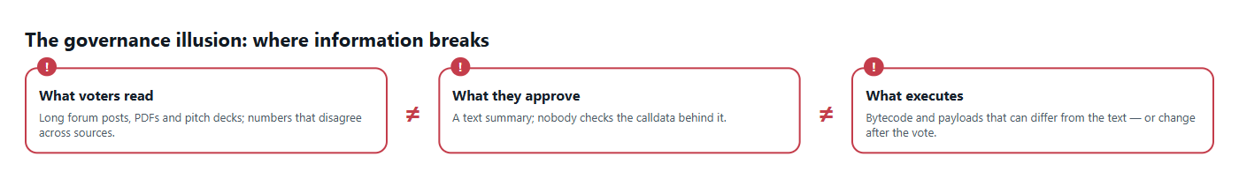
Figure 2. Three versions of the same decision rarely match: what voters read, what they approve, and what the chain executes.

Core problems we address
# | Problem | Why it happens | Consequence
P1 | Information overload | Proposals arrive as long forum posts, PDFs and decks; claims are uncited and numbers disagree. | Voters skim or delegate blindly; contradictions (e.g. 520k vs 500k) go unnoticed.
P2 | Missing information | No standard for budgets, milestones, audits or disclosures. | Gaps look like completeness; nobody asks the right question.
P3 | Hidden conflicts of interest | Proposer–recipient links live in on-chain transfers few people trace. | Insiders fund themselves; trust erodes after the fact.
P4 | Text ≠ code | Voters approve a description, not the calldata or bytecode behind it. | Malicious or buggy payloads execute with full legitimacy.
P5 | Payload can change after the vote | Execution is a separate step that rarely binds to exactly what was approved. | Recipient, amount or implementation swapped between vote and execution.
P6 | No trustworthy record | Decisions, reviews and disputes are scattered across Discord, forums and chains. | Accountability is impossible; disputes become he-said-she-said.

In one sentence
DAOGuard closes the gap between what voters read, what they approve and what executes, and keeps tamper-evident proof of every step.

2. Who faces these problems, and how
Stakeholder | Pain today | Example | What DAOGuard gives them
Token holders & voters | No time or expertise to read 30-page proposals or check payloads. | A holder approves a grant whose forum post asks for 520,000 while the payload pays 500,000, with no way to tell which is right. | A two-minute cited brief, flagged contradictions and a plain-language view of what will execute.
Delegates | Represent thousands of voters; reputational risk from bad votes. | A delegate backs an upgrade described as "moves no funds" that hides a drain function. | Evaluation chain, simulation verdicts and an evidence pack to justify each vote.
Treasury / finance stewards | Cannot see how a grant changes runway under overruns or milestone timing. | A 30% overrun pushes available balance below a safe level by month 9. | Treasury model in base units, 2D/3D scenario surface and threshold alerts.
Security councils & guardians | Must review approvals in hours, often manually. | An approved manifest is executed with a swapped recipient. | Sentinel simulation within the review window, contract-enforced halt, preflight checks.
Proposers & grantees | Honest teams cannot prove good faith; questions go unanswered. | A grantee's undisclosed past transfer looks suspicious. | Signed disclosures and signed answers to reviewer questions, linked to evidence.
Auditors, researchers, regulators | No reliable trail of who decided what, when and on what evidence. | A dispute months later cannot be reconstructed. | Hash-chained audit ledger anchored on-chain, exportable reports.

3. Case studies we studied and learnt from
We reviewed public post-mortems of governance failures to identify failure patterns. Each pattern maps to a DAOGuard control.
Case (public reports) | What went wrong | Lesson | DAOGuard control
Beanstalk (Apr 2022) | A flash loan bought a governance supermajority and passed a malicious proposal through emergency execution; roughly $180M of assets were drained. | Vote power concentration plus instant execution is lethal. | Voting concentration metrics; guard review window; sentinel auto-halt before execution.
Tornado Cash governance (May 2023) | A proposal claimed to mirror an earlier benign one, but its contract contained hidden logic that granted the attacker votes and control. | The description is not the code. | Bytecode analysis, differential probes, submitted-vs-reviewed implementation comparison.
Compound Proposal 62 (Sep 2021) | An upgrade with a bug distributed far more COMP rewards than intended. | Simulate upgrades on real state before execution. | Snapshot simulation of the exact approved manifest; intent assertions vs observed behaviour.
Build Finance DAO (Feb 2022) | Low participation let one actor pass a proposal granting themselves control of the treasury and minting. | Low turnout is a security risk, not just apathy. | Participation and margin signals in the evaluation chain; escalation inbox.
Arbitrum AIP-1 (Mar 2023) | Funds were allocated before the community vote had ratified the proposal, causing a trust crisis. | Execution must bind to what was approved. | ExecutionGuard executes only the exact EIP-712 manifest digest approved by the vote.

Pattern we designed around
Every major incident combined at least one information gap (misread text, hidden link, low turnout) with an execution path that did not check the approval. DAOGuard attacks both halves: it informs the vote and it enforces the result.

4. Existing solutions and what they lack
Category | Examples | What they do well | What they lack
Voting platforms | Snapshot, Tally, Agora | Ballots, delegation, proposal pages, on-chain execution via Governor. | No verification that text matches calldata; no conflict analysis; no binding of payload after approval beyond the Governor itself.
Analytics dashboards | DeepDAO, Boardroom, Messari Governor | Treasury sizes, participation stats, proposal feeds. | Descriptive only: no per-proposal evidence, no simulation, no enforcement.
Transaction simulation & monitoring | Tenderly, OpenZeppelin Defender, Forta | Simulate and monitor transactions; alerting. | Developer-oriented; not tied to the governance decision or the proposal text; no voter-facing explanation.
Multisig / modules | Safe, Zodiac Reality, timelocks | Delays and signer control over execution. | Signers still eyeball payloads; no automated diff against an approved manifest.
Forums & manual review | Discourse forums, delegate write-ups, audits | Context and expert opinion. | Unstructured, unverifiable, slow; contradictions and gaps rarely surfaced.
AI summarisers | Generic LLM summaries | Fast summaries of long text. | Hallucination risk, no citations, vulnerable to prompt injection hidden in proposal documents.

The gap
No existing tool connects the three layers of a governance decision: the evidence voters read, the decision they make, and the code that executes. Tools are siloed by audience: analytics for researchers, simulation for developers, voting for token holders. Nobody owns the end-to-end question: "Is what will execute exactly what we understood and approved?"

5. Research behind DAOGuard
Research activity | What we did | Key insight
Incident post-mortems | Analysed public reports of governance and execution incidents (Section 3). | Failures cluster at the hand-offs: text → vote and vote → execution.
Proposal corpus review | Read grant, budget and upgrade proposals across large DAOs' forums. | Budgets, milestones, audits and disclosures are inconsistently present; amounts often disagree across documents.
Standards study | EIP-712 typed data, OpenZeppelin Governor, TimelockController, EIP-1967 proxies. | A typed, chain- and contract-bound manifest digest can make approval cryptographically specific.
Voter-behaviour literature | Participation and delegation studies, rational-ignorance arguments. | Voters need a short, cited, trustworthy view, not more raw data.
AI safety review | Prompt-injection patterns in documents fed to language models. | Analysis must be extractive and cited by default; model output is labelled and never overrides rules.
Probabilistic reasoning | Bayesian updating in odds form with explicit likelihood ratios. | Transparent, editable risk estimates beat black-box scores for trust.

Design principles from the research
Evidence over opinion: every claim cites its sentence; every edge cites its transaction.
Enforce, don't warn: the contract, not the dashboard, refuses a mismatched payload.
Honest limits: a hash proves equality, not truth; a transfer proves movement, not ownership; a passing simulation is not proof of safety.

6. Our approach and solution
DAOGuard is a governance co-pilot plus an on-chain execution guard. It works in three moves that mirror the life of a proposal:
Move | What DAOGuard does | Outcome
1. Understand the decision | Cited brief, missing-information rules, contradiction and prompt-injection detection, conflict-of-interest graph from chain events, proposer Q&A with signed answers, treasury impact in exact base units. | Voters know what is claimed, what is missing and who is connected, in minutes.
2. Verify the execution | The vote approves one EIP-712 manifest digest. A sentinel simulates the approved payload inside a review window and can halt it on-chain. The ExecutionGuard executes only the exact approved digest. | Tampered, swapped or malicious payloads revert on-chain; nothing moves.
3. Preserve the evidence | Every event goes into a hash-chained audit ledger whose head is anchored on-chain; versions, disclosures and disputes are committed to a registry. | Anyone can verify later that nothing was edited after the fact.

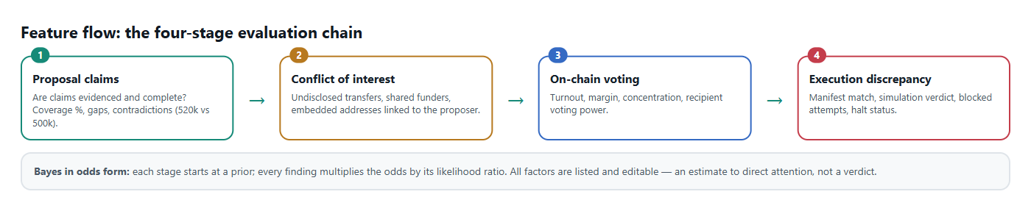
Figure 3. The evaluation chain: four questions, each a transparent Bayesian update over listed evidence.

7. Features in the prototype
Module | Feature | How it works
Overview | Evaluation chain, metrics, relationship map, sentinel status | Priors × likelihood ratios per stage; live data over Server-Sent Events.
Proposals | Cited brief, evidence vault, disclosures, versions, milestones, findings | Extractive analysis; evidence hashed with SHA-256 and a Merkle root per version.
Proposer Q&A | Ask about any gap; signed answers; accept or ask for more | Answers are EIP-712 signed by the proposer; accepting resolves the finding and updates the chain.
Relationships | Wallet graph and suspected transaction chains | Built from on-chain transfers and delegations; leads are labelled, never claimed as ownership.
Voting | Turnout, margin, concentration, delegates | Read from the Governor; flags thin margins and recipient voting power.
Financial impact | Treasury model, scenarios, 2D chart and 3D scenario surface | Integer base-unit arithmetic; overrun and milestone timing; exploration threshold.
Execution guardian | Execution tunnel, payload diff, manifest builder, preflight, guarded execution | Preflight is an eth_call; execution is a real transaction to the guard.
Attack simulation | Submitted vs reviewed implementation comparison | Both run on isolated snapshots from the same block with the same probe callers.
Sentinel | Autonomous review of each approval; on-chain halt on BLOCK | Listens for ManifestApproved, simulates, halts inside the review window.
Audit & reports | Hash-chained timeline, on-chain anchors, verification; PDF/JSON/CSV | Re-hashes every event and re-checks transaction receipts against the node.
Guided tour | Ten-step demo that waits for the user to act | Detects completion from live ledger and sentinel events.

7.1 Understand: cited brief and conflict graph
The proposal workspace puts the cited brief, evidence, disclosure, versions, milestones, findings and Q&A in tabs beside a live decision panel. The relationship explorer builds a wallet graph from transfers and delegations, so an undisclosed payment from the proposer to the grant recipient becomes visible before the vote.
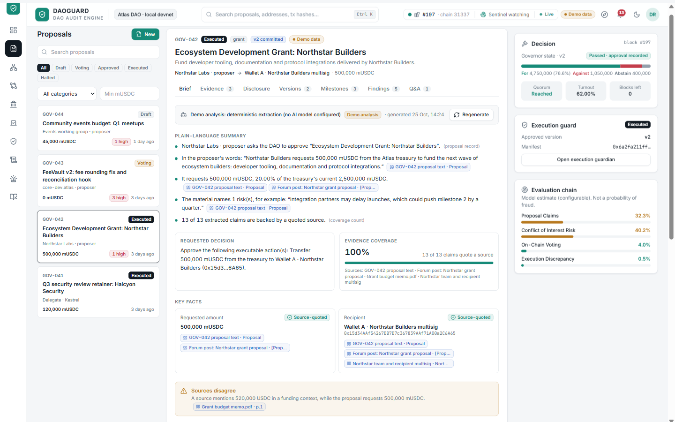
Figure 4. Proposal workspace: cited brief, contradictions, missing-information questions and the decision panel.
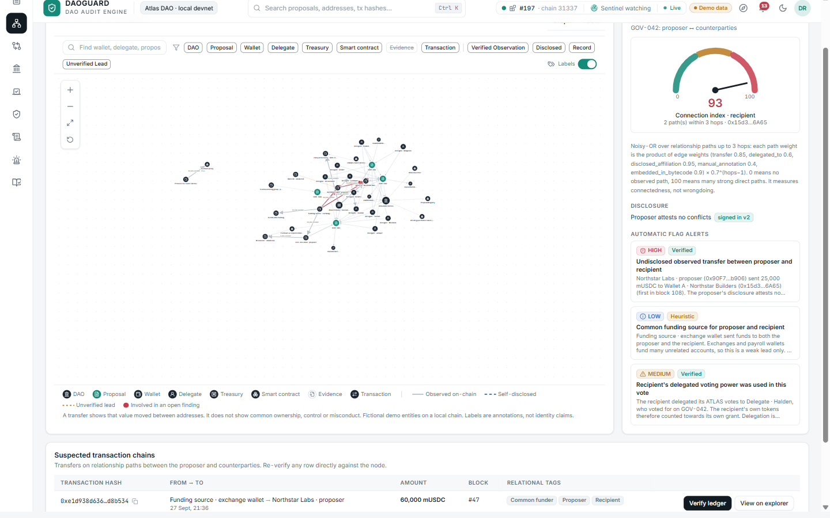
Figure 5. Relationship explorer: proposer, recipient and delegates, with evidence-backed edges and labelled leads.

7.2 Close the loop: proposer Q&A and voting context
Gaps no longer end as a warning. A reviewer asks the proposer, the proposer answers with an EIP-712 signature (optionally attaching evidence), and accepting the answer resolves the finding and lowers the Proposal Claims estimate. Voting analytics add turnout, margin and voting-power concentration beside the ballot.
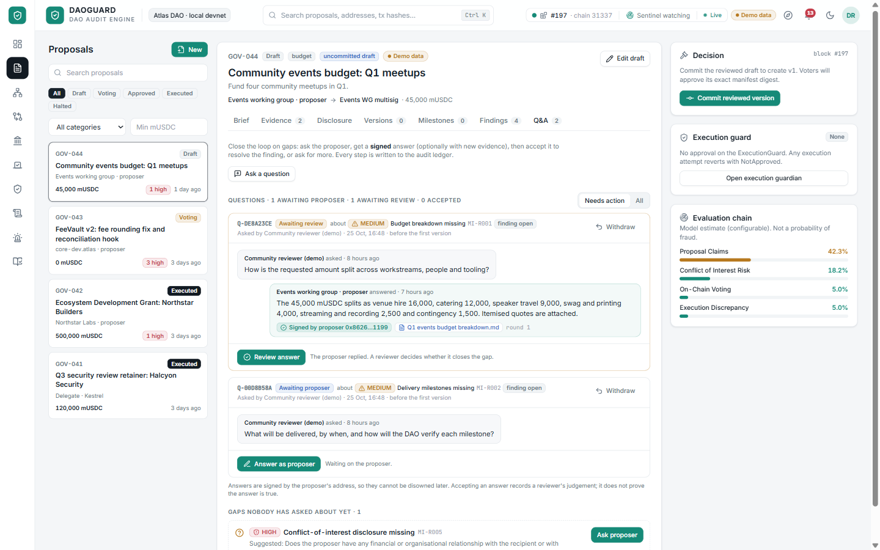
Figure 6. Proposer Q&A: signed answers, reviewer decisions and the gaps nobody has asked about yet.
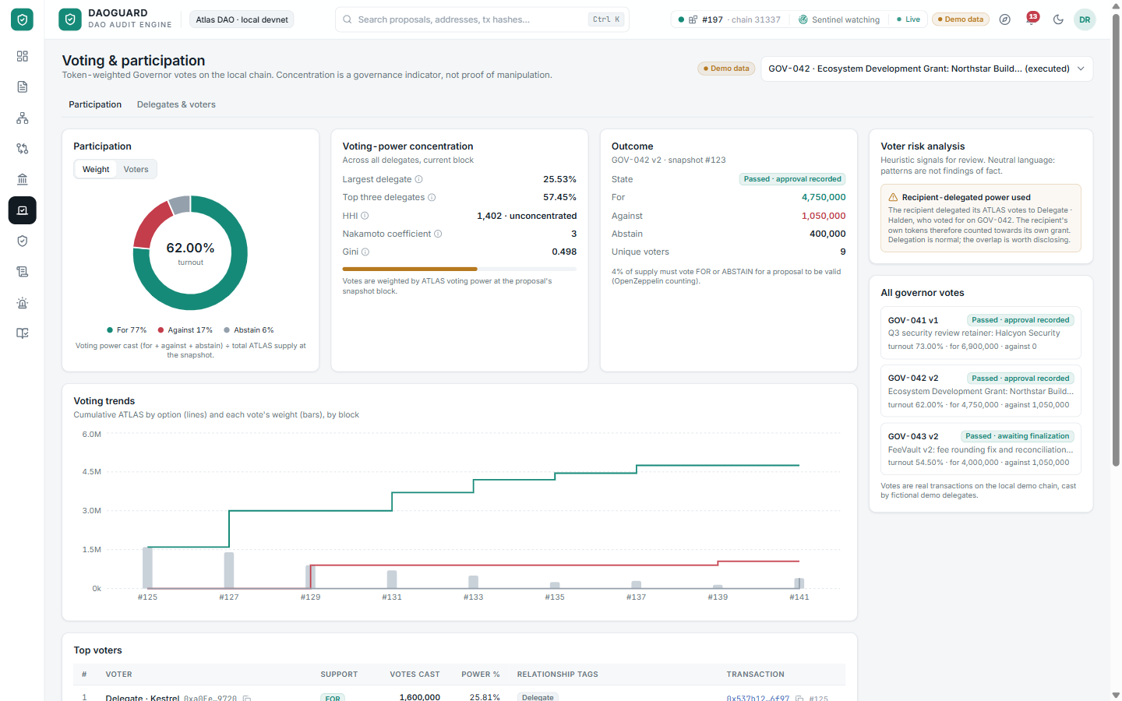
Figure 7. Voting & delegates: participation, margin, concentration and delegate positions.

7.3 Verify: the execution tunnel
The execution tunnel shows one payload passing six checkpoints. Here a payload that swaps the recipient is stopped at the guard: preflight predicts ManifestMismatch, the approved and attempted recipients are shown side by side, and the treasury is untouched. Submitting it sends a real transaction that reverts on-chain.
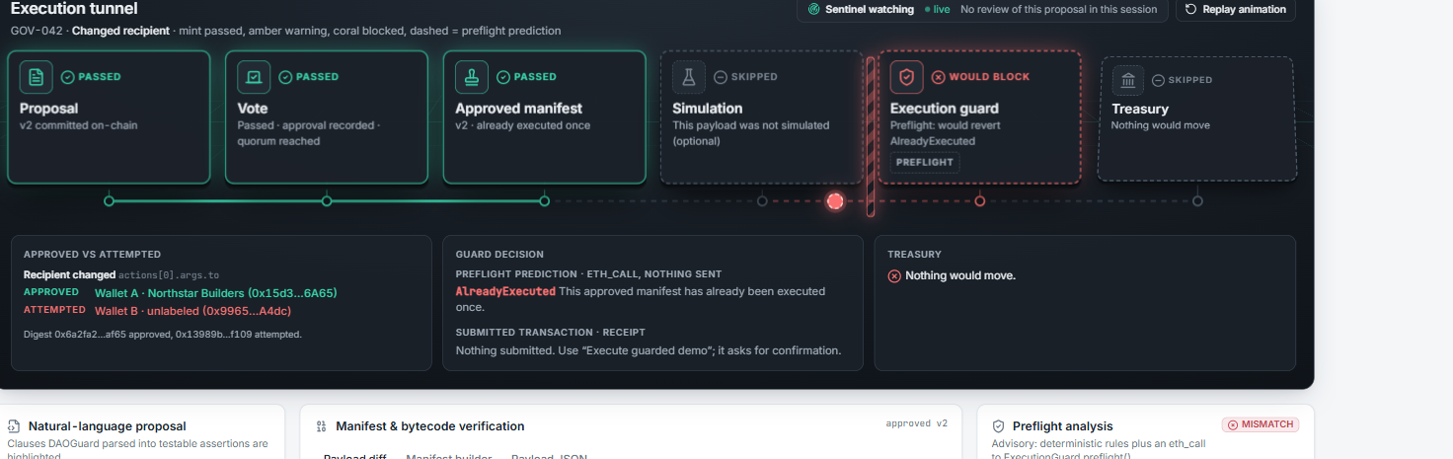
Figure 8. Execution tunnel: Proposal → Vote → Approved manifest → Simulation → Execution guard → Treasury, with the coral barrier at the guard.

7.4 Verify: attack simulation and manifest builder
For upgrades, DAOGuard simulates the submitted implementation and the one reviewers actually audited from the same block with the same probe callers. In GOV-043 the first divergence is syncAccounting(): called by an address hard-coded in the new bytecode, it moves the vault's entire 60,000 mUSDC, while the reviewed code moves nothing. The manifest builder lets reviewers edit actions as fields and see the EIP-712 digest and the guard's own preflight answer update live.
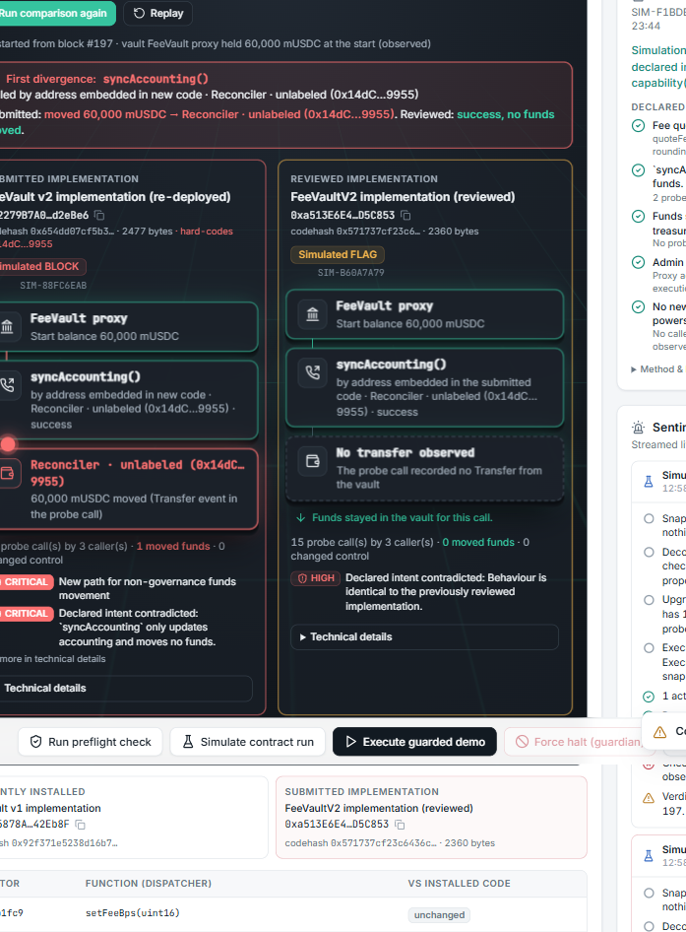  Figure 9. Attack simulation: submitted vs reviewed implementation, first divergence and observed fund movement. | 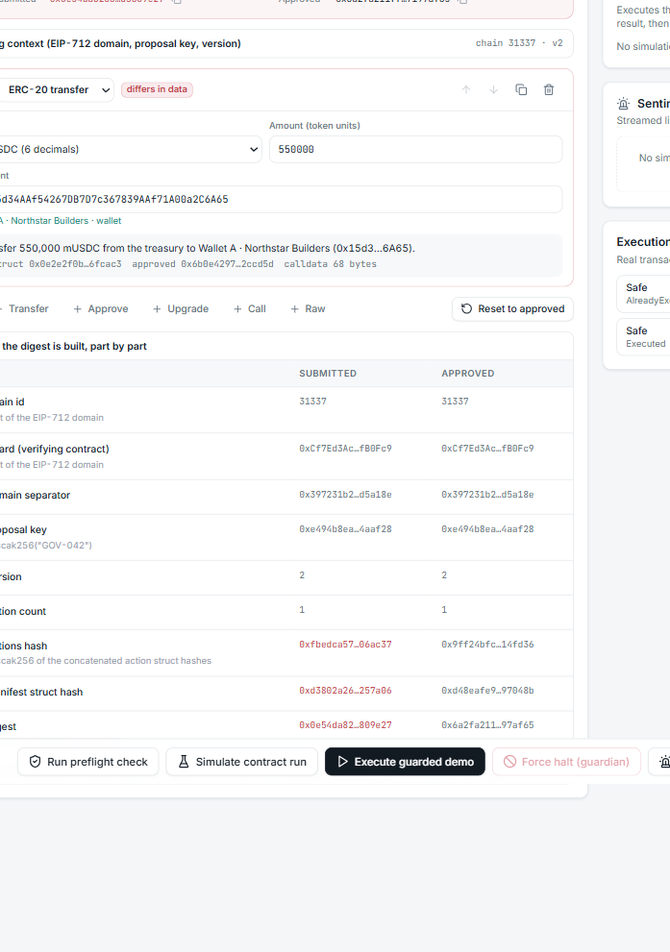  Figure 10. Manifest builder: structured actions, live digest comparison and preflight verdict.

7.5 Quantify and preserve: 3D treasury explorer and audit ledger
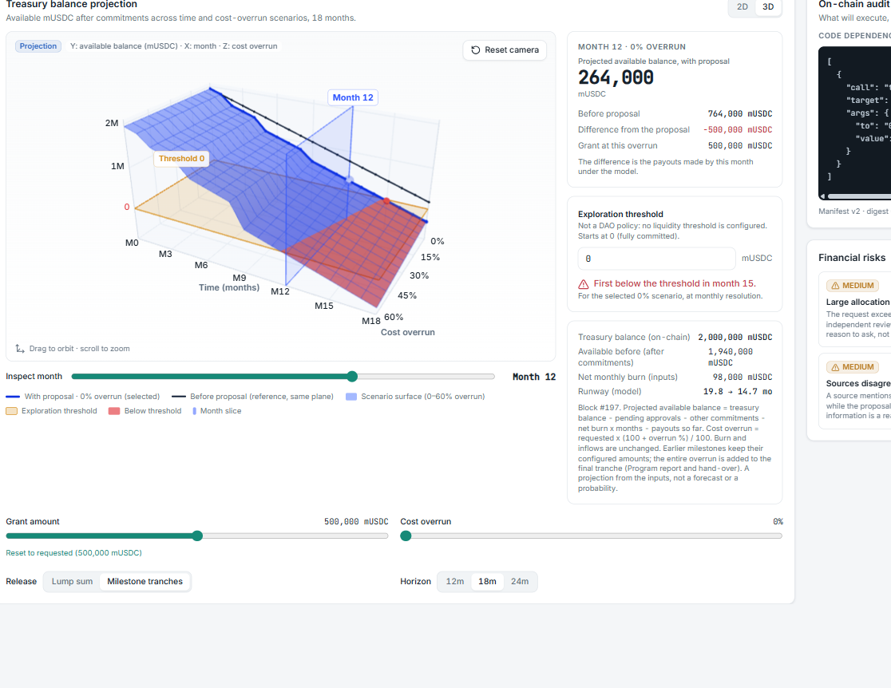
Figure 11. 3D treasury explorer: projected available balance by month and cost overrun, selected scenario, month slice and threshold.
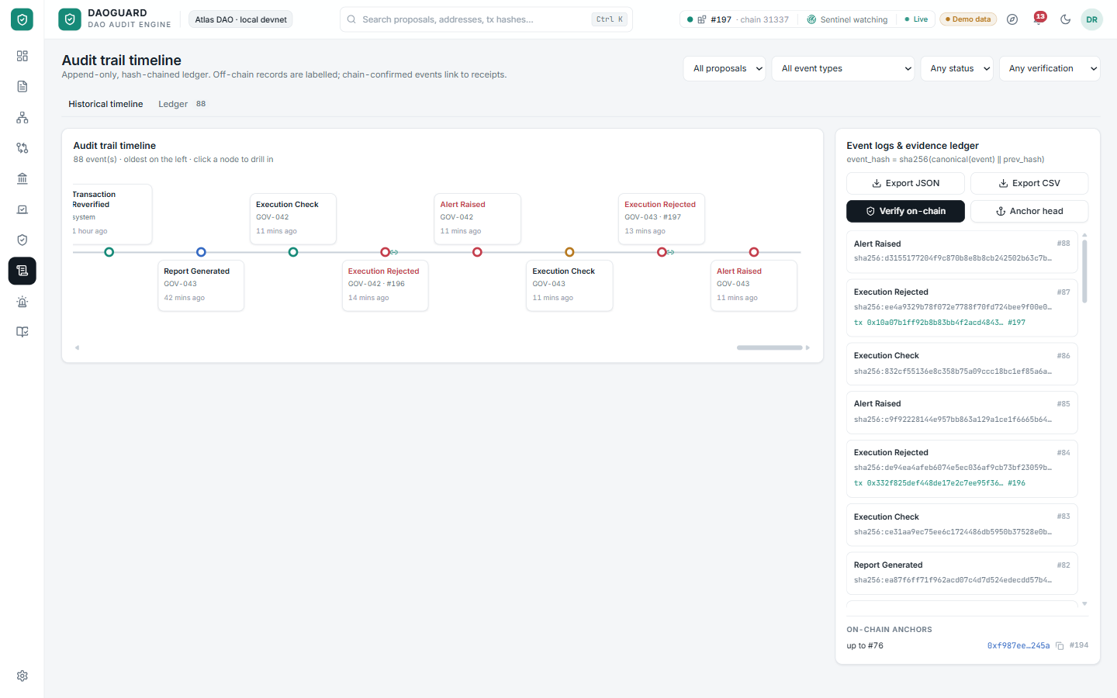
Figure 12. Audit timeline: hash-linked events, chain-confirmed receipts and on-chain anchors.

7.6 UI/UX design
Principle | How it shows in the prototype
Answer first, detail on demand | Every page opens with the verdict (status, estimate, digest match); evidence, formulas and raw payloads sit one click below.
Colour carries meaning | Mint = verified / passed, amber = warning or assumption, coral = mismatch or blocked, dashed = prediction rather than confirmed result.
Evidence is clickable | Citation chips open the source sentence; transaction hashes and addresses open inspector drawers with chain data.
Honest labelling | Demo data, projections, model estimates, manual inputs and AI output are labelled as such on screen.
Accessible and presentable | Light and dark themes, keyboard-operable controls, reduced-motion support, layouts checked at 1280, 1440 and 1920 px.
Guided onboarding | A ten-step tour highlights the real control for each step and waits for the user to perform it.

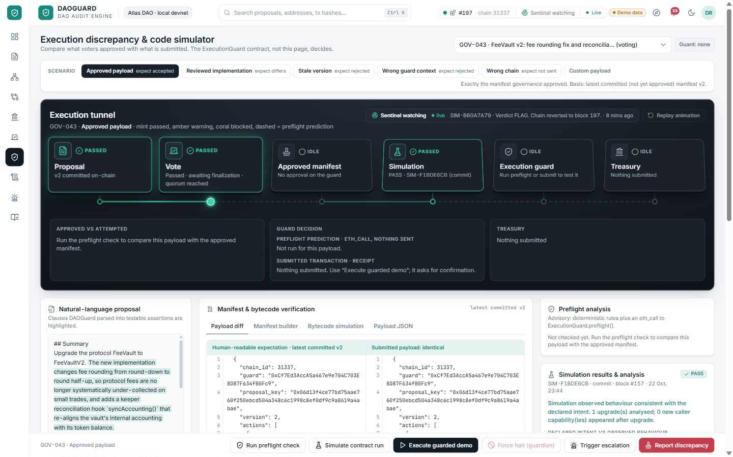
Figure 13. Execution guardian: scenario bar, intent parsing, payload diff, preflight, simulation results and the action bar.
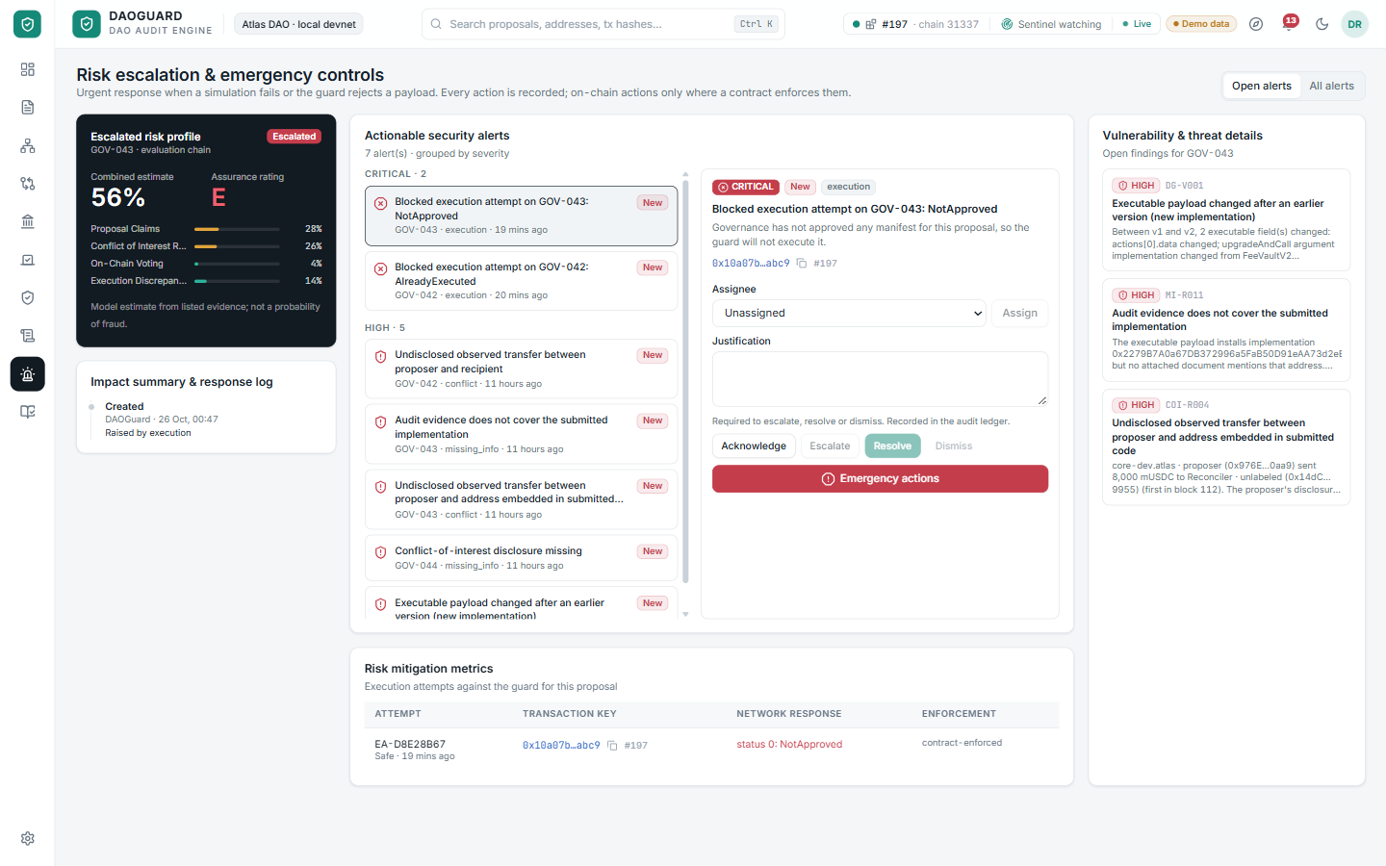
Figure 14. Risk escalation inbox: alerts by severity with triage, escalation and resolution history.

7.7 Worked example: two proposals end to end
Step | GOV-042 · Ecosystem grant (500,000 mUSDC) | GOV-043 · FeeVault upgrade
Brief | Forum post says 520,000; payload says 500,000. Flagged as a contradiction (MI-R012). | Text says the upgrade "moves no funds" and is identical to the reviewed code.
Conflicts | Proposer sent funds to the recipient wallet before the proposal; not disclosed (COI-R001). | New bytecode hard-codes an address linked to the proposer (SIM-R010).
Q&A | Reviewer asks which figure is right; proposer answers with a signed statement. | Audit evidence does not cover the submitted implementation (MI-R011).
Vote | Passes with quorum; manifest v2 approved on the guard. | Passes; finalisation approves the manifest and triggers the sentinel.
Simulation | PASS: one transfer to the approved recipient. | BLOCK: syncAccounting() drains the vault; intent assertions violated.
Execution | Swapped recipient reverts (ManifestMismatch); approved payload executes once; replay reverts (AlreadyExecuted). | Sentinel halts on-chain inside the review window; execution reverts with ProposalIsHalted.
Evidence | Every step in the hash-chained ledger with transaction receipts. | Halt reason hash on-chain; simulation report linked from the ledger.

8. Unique approach, USP and moat
USP | Why it matters | Why it is hard to copy
Approval = one cryptographic digest | Voters approve the exact executable manifest (chain, guard, proposal key, version, every action). Any change reverts. | Requires contract-level integration (ExecutionGuard + Governor) and a canonical manifest format, not a UI feature.
Autonomous sentinel with limited power | Simulates every approval inside the review window and can halt it on-chain, but can never approve or execute. | Combines a snapshot simulator, bytecode probes and a narrowly scoped guardian role.
Evidence-first, injection-safe analysis | Every claim cites its source sentence; instruction-like text in documents is flagged and treated as data. | Extractive rules plus optional labelled AI, instead of an unverifiable summary.
Transparent probability, not a score | Every factor and likelihood ratio is listed and editable. | Calibrated rule library and evidence model built from incident research.
Tamper-evident memory | Hash-chained ledger anchored on-chain; signed disclosures and answers. | Accumulated, verifiable history per DAO becomes a data asset over time.

Moat
- Protocol position: once a DAO routes treasury execution through ExecutionGuard, DAOGuard sits on the critical path of every payout.
- Data network effect: labelled wallets, conflict edges, rule outcomes and incident patterns improve detection for every DAO on the platform.
- Trust and standards: an open manifest format and signed-disclosure schema can become the default way DAOs publish executable decisions.
- Workflow lock-in: delegates, reviewers and proposers share one workspace with history, Q&A and reports.

9. Technical aspect: stack and rationale
Layer | Technology | Used for | Why this choice
Smart contracts | Solidity 0.8.28, OpenZeppelin 5, Hardhat | ExecutionGuard, AtlasGovernor, ProposalRegistry, FeeVault proxy | Battle-tested Governor/proxy code; Hardhat gives a deterministic local chain with snapshots and impersonation.
Chain access | web3.py 7, eth-abi, eth-account | Reads, transactions, EIP-712 signing and recovery, log decoding | Mature Python Ethereum tooling; exact ABI encoding for digests.
Backend API | FastAPI, Pydantic 2, Uvicorn | REST endpoints, validation, Server-Sent Events | Typed, fast, auto-documented; strict input schemas reject coercion.
Persistence | SQLAlchemy 2, SQLite (WAL) | Proposals, findings, Q&A, simulations, audit ledger | Zero-ops for a prototype; swappable for Postgres.
Analysis | Rule engine, pypdf, optional Claude model | Extractive brief, missing-info rules, injection scan, interpretation | Deterministic and cited by default; AI is optional and clearly labelled.
Simulation | evm_snapshot / evm_revert, bytecode analysis, probes | Run exact payloads as the guard, probe new capabilities, then revert | Real execution on real state, leaving the chain untouched.
Frontend | React 18, TypeScript, Vite, Tailwind, React Query | All pages, live updates, caching, accessible controls | Fast iteration, type safety, consistent design tokens (light/dark).
Visualisation | Recharts, d3-force, three.js, CSS 3D | Charts, relationship graph, 3D treasury surface, execution tunnel | Lightweight; three.js loaded lazily only for the 3D view.
Quality | Hardhat tests, pytest, Node test runner | 25 contract, 52 backend and 5 frontend tests | Every rejection case and model calculation is checked automatically.

9.1 Smart-contract design
ExecutionGuard holds the treasury and executes only a manifest whose EIP-712 digest equals the one the Governor approved. The digest binds chain id, guard address, proposal key, version and every action's target, value, calldata and operation, so changing any byte changes the hash.
Custom error | When the guard reverts
ManifestMismatch(approvedHash, submittedHash) | Submitted actions hash to a different digest than governance approved.
NotApproved(proposalKey) | No approval recorded for this proposal.
AlreadyExecuted(proposalKey) | The approved manifest already ran once (replay protection).
ProposalIsHalted(proposalKey, reasonHash) | A guardian or the sentinel halted the approval during review.
ReviewWindowActive(executableAt, current) | Execution attempted before the review window elapsed.
StaleVersion(approved, submitted) | Payload built for an older or different proposal version.
UnsupportedOperation(index, operation) | DELEGATECALL requested; the guard never performs it.
EmptyManifest() · ActionFailed(index, data) | Empty batch, or an action reverted (the whole batch reverts).

AtlasGovernor is an OpenZeppelin Governor whose only executable action is approveManifest(key, version, digest). ProposalRegistry stores version commits verified by the proposer's EIP-712 disclosure signature, audit-ledger anchors and dispute hashes. A FeeVault proxy with honest and backdoored V2 implementations provides the upgrade scenario.

9.2 Rule catalogue
Missing-information rules (proposal text & evidence) | Payload rules (approved vs submitted)
MI-R001 Budget breakdown missing · MI-R002 Delivery milestones missing · MI-R003 No independent audit for the code change · MI-R004 Recipient details not evidenced · MI-R005 Conflict-of-interest disclosure missing · MI-R006 Upgrade plan missing · MI-R007 Rollback plan missing · MI-R008 Risks not described · MI-R009 No supporting evidence · MI-R010 Large allocation without independent review · MI-R011 Audit does not cover the submitted implementation · plus contradiction and prompt-injection checks. | DG-R000 Digest mismatch · R001 Chain changed · R002 Guard changed · R003 Proposal key changed · R004 Stale version · R005 Action missing · R006 Extra action · R007 Target changed · R008 Function changed · R009 Recipient changed · R010 Amount changed · R011 Unapproved privileged call · R012 Arguments changed · R013 DELEGATECALL · R014 Native value changed · R015 Undecodable calldata · R016 Order changed · R017 Upgrade implementation changed.

Each rule states what was searched and where, and the question voters should ask. A missing item is a reason to ask, never evidence of wrongdoing on its own.

9.3 API and data model
Area | Representative endpoints | Stored entities
Proposals & analysis | /proposals, /proposals/{id}, /analyze, /findings, /challenges, /questions | Proposal, ProposalVersion, EvidenceDocument, Disclosure, AnalysisRun, Finding, Challenge, Question
Governance & execution | /governance/*, /manifest, /manifest/preview, /execution-checks, /demo-execution, /halt | ExecutionCheck, ExecutionAttempt
Simulation | /simulations, /simulations/compare | Simulation (report, verdict, chain block)
Treasury | /treasury, /treasury/surface, /treasury/inputs | KeyValue (inputs, policy)
Audit & ops | /audit-events, /audit/verify, /audit/anchors, /alerts, /reports, /stream (SSE) | AuditEvent (hash-chained), AuditAnchor, Alert, Report, Notification

10. Architecture, system flow and user flow
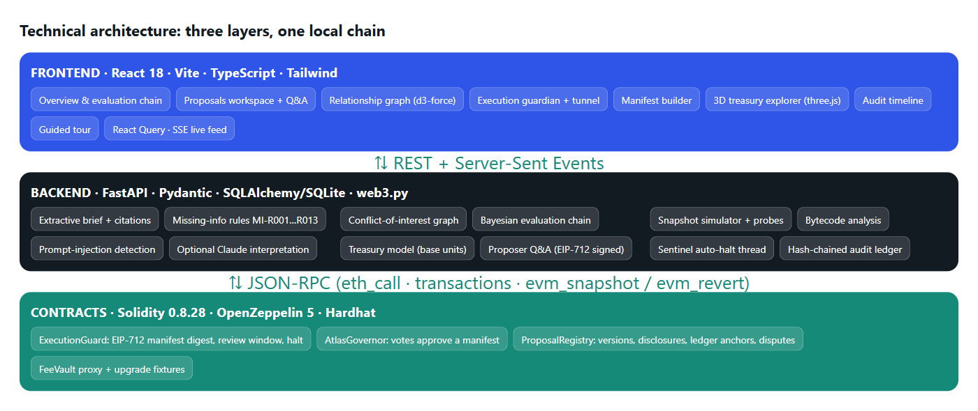
Figure 15. Technical architecture: React frontend, FastAPI services and Solidity contracts on a local Hardhat chain.
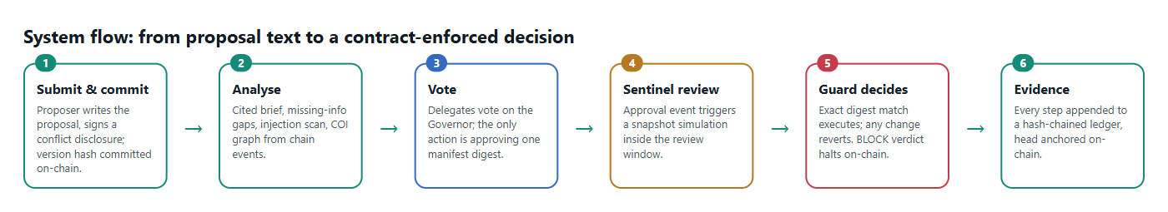
Figure 16. System flow from proposal submission to contract-enforced execution and evidence.
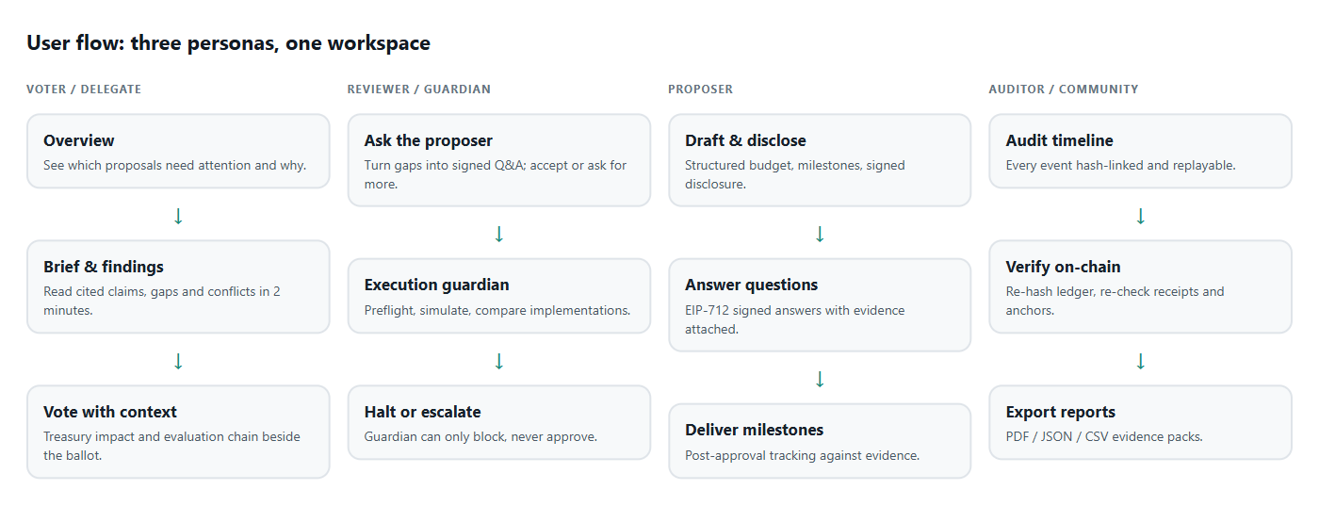
Figure 17. User flow for voters, reviewers, proposers and auditors.

Trust model in brief
Guarantee | Mechanism | Honest limit
Executed payload = approved payload | EIP-712 digest recomputed on-chain by ExecutionGuard | Only protects execution routed through the guard.
Bad approvals can be stopped | Review window + sentinel simulation + guardian halt | Probes cover tested callers and current state; not proof of absence of backdoors.
Records were not edited later | Hash-chained ledger, on-chain anchors, receipt re-checks | Proves integrity of the record, not truth of off-chain statements.
Statements cannot be disowned | EIP-712 signed disclosures and Q&A answers | A signature proves who said it, not that it is true.

11. Testing and validation
Suite | Count | What it proves
Contracts (Hardhat) | 25 | Every guard rejection case, Governor end-to-end flow, registry signatures, upgrade fixtures.
Backend unit (pytest) | 24 | Canonical JSON, Merkle proofs, EIP-712 digest parity with a reference implementation, payload parsing, rules, Bayesian updates, encoders.
Backend integration (pytest) | 28 | Full demo on a fresh chain: tampered payloads revert on-chain, sentinel halts the backdoor, comparison isolation, treasury surface equals the projection, Q&A tamper detection, ledger tamper detection.
Frontend (Node test runner) | 5 | Exact base-unit threshold crossing, month details, stale-result rejection, input parsing.
Browser checks | Manual | Guided tour end to end, execution tunnel journey, comparison replay sends nothing, 3D fallback without WebGL, layouts at three resolutions.

12. Impact
2 min  to understand a proposal | Any  payload change reverts | 5 blocks  review window to halt | Every  step provable later

Who | Before DAOGuard | With DAOGuard
Voters | Skim or follow a delegate; contradictions unnoticed. | Cited brief, gaps and conflicts surfaced; informed votes.
Treasury | Payload swaps and malicious upgrades execute legitimately. | Mismatched payloads revert; malicious approvals halted in the review window.
Proposers | Honest teams cannot prove good faith. | Signed disclosures and answers build reputation.
Ecosystem | Each incident damages trust in DAOs broadly. | A verifiable standard for executable decisions raises the floor for everyone.

Demonstrated in the prototype: a recipient-swap payload is rejected on-chain with ManifestMismatch; the approved payload executes once and a replay is rejected with AlreadyExecuted; an upgrade hiding a fund drain is detected by simulation and halted by the sentinel before it can execute; editing a stored audit event or signed answer is detected on verification.

12.1 Success metrics for a pilot
Metric | How it is measured | Pilot target
Time to understand a proposal | Median reading time of the brief vs the full source documents (user study) | Under 3 minutes
Gap closure rate | Missing-information findings answered and accepted before the vote | Over 60% of high and medium gaps
Undisclosed conflicts surfaced | Conflict findings later confirmed or disclosed by the proposer | Every transfer-based link surfaced before the vote
Payload integrity | Executions through the guard whose digest matched the approval | 100% (mismatches revert on-chain)
Review coverage | Approvals simulated by the sentinel inside the review window | 100% of approvals
Voter confidence | Survey: 'I understood what I voted for' | +30 points vs baseline

13. Feasibility and viability
Dimension | Assessment | Evidence / plan
Technical feasibility | High | Fully working prototype on standard Ethereum tooling; contracts use OpenZeppelin primitives; 82 automated tests.
Integration effort | Moderate | DAOs route treasury execution through ExecutionGuard and have the Governor approve manifest digests; existing Governor DAOs need one upgrade proposal.
Operational feasibility | High | Backend is stateless apart from a database; sentinel is a single watcher process; can run per-DAO or as a hosted service.
Scalability | Good | Analysis is per proposal; simulation is per approval; ledger appends are cheap and anchoring is batched.
Security | Strong by design | Guardian can only block; digest binding is enforced in Solidity; no private keys stored by the app in the demo.
Economic viability | Promising | Protects payouts that are orders of magnitude larger than subscription cost; one prevented incident pays for years of service.

Risks and mitigations
Risk | Mitigation
Adoption friction for existing DAOs | Start with read-only analysis and preflight (no contract change), then offer the guard for new treasuries or grant programmes.
False positives in rules or simulation | Transparent findings with challenges, appeals and reviewer resolution; likelihood ratios editable per DAO.
Sentinel liveness or compromise | Halt power only; multiple independent sentinels possible; review window configurable.
AI misuse or prompt injection | Extractive analysis by default; model output labelled; injection flagged and never overrides rules.

14. Business aspect (summary)
Market. Every DAO with an on-chain treasury, grant programme or upgradeable protocol is a potential customer, alongside the delegate teams, security councils and foundations that serve them. The buyer is usually the treasury or governance working group; the users are voters, delegates and reviewers.
Capability | Voting platforms | Analytics | Simulation tools | DAOGuard
Cited proposal brief & gaps | – | – | – | ✓
Conflict-of-interest graph | – | Partial | – | ✓
Payload simulation | – | – | ✓ | ✓
Execution bound to approval digest | Partial | – | – | ✓
Autonomous halt in review window | – | – | Alerts only | ✓
Tamper-evident decision record | – | – | – | ✓

Tier | For | Includes | Indicative price
Community | Any DAO, voters | Briefs, findings, conflict graph, public reports | Free
Pro | Active DAOs, delegate teams | Q&A, treasury model, alerts, exports, API | Monthly subscription per DAO
Guardian | Treasuries and grant programmes | ExecutionGuard deployment, hosted sentinel, SLA, incident support | Annual contract, scaled to treasury size
Audit packs | Large or contested proposals | Independent review report and simulation evidence | Per proposal

Element | Plan
Customers | DAOs with active treasuries and grant programmes; delegate teams; security councils; protocol foundations.
Revenue model | Free community tier (briefs, findings); Pro subscription per DAO (Q&A, treasury model, reports, alerts); Guardian tier (hosted sentinel, ExecutionGuard deployment, SLA); paid per-proposal audit packs.
Go-to-market | Partner with grant programmes and delegate groups first; integrate as a plugin beside existing voting platforms; open-source the manifest and disclosure standards to drive adoption.
Competitive edge | Only end-to-end link from proposal evidence to contract-enforced execution.
Roadmap | Q1: mainnet-fork simulation and Postgres. Q2: Snapshot/Tally integration, multi-sentinel. Q3: cross-DAO wallet intelligence. Q4: audits of the guard contract and formal manifest standard.

14.1 Roadmap
Phase | Timeline | Scope | Exit criterion
Prototype | Done | End-to-end demo on a local chain: analysis, Q&A, guard, sentinel, ledger, 3D treasury explorer. | All scenarios demonstrable; 82 tests passing.
Pilot | 0–3 months | Mainnet-fork simulation, Postgres, read-only mode for one or two partner DAOs' grant programmes. | Briefs used by delegates on live proposals.
Guarded launch | 3–6 months | Audited ExecutionGuard for a grant treasury; hosted sentinel with alerting; voting-platform integration. | First treasury payouts executed only via approved digests.
Scale | 6–12 months | Cross-DAO wallet intelligence, multiple independent sentinels, open manifest and disclosure standards. | Several DAOs on Pro/Guardian tiers; standard adopted by a second tool.

14.2 Cost structure and partnerships
Cost driver | Notes | Partnership lever
Engineering & security | Core team plus external audits of the guard contract before mainnet use. | Co-funded audits with partner DAOs or ecosystem grants.
Infrastructure | RPC access, simulation nodes, database and hosted sentinels per guarded treasury. | Credits from RPC and node providers; DAO-hosted sentinels option.
Optional AI | Model calls only for labelled interpretation; deterministic analysis needs none. | Usage-based, passed through on higher tiers.
Go-to-market | Delegate programmes, governance forums, hackathons and grant committees. | Integrations with voting platforms and delegate tooling.

Conclusion
DAOGuard turns governance from an act of faith into a verifiable process: voters understand what they approve, the chain executes only what was approved, and everyone can prove it later. The prototype demonstrates every step end to end on a real (local) chain.

Appendix A. Running and demonstrating the prototype
Step | Action | What to show
1 | Run npm run setup once, then npm run dev (or double-click Start-DAOGuard.cmd). Open http://127.0.0.1:5173. | The chain deploys and seeds a 30-day demo history in about 10 seconds.
2 | Click the compass icon to start the guided tour, or follow the steps below. | Ten steps that wait for you to perform each action.
3 | Overview → evaluation chain; Proposals → GOV-042 brief. | Cited claims, the 520k vs 500k contradiction, gaps.
4 | Relationships → GOV-042. | Undisclosed proposer → recipient transfer with its transaction.
5 | Proposals → GOV-044 → Q&A → Review answer → Accept. | The finding resolves and the claims estimate drops.
6 | Financial impact → 3D → Milestone tranches → 30% overrun → month 9 → threshold 500000. | Scenario surface, month slice and first threshold crossing.
7 | Execution guardian → GOV-042 → Changed recipient → Run preflight → Execute guarded demo. | Coral barrier; on-chain revert with ManifestMismatch.
8 | Approved payload → Execute; execute again. | Treasury −500,000 / recipient +500,000; replay rejected with AlreadyExecuted.
9 | GOV-043 → Bytecode simulation → Run comparison; then Proposals → GOV-043 → Finalize vote. | syncAccounting() drain; the sentinel halts the approval live.
10 | Audit timeline → Verify on-chain. | Ledger intact, receipts re-checked, anchors matched.

Appendix B. Glossary
Term | Meaning
DAO | Decentralised Autonomous Organisation: a community that governs a shared treasury and protocol through token votes.
Manifest | The exact list of actions (target, value, calldata, operation) a proposal will execute, bound to chain, guard, proposal and version.
EIP-712 | Ethereum standard for hashing and signing typed structured data; used for manifest digests, disclosures and Q&A answers.
ExecutionGuard | DAOGuard contract that holds funds and executes only the manifest digest governance approved.
Sentinel | Background service that simulates each approval and can halt it on-chain during the review window; it can never approve or execute.
Review window | Blocks between approval and earliest execution, reserved for review and halting.
Preflight | A read-only call to the guard that predicts whether a payload would execute, without sending a transaction.
Likelihood ratio | How much a piece of evidence multiplies the odds that a stage has a material issue.
Audit ledger | Append-only, hash-chained record of every event, with its head periodically anchored on-chain.
mUSDC | Fictional demo stablecoin with 6 decimals used throughout the prototype.

Appendix C. Additional prototype screens
Settings expose the risk model itself: every prior and likelihood ratio used by the evaluation chain, the review policy and the demo reset, so each DAO can tune the model and see exactly why an estimate changed. The 2D treasury view keeps the original projection, scenario table, formulas and dependency checklist alongside the 3D explorer.
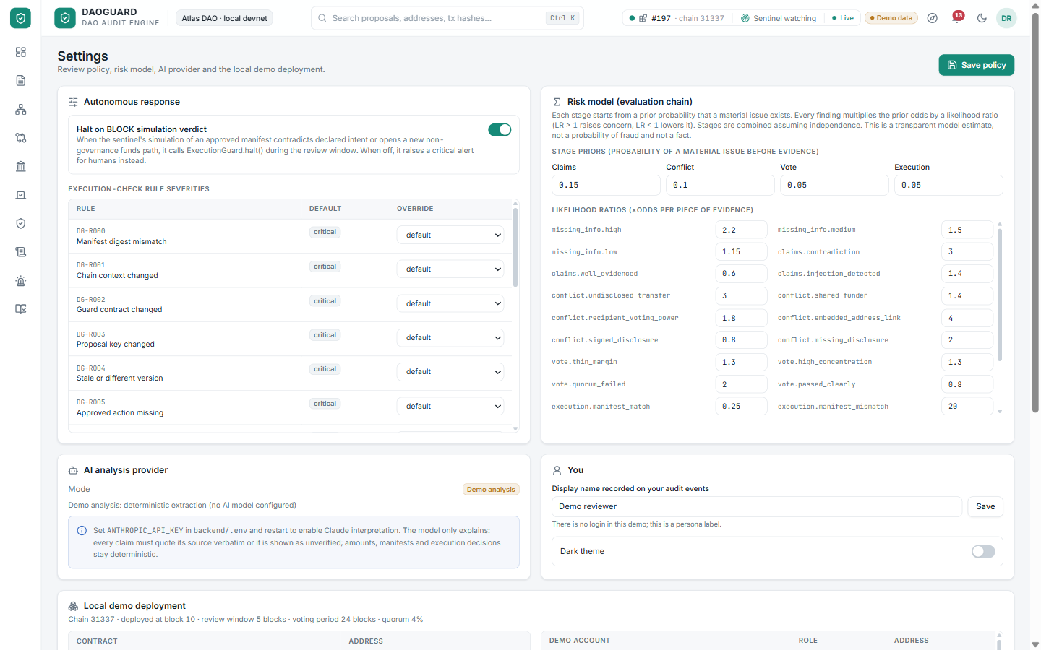
Figure 18. Settings: editable priors, likelihood ratios and review policy behind the evaluation chain.
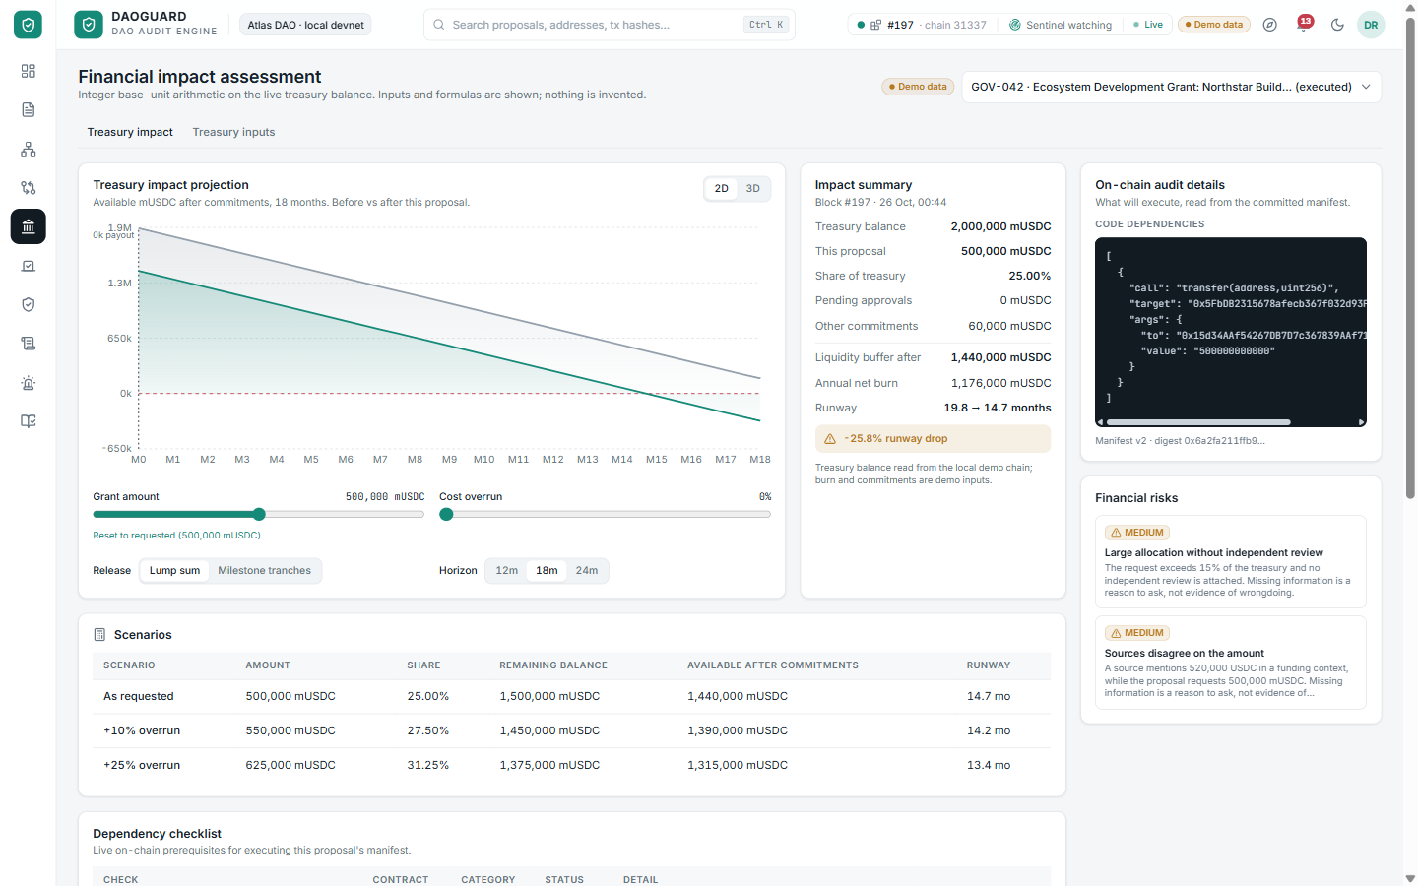
Figure 19. Financial impact (2D): before/after projection, impact summary and on-chain audit details.

