ET Gen AI Hackathon 2026 · Phase 2: Build Sprint
ET AI Concierge
Architecture & Technical Design Document
Problem Statement 7 — AI Concierge for ET
Problem Statement | PS 7 — AI Concierge for ET · ET Gen AI Hackathon 2026
Solution | Multi-agent conversational AI that profiles users in 5 questions and maps them to the right ET products, services, and content — turning passive news readers into active ET ecosystem participants.
Sub-modules | ET Welcome Concierge · Financial Life Navigator · Cross-Sell Engine
Agent count | 4 agents — Profiling Agent (A1), Gap Analyser (A2), ET Mapper (A3), Cross-Sell Trigger (A4)
Core LLM | Claude Sonnet 4.5 via Anthropic API · Structured JSON output mode
Backend | Python 3.11 · FastAPI · Redis · LangGraph orchestration
Frontend | React + TypeScript · Tailwind CSS · Vercel deployment

1. Problem Statement
The Economic Times operates one of India's largest digital ecosystems — ET Prime, ET Markets, ET Money, ET Wealth, ET Edge, ETHRWorld, ETCIO, ETBrandEquity, and 8 vernacular platforms. Despite this breadth, the average ET user interacts with fewer than 10% of available products.
The core failure is structural: there is no personalisation at the entry point. Every user — regardless of age, financial goal, or professional context — encounters the same homepage, the same content feed, and the same generic prompts. ET has no mechanism to learn who a user is or route them to the right product.

1.1 Quantified Problem
Metric | Data point
ET registered users | 10 crore+ (per Times Group disclosures)
ET ecosystem discovery rate | ~10% — average user accesses fewer than 5 of 50+ ET products
Demat account holders in India | 14 crore+ (SEBI, 2024) — most investing without a personalised financial guide
ET Money AUM | ₹28,000 crore managed — yet most ET users are unaware ET Money exists
Life insurance lapse rate | ~60% of policies lapse by year 5 (ET Wealth) — ET has tools to prevent this but users don't find them

1.2 Affected User Profiles
User | Their situation | ET product they never find
Rahul, 28 | Wants to buy a flat in 3 years, has SIPs | ET Prime home guides, ET Wealth credit score, partner home loan comparison
Priya, 35 | Founder, tracks competitors manually | ET Edge summits, ETBrandEquity, ET Prime corporate intelligence
Suresh, 52 | 3 years to retirement, anxious about corpus | ET Money NPS portal, ET Wealth retirement calculators, ET Prime corpus planning
Ananya, 22 | First salary, no investments yet | ET Money Mentor, ET Vernacular (regional language), ET Wealth tax basics

2. Solution Overview
ET AI Concierge is a multi-agent AI system that sits at the ET entry point. It conducts a 5-question natural language conversation, identifies the user's financial life stage and professional context, detects gaps in their current financial situation, and instantly generates a personalised ET product dashboard — mapping each user to the right slice of ET's 50+ product ecosystem.
The concierge operates across three sub-modules defined in PS 7:
Sub-module | Function
ET Welcome Concierge | Greets new and returning users. Conducts smart 5-turn profiling conversation. Extracts life stage, financial goal, investment status, insurance status, and career/financial focus — with no forms.
Financial Life Navigator | Maps the user's complete financial life. Identifies gaps across 6 dimensions: insurance, tax efficiency, investment horizon, home loan readiness, emergency fund, retirement planning. Guides user to relevant ET tools and partner services.
Cross-Sell Engine | Monitors user behaviour post-onboarding. Detects signal thresholds (e.g. 3 real estate articles read → surface home loan comparison). Triggers personalised ET product nudges at the right moment via the concierge chat or toast notifications.

3. End-to-End User Journey
The diagram below shows the complete user journey from landing on ET to receiving a personalised dashboard, including the 4-agent pipeline and the independent background cross-sell trigger.
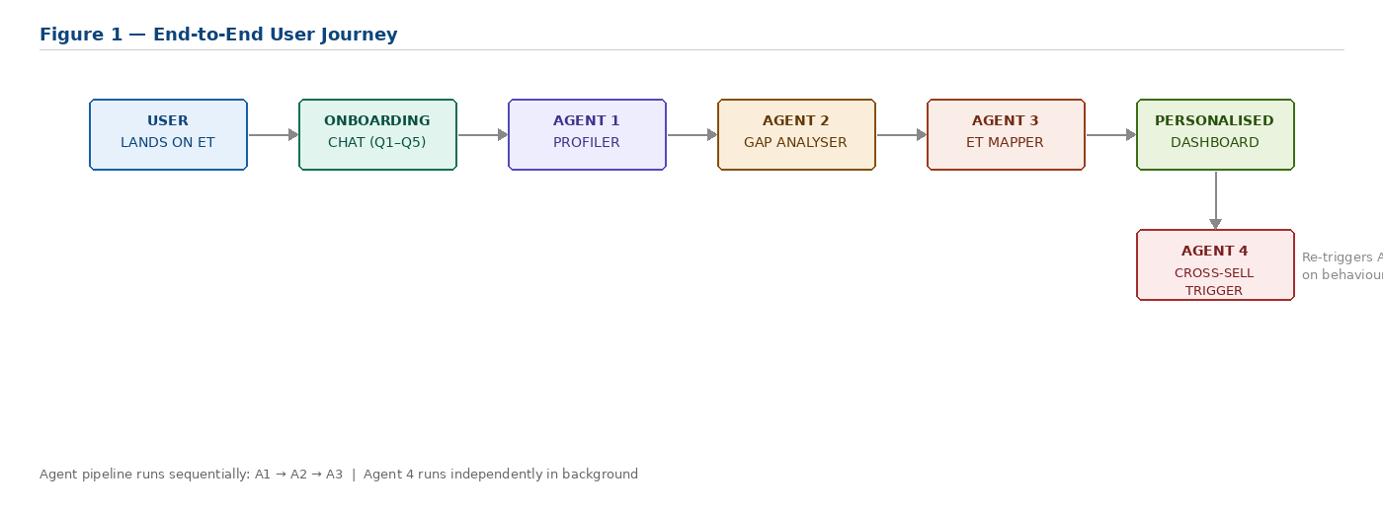

3.1 Onboarding Conversation — 5 Questions
Q | ET asks | Quick reply options
1 | What is your main financial goal right now? | Buy a home · Grow my investments · Plan for retirement · Just started earning
2 | Are you already investing or just getting started? | Have SIPs running · Some FDs and savings · Just starting out · Have a portfolio
3 | What is your age bracket? | Under 25 · 25–35 · 35–45 · 45+
4 | Do you have term insurance in place? | Yes, covered · No, not yet · Not sure what that is
5 | Are you more focused on career growth or financial growth? | Financial growth · Career growth · Both equally

4. Multi-Agent Architecture
The system is composed of four specialised agents. Agents 1, 2, and 3 execute sequentially as a pipeline triggered by completion of the onboarding conversation. Agent 4 runs independently as a background process monitoring user behaviour.
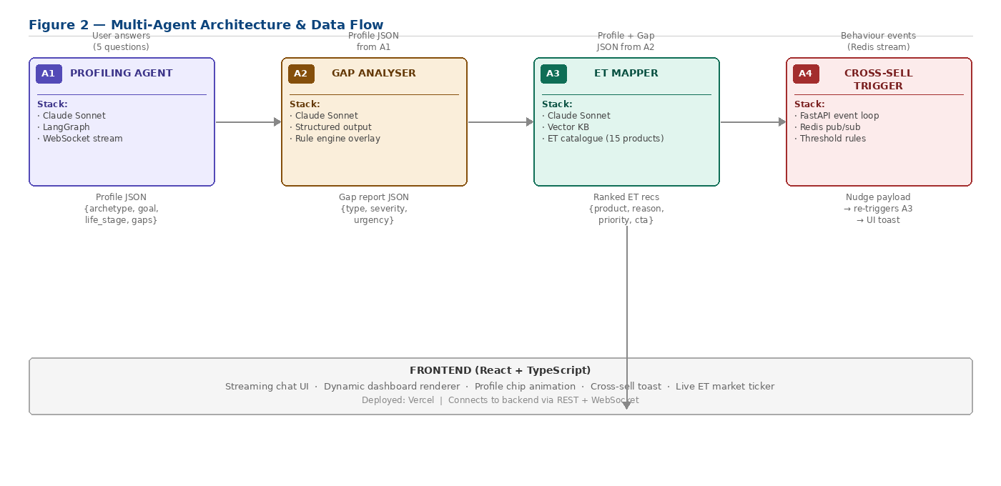

4.1 Agent Specifications
 | Agent | Input | Output | Key technology
A1 | Profiling Agent  Drives the welcome conversation. Picks next question based on prior answer. Detects completion. Handles vague responses. | 5 user answers + session context (device, time, referral) | Profile JSON: age_bracket, goal, investment_status, insurance_status, life_stage, archetype_name, career_focus, professional_vertical | Claude Sonnet 4.5, LangGraph, WebSocket streaming
A2 | Gap Analyser  Evaluates financial health across 6 dimensions. Returns gaps with severity scores and urgency classification. | Profile JSON from A1 | Gap report JSON: gap_type, severity (1–5), title, explanation, urgency (critical / high / medium / low) | Claude Sonnet 4.5, structured JSON output, rule engine overlay
A3 | ET Mapper  Queries ET product catalogue (15 products). Matches archetype + gaps to best ET entry points. Returns ranked, personalised list. | Profile JSON + Gap report JSON from A2 | Ranked recommendations: product_id, product_name, priority, reason, match_tag, cta_text, is_top_pick | Claude Sonnet 4.5, ET product KB (15 products), vector matching
A4 | Cross-Sell Trigger  Runs independently. Monitors user behaviour event stream. Fires when signals cross defined thresholds. | Real-time behaviour event stream (Redis pub/sub) | Trigger event → re-runs A3 → pushes personalised nudge to UI via WebSocket | FastAPI background tasks, Redis pub/sub, threshold rule engine

4.2 Inter-Agent JSON Contracts
All agents communicate via structured JSON. Each agent's output is the next agent's input. This ensures each agent is independently testable and replaceable.
Handoff | JSON payload (key fields)
A1 → A2 | { "age_bracket": "25-35", "goal": "home_purchase", "investment_status": "has_sips", "insurance_status": "no_insurance", "life_stage": "goal_saver", "archetype_name": "Goal-saver", "career_focus": "financial", "professional_vertical": "none" }
A2 → A3 | { "gaps": [ { "gap_type": "no_term_insurance", "severity": 5, "title": "No term insurance", "explanation": "Critical before EMI commitment", "urgency": "critical" }, { "gap_type": "unused_80c_capacity", "severity": 4, "urgency": "high" } ] }
A3 → UI | { "recommendations": [ { "product_id": "et_prime", "product_name": "ET Prime", "priority": 1, "reason": "Deep-dive home buying guides for first-time buyers", "match_tag": "MATCHES YOUR HOME PURCHASE GOAL", "cta_text": "Explore ET Prime", "is_top_pick": true } ] }
A4 → UI | { "trigger": "real_estate_articles_3x", "nudge": { "product": "ET Home Loan", "message": "You've read 3 property articles — check your home loan eligibility now", "channel": "chat_bubble" } }

5. API Architecture
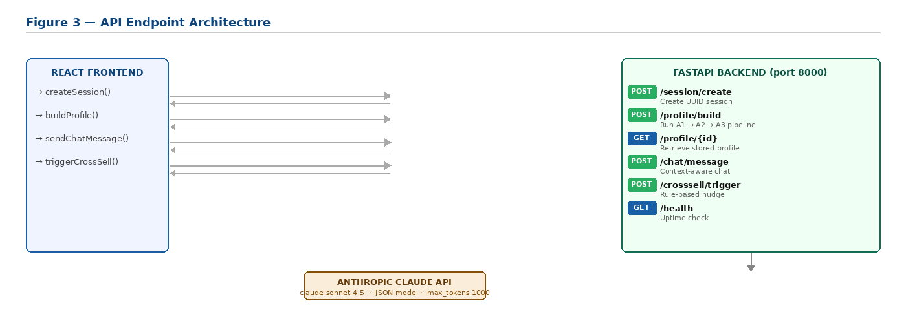

5.1 Endpoint Reference
Method | Endpoint | Function | Calls Claude
POST | /session/create | Generates UUID session ID. Initialises empty session store entry. | No
POST | /profile/build | Main pipeline endpoint. Receives 5 answers. Runs A1 → A2 → A3 sequentially. Returns complete profile, gaps, and ET recommendations. ~4–6 second response. | Yes — 3×
GET | /profile/{session_id} | Returns stored session data. Used if user navigates away and returns. | No
POST | /chat/message | Accepts free-text question from 'Ask ET anything' chat box. Calls Claude with user's profile as context. Returns a 2–3 sentence personalised answer. | Yes — 1×
POST | /crosssell/trigger | Rule-based endpoint. No Claude call. Maps behaviour_event to ET product nudge using predefined threshold rules. | No
GET | /health | Returns server status and timestamp. Used for deployment health checks. | No

6. User Archetypes & ET Product Mapping
Agent 1 classifies every user into one of six archetypes based on their 5 answers. Agent 3 then uses this archetype, combined with detected gaps, to select from a catalogue of 15 ET products.
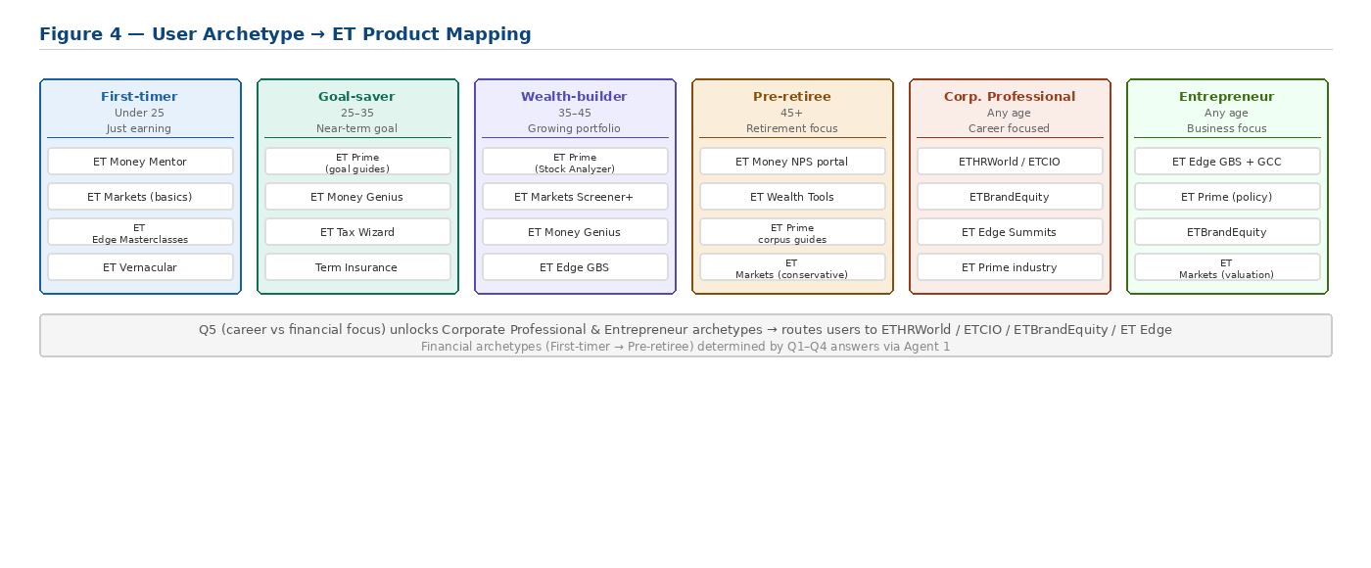

6.1 ET Product Catalogue (Agent 3 Knowledge Base — 15 Products)
ET Product | Description | Best-fit archetypes
ET Prime | Premium research: Prime Shots, Prime Vantage, Prime Decoder. Stock Reports Plus, Big Bull Portfolio, Stock Analyzer (30+ parameters). | Goal-saver, Wealth-builder, Pre-retiree
ET Markets | Live Sensex/Nifty, Screener Plus, Market Mood (fear/greed indicator), 20+ technical indicators, Free Live TV via ET NOW. | Wealth-builder, Goal-saver (SIP track)
ET Money Genius | Commission-free MF investing. Dynamic asset allocation across equity/gold/debt. Monthly auto-rebalancing. Manages ₹28,000 crore AUM. Acquired by 360 ONE Wealth. | First-timer, Goal-saver
ET Wealth Tools | Tax Saving Maximizer, SIP/FD/EPF calculators, insurance guides, free credit score check, retirement planning tools, property & loan advice. | Goal-saver, Pre-retiree
ET Partner — Term Insurance | ₹1 crore term cover quotes. Compare insurers. Instant eligibility. From ₹700/month for 25–35 age bracket. | Goal-saver (no insurance gap)
ET Partner — Home Loan | Compare home loan rates across 20+ banks. Eligibility check. EMI calculator. | Goal-saver (home_purchase goal)
ET Money — NPS & FD | National Pension Scheme portal (world's lowest-cost pension). High-interest FDs from Bajaj Finance and Shriram Finance. DICGC insured. | Pre-retiree
ET Money Mentor | SIP recommendations for beginners. First investment guide. Explainer-first content. For new earners with no investment history. | First-timer
ET Edge — Masterclasses | Masterclasses by Dr. Ram Charan, Seth Godin. Global Business Summit (2000+ leaders). GCC, SCM, ESG, Infrastructure summits. | Corp. Professional, Entrepreneur
ETHRWorld | HR community: CHRO Club (Infosys, Amazon, Tata). Future Forward Summits. Global Learning & Skilling Report. | Corp. Professional (HR vertical)
ETCIO | Tech leadership: CIO Annual Conclave, AI Playbook Index, CIO Satisfaction Survey, DeepTalks series. | Corp. Professional (tech vertical)
ETBrandEquity | Marketing platform for 2M+ professionals. Brand World Summit, The Shark Awards, Seth Godin masterclasses. | Corp. Professional (marketing)
ET Vernacular | ET business news in 8 Indian languages: Hindi, Gujarati, Marathi, Bengali, Tamil, Malayalam, Telugu, Kannada. | Regional investor (any archetype)
ET Markets — Screener Plus | Filter stocks on 30+ fundamental and technical parameters. Market Mood indicator (fear/greed). | Wealth-builder
ET Wealth — Credit Score | Free CIBIL score check via ET Wealth. Critical before home loan application. 60% of applications rejected due to poor CIBIL. | Goal-saver (home_purchase gap)

7. Technology Stack
Layer | Technologies | Responsibility
LLM / AI | Claude Sonnet 4.5 (Anthropic API) · JSON structured output mode · LangGraph agent orchestration | Powers all 3 Claude-calling agents. Guarantees parseable JSON responses.
Backend | Python 3.11 · FastAPI · Uvicorn · Pydantic v2 · python-dotenv | REST API server. Agent pipeline execution. Session management.
Session store | Python in-memory dict (demo) · Redis (production option) | Stores user profile, gaps, and recommendations by session_id.
Real-time comms | WebSocket (FastAPI native) · Redis pub/sub (Agent 4 events) | Streaming LLM responses to chat UI. Cross-sell event propagation.
Frontend | React 18 · TypeScript · Tailwind CSS · Vite build | Onboarding chat, loading animation, personalised dashboard, ET product cards.
Deployment | Vercel (frontend) · Railway / Render (FastAPI backend) | Zero-config deployment. Both free tier. Live demo accessible via URL.
CORS / Security | FastAPI CORSMiddleware · .env for API key · .env.example in repo | Frontend can call backend from any origin. API key never committed to repo.

8. Error Handling & Resilience
Failure scenario | Handling strategy
Claude API timeout / error | Exponential backoff (3 retries, 1s/2s/4s). On sustained failure, returns hardcoded fallback JSON matching the user's archetype. Frontend never shows an error state.
JSON parse failure | Raw Claude response logged. Fallback profile for detected archetype returned. Prevents demo crash.
User gives vague answers | Agent 1 has fallback prompt library. After 2 ambiguous answers, switches to binary-choice quick replies. Minimum viable profile (goal + life stage) is sufficient to trigger A3.
User abandons chat midway | Partial profile saved to session store. On return, A1 resumes from the unanswered question. Minimum 2 answers sufficient for partial recommendations.
A3 returns no matching products | Guaranteed fallback: always return ET Prime + ET Money + ET Markets as baseline. Dashboard is never empty.
Cross-sell trigger overfire | Per-user cooldown: 48 hours between nudges for the same product category. Max 2 nudges per session. User can dismiss permanently.
Session not found | /profile/{id} returns 404. Frontend calls /session/create automatically and restarts onboarding. No user-visible error.

9. Business Impact Model
The following projections are based on published ET/SEBI data and conservative industry conversion benchmarks. All assumptions are stated.
Metric | Estimate & assumption
ET registered users | 10 crore+ (Times Group, 2024)
Users discovering <10% of ET ecosystem | ~9 crore users (90% of base, per PS 7 problem statement)
Concierge deployment (new user onboarding flow) | 30% complete profiling (WhatsApp Business chatbot benchmark: 25–35%)
Discovery improvement: 10% → 30% | 2× product touchpoints per engaged user
ET Prime conversion from concierge-referred users | 5% conversion → ~45 lakh new Prime subscriptions
Partner lead revenue (loan, insurance, wealth mgmt) | ₹500–₹2,000 per qualified lead (financial affiliate industry standard)
Estimated annual revenue impact | ₹200 – ₹500 crore (conservative scenario)

