CSE 102: Data Structures Lab - Lab Task 6
Name: Rishit Agarwal
Registration Number: AP25110070245
Department: B.Tech CSE (AI/ML)

Introduction
This lab focuses on the implementation of the Queue data structure using arrays. Queues follow the First-In, First-Out (FIFO) principle, where the first element inserted is the first one to be removed. We implement both Linear and Circular Queues to understand data flow management and memory optimization techniques.

Question 1: Linear Queue using arrays

Logic:
A Linear Queue uses two pointers, front and rear, to manage the data. The enqueue function adds an element to the rear of the queue, while the dequeue function removes an element from the front. To find an element, the search function iterates through the array from the current front index to the rear index.
#include <stdio.h>
int q[5];
int f = -1, r = -1;
int size = 5;
void enqueueLinear(int val) {
if (r == size - 1) {
printf("Linear Queue Overflow\n");
} else {
if (f == -1) f = 0;
q[++r] = val;
printf("Enqueued %d to Linear Queue\n", val);
}
}
int dequeueLinear() {
if (f == -1 || f > r) {
printf("Linear Queue Underflow\n");
return -1;
} else {
int val = q[f++];
if (f > r) f = r = -1;
return val;
}
}
void searchLinear(int key) {
int found = 0;
if (f == -1) {
printf("Queue is empty\n");
return;
}
for (int i = f; i <= r; i++) {
if (q[i] == key) {
printf("Element %d found at index %d\n", key, i);
found = 1;
break;
}
}
if (!found) printf("Element %d not found\n", key);
}
int main() {
enqueueLinear(10);
enqueueLinear(20);
enqueueLinear(30);
searchLinear(20);
printf("Dequeued: %d\n", dequeueLinear());
return 0;
}

Output:
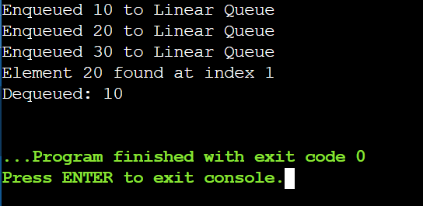

Question 2: Circular queue using arrays

Logic:
A Circular Queue connects the last index of the array back to the first index, forming a circle to prevent memory waste. The enqueue function uses the modulo operator (rear + 1) % size to wrap around the array, and the dequeue function uses (front + 1) % size to move the pointer circularly. This allows the program to reuse empty spaces left by previously dequeued elements.
#include <stdio.h>
int cq[5];
int cf = -1, cr = -1;
int size = 5;
void enqueueCircular(int val) {
if ((cr + 1) % size == cf) {
printf("Circular Queue Overflow\n");
} else {
if (cf == -1) cf = 0;
cr = (cr + 1) % size;
cq[cr] = val;
printf("Enqueued %d to Circular Queue\n", val);
}
}
int dequeueCircular() {
if (cf == -1) {
printf("Circular Queue Underflow\n");
return -1;
} else {
int val = cq[cf];
if (cf == cr) cf = cr = -1;
else cf = (cf + 1) % size;
return val;
}
}
void searchCircular(int key) {
if (cf == -1) {
printf("Queue is empty\n");
return;
}
int i = cf, found = 0;
while (1) {
if (cq[i] == key) {
printf("Element %d found at index %d\n", key, i);
found = 1;
break;
}
if (i == cr) break;
i = (i + 1) % size;
}
if (!found) printf("Element %d not found\n", key);
}
int main() {
enqueueCircular(40);
enqueueCircular(50);
enqueueCircular(60);
searchCircular(50);
printf("Dequeued: %d\n", dequeueCircular());
return 0;
}

Output:
