CSE 102: Data Structures Lab
LAB-TASK-7 REPORT
Name: | Rishit Agarwal
Registration Number: | AP25110070245
Department: | B.Tech CSE (AI/ML)

Introduction
This assignment covers the practical application of Queues and Singly Linked Lists to solve data management problems. We explore logic for reversing processing sequences in logistics, maintaining student roll numbers, and efficiently traversing lists to find specific elements like the middle node.

Question 1: Logistics Queue Reversal
Question: A logistics company needs to reverse the order of package processing without changing the sequence of new arrivals. Implement a system that enqueues codes, prints the original order, reverses the queue, and prints the reversed order.
Logic: We implement a standard queue using an array with front and rear pointers. To reverse the queue, we dequeue each element and push it onto a temporary stack. Once the queue is empty, we pop elements from the stack and enqueue them back into the queue, effectively flipping the order.
#include <stdio.h>
int main() {
int capacity, queue[100], stack[100];
int front = 0, rear = -1, top = -1;
scanf("%d", &capacity);
for (int i = 0; i < capacity; i++) {
scanf("%d", &queue[++rear]);
}
printf("Original queue: ");
for (int i = front; i <= rear; i++) {
printf("%d%s", queue[i], (i == rear) ? "" : " ");
}
printf("\n");
while (front <= rear) {
stack[++top] = queue[front++];
}
front = 0; rear = -1;
while (top >= 0) {
queue[++rear] = stack[top--];
}
printf("Reversed queue: ");
for (int i = front; i <= rear; i++) {
printf("%d%s", queue[i], (i == rear) ? "" : " ");
}
printf("\n");
return 0;
}
Output Screenshot:
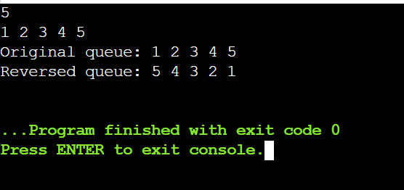

Question 2: Student Roll Numbers (Insert at End)
Question: John needs to manage student roll numbers using a singly linked list. Write a program that accepts roll numbers, inserts them at the end of the list, and displays them.
Logic: For each roll number, a new node is created. If the list is empty, the new node becomes the head. Otherwise, we traverse from the head until we reach the last node (where next is NULL) and link the new node there.
#include <stdio.h>
#include <stdlib.h>
struct Node {
int data;
struct Node* next;
};
void insertEnd(struct Node** head, int val) {
struct Node* newNode = (struct Node*)malloc(sizeof(struct Node));
newNode->data = val;
newNode->next = NULL;
if (*head == NULL) {
*head = newNode;
return;
}
struct Node* temp = *head;
while (temp->next != NULL) temp = temp->next;
temp->next = newNode;
}
int main() {
int N, roll;
struct Node* head = NULL;
scanf("%d", &N);
for (int i = 0; i < N; i++) {
scanf("%d", &roll);
insertEnd(&head, roll);
}
struct Node* temp = head;
while (temp != NULL) {
printf("%d%s", temp->data, (temp->next == NULL) ? "" : " ");
temp = temp->next;
}
return 0;
}
Output Screenshot:
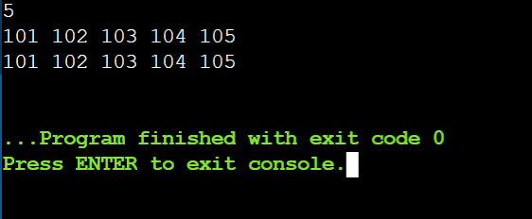

Question 3: Arun’s Linked List Reversal
Question: Populate a singly linked list by inserting elements at the beginning, traverse the list, and then reverse the order of its elements.
Logic: We populate the list using front insertion, which naturally places elements in the reverse of their input order. To perform the actual reversal, we use three pointers (prev, curr, next) to iteratively flip the direction of each node's next pointer.
#include <stdio.h>
#include <stdlib.h>
struct Node {
int data;
struct Node* next;
};
void insertFront(struct Node** head, int val) {
struct Node* newNode = (struct Node*)malloc(sizeof(struct Node));
newNode->data = val;
newNode->next = *head;
*head = newNode;
}
void reverse(struct Node** head) {
struct Node *prev = NULL, *curr = *head, *next = NULL;
while (curr != NULL) {
next = curr->next;
curr->next = prev;
prev = curr;
curr = next;
}
*head = prev;
}
int main() {
int N, val;
struct Node* head = NULL;
scanf("%d", &N);
for (int i = 0; i < N; i++) {
scanf("%d", &val);
insertFront(&head, val);
}
struct Node* temp = head;
while (temp != NULL) { printf("%d ", temp->data); temp = temp->next; }
printf("\n");
reverse(&head);
temp = head;
while (temp != NULL) { printf("%d ", temp->data); temp = temp->next; }
return 0;
}
Output Screenshot:
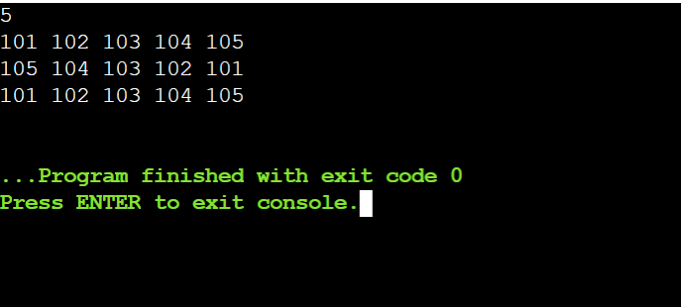

Question 4: Dev’s Middle Element Finder
Question: Create a program that populates a linked list by inserting at the front and accurately identifies the middle element.
Logic: We use the two-pointer approach (Tortoise and Hare). The "fast" pointer moves two nodes at a time while the "slow" pointer moves one node. When the fast pointer reaches the end of the list, the slow pointer will be positioned exactly at the middle node.
#include <stdio.h>
#include <stdlib.h>
struct Node {
int data;
struct Node* next;
};
void insertFront(struct Node** head, int val) {
struct Node* newNode = (struct Node*)malloc(sizeof(struct Node));
newNode->data = val;
newNode->next = *head;
*head = newNode;
}
int main() {
int n, val;
struct Node* head = NULL;
scanf("%d", &n);
for (int i = 0; i < n; i++) {
scanf("%d", &val);
insertFront(&head, val);
}
struct Node* temp = head;
while (temp != NULL) { printf("%d ", temp->data); temp = temp->next; }
printf("\n");
struct Node *slow = head, *fast = head;
while (fast != NULL && fast->next != NULL) {
slow = slow->next;
fast = fast->next->next;
}
printf("Middle Element: %d\n", slow->data);
return 0;
}
Output Screenshot:
