CSE 102: Data Structures Lab - DLL and CLL Tasks
Name: Rishit Agarwal
Registration Number: AP25110070245
Department: B.Tech CSE (AI/ML)

Introduction
This lab focuses on the implementation of Doubly Linked Lists (DLL) and Circular Linked Lists (CLL). These structures allow for more complex data management, such as bidirectional traversal and wrap-around queue logic.

Question 1: Bob's Employee Record Management (DLL)
Logic: A Doubly Linked List is used where each node points to both the previous and next nodes. We perform front insertion by linking the new node to the current head and updating the head's prev pointer. The list status is printed after every insertion.
C Code:
#include <stdio.h>
#include <stdlib.h>
struct Node {
int id;
struct Node *prev, *next;
};
int main() {
int N, val;
struct Node *head = NULL;
scanf("%d", &N);
for (int i = 0; i < N; i++) {
scanf("%d", &val);
struct Node* newNode = (struct Node*)malloc(sizeof(struct Node));
newNode->id = val;
newNode->prev = NULL;
newNode->next = head;
if (head != NULL) head->prev = newNode;
head = newNode;
printf("Node Inserted\n");
struct Node* temp = head;
while (temp != NULL) {
printf("%d ", temp->id);
temp = temp->next;
}
printf("\n");
}
return 0;
}
Output:
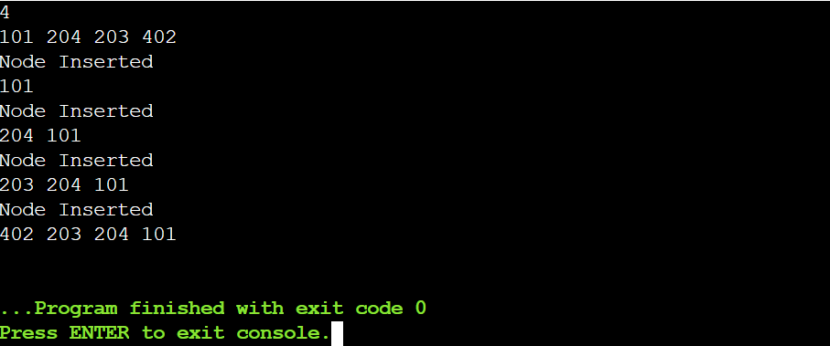

Question 2: Saran's DLL (Remove Last Element)
Logic: Elements are appended to the end of the doubly linked list. To remove the last element, the tail pointer is moved back to the previous node, and the old tail is freed from memory.
C Code:
#include <stdio.h>
#include <stdlib.h>
struct Node {
int data;
struct Node *prev, *next;
};
int main() {
int n, val;
struct Node *head = NULL, *tail = NULL;
scanf("%d", &n);
for (int i = 0; i < n; i++) {
scanf("%d", &val);
struct Node* newNode = (struct Node*)malloc(sizeof(struct Node));
newNode->data = val;
newNode->next = NULL;
if (head == NULL) {
newNode->prev = NULL;
head = tail = newNode;
} else {
newNode->prev = tail;
tail->next = newNode;
tail = newNode;
}
}
if (tail != NULL) {
struct Node* toDelete = tail;
if (tail->prev != NULL) {
tail = tail->prev;
tail->next = NULL;
} else {
head = tail = NULL;
}
free(toDelete);
}
struct Node* temp = head;
while (temp != NULL) {
printf("%d ", temp->data);
temp = temp->next;
}
return 0;
}
Output:
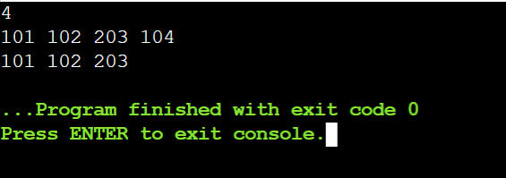

Question 3: Raj's Circular List (Positional Insertion)
Logic: In a Circular Linked List, the last node's next points back to the head. To insert at position M, we traverse to M-1 and bridge the new node into the sequence while maintaining the circular link.
C Code:
#include <stdio.h>
#include <stdlib.h>
struct Node {
int data;
struct Node* next;
};
int main() {
int N, val, pos, i;
struct Node *head = NULL, *tail = NULL;
scanf("%d", &N);
for (i = 0; i < N; i++) {
scanf("%d", &val);
struct Node* newNode = (struct Node*)malloc(sizeof(struct Node));
newNode->data = val;
if (head == NULL) {
head = tail = newNode;
newNode->next = head;
} else {
tail->next = newNode;
newNode->next = head;
tail = newNode;
}
}
scanf("%d %d", &val, &pos);
struct Node* newNode = (struct Node*)malloc(sizeof(struct Node));
newNode->data = val;
struct Node* temp = head;
for (i = 1; i < pos - 1; i++) temp = temp->next;
newNode->next = temp->next;
temp->next = newNode;
temp = head;
do {
printf("%d ", temp->data);
temp = temp->next;
} while (temp != head);
return 0;
}
Output:
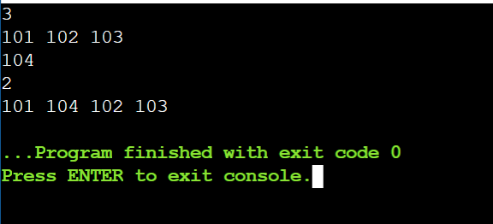

Question 4: Supermarket Queue (CLL Remove Last)
Logic: A supermarket queue is modeled using a circular list. Removing the last person involves finding the node before the tail, setting its next to the head, and deleting the tail node.
C Code:
#include <stdio.h>
#include <stdlib.h>
struct Node {
int id;
struct Node* next;
};
int main() {
int N, i, val;
struct Node *head = NULL, *tail = NULL;
scanf("%d", &N);
for (i = 0; i < N; i++) {
scanf("%d", &val);
struct Node* newNode = (struct Node*)malloc(sizeof(struct Node));
newNode->id = val;
if (head == NULL) {
head = tail = newNode;
newNode->next = head;
} else {
tail->next = newNode;
newNode->next = head;
tail = newNode;
}
}
if (N > 1) {
struct Node* temp = head;
while (temp->next != tail) temp = temp->next;
free(tail);
temp->next = head;
tail = temp;
} else if (N == 1) {
free(head);
head = NULL;
}
if (head != NULL) {
struct Node* temp = head;
do {
printf("%d ", temp->id);
temp = temp->next;
} while (temp != head);
}
return 0;
}
Output:

