CSE 102: Data Structures Lab - Lab Task 9

Name: Rishit Agarwal
Registration Number: AP25110070245
Department: B.Tech CSE (AI/ML)
Introduction
Searching is a fundamental operation in data structures used to retrieve the location of specific data within a collection. This lab focuses on Linear Search (sequential) and Binary Search (divide-and-conquer).
Question 1: Implementation of Linear Search
Logic: A sequential search that examines each element from the start (index 0) until a match is found or the end of the array is reached.
C Code:
#include <stdio.h>
int main() {
int array[100], target, n, found = 0;
printf("Enter number of elements: ");
scanf("%d", &n);
printf("Enter %d integers: ", n);
for (int i = 0; i < n; i++) {
scanf("%d", &array[i]);
}
printf("Enter value to find: ");
scanf("%d", &target);
// Linear Search Logic
for (int i = 0; i < n; i++) {
if (array[i] == target) {
printf("%d is present at index %d.\n", target, i);
found = 1;
break;
}
}
if (found == 0) {
printf("%d is not present in the array.\n", target);
}
return 0;
}
Output:
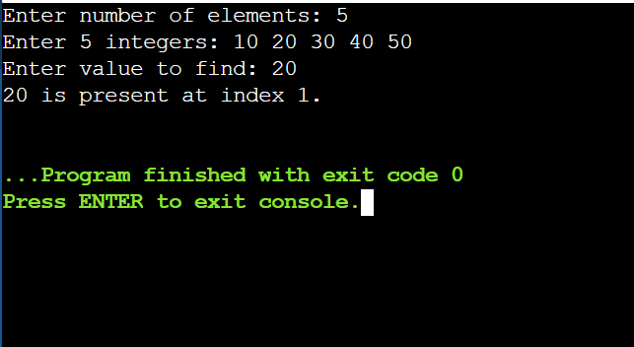

Question 2: Implementation of Binary Search
Logic: An efficient search that works on sorted data by repeatedly halving the search space. It compares the target to the middle element to decide which half to discard.
C Code:
#include <stdio.h>
int main() {
int array[100], n, target, low, high, mid, found = 0;
printf("Enter number of elements (must be sorted): ");
scanf("%d", &n);
printf("Enter %d sorted integers: ", n);
for (int i = 0; i < n; i++) {
scanf("%d", &array[i]);
}
printf("Enter value to find: ");
scanf("%d", &target);
low = 0;
high = n - 1;
// Binary Search Logic
while (low <= high) {
mid = low + (high - low) / 2;
if (array[mid] == target) {
printf("%d found at index %d.\n", target, mid);
found = 1;
break;
}
else if (array[mid] < target) {
low = mid + 1;
}
else {
high = mid - 1;
}
}
if (found == 0) {
printf("Not found! %d is not in the array.\n", target);
}
return 0;
}
Output:
