PRACTICAL – 4
PART – A

Prob 1 | . Password strength (PasswordChecker.java + Driver.java)  (a) In PasswordChecker, check four rules — length ≥ 8, contains an uppercase letter,  contains a digit, contains a special character — using regex (e.g. “.*[A-Z].*”) or  String methods.  (b) Write strength(String pw) that counts how many rules pass and returns “Weak” (0–  1), “Medium” (2–3) or “Strong” (4).  (c) In Driver.main: test several passwords; for each, print which rules passed and the  final label.  Expected output: “abc” → Weak; “Abcd1234!” → Strong.
Code | PasswordChecker.java  public class PasswordChecker {  public static boolean hasLength(String pw) {  return pw.matches(".{8,}");  }  public static boolean hasUpperCase(String pw) {  return pw.matches(".*[A-Z].*");  }  public static boolean hasDigit(String pw) {  return pw.matches(".*\\d.*");  }  public static boolean hasSpecialCharacter(String pw) {  return pw.matches(".*[^a-zA-Z0-9].*");  }  public static String strength(String pw) {  int count = 0;  if (hasLength(pw))  count++;  if (hasUpperCase(pw))  count++;  if (hasDigit(pw))  count++;  if (hasSpecialCharacter(pw))  count++;  if (count <= 1)  return "Weak";  else if (count <= 3)  return "Medium";  else  return "Strong";  }  }  Driver.java  public class Driver {  public static void main(String[] args) {  String[] passwords = {  "abc",  "Password",  "Password1",  "Abcd1234!"  };  for (String pw : passwords) {  System.out.println("Password: " + pw);  System.out.println("Length >= 8: " + PasswordChecker.hasLength(pw));  System.out.println("Has Uppercase: " + PasswordChecker.hasUpperCase(pw));  System.out.println("Has Digit: " + PasswordChecker.hasDigit(pw));  System.out.println("Has Special Character: " + PasswordChecker.hasSpecialCharacter(pw));  System.out.println("Strength: " + PasswordChecker.strength(pw));  System.out.println("---------------------------------");  }  }  }
Output | 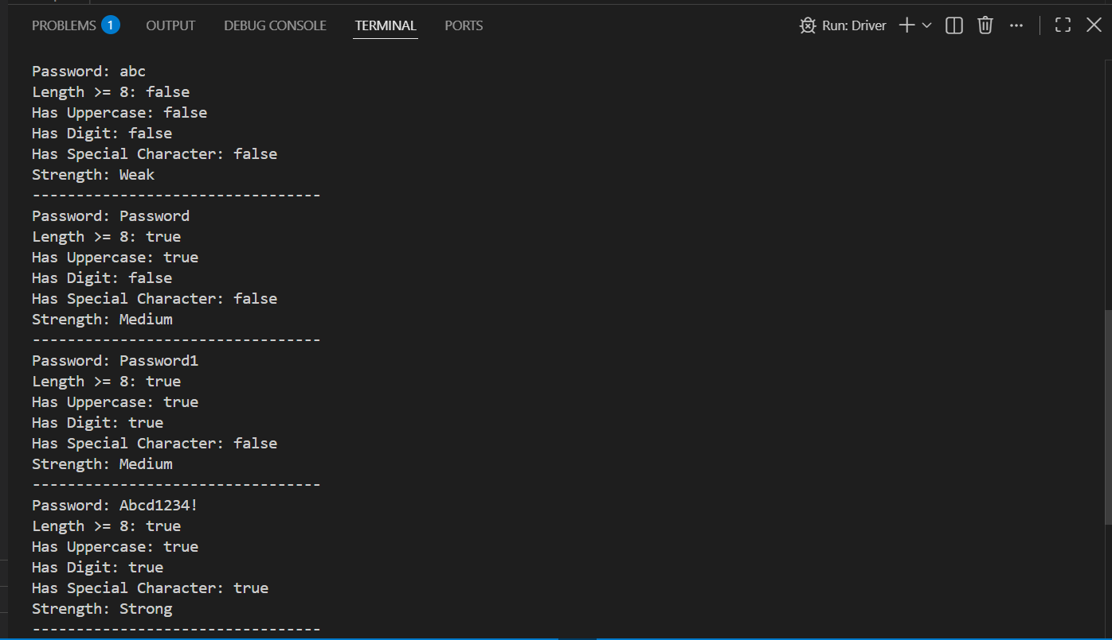

Prob 2

