Java
Practical – 10

Prob 1 | Thread-pool runner: with a fixed pool of 3 (ExecutorService), submit about 10 Runnable  tasks that print their id and sleep briefly; shut down and await completion, observing the  few threads being reused.
Code | import java.util.concurrent.*;  public class ThreadPoolRunner {  public static void main(String[] args)throws InterruptedException, ExecutionException{  ExecutorService executorService = Executors.newFixedThreadPool(3);  for (int i =0; i<10; i++){  int taskNumber = i;  String threadName = Thread.currentThread().getName();  executorService.execute(() -> {  System.out.println(threadName + " is executing task" + taskNumber);  });  try{  Thread.sleep(2000);  } catch (InterruptedException e) {  e.printStackTrace();  }  System.out.println("Task " + taskNumber + " submitted by " + threadName);  }  executorService.shutdown();  }  }
Output | 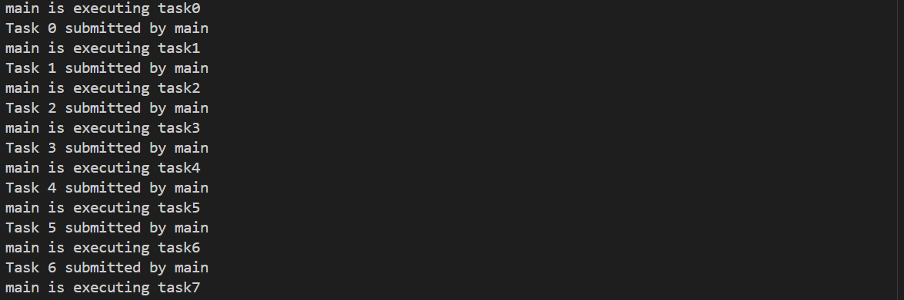

Prob 2 | Producer–consumer: one thread adds numbers to a small shared buffer and another  removes them, coordinated with wait()/notify(); produce and consume a fixed number of  items in order with none lost.
Code | class Buffer {  int[] a = new int[3];  int count = 0;  int next = 1;  synchronized void produce() throws InterruptedException {  while (count == 3)  wait();  while (count < 3 && next <= 10) {  a[count] = next;  System.out.println("Produced: " + next);  count++;  next++;  }  if (count == 3 || next > 10) {  System.out.println("Buffer full/ready");  notify();  wait();  }  }  synchronized void consume() throws InterruptedException {  while (count == 0)  wait();  for (int i = 0; i < count; i++) {  System.out.println("Consumed: " + a[i]);  }  count = 0;  System.out.println("Buffer empty");  notify();  }  }  public class ProducerConsumer {  public static void main(String[] args) {  Buffer b = new Buffer();  Thread p = new Thread(() -> {  try {  while (b.next <= 10)  b.produce();  } catch (InterruptedException e) {  Thread.currentThread().interrupt();  }  });  Thread c = new Thread(() -> {  try {  for (int i = 0; i < 4; i++)  b.consume();  } catch (InterruptedException e) {  Thread.currentThread().interrupt();  }  });  p.start();  c.start();  }  }
Output | 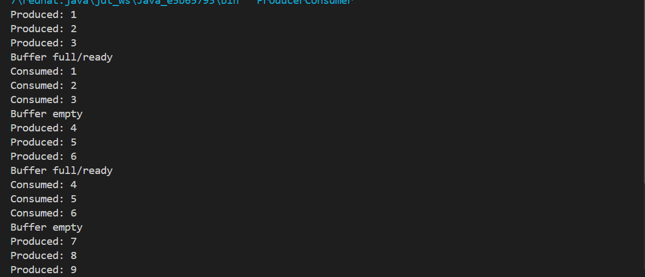

Prob 3 | Reproduce a deadlock between two threads that lock  two objects in opposite order, then remove it with a consistent lock order. Choose the  scenario yourself.
Code | class Deadlock{  static final Object laptop = new Object();  static final Object mouse = new Object();  public static void main(String[] args) {  Thread t1 = new Thread(() -> {  synchronized (laptop) {  System.out.println("Thread 1 locked Laptop");  try { Thread.sleep(100); }  catch (Exception e) {}  System.out.println("Thread 1 waiting for Mouse");  synchronized (mouse) {  System.out.println("Thread 1 locked Mouse");  }  }  });  Thread t2 = new Thread(() -> {  synchronized (mouse) {  System.out.println("Thread 2 locked Mouse");  try { Thread.sleep(100); }  catch (Exception e) {}  System.out.println("Thread 2 waiting for Laptop");  synchronized (laptop) {  System.out.println("Thread 2 locked Laptop");  }  }  });  t1.start();  t2.start();  }  }
Output | 