Java
Practical – 11

Problem 1 | Save/load: make a small class Serializable, save an array of its objects to a file with  ObjectOutputStream, then read it back into fresh objects and confirm the values survived.  Mark one field transient and show it is not saved.
Code | package Lab11;  import java.io.*;  class Student implements Serializable { private static final long serialVersionUID = 1L;  int id;  String name;  transient String password;  Student(int id, String name, String password) {  this.id = id;  this.name = name;  this.password = password;  }  void display() {  System.out.println("ID: " + id);  System.out.println("Name: " + name);  System.out.println("Password: " + password);  System.out.println();  }  }  public class SerializationDemo { public static void main(String[] args) { Student[] students = { new Student(1, "Rahul", "abc123"), new Student(2, "Amit", "xyz456") };  try (ObjectOutputStream out =  new ObjectOutputStream(  new FileOutputStream("students.dat"))) {  out.writeObject(students);  System.out.println("Objects saved successfully.");  } catch (IOException e) {  System.out.println(e.getMessage());  }  try (ObjectInputStream in =  new ObjectInputStream(  new FileInputStream("students.dat"))) {  Student[] loadedStudents =  (Student[]) in.readObject();  System.out.println("\nLoaded Student Details:");  for (Student s : loadedStudents) {  s.display();  }  } catch (IOException | ClassNotFoundException e) {  System.out.println(e.getMessage());  }  }  }
Output | 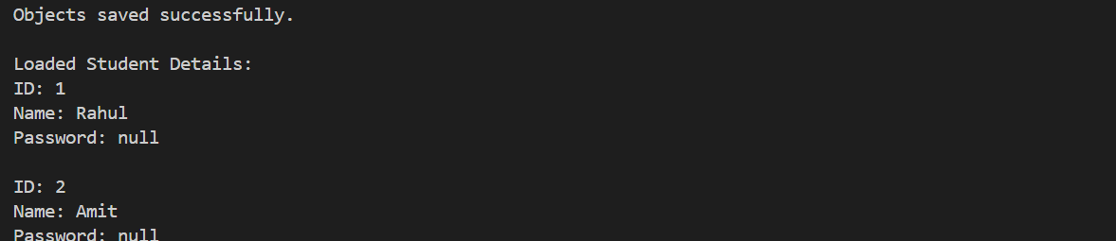

Prob 2 | Log analyzer: create a few text files, then use Path/Files to read each line by line and  count the total lines and how many contain a keyword across all files; also print each  file’s size from its attributes.
Code | package Lab11;  import java.nio.file.*;  import java.io.*;  import java.util.*;  public class LogAnalyzer {  public static void main(String[] args) throws IOException {  // Create sample files  Files.write(Paths.get("log1.txt"), Arrays.asList(  "Java started",  "Error found",  "Program running"  ));  Files.write(Paths.get("log2.txt"), Arrays.asList(  "Error occurred",  "Java completed"  ));  String[] files = {"log1.txt", "log2.txt"};  int totalLines = 0;  int errorLines = 0;  for (String file : files) {  Path path = Paths.get(file);  List<String> lines = Files.readAllLines(path);  totalLines += lines.size();  for (String line : lines) {  if (line.contains("Error")) {  errorLines++;  }  }  System.out.println("File: " + file);  System.out.println("Size: " +  Files.size(path) + " bytes");  }  System.out.println("Total lines: " + totalLines);  System.out.println("Lines containing Error: " + errorLines);  }  }
Output | 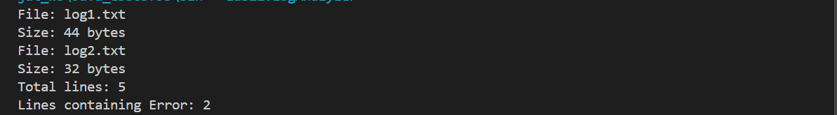

Prob 3 | Walk a folder tree with NIO and produce a report of  the files it contains (name, size, modified time), writing the summary to a file; decide  what to include.
Code | package Lab11;  import java.io.*;  import java.nio.file.*;  import java.nio.file.attribute.*;  import java.util.*;  public class FolderReport {  public static void main(String[] args) throws IOException {  Path folder = Paths.get("sample_folder");  Path report = Paths.get("file_report.txt");  // Create sample folder and files  Files.createDirectories(folder);  Files.write(folder.resolve("first.txt"),  Arrays.asList("Hello Java"));  Files.write(folder.resolve("second.txt"),  Arrays.asList("Learning NIO", "File handling"));  Files.createDirectories(folder.resolve("subfolder"));  Files.write(  folder.resolve("subfolder/third.txt"),  Arrays.asList("Nested file"));  // Generate report  try (PrintWriter writer =  new PrintWriter(  Files.newBufferedWriter(report))) {  writer.println("FOLDER TREE REPORT");  writer.println("==================");  Files.walkFileTree(folder,  new SimpleFileVisitor<Path>() {  @Override  public FileVisitResult visitFile(  Path file, BasicFileAttributes attrs)  throws IOException {  writer.println(  "Name: " + file.getFileName());  writer.println(  "Size: " + attrs.size() + " bytes");  writer.println(  "Modified: " +  attrs.lastModifiedTime());  writer.println();  return FileVisitResult.CONTINUE;  }  });  }  System.out.println(  "Report generated: " + report.toAbsolutePath());  }  }
Output

