Java
Practical – 12

Problem 1 | Word frequency: split a paragraph into words, count each in a HashMap, and print the  words sorted by frequency (highest first) using a Comparator.
Code | package Lab12;  import java.util.*;  public class WordFrequency {  public static void main(String[] args) {  String text = "java is easy java is useful java";  String[] words = text.split(" ");  HashMap<String, Integer> map = new HashMap<>();  for (String word : words) {  if (map.containsKey(word)) {  map.put(word, map.get(word) + 1);  } else {  map.put(word, 1);  }  }  List<String> list = new ArrayList<>(map.keySet());  Collections.sort(list, new Comparator<String>() {  public int compare(String a, String b) {  return map.get(b) - map.get(a);  }  });  for (String word : list) {  System.out.println(word + " : " + map.get(word));  }  }  }
Output | 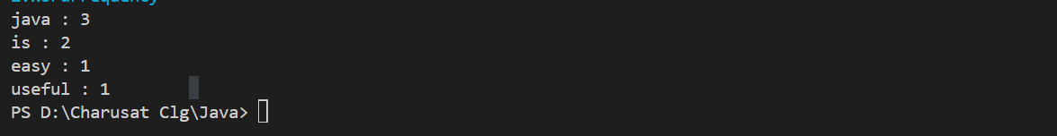

Prob 2 | Unique visitors: from a list of login names with repeats, use a HashSet to count unique  users and a LinkedHashSet to keep first-seen order; print the unique count and the first  three distinct names.
Code | package Lab12;  import java.util.*;  public class UniqueVisitors {  public static void main(String[] args) {  String[] names = {  "Rahul", "Amit", "Rahul",  "Priya", "Amit", "Neha"  };  HashSet<String> set = new HashSet<>();  LinkedHashSet<String> orderedSet = new LinkedHashSet<>();  for (String name : names) {  set.add(name);  orderedSet.add(name);  }  System.out.println("Unique users: " + set.size());  System.out.println("First three unique users:");  int count = 0;  for (String name : orderedSet) {  if (count == 3) {  break;  }  System.out.println(name);  count++;  }  }  }
Output | 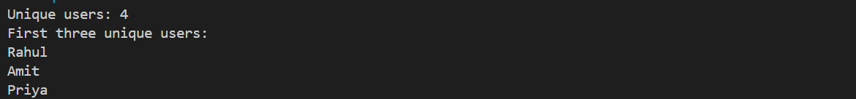

Prob 3 | Build a leaderboard from player scores held in a Map  and print the top-N sorted by score (ties broken by name); choose the data and sorting  details.
Code | package Lab12;  import java.util.*;  public class Leaderboard {  public static void main(String[] args) {  Map<String, Integer> scores = new HashMap<>();  scores.put("Rahul", 90);  scores.put("Amit", 85);  scores.put("Priya", 95);  scores.put("Neha", 90);  List<String> players =  new ArrayList<>(scores.keySet());  Collections.sort(players, new Comparator<String>() {  public int compare(String a, String b) {  if (scores.get(a).equals(scores.get(b))) {  return a.compareTo(b);  }  return scores.get(b) - scores.get(a);  }  });  System.out.println("Top 3 Players:");  for (int i = 0; i < 3; i++) {  String name = players.get(i);  System.out.println(  name + " : " + scores.get(name));  }  }  }
Output

