Java
Practical – 13

Problem 1 | Generic containers: a generic Box<T> with get/set and a Pair<A,B>; use them with  different types to show type safety without casts, and write a generic method that returns  the first element of any array.
Code | package Lab13;  class Box<T> {  T value;  void set(T value) {  this.value = value;  }  T get() {  return value;  }  }  class Pair<A, B> {  A first;  B second;  Pair(A first, B second) {  this.first = first;  this.second = second;  }  void display() {  System.out.println(first + " " + second);  }  }  public class GenericDemo {  static <T> T first(T[] array) {  return array[0];  }  public static void main(String[] args) {  Box<Integer> b1 = new Box<>();  b1.set(100);  System.out.println("Box value: " + b1.get());  Box<String> b2 = new Box<>();  b2.set("Java");  System.out.println("Box value: " + b2.get());  Pair<String, Integer> p =  new Pair<>("Rahul", 20);  p.display();  String[] names = {"Amit", "Rahul", "Neha"};  System.out.println("First name: " + first(names));  Integer[] numbers = {10, 20, 30};  System.out.println("First number: " + first(numbers));  }  }
Output | 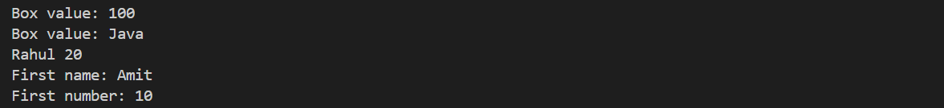

Prob 2 | Bounded stats: a generic method <N extends Number> double average(N[] values) that  works for Integer[], Double[] and Long[]; note why it refuses non-Number types.
Code | package Lab13;  public class AverageDemo {  static <N extends Number> double average(N[] values) {  double sum = 0;  for (N value : values) {  sum = sum + value.doubleValue();  }  return sum / values.length;  }  public static void main(String[] args) {  Integer[] a = {10, 20, 30};  Double[] b = {2.5, 3.5, 4.5};  Long[] c = {100L, 200L, 300L};  System.out.println("Integer average: " + average(a));  System.out.println("Double average: " + average(b));  System.out.println("Long average: " + average(c));  }  }
Output

Prob 3 | Implement a small generic container of your choice  (e.g. a stack) backed by an array, reuse it for two different types, and handle the empty  case sensibly.
Code | package Lab13;  class Stack<T> {  T[] arr;  int top = -1;  @SuppressWarnings("unchecked")  Stack(int size) {  arr = (T[]) new Object[size];  }  void push(T value) {  if (top == arr.length - 1) {  System.out.println("Stack is full");  } else {  arr[++top] = value;  }  }  T pop() {  if (top == -1) {  System.out.println("Stack is empty");  return null;  } else {  return arr[top--];  }  }  }  public class GenericStack {  public static void main(String[] args) {  Stack<Integer> s1 = new Stack<>(5);  s1.push(10);  s1.push(20);  System.out.println(s1.pop());  Stack<String> s2 = new Stack<>(5);  s2.push("Java");  s2.push("Python");  System.out.println(s2.pop());  System.out.println(s2.pop());  System.out.println(s2.pop());  }  }
Output | 