Java
Practical – 14

Prob 1 | Assemble and test: build a tiny layered app (a model, a service using an ArrayList, and a  menu main), then write two or three JUnit @Test methods checking that adding increases  the count and an invalid action throws — practice before testing MiniBank.
Code | Main.java  import java.util.Scanner;  public class Main {  public static void main(String[] args) {  Scanner sc = new Scanner(System.in);  StudentService service = new StudentService();  while (true) {  System.out.println("\n1. Add Student");  System.out.println("2. Show Count");  System.out.println("3. Exit");  System.out.print("Enter choice: ");  int choice = sc.nextInt();  sc.nextLine();  if (choice == 1) {  System.out.print("Enter name: ");  String name = sc.nextLine();  service.addStudent(name);  System.out.println("Student added.");  } else if (choice == 2) {  System.out.println("Total students: "  + service.getCount());  } else if (choice == 3) {  break;  } else {  System.out.println("Invalid choice");  }  }  sc.close();  }  }  Student.java  public class Student {  private String name;  public Student(String name) {  this.name = name;  }  public String getName() {  return name;  }  }  StudentService.java  import java.util.ArrayList;  public class StudentService {  private ArrayList<Student> students = new ArrayList<>();  public void addStudent(String name) {  if (name == null || name.trim().isEmpty()) {  throw new IllegalArgumentException("Invalid name");  }  students.add(new Student(name));  }  public int getCount() {  return students.size();  }  }  StudentServicetest.java  import org.junit.jupiter.api.Test;  import static org.junit.jupiter.api.Assertions.*;  public class StudentServiceTest {  @Test  void testAddStudent() {  StudentService service = new StudentService();  service.addStudent("Rahul");  assertEquals(1, service.getCount());  }  @Test  void testAddTwoStudents() {  StudentService service = new StudentService();  service.addStudent("Rahul");  service.addStudent("Amit");  assertEquals(2, service.getCount());  }  @Test  void testInvalidName() {  StudentService service = new StudentService();  assertThrows(IllegalArgumentException.class,  () -> service.addStudent(""));  }  }
OutPut | 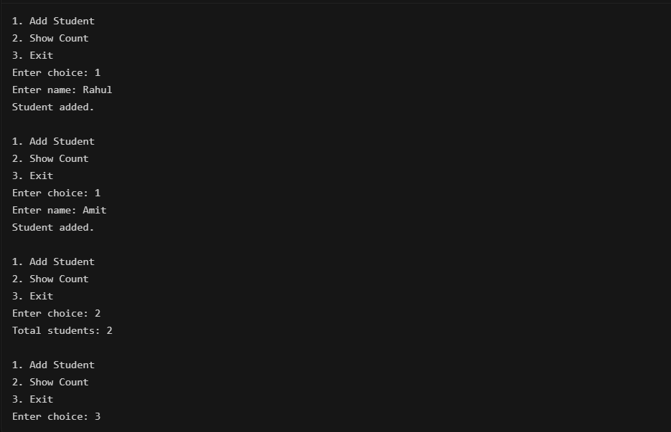

Practical – 2
Main
Main.class | // Source code is decompiled from a .class file using FernFlower decompiler (from Intellij IDEA).  package main;  import java.util.Scanner;  import service.StudentService;  public class Main {  public Main() {  }  public static void main(String[] var0) {  Scanner var1 = new Scanner(System.in);  StudentService var2 = new StudentService();  while(true) {  System.out.println("\n1. Add Student");  System.out.println("2. Show Count");  System.out.println("3. Save Data");  System.out.println("4. Load Data");  System.out.println("5. Exit");  System.out.print("Enter choice: ");  int var3 = var1.nextInt();  var1.nextLine();  if (var3 == 1) {  System.out.print("Enter name: ");  String var10 = var1.nextLine();  try {  var2.addStudent(var10);  System.out.println("Student added.");  } catch (IllegalArgumentException var6) {  System.out.println(var6.getMessage());  }  } else if (var3 == 2) {  System.out.println("Total students: " + var2.getCount());  } else if (var3 == 3) {  System.out.print("Enter filename: ");  String var4 = var1.nextLine();  try {  var2.saveToFile(var4);  System.out.println("Data saved successfully.");  } catch (Exception var8) {  System.out.println("Error saving data: " + var8.getMessage());  }  } else if (var3 == 4) {  System.out.print("Enter filename: ");  String var9 = var1.nextLine();  try {  var2.loadFromFile(var9);  System.out.println("Data loaded successfully.");  } catch (Exception var7) {  System.out.println("Error loading data: " + var7.getMessage());  }  } else {  if (var3 == 5) {  var1.close();  return;  }  System.out.println("Invalid choice");  }  }  }  }
Main.java | package main;  import service.StudentService;  import java.util.Scanner;  public class Main {  public static void main(String[] args) {  Scanner sc = new Scanner(System.in);  StudentService service = new StudentService();  while (true) {  System.out.println("\n1. Add Student");  System.out.println("2. Show Count");  System.out.println("3. Save Data");  System.out.println("4. Load Data");  System.out.println("5. Exit");  System.out.print("Enter choice: ");  int choice = sc.nextInt();  sc.nextLine();  if (choice == 1) {  System.out.print("Enter name: ");  String name = sc.nextLine();  try {  service.addStudent(name);  System.out.println("Student added.");  } catch (IllegalArgumentException e) {  System.out.println(e.getMessage());  }  } else if (choice == 2) {  System.out.println("Total students: " + service.getCount());  } else if (choice == 3) {  System.out.print("Enter filename: ");  String filename = sc.nextLine();  try {  service.saveToFile(filename);  System.out.println("Data saved successfully.");  } catch (Exception e) {  System.out.println("Error saving data: " + e.getMessage());  }  } else if (choice == 4) {  System.out.print("Enter filename: ");  String filename = sc.nextLine();  try {  service.loadFromFile(filename);  System.out.println("Data loaded successfully.");  } catch (Exception e) {  System.out.println("Error loading data: " + e.getMessage());  }  } else if (choice == 5) {  break;  } else {  System.out.println("Invalid choice");  }  }  sc.close();  }  }

Model
Student.class | // Source code is decompiled from a .class file using FernFlower decompiler (from Intellij IDEA).  package model;  import java.io.Serializable;  import java.util.Objects;  public class Student implements Serializable {  private static final long serialVersionUID = 1L;  private String name;  public Student(String var1) {  this.name = var1;  }  public String getName() {  return this.name;  }  public boolean equals(Object var1) {  if (this == var1) {  return true;  } else if (var1 != null && this.getClass() == var1.getClass()) {  Student var2 = (Student)var1;  return Objects.equals(this.name, var2.name);  } else {  return false;  }  }  public int hashCode() {  return Objects.hash(new Object[]{this.name});  }  }
Student.java | package model;  import java.io.Serializable;  import java.util.Objects;  public class Student implements Serializable {  private static final long serialVersionUID = 1L;  private String name;  public Student(String name) {  this.name = name;  }  public String getName() {  return name;  }  @Override  public boolean equals(Object obj) {  if (this == obj) return true;  if (obj == null || getClass() != obj.getClass()) return false;  Student student = (Student) obj;  return Objects.equals(name, student.name);  }  @Override  public int hashCode() {  return Objects.hash(name);  }  }

Service
StudentService.class | // Source code is decompiled from a .class file using FernFlower decompiler (from Intellij IDEA).  package service;  import java.io.FileInputStream;  import java.io.FileOutputStream;  import java.io.IOException;  import java.io.ObjectInputStream;  import java.io.ObjectOutputStream;  import java.util.ArrayList;  import model.Student;  public class StudentService {  private ArrayList<Student> students = new ArrayList();  public StudentService() {  }  public void addStudent(String var1) {  if (var1 != null && !var1.trim().isEmpty()) {  this.students.add(new Student(var1));  } else {  throw new IllegalArgumentException("Invalid name");  }  }  public int getCount() {  return this.students.size();  }  public ArrayList<Student> getStudents() {  return this.students;  }  public void saveToFile(String var1) throws IOException {  ObjectOutputStream var2 = new ObjectOutputStream(new FileOutputStream(var1));  try {  var2.writeObject(this.students);  } catch (Throwable var6) {  try {  var2.close();  } catch (Throwable var5) {  var6.addSuppressed(var5);  }  throw var6;  }  var2.close();  }  public void loadFromFile(String var1) throws IOException, ClassNotFoundException {  ObjectInputStream var2 = new ObjectInputStream(new FileInputStream(var1));  try {  this.students = (ArrayList)var2.readObject();  } catch (Throwable var6) {  try {  var2.close();  } catch (Throwable var5) {  var6.addSuppressed(var5);  }  throw var6;  }  var2.close();  }  }
StudentService.java | package service;  import model.Student;  import java.io.*;  import java.util.ArrayList;  public class StudentService {  private ArrayList<Student> students = new ArrayList<>();  public void addStudent(String name) {  if (name == null || name.trim().isEmpty()) {  throw new IllegalArgumentException("Invalid name");  }  students.add(new Student(name));  }  public int getCount() {  return students.size();  }  public ArrayList<Student> getStudents() {  return students;  }  public void saveToFile(String filename) throws IOException {  try (ObjectOutputStream out = new ObjectOutputStream(new FileOutputStream(filename))) {  out.writeObject(students);  }  }  @SuppressWarnings("unchecked")  public void loadFromFile(String filename) throws IOException, ClassNotFoundException {  try (ObjectInputStream in = new ObjectInputStream(new FileInputStream(filename))) {  students = (ArrayList<Student>) in.readObject();  }  }  }
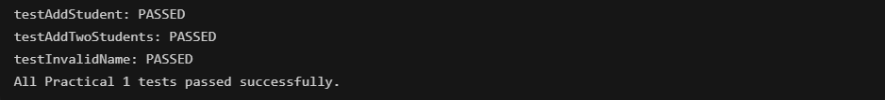

Test

StudentServicetest.class | // Source code is decompiled from a .class file using FernFlower decompiler (from Intellij IDEA).  package test;  import java.io.File;  import org.junit.jupiter.api.Assertions;  import org.junit.jupiter.api.Test;  import service.StudentService;  public class StudentServiceTest {  public StudentServiceTest() {  }  @Test  public void testAddStudent() {  StudentService var1 = new StudentService();  var1.addStudent("Rahul");  Assertions.assertEquals(1, var1.getCount());  }  @Test  public void testAddTwoStudents() {  StudentService var1 = new StudentService();  var1.addStudent("Rahul");  var1.addStudent("Amit");  Assertions.assertEquals(2, var1.getCount());  }  @Test  public void testInvalidName() {  StudentService var1 = new StudentService();  Assertions.assertThrows(IllegalArgumentException.class, () -> var1.addStudent(""));  }  @Test  public void testSaveAndReloadData() throws Exception {  StudentService var1 = new StudentService();  var1.addStudent("Rahul");  var1.addStudent("Amit");  String var2 = "students_test.dat";  var1.saveToFile(var2);  StudentService var3 = new StudentService();  var3.loadFromFile(var2);  Assertions.assertEquals(var1.getCount(), var3.getCount());  Assertions.assertEquals(var1.getStudents(), var3.getStudents());  (new File(var2)).delete();  }  }
StudentServicetest.java | package test;  import service.StudentService;  import org.junit.jupiter.api.Test;  import static org.junit.jupiter.api.Assertions.*;  public class StudentServiceTest {  @Test  public void testAddStudent() {  StudentService service = new StudentService();  service.addStudent("Rahul");  assertEquals(1, service.getCount());  }  @Test  public void testAddTwoStudents() {  StudentService service = new StudentService();  service.addStudent("Rahul");  service.addStudent("Amit");  assertEquals(2, service.getCount());  }  @Test  public void testInvalidName() {  StudentService service = new StudentService();  assertThrows(IllegalArgumentException.class,  () -> service.addStudent(""));  }  @Test  public void testSaveAndReloadData() throws Exception {  StudentService service1 = new StudentService();  service1.addStudent("Rahul");  service1.addStudent("Amit");  String filename = "students_test.dat";  service1.saveToFile(filename);  StudentService service2 = new StudentService();  service2.loadFromFile(filename);  assertEquals(service1.getCount(), service2.getCount());  assertEquals(service1.getStudents(), service2.getStudents());  new java.io.File(filename).delete();  }  }
