Practical 2
Part A

Prob 1 | Smart thermostat (Thermostat.java, main in this file)  (a) Create class Thermostat with private String location, private int temperature, private  static final int MIN=16 and MAX=30, and private static int activeCount=0.  (b) Constructor(location, startTemp): store location; set temperature to startTemp if it is  within MIN..MAX else 22; increment activeCount.  (c) Constructor(location): chain with this(location, 22).  (d) raise(): if temperature < MAX add 1, else print “Already at maximum (30)”.  (e) lower(): if temperature > MIN subtract 1, else print “Already at minimum (16)”.  (f) Add getTemperature() (no setter) and static getActiveCount().  (g) In main: create two thermostats, call raise() 10 times then lower() 20 times in loops  (printing the temperature each time), then print getActiveCount().  Expected output: temperature rises to 30 then “Already at maximum”, falls to 16  then “Already at minimum”, count 2.
Code | public class Thermostat {  private String location;  private int temperature;  private static final int MIN = 16;  private static final int MAX = 30;  private static int activeCount = 0;  public Thermostat(String location, int startTemp) {  this.location = location;  if (startTemp >= MIN && startTemp <= MAX) {  this.temperature = startTemp;  } else {  this.temperature = 22;  }  activeCount++;  }  public Thermostat(String location) {  this(location, 22);  }  public void raise() {  if (temperature < MAX) {  temperature++;  } else {  System.out.println("Already at maximum (30)");  }  }  public void lower() {  if (temperature > MIN) {  temperature--;  } else {  System.out.println("Already at minimum (16)");  }  }  public int getTemperature() {  return temperature;  }  public static int getActiveCount() {  return activeCount;  }  public static void main(String[] args) {  Thermostat t1 = new Thermostat("Bedroom", 22);  Thermostat t2 = new Thermostat("Living Room");  System.out.println("Increasing Temperature:");  for (int i = 1; i <= 10; i++) {  t1.raise();  System.out.println("Temperature: " + t1.getTemperature());  }  System.out.println();  System.out.println("Decreasing Temperature:");  for (int i = 1; i <= 20; i++) {  t1.lower();  System.out.println("Temperature: " + t1.getTemperature());  }  System.out.println();  System.out.println("Active Thermostats: " + Thermostat.getActiveCount());  }  }
Output | 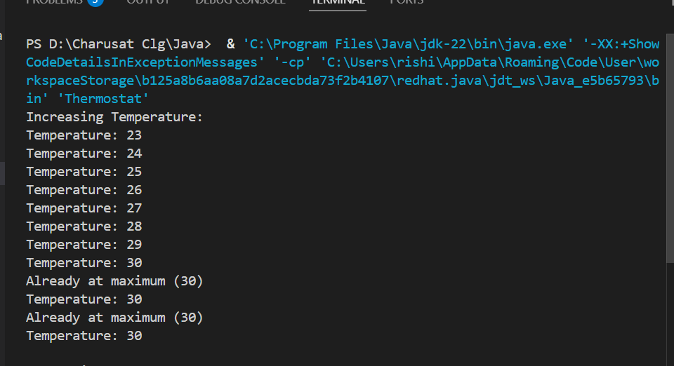
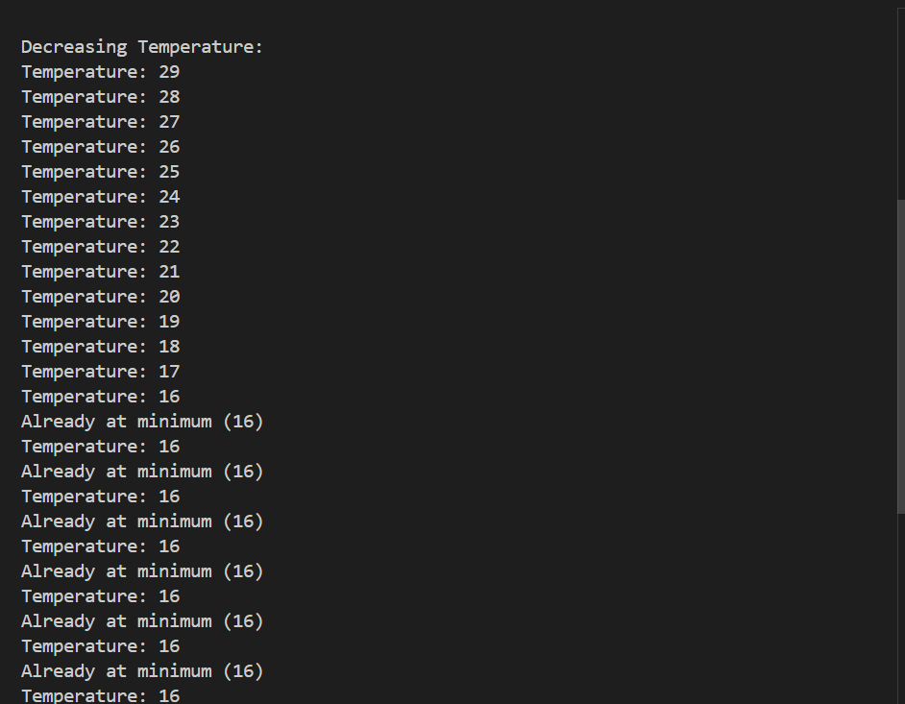
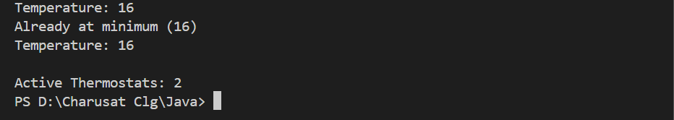

Prob 2 | (a) Create class CinemaShow with private String title, private int seatsAvailable, private  final int capacity, and private static int totalBooked=0.  (b) Constructor(title, capacity): set both and seatsAvailable = capacity.  Constructor(title): chain with this(title, 100).  (c) book(int n): if n ≤ seatsAvailable, reduce seatsAvailable by n, add n to totalBooked,  return true; else return false unchanged.  (d) cancel(int n): increase seatsAvailable by n but never above capacity.  (e) Add getSeatsAvailable() and static getTotalBooked().  (f) In main: run a sequence of book and cancel calls, printing the result and seats after  each, then print getTotalBooked().  Expected output: booking more than available prints false and leaves seats  unchanged; totalBooked equals the successful bookings.
Code | public class CinemaShow {  private String title;  private int seatsAvailable;  private final int capacity;  private static int totalBooked = 0;  public CinemaShow(String title, int capacity) {  this.title = title;  this.capacity = capacity;  this.seatsAvailable = capacity;  }  public CinemaShow(String title) {  this(title, 100);  }  public boolean book(int n) {  if (n <= seatsAvailable) {  seatsAvailable -= n;  totalBooked += n;  return true;  } else {  return false;  }  }  public void cancel(int n) {  seatsAvailable += n;  if (seatsAvailable > capacity) {  seatsAvailable = capacity;  }  }  public int getSeatsAvailable() {  return seatsAvailable;  }  public static int getTotalBooked() {  return totalBooked;  }  public static void main(String[] args) {  CinemaShow show1 = new CinemaShow("Avengers", 50);  System.out.println("Booking 20 seats: " + show1.book(20));  System.out.println("Seats Available: " + show1.getSeatsAvailable());  System.out.println();  System.out.println("Booking 25 seats: " + show1.book(25));  System.out.println("Seats Available: " + show1.getSeatsAvailable());  System.out.println();  System.out.println("Booking 10 seats: " + show1.book(10));  System.out.println("Seats Available: " + show1.getSeatsAvailable());  System.out.println();  show1.cancel(15);  System.out.println("Cancelled 15 seats");  System.out.println("Seats Available: " + show1.getSeatsAvailable());  System.out.println();  System.out.println("Booking 10 seats: " + show1.book(10));  System.out.println("Seats Available: " + show1.getSeatsAvailable());  System.out.println();  show1.cancel(100);  System.out.println("Cancelled 100 seats");  System.out.println("Seats Available: " + show1.getSeatsAvailable());  System.out.println();  System.out.println("Total Booked Seats: " + CinemaShow.getTotalBooked());  }  }
Output | 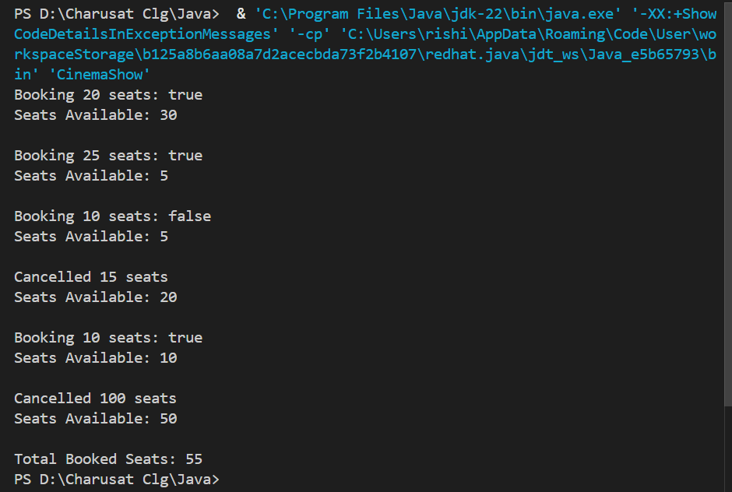

Prob 3 | (For Advanced Learners – home) Parking lot (ParkingLot.java)  (a) Create class ParkingLot with private int twoWheelers and fourWheelers, private final  int twoCap and fourCap, and private static long revenue=0.  (b) park(String type): for “two”, if twoWheelers < twoCap increment and add 20 to  revenue; for “four”, if fourWheelers < fourCap increment and add 40; otherwise print  “Full” and reject.  (c) leave(String type): decrement the matching count but never below 0.  (d) In main: simulate a sequence of park/leave events, printing each outcome, then print  final occupancy and revenue.  Expected output: parking into a full section is refused; revenue = 20×(two parked)  + 40×(four parked).
Code | public class ParkingLot {  private int twoWheelers;  private int fourWheelers;  private final int twoCap;  private final int fourCap;  private static long revenue = 0;  public ParkingLot(int twoCap, int fourCap) {  this.twoCap = twoCap;  this.fourCap = fourCap;  this.twoWheelers = 0;  this.fourWheelers = 0;  }  public void park(String type) {  if (type.equalsIgnoreCase("two")) {  if (twoWheelers < twoCap) {  twoWheelers++;  revenue += 20;  System.out.println("Two-wheeler parked.");  } else {  System.out.println("Two-wheeler section Full");  }  } else if (type.equalsIgnoreCase("four")) {  if (fourWheelers < fourCap) {  fourWheelers++;  revenue += 40;  System.out.println("Four-wheeler parked.");  } else {  System.out.println("Four-wheeler section Full");  }  } else {  System.out.println("Invalid vehicle type.");  }  }  public void leave(String type) {  if (type.equalsIgnoreCase("two")) {  if (twoWheelers > 0) {  twoWheelers--;  System.out.println("Two-wheeler left.");  } else {  System.out.println("No two-wheelers to leave.");  }  } else if (type.equalsIgnoreCase("four")) {  if (fourWheelers > 0) {  fourWheelers--;  System.out.println("Four-wheeler left.");  } else {  System.out.println("No four-wheelers to leave.");  }  } else {  System.out.println("Invalid vehicle type.");  }  }  public int getTwoWheelers() {  return twoWheelers;  }  public int getFourWheelers() {  return fourWheelers;  }  public static long getRevenue() {  return revenue;  }  public static void main(String[] args) {  ParkingLot lot = new ParkingLot(3, 2);  lot.park("two");  lot.park("two");  lot.park("two");  lot.park("two");  lot.park("four");  lot.park("four");  lot.park("four");  lot.leave("two");  lot.leave("four");  lot.park("two");  lot.park("four");  System.out.println();  System.out.println("Final Two-Wheelers: " + lot.getTwoWheelers());  System.out.println("Final Four-Wheelers: " + lot.getFourWheelers());  System.out.println("Total Revenue: " + ParkingLot.getRevenue());  }  }
Output | 