PRACTICAL – 4
PART – A

Prob 1 | . Password strength (PasswordChecker.java + Driver.java)  (a) In PasswordChecker, check four rules — length ≥ 8, contains an uppercase letter,  contains a digit, contains a special character — using regex (e.g. “.*[A-Z].*”) or  String methods.  (b) Write strength(String pw) that counts how many rules pass and returns “Weak” (0–  1), “Medium” (2–3) or “Strong” (4).  (c) In Driver.main: test several passwords; for each, print which rules passed and the  final label.  Expected output: “abc” → Weak; “Abcd1234!” → Strong.
Code | PasswordChecker.java  public class PasswordChecker {  public static boolean hasLength(String pw) {  return pw.matches(".{8,}");  }  public static boolean hasUpperCase(String pw) {  return pw.matches(".*[A-Z].*");  }  public static boolean hasDigit(String pw) {  return pw.matches(".*\\d.*");  }  public static boolean hasSpecialCharacter(String pw) {  return pw.matches(".*[^a-zA-Z0-9].*");  }  public static String strength(String pw) {  int count = 0;  if (hasLength(pw))  count++;  if (hasUpperCase(pw))  count++;  if (hasDigit(pw))  count++;  if (hasSpecialCharacter(pw))  count++;  if (count <= 1)  return "Weak";  else if (count <= 3)  return "Medium";  else  return "Strong";  }  }  Driver.java  public class Driver {  public static void main(String[] args) {  String[] passwords = {  "abc",  "Password",  "Password1",  "Abcd1234!"  };  for (String pw : passwords) {  System.out.println("Password: " + pw);  System.out.println("Length >= 8: " + PasswordChecker.hasLength(pw));  System.out.println("Has Uppercase: " + PasswordChecker.hasUpperCase(pw));  System.out.println("Has Digit: " + PasswordChecker.hasDigit(pw));  System.out.println("Has Special Character: " + PasswordChecker.hasSpecialCharacter(pw));  System.out.println("Strength: " + PasswordChecker.strength(pw));  System.out.println("---------------------------------");  }  }  }
Output | 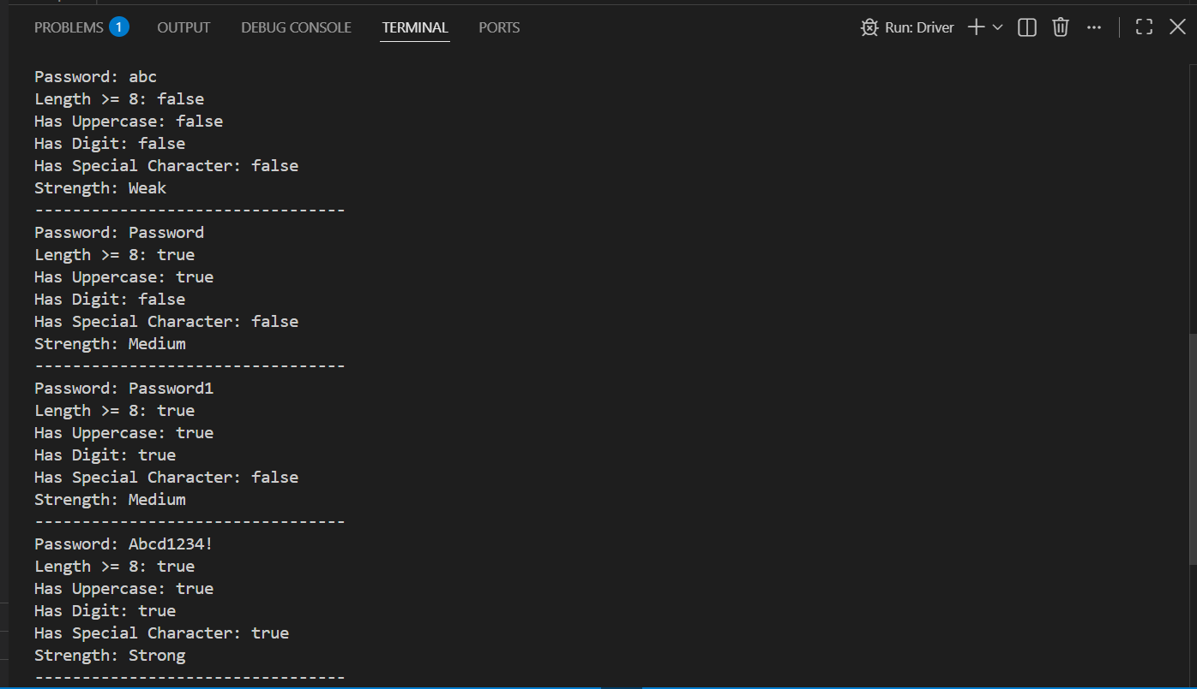

Prob 2 | Chat-log filter (ChatFilter.java + Driver.java)  (a) In Driver.main, define a String[] of log lines like “10:05 alice Hello there” (include  one malformed line with fewer than 3 parts).  (b) Read a keyword from the user.  (c) For each line, split into time/user/message with split(“ ”, 3); skip lines that do not  have 3 parts.  (d) If the message contains the keyword (case-insensitive), increment a counter and  append “time user: message” to a StringBuilder.  (e) Print “Matches: N” and the built report.  Expected output: keyword “hello” over 3 lines (1 malformed) → “Matches: 1” and  the matching line.
Code | ChatFilter.java  public class ChatFilter {  public static String filter(String logs[], String keyWord){  int count = 0;  StringBuilder report = new StringBuilder();  for (String s : logs){  String[] parts = s.split(" ",3);  if (parts.length < 3){  continue;  }  String time = parts[0];  String name = parts[1];  String msg = parts[2];  if (msg.toLowerCase().contains(keyWord.toLowerCase())){  count++;  report.append(time);  report.append(" ");  report.append(name);  report.append(" ");  report.append(msg);  report.append(" ");  }  }  return "Matches: " + count + "\n" + report.toString();  }  }  Driver.java  import java.util.Scanner;  public class Driver{  public static void main(String[] args){  Scanner sc = new Scanner(System.in);  String[] logs =  {  "10:05 alice Hello there",  "10:10 bob How are you?",  "InvalidLine"  };  System.out.println("Enter A Word : ");  String word = sc.next();  String result = ChatFilter.filter(logs, word);  System.out.println(" ");  System.out.println(result);  sc.close();  }  }
Output | 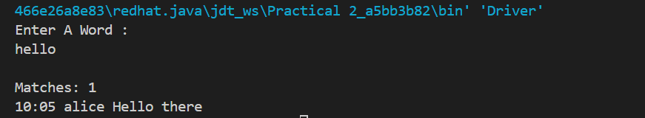

Prob 3 | Template filler (TemplateFiller.java +  Driver.java)  (a) In Driver.main, define a template like “Dear {name}, order {id} ships {date}.” and  two parallel arrays: names {“name”, “id”} and values {“Riya”, “A07”} (note {date}  is not supplied).  (b) Compile a Pattern for \{(\w+)\} and get a Matcher on the template.  (c) Walk the matches with a StringBuilder: for each {placeholder}, look up its value in  the names array and replace with the value, or with “[?]” if not found.  (d) Print the filled template.  Expected output: the unsupplied {date} becomes [?].
Code | TemplateFilter.java  import java.util.regex.Matcher;  import java.util.regex.Pattern;  public class TemplateFilter{  public static String FTemplate(String template, String[] names, String[] values) {  Pattern pattern = Pattern.compile("\\{(\\w+)\\}");  Matcher matcher = pattern.matcher(template);  StringBuilder result = new StringBuilder();  int lastIndex = 0;  while (matcher.find()) {  result.append(template.substring(lastIndex, matcher.start()));  String key = matcher.group(1);  String replacement = "[?]";  for (int i = 0; i < names.length; i++) {  if (names[i].equals(key)) {  replacement = values[i];  break;  }  }  result.append(replacement);  lastIndex = matcher.end();  }  result.append(template.substring(lastIndex));  return result.toString();  }  }  Driver.java  public class Driver {  public static void main(String[] args) {  String template = "Dear {name}, order {id} ships {date}.";  String[] names = {  "name",  "id"  };  String[] values = {  "Rishit",  "089"  };  String output = TemplateFilter.FTemplate(template, names, values);  System.out.println(output);  }  }
Output

