Practical – 5
Part – A

Prob 1 | Shape areas: an abstract Shape with abstract area(); subclasses Circle, Rectangle,  Triangle. Put a mix in a Shape[] and loop once to print each area and the running total,  tracking the largest — one loop handling every shape through polymorphism.
Code | abstract class Shape{ abstract double area(); }  class Circle extends Shape{ int radius = 0; Circle(int radius){ this.radius = radius; }  @Override  double area() {  return Math.PI*radius*radius;  }  }  class Rectangle extends Shape{ int length = 0; int width = 0;  Rectangle(int length , int width){  this.length = length;  this.width = width;  }  @Override  double area(){  return length*width;  }  }  class Triangle extends Shape{ int height = 0; int base = 0;  Triangle(int height, int base){  this.height = height;  this.base = base;  }  @Override  double area(){  return 0.5 * height * base;  }  }  public class Shape1{ public static void main(String[] args){ Shape[] shapes = { new Circle(5), new Rectangle(10, 20), new Triangle(20, 5) };  double total = 0;  double largest = 0;  for(Shape shape: shapes){  double area = shape.area();  total += area;  System.out.println("Area : " + area);  if(area>largest){  largest = area;  }  }  System.out.println("Total Area :" + total);  System.out.println("Largest :" + largest);  }  }
Output | 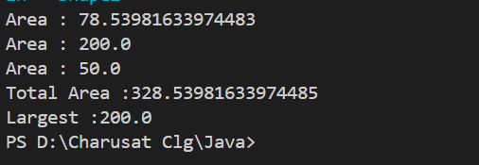

Prob 2 | Payroll: an abstract Employee with abstract monthlySalary(); FullTime (fixed), PartTime  (hours × rate) and Intern (stipend), each calling super for the shared name/id. Loop a  mixed array to print each salary and the total; use instanceof to add a note only for  interns.
Code | abstract class Employee {  String name;  int id;  Employee(String name, int id) {  this.name = name;  this.id = id;  }  abstract int monthlySalary();  }  class FullTime extends Employee {  int salary;  FullTime(String name, int id, int salary) {  super(name, id);  this.salary = salary;  }  @Override  int monthlySalary() {  return salary;  }  }  class PartTime extends Employee {  int hoursWorked;  int hourRate;  PartTime(String name, int id, int hoursWorked, int hourRate) {  super(name, id);  this.hoursWorked = hoursWorked;  this.hourRate = hourRate;  }  @Override  int monthlySalary() {  return hoursWorked * hourRate;  }  }  class Intern extends Employee {  int stipend;  Intern(String name, int id, int stipend) {  super(name, id);  this.stipend = stipend;  }  @Override  int monthlySalary() {  return stipend;  }  }  public class Payroll {  public static void main(String[] args) {  Employee[] employees = {  new FullTime("Rishi", 101, 50000),  new PartTime("keval", 102, 80, 200),  new Intern("shreyansh", 103, 10000),  new FullTime("hasti", 104, 45000)  };  int total = 0;  for (Employee employee : employees) {  int salary = employee.monthlySalary();  System.out.println(  employee.name + " (ID: " + employee.id + ") Salary: " + salary  );  total += salary;  if (employee instanceof Intern) {  System.out.println("Note: This employee is an intern.");  }  }  System.out.println("Total Payroll: " + total);  }  }
OutPut | 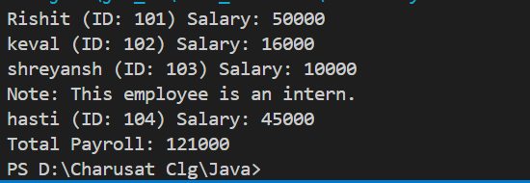

Prob 3 | Model a few media types that each compute a late fee  differently and total the fees for a returned batch. Design the hierarchy and rules yourself.
Code | abstract class Media { String title; int daysLate;  Media(String title, int daysLate) {  this.title = title;  this.daysLate = daysLate;  }  abstract int lateFee();  }  class Movie extends Media {  Movie(String title, int daysLate) {  super(title, daysLate);  }  @Override  int lateFee() {  return daysLate * 20;  }  }  class Game extends Media {  Game(String title, int daysLate) {  super(title, daysLate);  }  @Override  int lateFee() {  return daysLate * 40;  }  }  class Book extends Media {  Book(String title, int daysLate) {  super(title, daysLate);  }  @Override  int lateFee() {  return daysLate * 10;  }  }  public class MediaRental { public static void main(String[] args) {  Media[] returnedMedia = {  new Movie("Avatar", 3),  new Game("GTA", 2),  new Book("Java OOP", 5),  new Movie("Batman", 2),  new Game("FIFA", 3)  };  int totalFee = 0;  for (Media media : returnedMedia) {  int fee = media.lateFee();  System.out.println(  media.title + " | Days Late: " +  media.daysLate + " | Late Fee: ₹" + fee  );  totalFee += fee;  }  System.out.println("-------------------------");  System.out.println("Total Late Fees: ₹" + totalFee);  }  }
Output | 