Practical – 6
Part – A

Prob 1 | Remote control: an interface Switchable with on()/off() and a default toggle(); Fan and  Light implement it. Loop over a Switchable[] toggling each. Then add a functional  interface that decides, given a device and an hour, whether it may switch on, and supply it  once as an anonymous class and once as a lambda.
Code | interface Switchable {  void on();  void off();  default void toggle() {  System.out.println("Toggling device...");  }  }  class Fan implements Switchable {  public void on() {  System.out.println("Fan is ON");  }  public void off() {  System.out.println("Fan is OFF");  }  public void toggle() {  System.out.println("Fan toggled");  }  }  class Light implements Switchable {  public void on() {  System.out.println("Light is ON");  }  public void off() {  System.out.println("Light is OFF");  }  public void toggle() {  System.out.println("Light toggled");  }  }  interface SwitchPermission {  boolean maySwitchOn(Switchable device, int hour);  }  public class RemoteControl {  public static void main(String[] args) {  Switchable[] devices = {  new Fan(),  new Light()  };  for (Switchable device : devices) {  device.toggle();  }  SwitchPermission permission1 = new SwitchPermission() {  public boolean maySwitchOn(Switchable device, int hour) {  return hour >= 6 && hour <= 22;  }  };  System.out.println(  "Anonymous class: " +  permission1.maySwitchOn(new Fan(), 10)  );  SwitchPermission permission2 =  (device, hour) -> hour >= 6 && hour <= 22;  System.out.println(  "Lambda: " +  permission2.maySwitchOn(new Light(), 23)  );  }  }
Output | 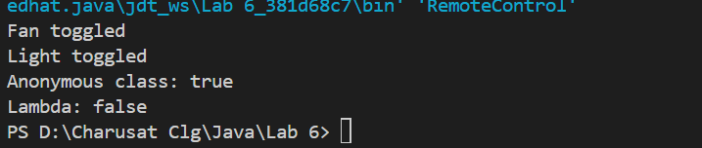

Prob 2 | Notification senders: a functional interface Notifier with send(String); make email and  SMS senders as lambdas, hold them in an array, and broadcast one message through all.  Add a marker interface Urgent and send twice for senders marked urgent.
Code | @FunctionalInterface  interface Notifier {  void send(String message);  }  interface Urgent {  }  class UrgentNotifier implements Notifier, Urgent {  private Notifier notifier;  UrgentNotifier(Notifier notifier) {  this.notifier = notifier;  }  public void send(String message) {  notifier.send(message);  }  }  public class NotificationSenders{  public static void main(String[] args) {  Notifier email = message ->  System.out.println("Email: " + message);  Notifier sms = message ->  System.out.println("SMS: " + message);  Notifier urgentEmail =  new UrgentNotifier(email);  Notifier[] senders = {  urgentEmail,  sms  };  String message = "Server maintenance at 10 PM";  for (Notifier sender : senders) {  sender.send(message);  if (sender instanceof Urgent) {  sender.send(message);  }  }  }  }
Output | 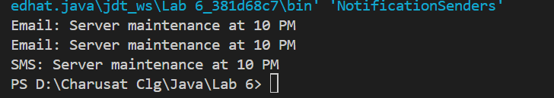

Prob 3 | Build a small discount engine where each rule is a  lambda the user picks at runtime and applies to a list of prices; organise it into packages  and ship it as a runnable JAR.
Code | DiscountRule.java  @FunctionalInterface  interface DiscountRule {  double apply(double price);  }  DiscountEngine.java  import java.util.*;  public class DiscountEngine {  public static void main(String[] args) {  Scanner sc = new Scanner(System.in);  List<Double> prices = Arrays.asList(  500.0,  1000.0,  2000.0,  3000.0  );  System.out.println("Choose Discount Rule:");  System.out.println("1. 10% Discount");  System.out.println("2. 20% Discount");  System.out.println("3. Rs. 100 Discount");  int choice = sc.nextInt();  DiscountRule rule;  switch (choice) {  case 1:  rule = price -> price * 0.90;  break;  case 2:  rule = price -> price * 0.80;  break;  case 3:  rule = price -> price - 100;  break;  default:  System.out.println("Invalid choice");  sc.close();  return;  }  System.out.println("\nOriginal -> Discounted");  for (double price : prices) {  double discountedPrice = rule.apply(price);  System.out.println(  price + " -> " + discountedPrice  );  }  sc.close();  }  }
Output | 