Java
Practical – 8

Prbl 1 | Guarded calculator: read two numbers and an operator; throw a custom  DivideByZeroException and catch invalid-number input separately, printing a clear  message each time; loop until a valid calculation succeeds and use finally to log each  attempt.
Code | import java.util.Scanner;  class DivideByZeroException extends Exception {  DivideByZeroException(String message) {  super(message);  }  }  public class Guardedcalculator {  public static void main(String[] args) {  Scanner sc = new Scanner(System.in);  while (true) {  try {  System.out.println("Enter A Number : ");  int a = Integer.parseInt(sc.next());  System.out.println("Enter A Operator : ");  String OP = sc.next();  System.out.println("Enter Another Number : ");  int b = Integer.parseInt(sc.next());  if (OP.equals("+")) {  System.out.println("Result = " + (a + b));  }  else if (OP.equals("-")) {  System.out.println("Result = " + (a - b));  }  else if (OP.equals("*")) {  System.out.println("Result = " + (a * b));  }  else if (OP.equals("/")) {  if (b == 0) {  throw new DivideByZeroException(  "Cannot divide by zero"  );  }  System.out.println("Result = " + (a / b));  }  else {  System.out.println("Invalid Operator");  continue;  }  break;  } catch (NumberFormatException e) {  System.out.println("Invalid number");  } catch (DivideByZeroException e) {  System.out.println("Error: " + e.getMessage());  } finally {  System.out.println("Attempt logged.");  }  }  sc.close();  }  }
Output | 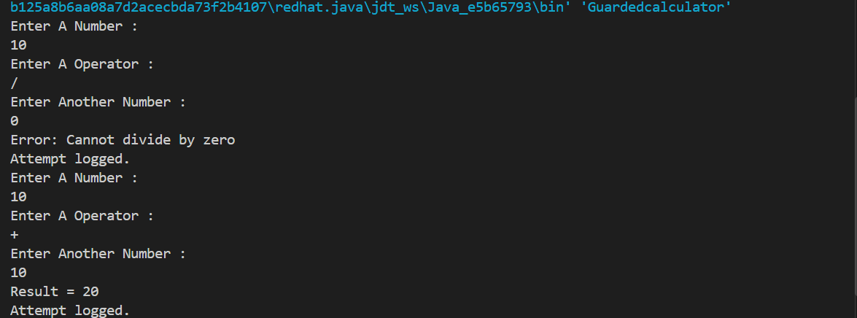

Prbl 2 | Stock issue: a Warehouse where issue(item, qty) throws a custom checked  OutOfStockException carrying the shortfall, and InvalidQuantityException for qty ≤ 0.  Process a list of requests, catching and reporting each failure without stopping the run.
Code | class OutOfStockException extends Exception {  int shortfall;  OutOfStockException(int shortfall) {  this.shortfall = shortfall;  }  public int getShortfall() {  return shortfall;  }  }  class InvalidQuantityException extends Exception {  InvalidQuantityException(String message) {  super(message);  }  }  class Warehouse {  String[] items = {"Laptop", "Mouse", "Keyboard"};  int[] stock = {5, 10, 3};  void issue(String item, int qty)  throws OutOfStockException, InvalidQuantityException {  if (qty <= 0) {  throw new InvalidQuantityException(  "Quantity must be greater than 0"  );  }  int index = -1;  // Find item  for (int i = 0; i < items.length; i++) {  if (items[i].equals(item)) {  index = i;  break;  }  }  // Item not found  if (index == -1) {  System.out.println("Item not found: " + item);  return;  }  // Check stock  if (qty > stock[index]) {  int shortfall = qty - stock[index];  throw new OutOfStockException(shortfall);  }  // Reduce stock  stock[index] = stock[index] - qty;  System.out.println("Issued " + qty + " " + item);  }  }  public class Stockissue{  public static void main(String[] args) {  Warehouse warehouse = new Warehouse();  String[] requestItems = {  "Laptop",  "Mouse",  "Keyboard",  "Laptop"  };  int[] requestQty = {  2,  20,  0,  2  };  for (int i = 0; i < requestItems.length; i++) {  try {  warehouse.issue(  requestItems[i],  requestQty[i]  );  } catch (OutOfStockException e) {  System.out.println(  "Out of stock: " +  requestItems[i] +  ", Shortfall = " +  e.getShortfall()  );  } catch (InvalidQuantityException e) {  System.out.println(  "Invalid quantity for " +  requestItems[i] +  ": " +  e.getMessage()  );  }  }  System.out.println("All requests processed.");  }  }
Output | 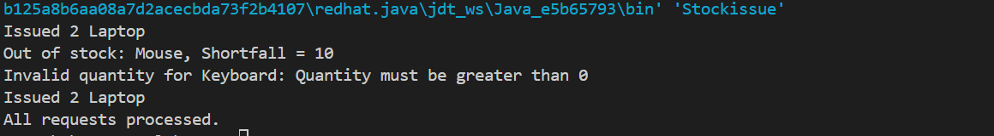

Prbl 3 | Create an AutoCloseable resource and use try-with-  resources to prove it always closes — even when an exception is thrown inside the block  — and that the original error is the one reported. Decide what to model as the resource.
Code | class FileResource implements AutoCloseable {  public FileResource() {  System.out.println("Resource opened");  }  public void read() {  System.out.println("Reading resource...");  }  @Override  public void close() {  System.out.println("Resource closed");  }  }  public class Closeable{  public static void main(String[] args) {  try (FileResource resource = new FileResource()) {  resource.read();  throw new RuntimeException("Something went wrong!");  } catch (Exception e) {  System.out.println("Error: " + e.getMessage());  }  }  }
Output | 