Java
Practical – 9

Prob 1 | Counter race: several threads each increment a shared counter many times. Run it  without synchronization to watch the total come out too low, then make the increment  synchronized and confirm it is exactly right every run.
Code | public class CounterRace {  static int count = 0;  public static void main(String[] args) throws InterruptedException {  Thread t1 = new Thread(() -> {  for (int i = 0; i < 10000; i++) {  count++;  }  });  Thread t2 = new Thread(() -> {  for (int i = 0; i < 10000; i++) {  count++;  }  });  t1.start();  t2.start();  t1.join();  t2.join();  System.out.println("Without synchronization: " + count);  count = 0;  Thread t3 = new Thread(() -> {  for (int i = 0; i < 10000; i++) {  increment();  }  });  Thread t4 = new Thread(() -> {  for (int i = 0; i < 10000; i++) {  increment();  }  });  t3.start();  t4.start();  t3.join();  t4.join();  System.out.println("With synchronization: " + count);  }  synchronized static void increment() {  count++;  }  }
OutPut | 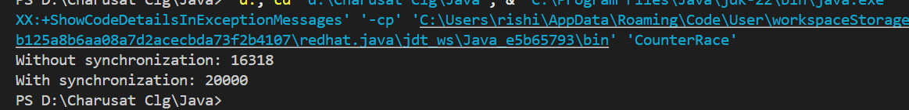

Prob 2 | Seat booking race: a shared seatsLeft of 5 with about 10 threads each trying to book one  seat. Without synchronization show that more than 5 can succeed (oversell); with a  synchronized book() exactly 5 do.
Code | public class SeatBooking {  static int availableSeats = 5;  static int successfulBookings = 0;  static void book() {  if (availableSeats > 0) {  try {  Thread.sleep(1);  } catch (InterruptedException e) {  e.printStackTrace();  }  availableSeats--;  successfulBookings++;  System.out.println(  Thread.currentThread().getName() + " booked a seat"  );  } else {  System.out.println(  Thread.currentThread().getName() + " failed - no seats"  );  }  }  public static void main(String[] args) throws InterruptedException {  availableSeats = 5;  Thread[] t = new Thread[10];  for (int i = 0; i < 10; i++) {  t[i] = new Thread(() -> {  book();  }, "Customer-" + (i + 1));  t[i].start();  }  for (int i = 0; i < 10; i++) {  t[i].join();  }  System.out.println("\nAvailable seats: " + availableSeats);  System.out.println("Successful bookings: " + successfulBookings);  }  }
Output | 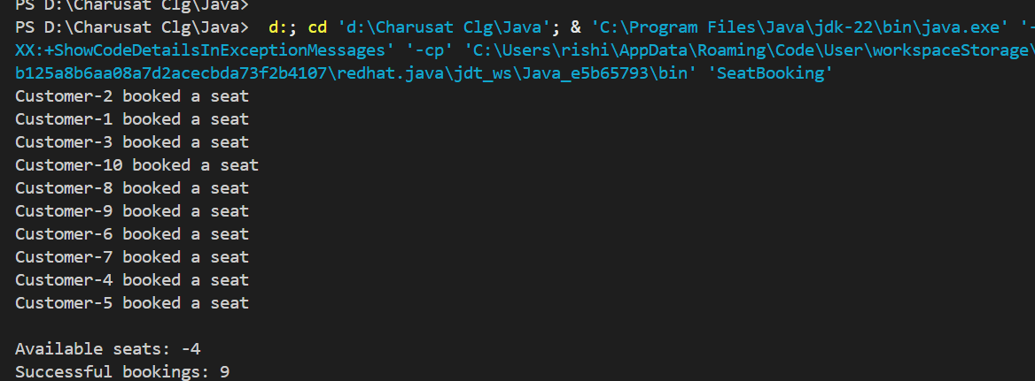

Prob 3 | Split a large array of numbers across several threads  that add into one shared total, show the wrong result, then fix it two ways and compare;  decide how to measure the difference.
Code | import java.util.concurrent.atomic.AtomicLong; public class AddNumbers{ static long sharedTotal = 0;  static void addWithoutSync(long value) { sharedTotal += value; }  static synchronized void addWithSync(long value) { sharedTotal += value; }  public static void main(String[] args) throws InterruptedException {  int size = 10_000_000;  int numberOfThreads = 4;  long[] numbers = new long[size];  // Fill array  for (int i = 0; i < size; i++) {  numbers[i] = 1;  }  long expected = 0;  for (long number : numbers) {  expected += number;  }  System.out.println("Expected result: " + expected);  sharedTotal = 0;  Thread[] threads = new Thread[numberOfThreads];  long start = System.nanoTime();  int chunk = size / numberOfThreads;  for (int i = 0; i < numberOfThreads; i++) {  int startIndex = i * chunk;  int endIndex = (i == numberOfThreads - 1)  ? size  : startIndex + chunk;  threads[i] = new Thread(() -> {  for (int j = startIndex; j < endIndex; j++) {  addWithoutSync(numbers[j]);  }  });  threads[i].start();  }  for (Thread thread : threads) {  thread.join();  }  long end = System.nanoTime();  System.out.println("\nWithout synchronization:");  System.out.println("Result: " + sharedTotal);  System.out.println("Time: " + (end - start) / 1_000_000 + " ms");  sharedTotal = 0;  threads = new Thread[numberOfThreads];  start = System.nanoTime();  for (int i = 0; i < numberOfThreads; i++) {  int startIndex = i * chunk;  int endIndex = (i == numberOfThreads - 1)  ? size  : startIndex + chunk;  threads[i] = new Thread(() -> {  for (int j = startIndex; j < endIndex; j++) {  addWithSync(numbers[j]);  }  });  threads[i].start();  }  for (Thread thread : threads) {  thread.join();  }  end = System.nanoTime();  System.out.println("\nWith synchronized:");  System.out.println("Result: " + sharedTotal);  System.out.println("Time: " + (end - start) / 1_000_000 + " ms");  AtomicLong atomicTotal = new AtomicLong(0);  threads = new Thread[numberOfThreads];  start = System.nanoTime();  for (int i = 0; i < numberOfThreads; i++) {  int startIndex = i * chunk;  int endIndex = (i == numberOfThreads - 1)  ? size  : startIndex + chunk;  threads[i] = new Thread(() -> {  for (int j = startIndex; j < endIndex; j++) {  atomicTotal.addAndGet(numbers[j]);  }  });  threads[i].start();  }  for (Thread thread : threads) {  thread.join();  }  end = System.nanoTime();  System.out.println("\nWith AtomicLong:");  System.out.println("Result: " + atomicTotal.get());  System.out.println("Time: " + (end - start) / 1_000_000 + " ms");  } }
Output | 