**Flask To-Do App (Dockerized & Deployed on AWS EC2)**

This project is a simple Flask-based To-Do list application, containerized using Docker and deployed on an AWS EC2 instance running Amazon Linux 2.

**Features**

* Add tasks to a list
* View and manage tasks
* Fully dockerized
* Hosted on an EC2 instance

**Live Demo**

http://13.203.67.226

**Tech Stack**

* Python with Flask
* HTML/CSS (Bootstrap)
* Docker
* AWS EC2 (Amazon Linux 2)

**Project Structure**

* **flask_todoapp/**
* **├── app.py**
* **├── templates/**
* **│ └── index.html**
* **├── static/**
* **│ └── (CSS files, etc.)**
* **├── requirements.txt**
* **└── Dockerfile**

**Deployment Steps**

* **Clone the project:**

**git clone https://github.com/RishitSharma88/flask_todoapp**

**cd flask_todoapp**

* **Create requirements.txt:**

Flask==2.3.3

Werkzeug==2.3.7

* **Create Dockerfile:**

**FROM python:3.9-slim**

**WORKDIR /app**

**COPY . .**

**RUN pip install -r requirements.txt**

**EXPOSE 5000**

**CMD ["python", "app.py"]**

* **Build Docker Image:**

**docker build -t flask-todo-app .**

* **Run Docker Container Locally:**

**docker run -d -p 5000:5000 flask-todo-app**

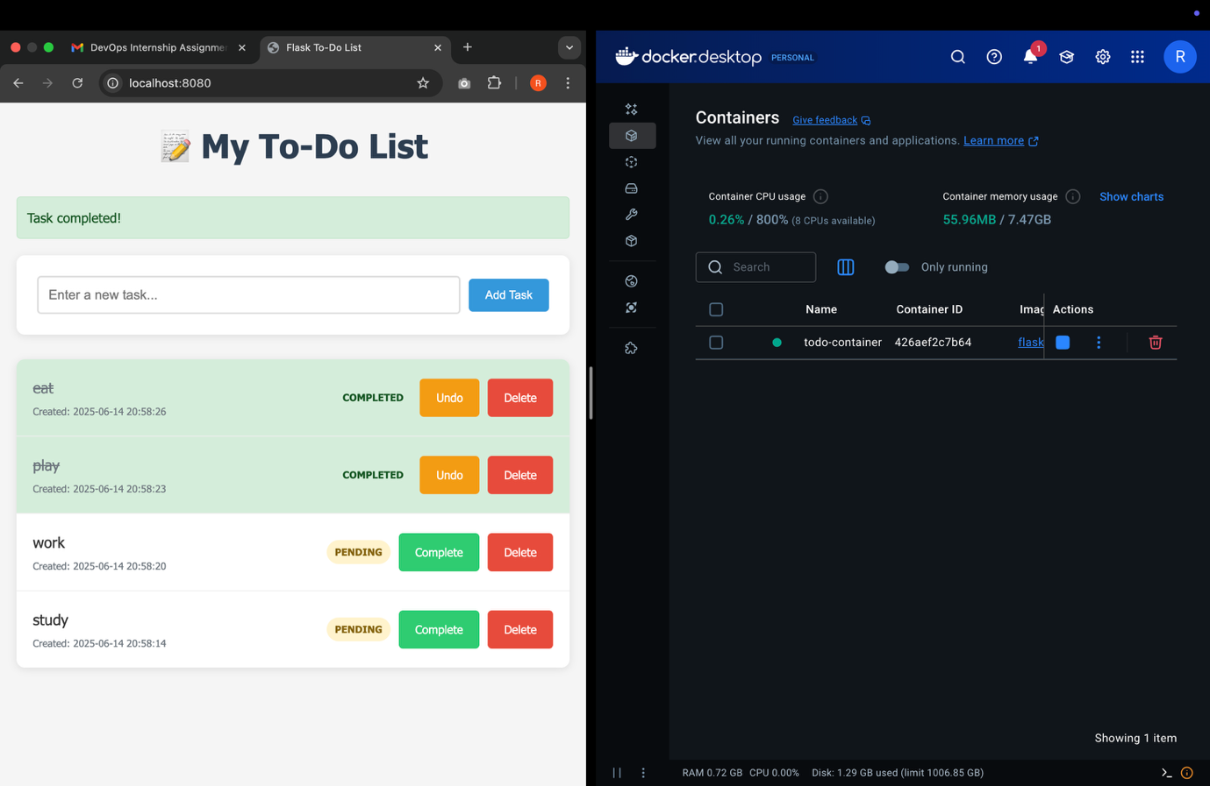

* **Upload App to EC2:**

**scp -i** todoapp.pem **flask_todoapp.zip ec2-user**13.203.67.226**:~/**

* **Connect to EC2:**

ssh -i todoapp.pem [ec2-user@13.203.67.226](mailto:ec2-user@13.203.67.226)

* **Install Docker on EC2 :**

**sudo yum update -y**

**sudo yum install docker -y**

**sudo service docker start**

**sudo usermod -a -G docker ec2-user**

* **Unzip and Build on EC2:**

**unzip flask_todoapp.zip**

**cd flask_todoapp**

**docker build -t flask-todo-app .**

* **Run Container on EC2:**

docker run -d -p 80:5000 --name todo-container flask-todo-app

**Access the App**

Open a browser and go to:

http://<your-ec2-public-ip>

Example: <http://13.203.67.226>

