Module 1A: Data Acquisition and Image pre-Processing
Individual Band
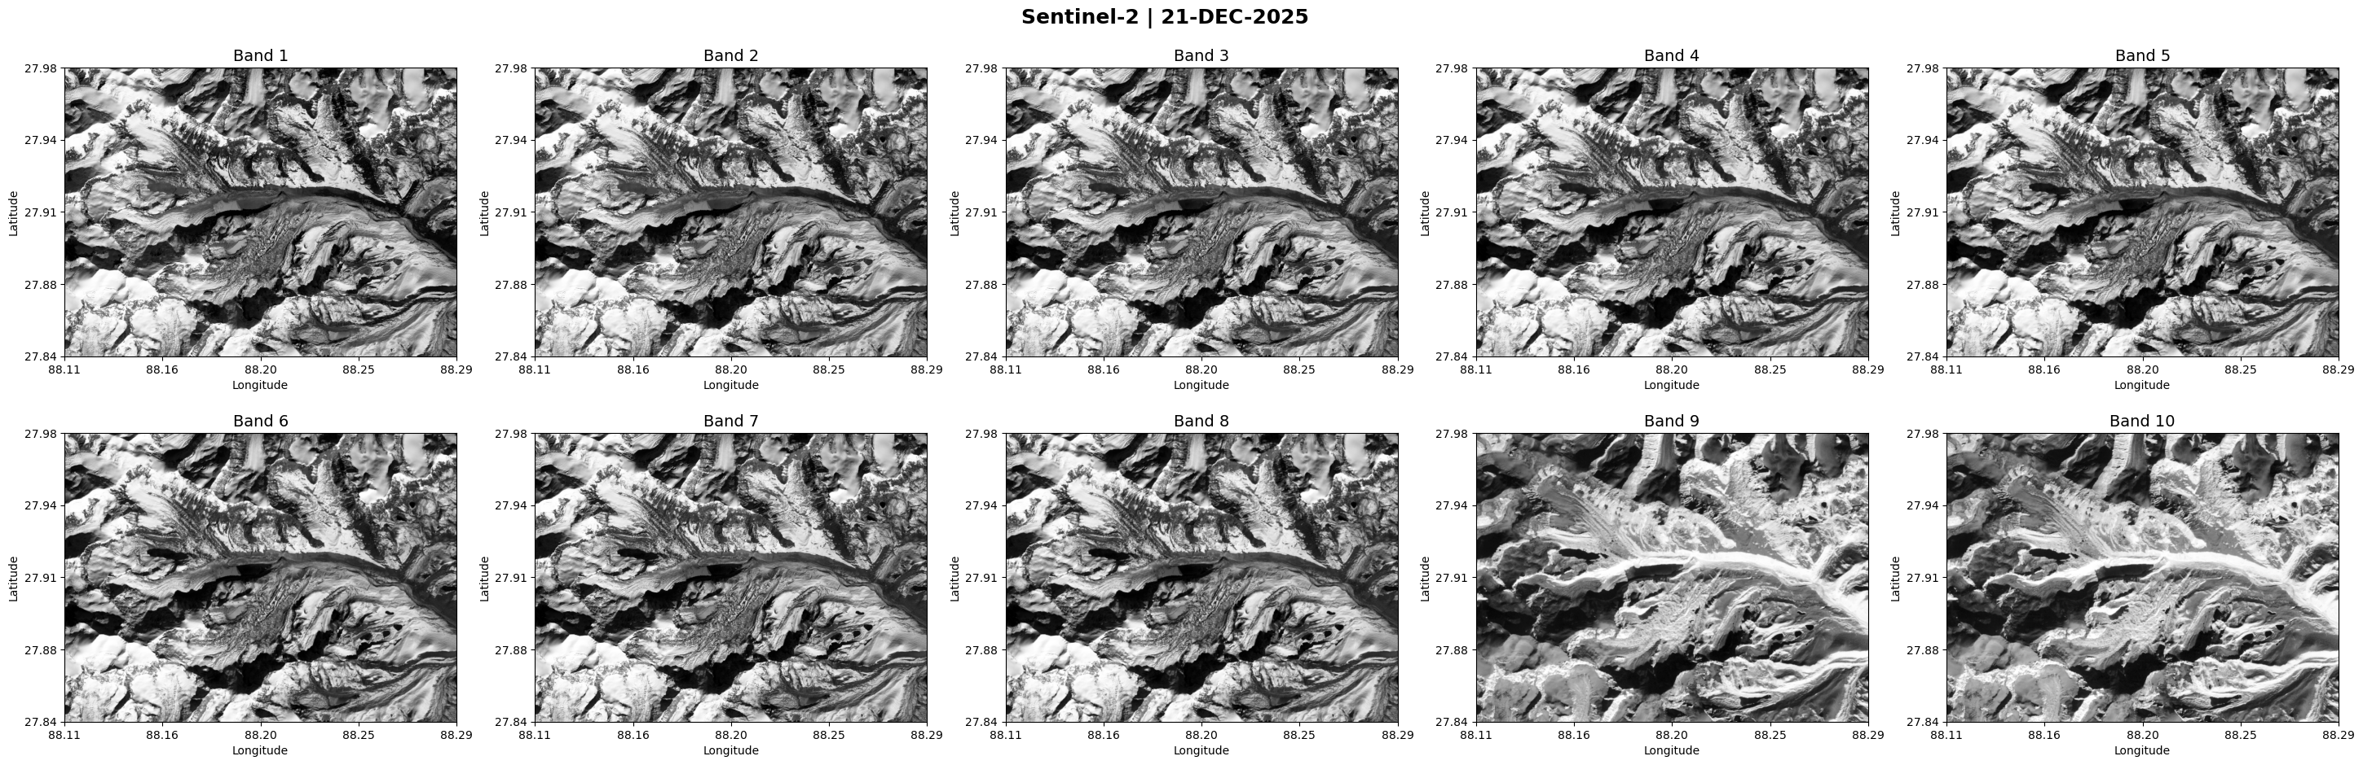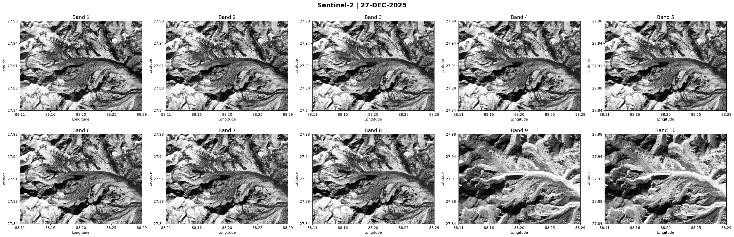
FCC
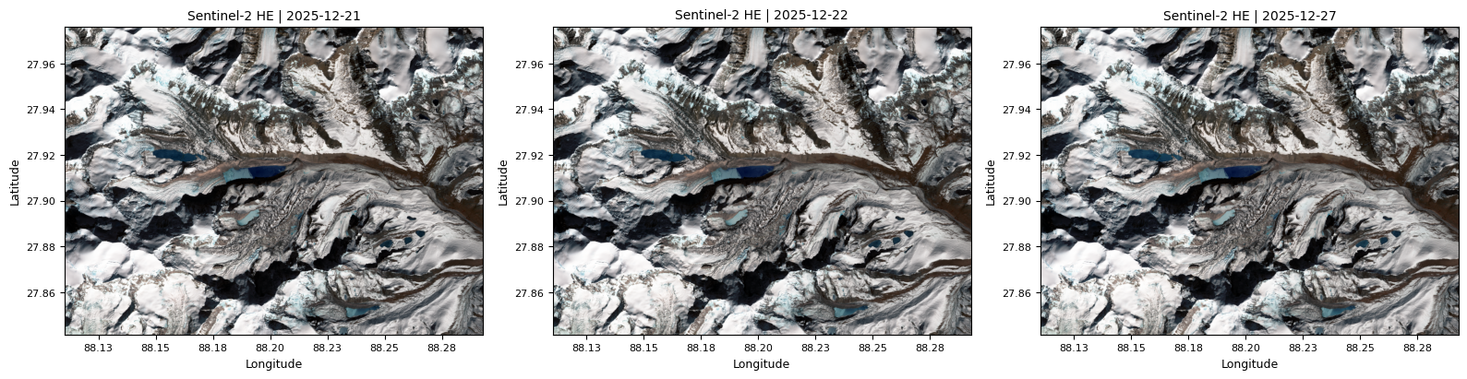
Module 1B: Image Processing – classification of Glacier, Glacial Lake and Non-glacier land
Raster
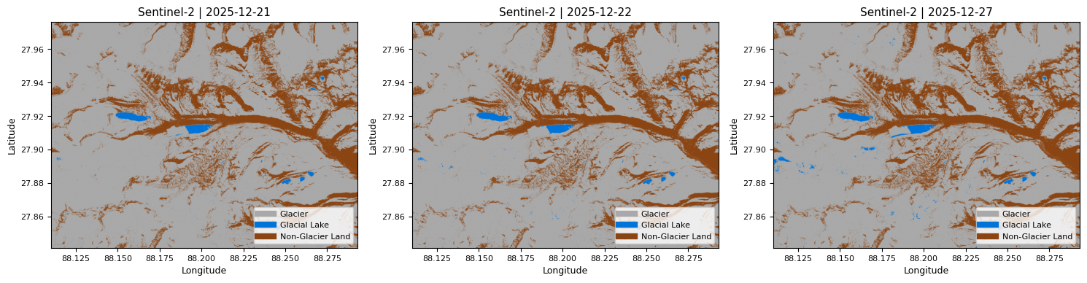
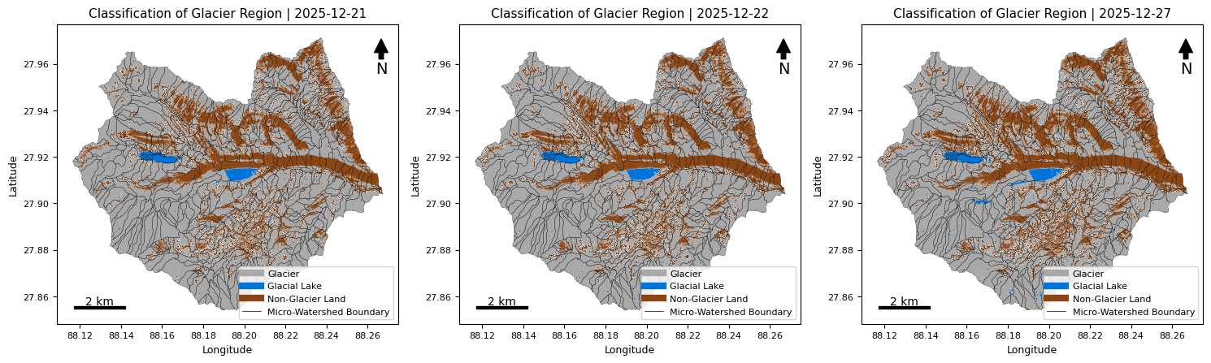

Vector Segmentation
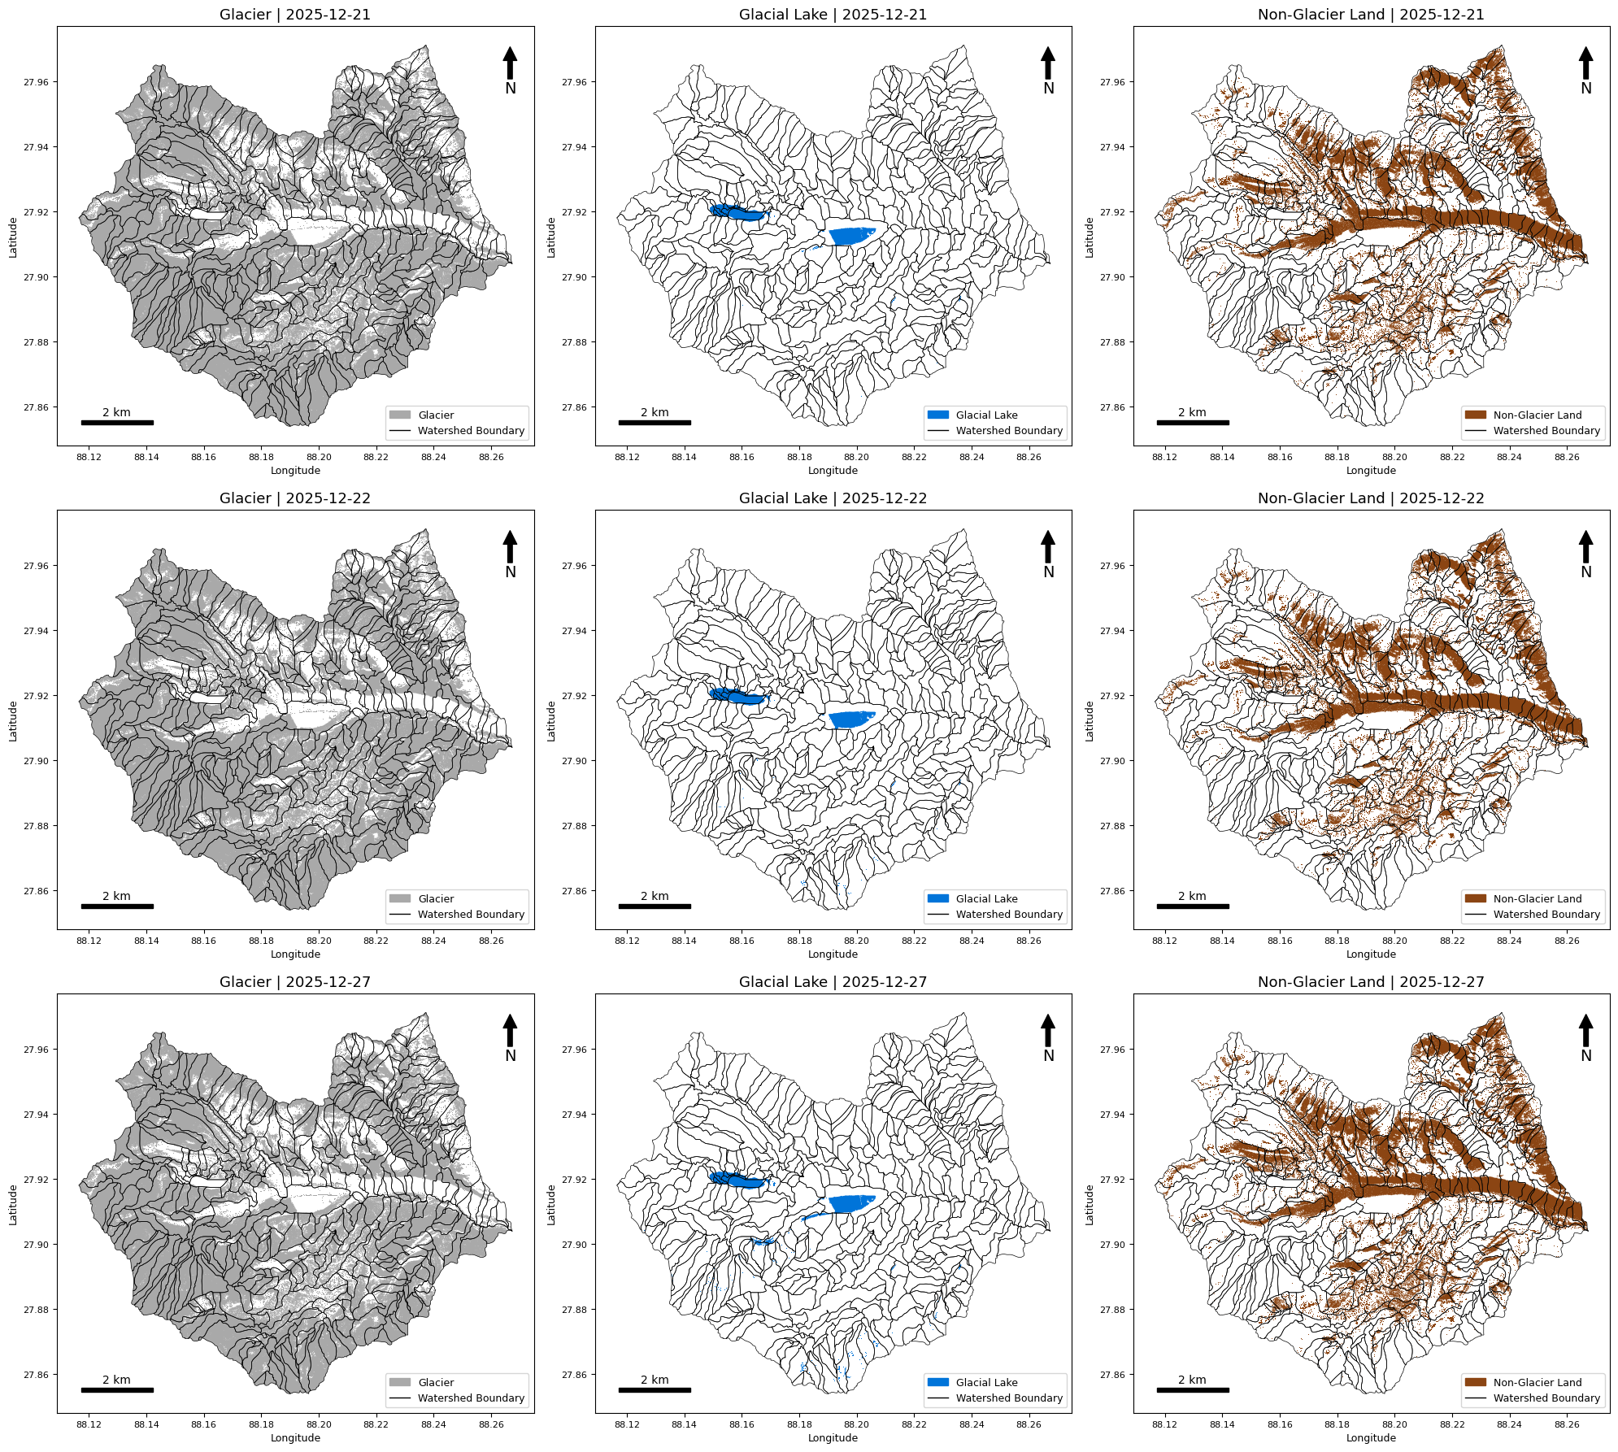

Module 2: Glacier Morphometric Computation
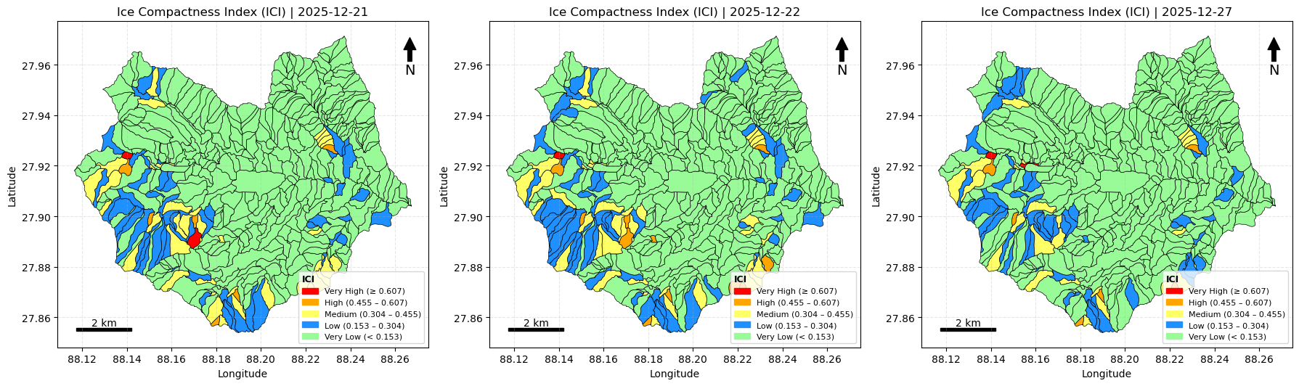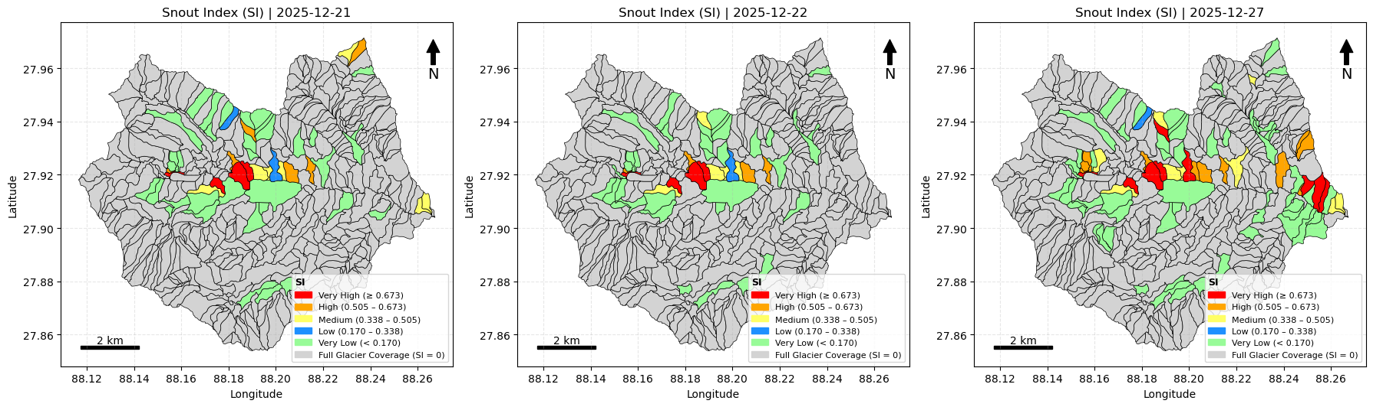
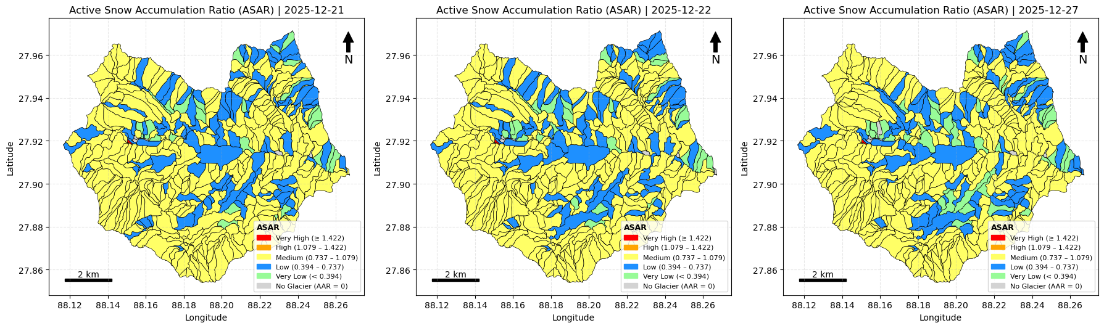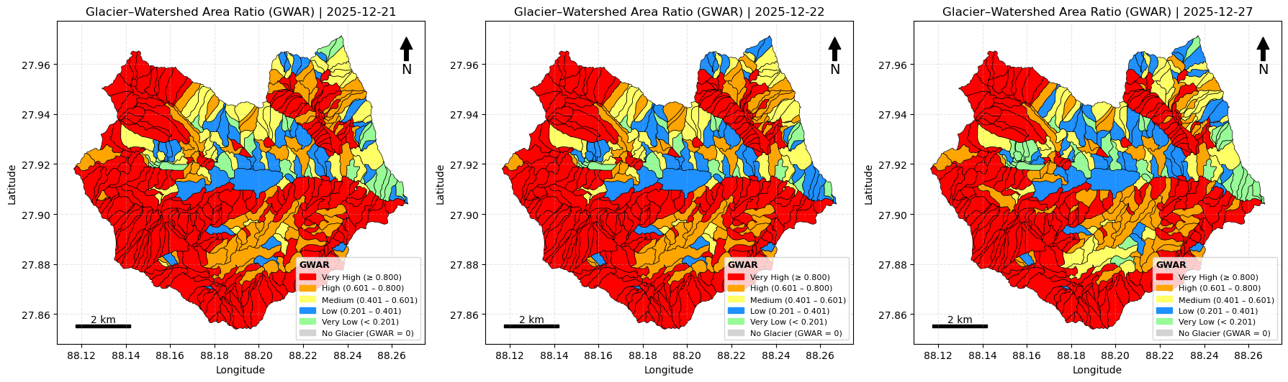
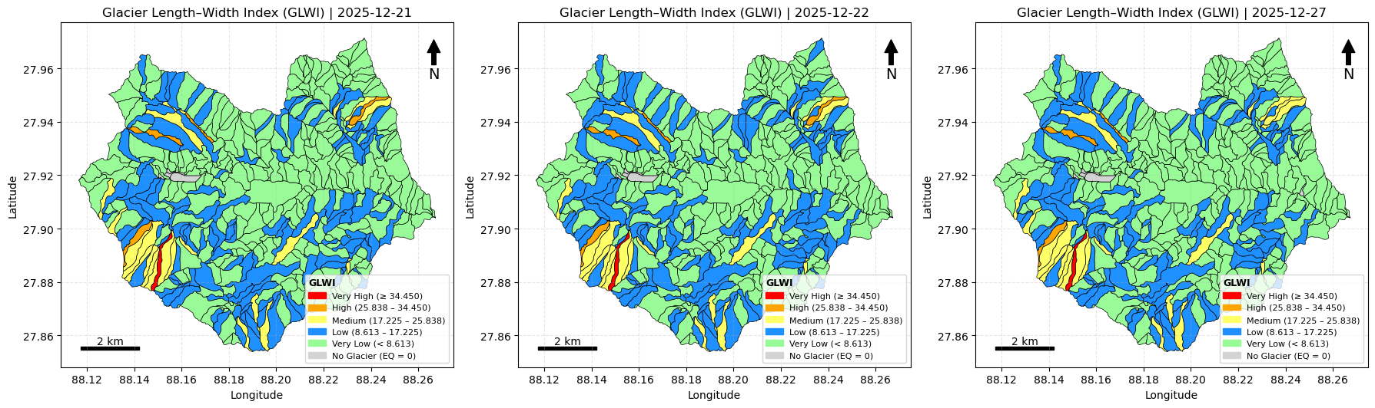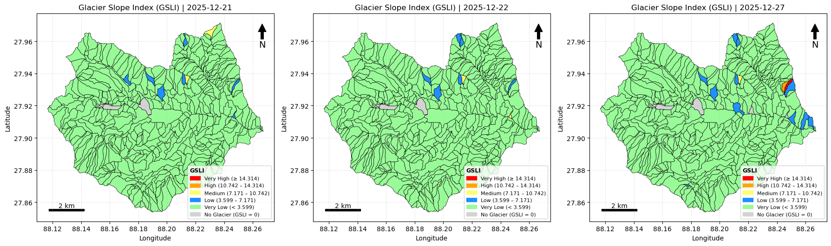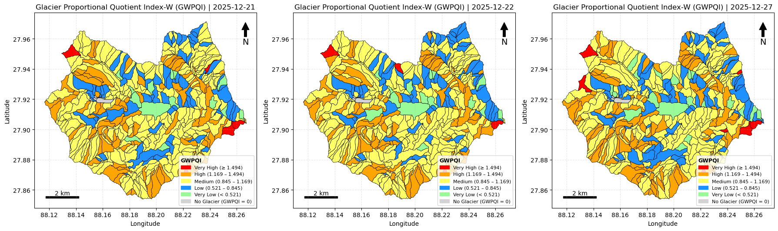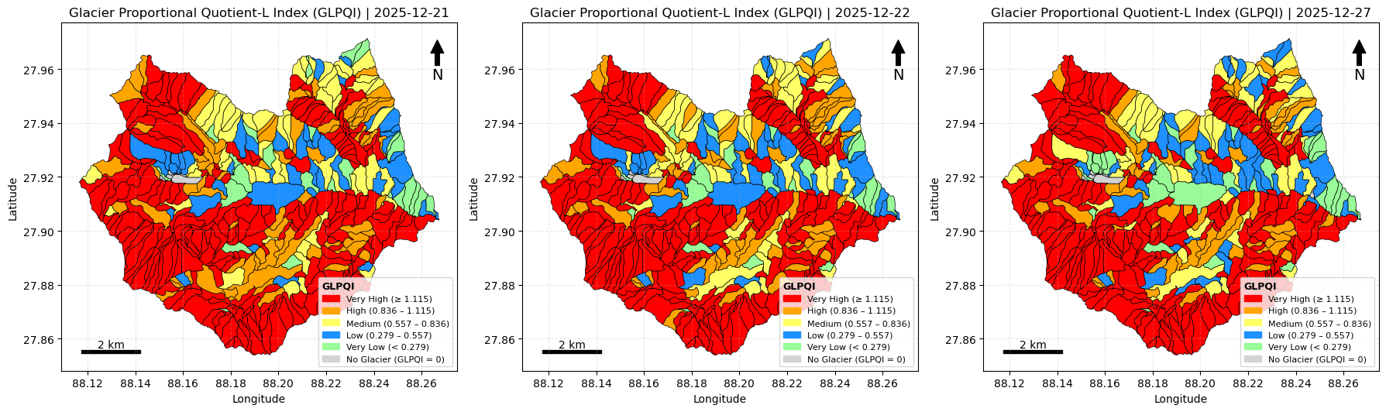

Module 3: Glacial Lake Morphometric Computation
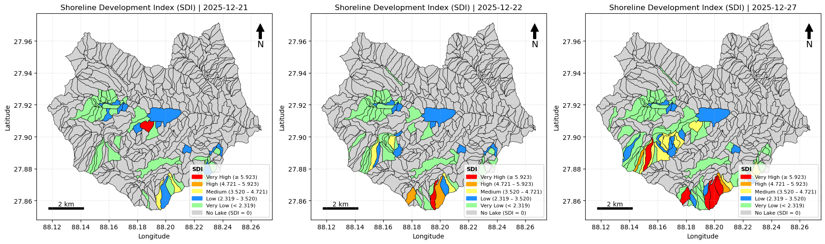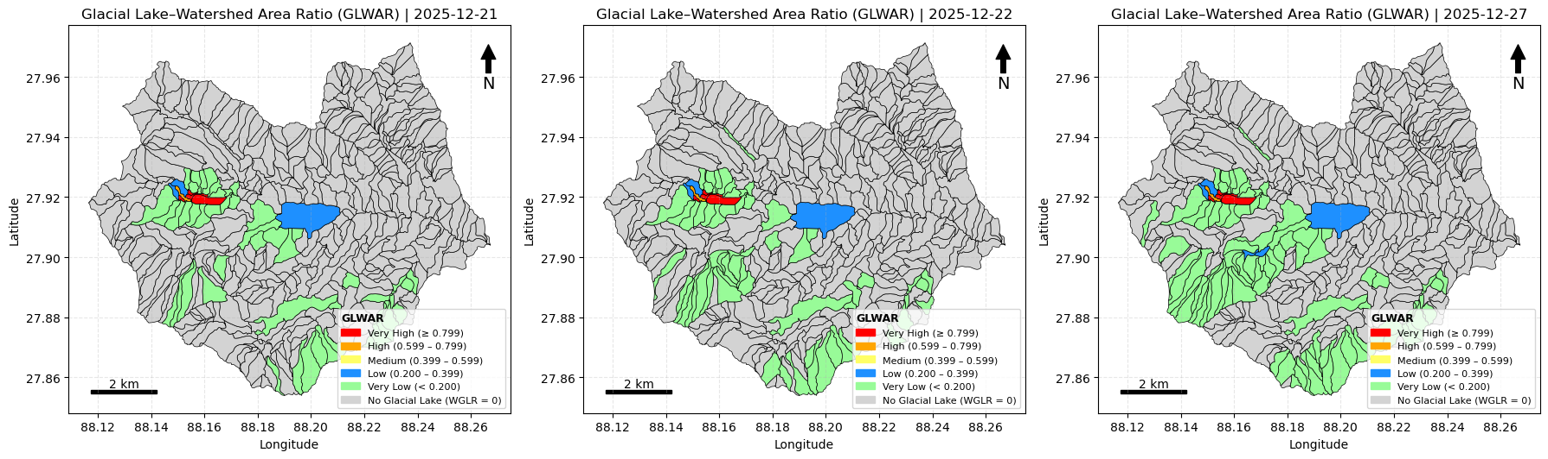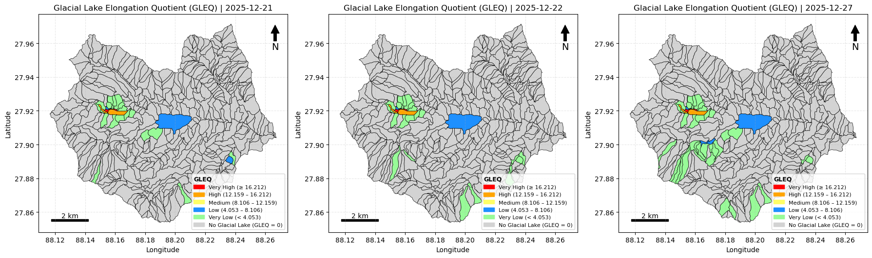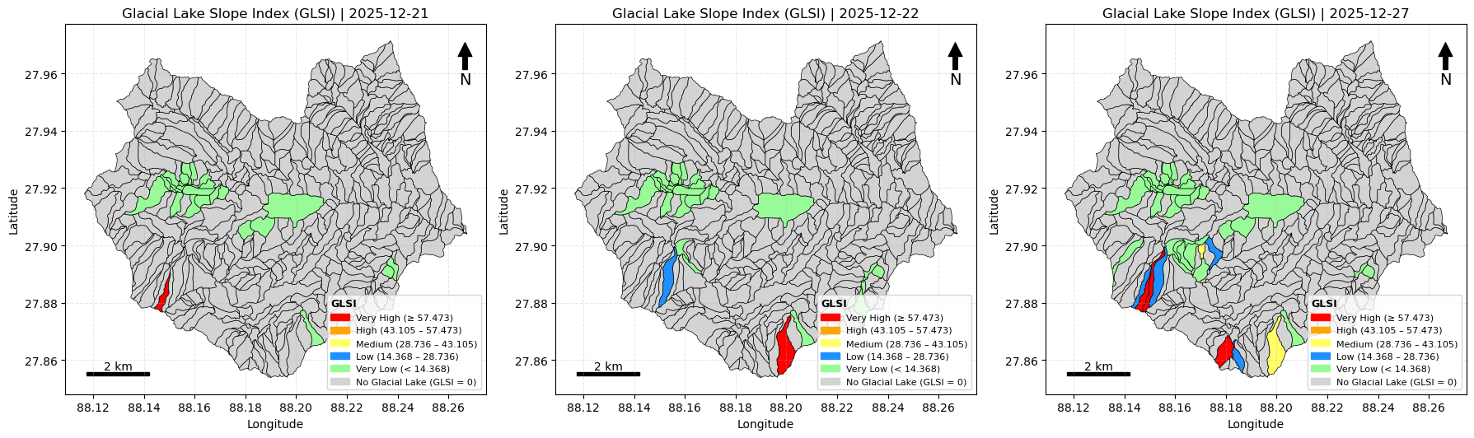
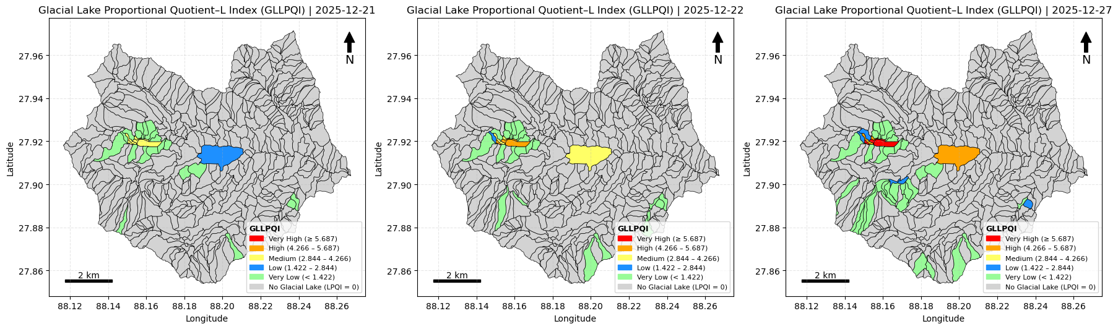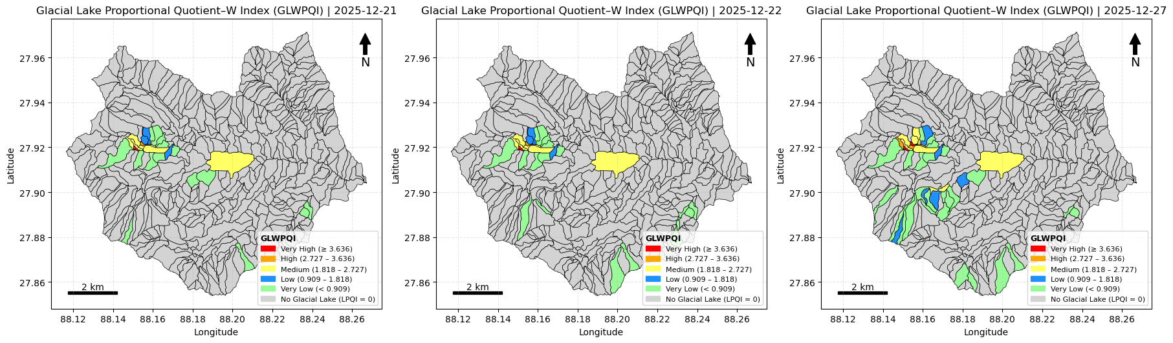

Module 4: Catchment Morphometric Computation
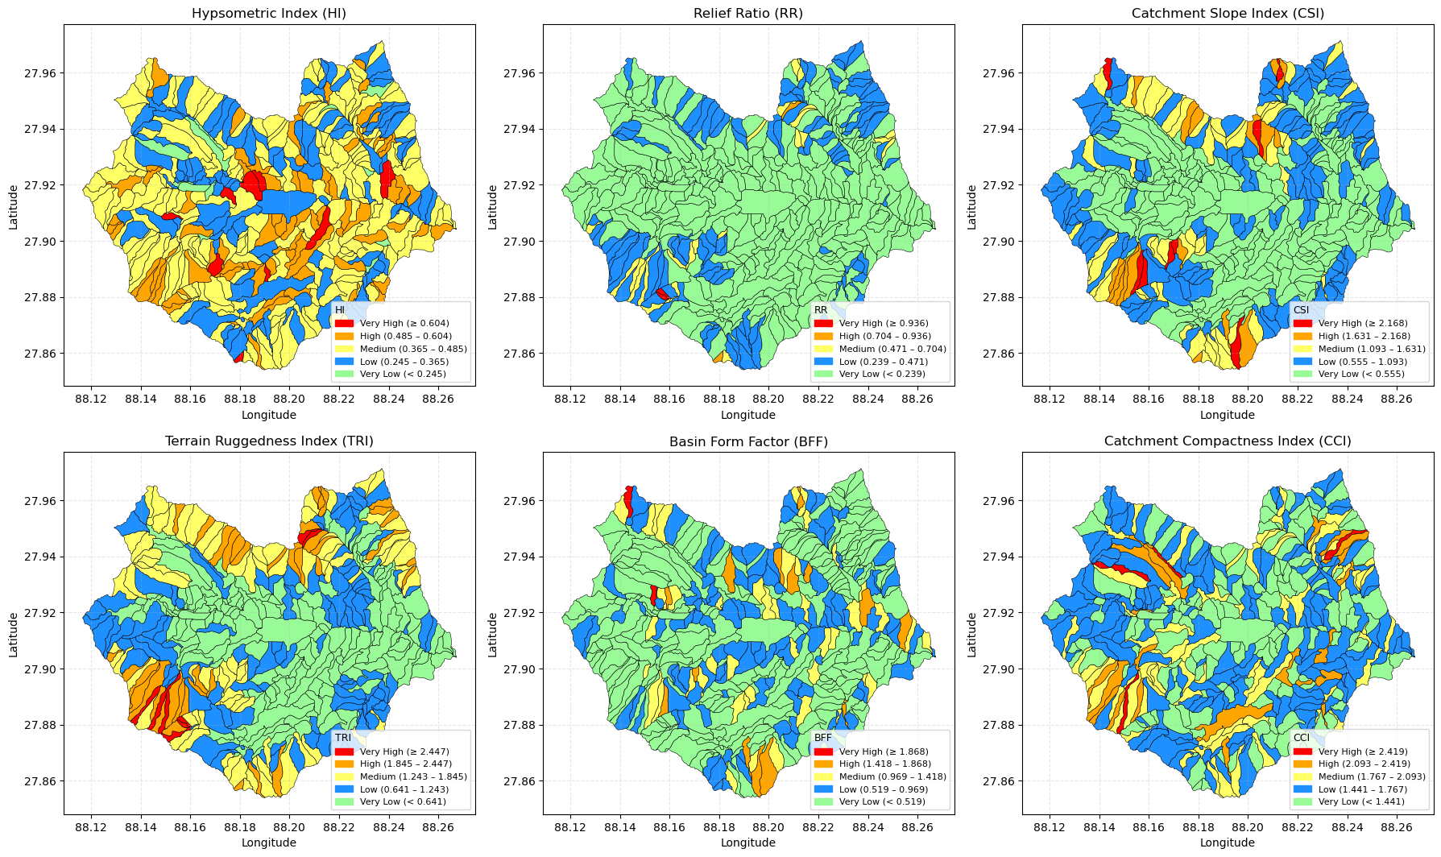

Module 5: GLOF INDEX
