OSSP (Operating Systems And Systems Programming) - 25CS2104E
pothurubhavna(2520030154 )
1. Write a C program where a parent process creates multiple child processes and synchronizes their completion using wait() and waitpid(). Compare the behavior of both functions.

Create a scenario where a child process becomes a zombie process. Investigate the process table and then modify the program to eliminate zombie processes using proper synchronization techniques.

Multiple child processes using wait()
#include <stdio.h> #include <stdlib.h> #include <unistd.h> #include <sys/wait.h>

int main()
{
int i; pid_t pid;

for (i = 0; i < 3; i++)
{
pid = fork();

if (pid == 0)
{
printf("Child %d PID: %d\n", i + 1, getpid()); sleep(i + 1);
printf("Child %d completed\n", i + 1);

exit(0);
}
}

for (i = 0; i < 3; i++)
{
wait(NULL);
}

printf("All children completed\n");

return 0;
}
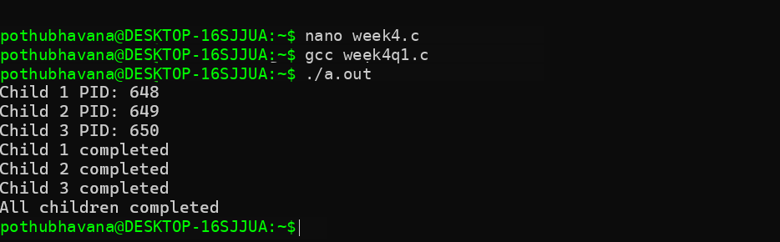

Multiple child processes using waitpid()
#include <stdio.h> #include <stdlib.h> #include <unistd.h> #include <sys/wait.h>

int main()
{
int i;

pid_t pid[3];

for (i = 0; i < 3; i++)
{
pid[i] = fork();

if (pid[i] == 0)
{
printf("Child %d PID: %d\n", i + 1, getpid()); sleep(i + 1);
printf("Child %d completed\n", i + 1); exit(0);
}
}

for (i = 0; i < 3; i++)
{
waitpid(pid[i], NULL, 0);
printf("Child PID %d terminated\n", pid[i]);
}

printf("All children completed\n");

return 0;

}
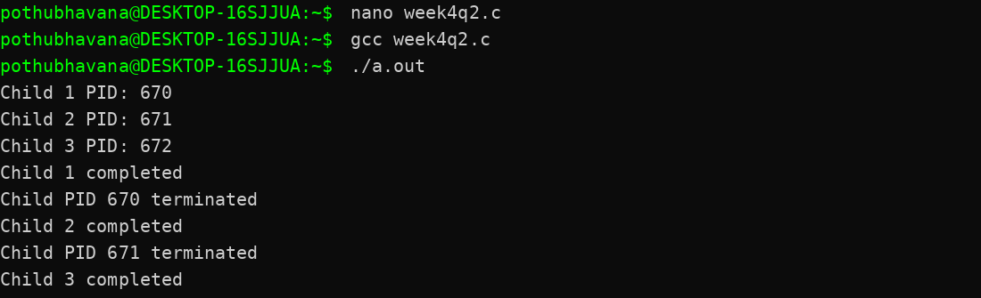
Zombie process #include <stdio.h> #include <stdlib.h> #include <unistd.h> #include <sys/wait.h>

int main()
{
pid_t pid;

pid = fork();

if (pid == 0)
{
printf("Child PID: %d\n", getpid()); exit(0);
}
else
{
printf("Parent PID: %d\n", getpid()); printf("Child PID: %d\n", pid);

sleep(5);

wait(NULL);

printf("Child process terminated\n");
}

return 0;
}


