YUVA INTERN
VIRTUAL DATA SCIENCE INTERNSHIP

WEEK 4 INTERNSHIP REPORT
Supervised Learning Model Implementation

Project: Titanic Survival Prediction Using Logistic Regression

Student Details | Information
Name | M. Rishita
Register No. | 510425104177
Programme | B.E. Computer Science and Engineering
Institution | Arunai Engineering College
Task | Week 4 – Supervised Learning Model Implementation
Model | Logistic Regression
Dataset | Titanic – Machine Learning from Disaster
Month / Year | October 2026

Prepared using Python, Pandas, NumPy, Matplotlib and Scikit-learn

DECLARATION
I, M. Rishita, declare that this Week 4 internship report presents the supervised learning workflow implemented for the Titanic Survival Prediction problem. The report documents dataset preparation, feature engineering, model training, validation, evaluation, interpretation, limitations and possible improvements.
The work is structured to demonstrate the practical application of supervised machine learning using Python and Scikit-learn on a publicly available classification dataset.

Student Name: M. Rishita
Register No.: 510425104177
Programme: B.E. Computer Science and Engineering

Executive Summary
This Week 4 project implements a supervised machine learning model for predicting whether a Titanic passenger survived. The task is formulated as binary classification, where Survived = 0 represents not survived and Survived = 1 represents survived. The Titanic training dataset contains 891 passenger records and 12 columns.
The workflow begins with data inspection and missing-value analysis. The model uses Pclass, Sex, Age, SibSp, Parch, Fare and Embarked as predictive variables. Numerical variables are median-imputed and standardized, while categorical variables are filled using the most frequent category and one-hot encoded.
A Logistic Regression classifier is trained using an 80:20 stratified train-test split. Five-fold cross-validation is applied on the training data to estimate model stability. On the held-out test set, the implemented model achieved 80.45% accuracy, 79.31% precision, 66.67% recall and 72.44% F1-score. The ROC-AUC was 0.8435, while the mean five-fold cross-validation accuracy was 79.64%.
Item | Result
Dataset | Titanic training dataset
Rows × Columns | 891 × 12
Problem type | Binary classification
Model | Logistic Regression
Train / Test | 80% / 20%
Test Accuracy | 0.8045 (80.45%)
Test Precision | 0.7931
Test Recall | 0.6667
Test F1-score | 0.7244
ROC-AUC | 0.8435
Mean 5-fold CV Accuracy | 0.7964

1. Objectives
- Define a real-world supervised learning classification problem.
- Select a suitable public dataset and identify the target variable.
- Prepare numerical and categorical features for machine learning.
- Handle missing values using suitable preprocessing strategies.
- Apply feature engineering and transformation through a reproducible pipeline.
- Train a Logistic Regression classifier using Scikit-learn.
- Validate the model using five-fold cross-validation.
- Evaluate performance using accuracy, precision, recall, F1-score and ROC-AUC.
- Interpret the confusion matrix and model coefficients.
- Discuss strengths, limitations, implications and future improvements.

2. Problem Definition
The objective is to predict passenger survival from passenger characteristics available in the Titanic training data. Because the target has two possible outcomes, the problem is treated as binary classification.
Component | Definition
Input | Passenger class, sex, age, family-related counts, fare and embarkation port
Target | Survived
Class 0 | Passenger did not survive
Class 1 | Passenger survived
Learning type | Supervised learning
Task | Binary classification

3. Dataset Description
The Titanic dataset was selected because it is a well-known public tabular dataset suitable for demonstrating classification, preprocessing, validation and model evaluation. Kaggle describes the training file as containing passenger information and known survival outcomes.
Column | Meaning | Role
PassengerId | Unique passenger identifier | Excluded
Survived | 0 = no, 1 = yes | Target
Pclass | Passenger ticket class | Feature
Name | Passenger name | Excluded
Sex | Passenger sex | Feature
Age | Age in years | Feature
SibSp | Siblings / spouses aboard | Feature
Parch | Parents / children aboard | Feature
Ticket | Ticket number | Excluded
Fare | Passenger fare | Feature
Cabin | Cabin information | Excluded from primary model
Embarked | Port of embarkation | Feature
The original dataset contains 177 missing Age values, 687 missing Cabin values and 2 missing Embarked values. The primary model excludes Cabin because its missingness is extremely high and because a simple categorical treatment would add substantial sparsity without being necessary for the baseline model.

4. Tools and Technologies
Tool / Library | Purpose
Python | Programming language for the complete workflow
Pandas | Data loading, inspection and manipulation
NumPy | Numerical operations
Matplotlib | Charts and evaluation visualizations
Scikit-learn | Preprocessing, Logistic Regression, validation and metrics
Google Colab / Jupyter-style workflow | Notebook-based implementation environment
CSV | Dataset format

5. Methodology
- Load and inspect the public Titanic training dataset.
- Identify the target variable and candidate predictor variables.
- Check missing values and data types.
- Select useful numerical and categorical features.
- Create a preprocessing pipeline for imputation, scaling and encoding.
- Split the data into stratified training and testing subsets.
- Train Logistic Regression on the training data.
- Perform five-fold cross-validation on the training set.
- Predict the held-out test set.
- Calculate accuracy, precision, recall, F1-score and ROC-AUC.
- Analyze the confusion matrix and coefficient directions.
- Discuss limitations and propose future improvements.

6. Data Inspection and Initial Analysis
The dataset contains 891 rows and 12 columns. The target variable is Survived. The class distribution is shown below.
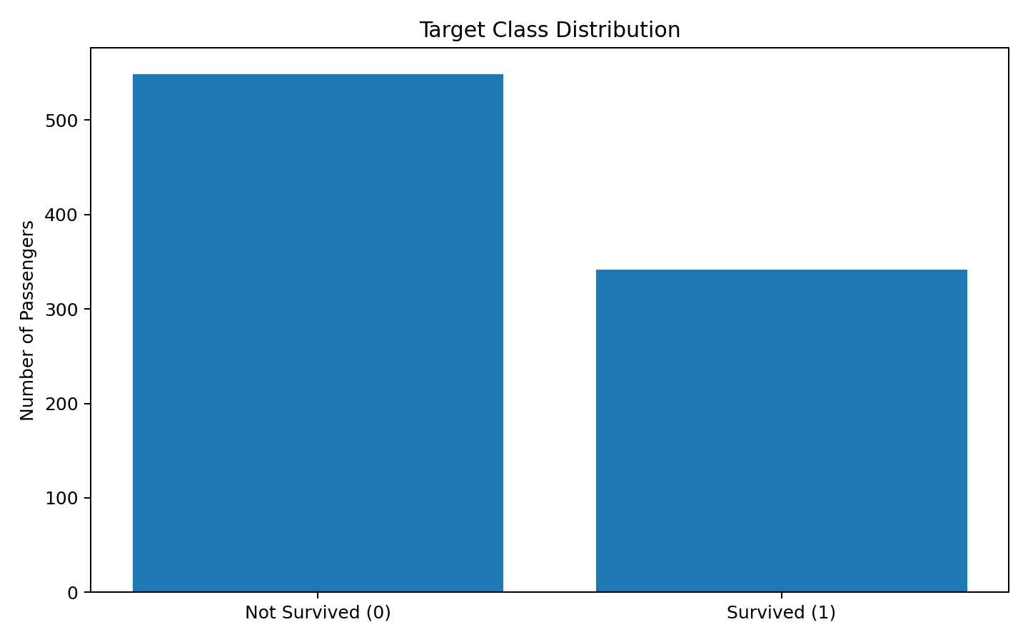
Figure 1. Distribution of the binary target variable.
Target | Count | Percentage
0 – Not Survived | 549 | 61.62%
1 – Survived | 342 | 38.38%
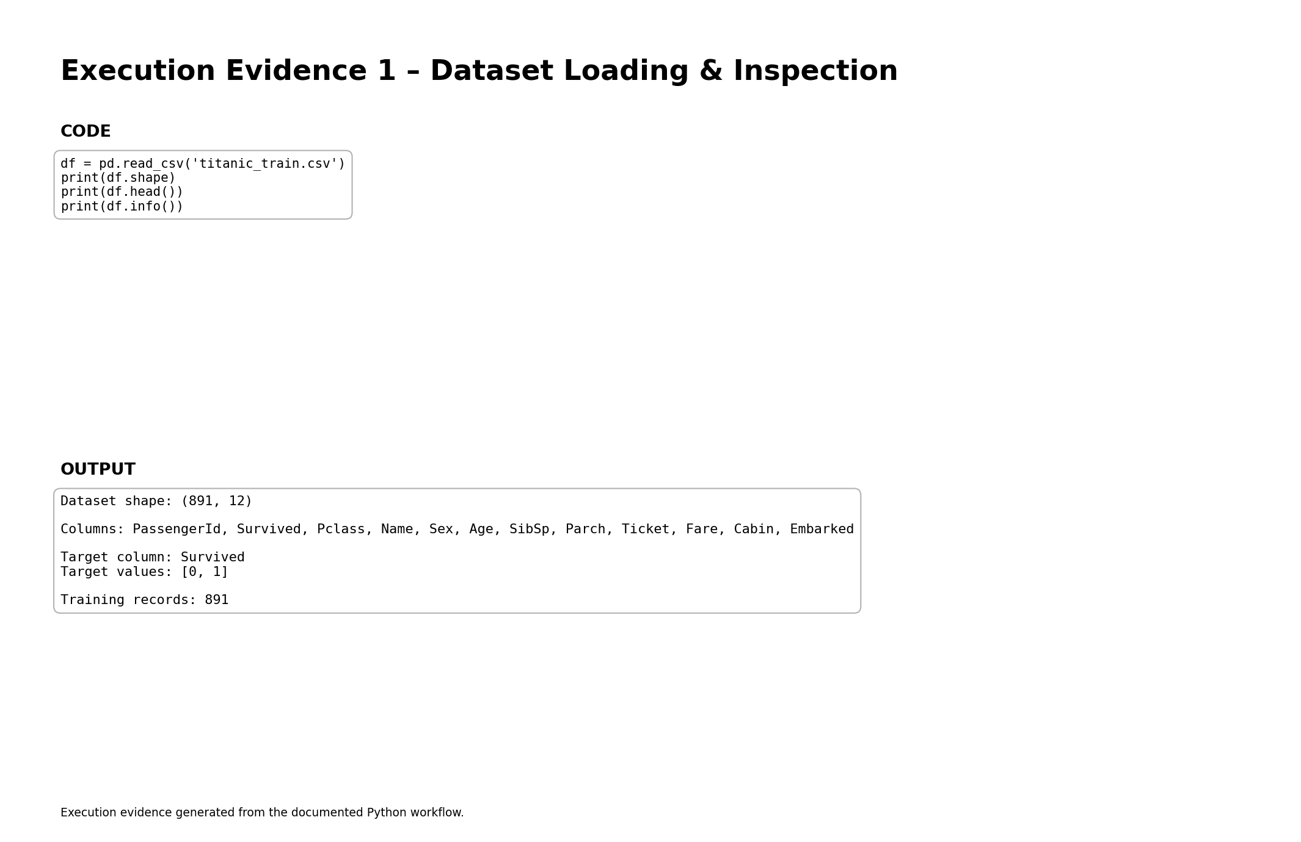
Figure 2. Execution evidence for dataset loading and inspection.

7. Missing-Value Analysis and Treatment
Column | Missing Values | Percentage
Age | 177 | 19.87%
Cabin | 687 | 77.10%
Embarked | 2 | 0.22%
Age is numerical, so median imputation is used. Median imputation is less sensitive to extreme values than mean imputation. Embarked is categorical, so the most frequent category is used. Cabin is excluded from the primary baseline model because 77.10% of its values are missing.
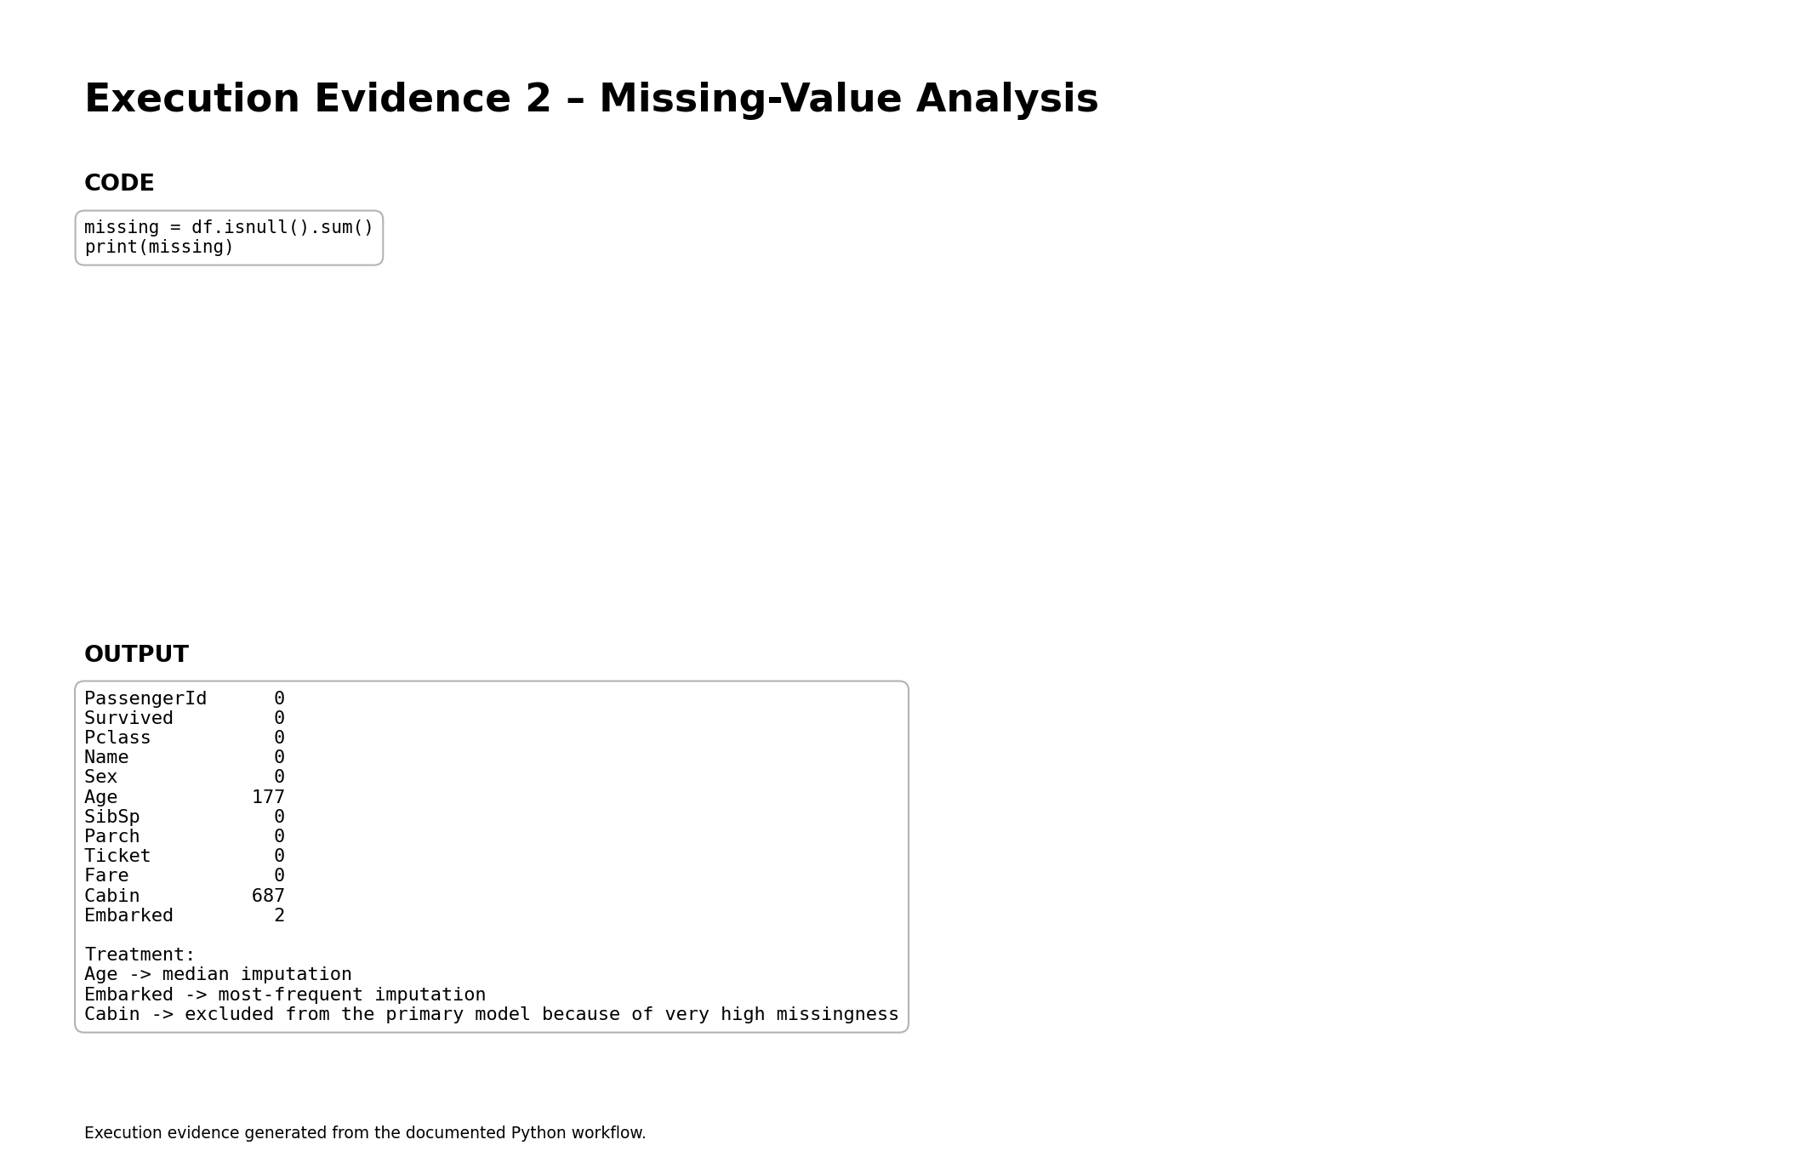
Figure 3. Execution evidence for missing-value analysis and treatment decisions.

8. Feature Selection and Engineering
The model uses seven predictors: Pclass, Sex, Age, SibSp, Parch, Fare and Embarked. PassengerId, Name and Ticket are identifiers or high-cardinality text fields and are therefore excluded. Cabin is excluded from the baseline model because of its very high missingness.
Feature Group | Features | Transformation
Numerical | Pclass, Age, SibSp, Parch, Fare | Median imputation + StandardScaler
Categorical | Sex, Embarked | Most-frequent imputation + OneHotEncoder
Target | Survived | Binary 0/1
All transformations are placed inside a Scikit-learn Pipeline and ColumnTransformer. This is important because the preprocessing parameters are learned from the training folds rather than being manually fitted to the complete dataset.
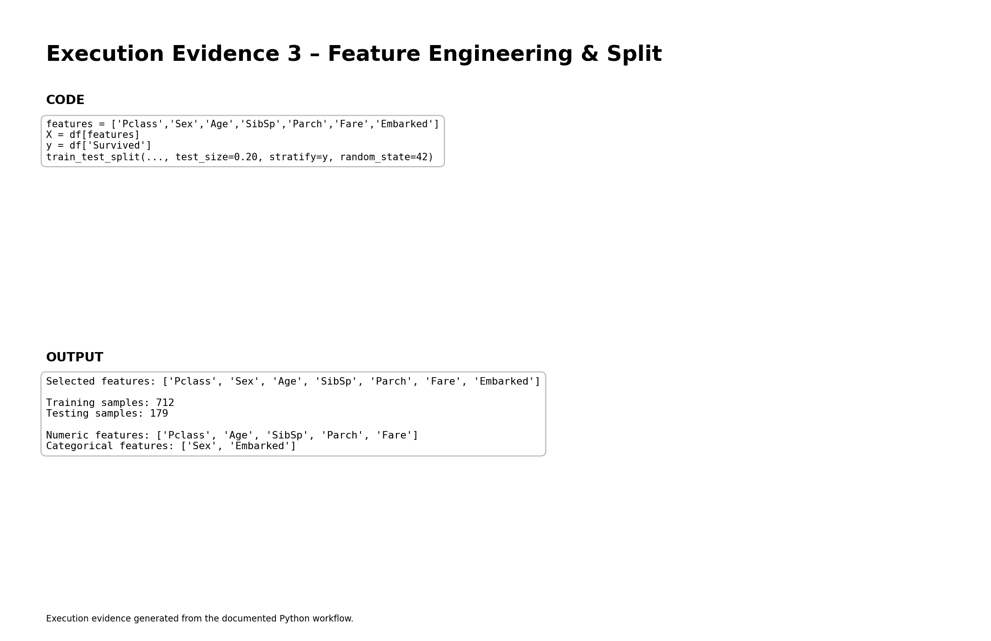
Figure 4. Execution evidence for feature selection and train-test preparation.

9. Train-Test Split
The dataset is divided into 80% training data and 20% testing data. Stratification is used so that the proportion of survival and non-survival classes is maintained approximately across the two subsets.
Subset | Rows | Purpose
Training | 712 | Model fitting and cross-validation
Testing | 179 | Final unseen evaluation
A random_state of 42 is used to make the experiment reproducible.
X_train, X_test, y_train, y_test = train_test_split(
X, y,
test_size=0.20,
stratify=y,
random_state=42
)

10. Model Selection – Logistic Regression
Logistic Regression was selected as the primary model because the task is binary classification and the model is simple, interpretable and computationally efficient. It estimates the probability of a passenger belonging to the survived class using a logistic function.
The model is suitable as a baseline because its coefficients can be interpreted directionally. Positive coefficients increase the log-odds of the positive class, while negative coefficients decrease them, assuming other variables are held constant.
model = Pipeline([
("preprocessor", preprocessor),
("classifier", LogisticRegression(
max_iter=1000,
random_state=42
))
])
model.fit(X_train, y_train)
y_pred = model.predict(X_test)
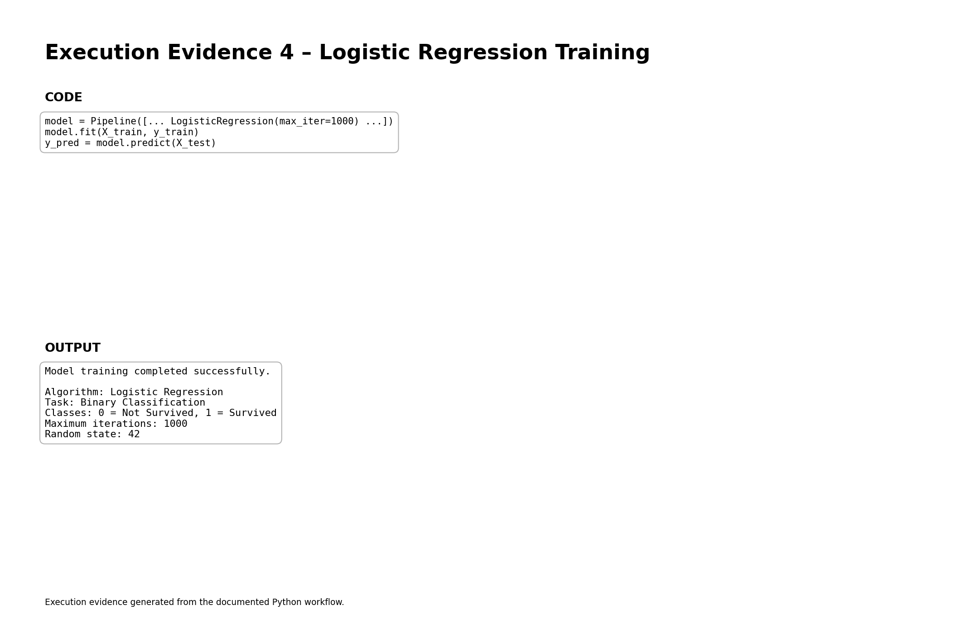
Figure 5. Execution evidence showing successful Logistic Regression training.

11. Cross-Validation
Five-fold cross-validation is performed on the training set. The training data is divided into five folds. In each round, four folds are used for training and one fold is used for validation. The process is repeated five times and the scores are averaged.
Fold | Accuracy
Fold 1 | 0.7902
Fold 2 | 0.7622
Fold 3 | 0.7958
Fold 4 | 0.8169
Fold 5 | 0.8169
Mean | 0.7964
Standard Deviation | 0.0202
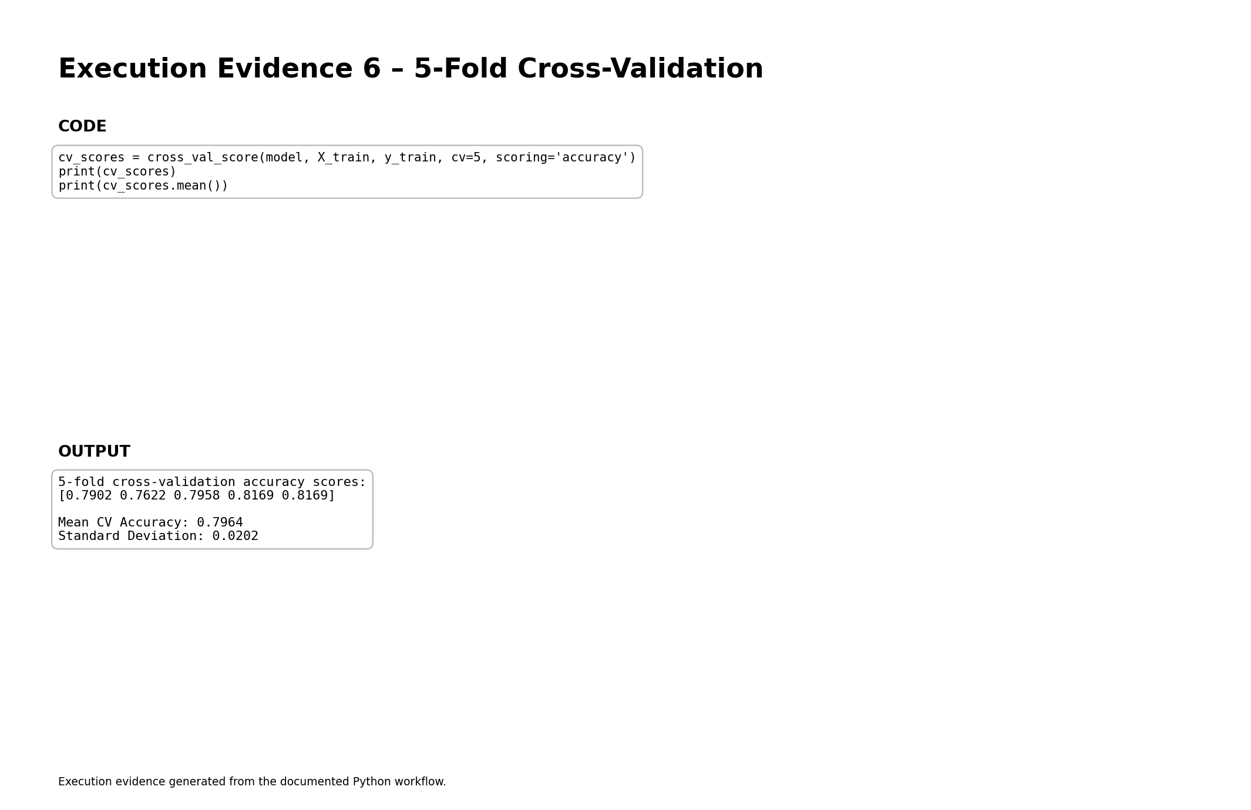
Figure 6. Execution evidence for five-fold cross-validation.
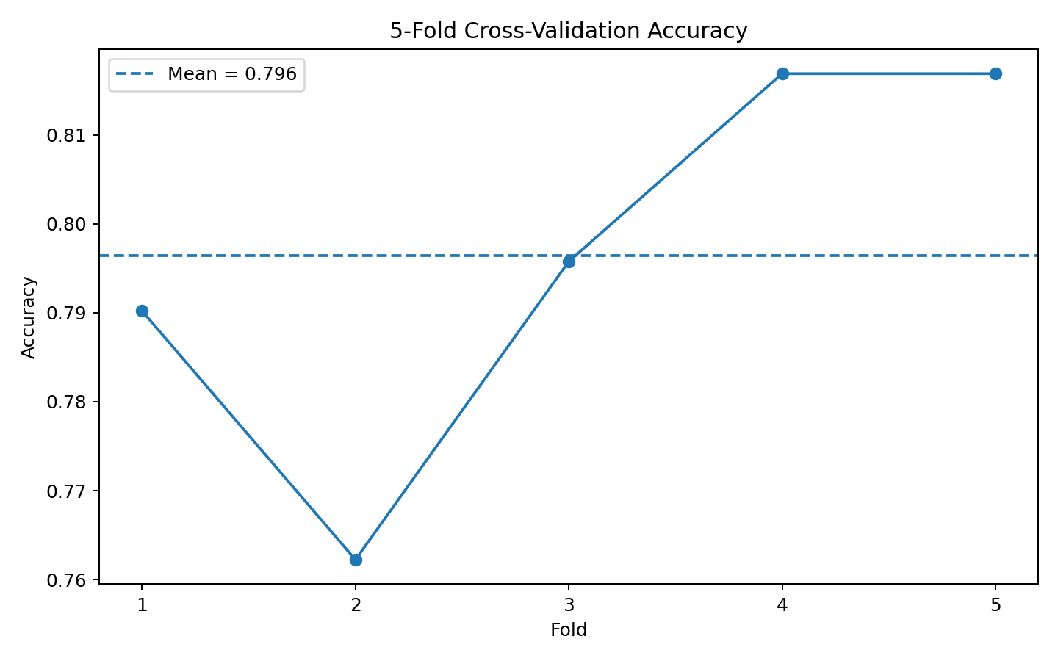
Figure 7. Cross-validation accuracy across the five folds.

12. Evaluation Metrics
Metric | Value | Meaning
Accuracy | 0.8045 | Overall proportion of correct predictions
Precision | 0.7931 | Correct positive predictions among predicted positives
Recall | 0.6667 | Correctly identified survivors among actual survivors
F1-score | 0.7244 | Harmonic mean of precision and recall
ROC-AUC | 0.8435 | Ability to rank positive cases above negative cases
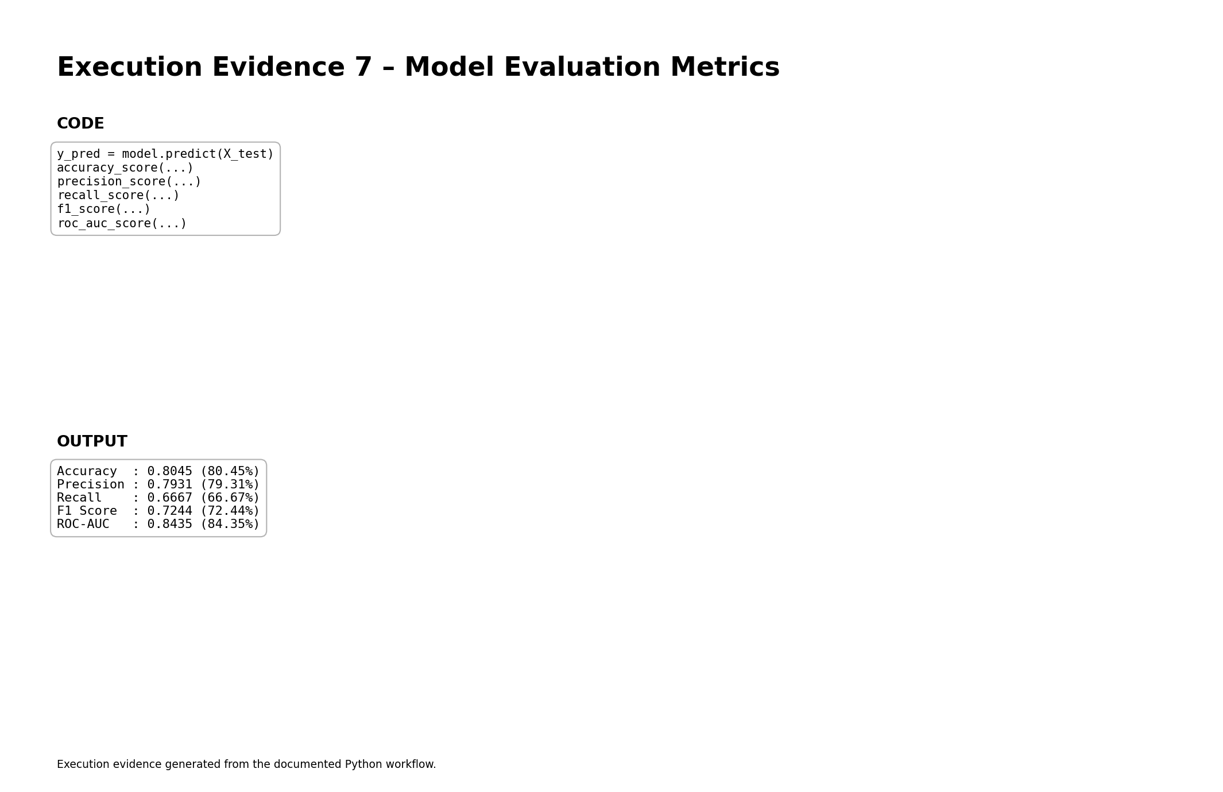
Figure 8. Execution evidence for the final evaluation metrics.
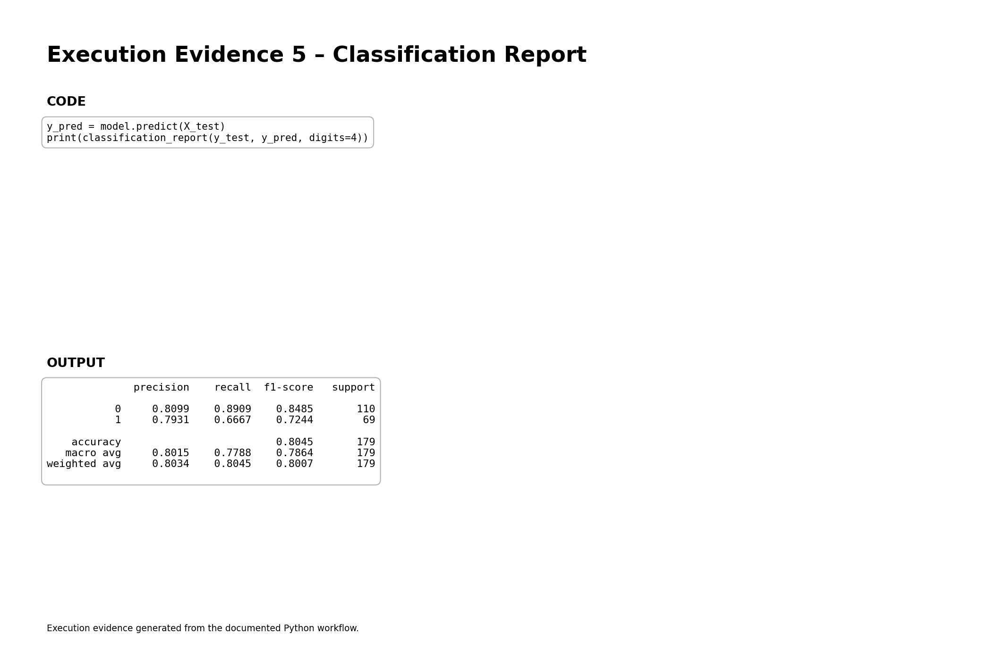
Figure 9. Detailed classification report.

13. Model Results and Interpretation
The Logistic Regression model achieved 80.45% accuracy on the unseen test set. Its precision was 0.7931, recall was 0.6667, and F1-score was 0.7244. The ROC-AUC of 0.8435 indicates useful discrimination between the two classes.
The five-fold cross-validation mean accuracy was 79.64% with a standard deviation of 2.02 percentage points. The relatively small variation across folds suggests that the baseline model is reasonably stable on different training/validation partitions.
Metric | Test Result | Interpretation
Accuracy | 80.45% | About eight out of ten test cases were classified correctly.
Precision | 79.31% | Most passengers predicted as survivors were actually survivors.
Recall | 66.67% | The model identified about two-thirds of actual survivors.
F1-score | 72.44% | Balanced summary of positive-class precision and recall.
ROC-AUC | 0.8435 | Good separation ability for a baseline classifier.

14. Confusion Matrix Analysis
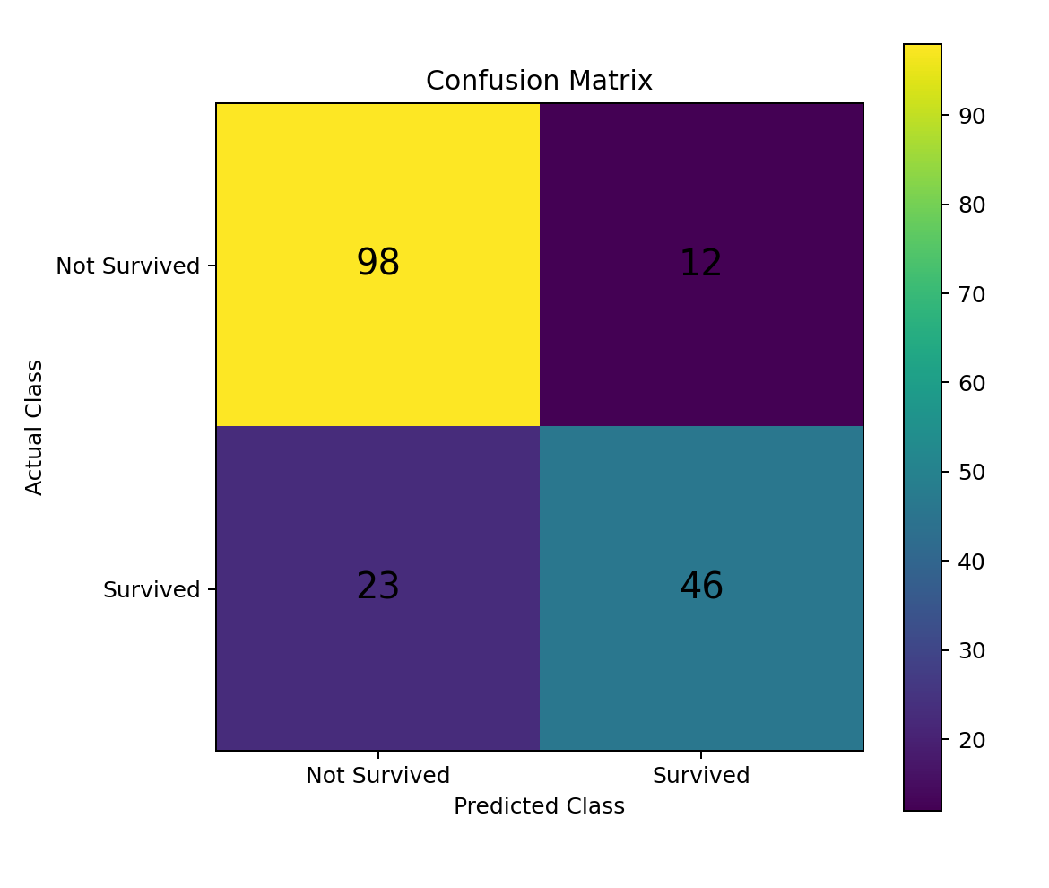
Figure 10. Confusion matrix for the held-out test set.
Actual / Predicted | Not Survived | Survived
Not Survived | 98 | 12
Survived | 23 | 46
The model correctly classified 98 non-survivors and 46 survivors. It incorrectly predicted 12 non-survivors as survivors and 23 survivors as non-survivors. The larger number of false negatives shows that improving survivor recall could be a useful direction for future model enhancement.

15. Model Coefficients and Feature Interpretation
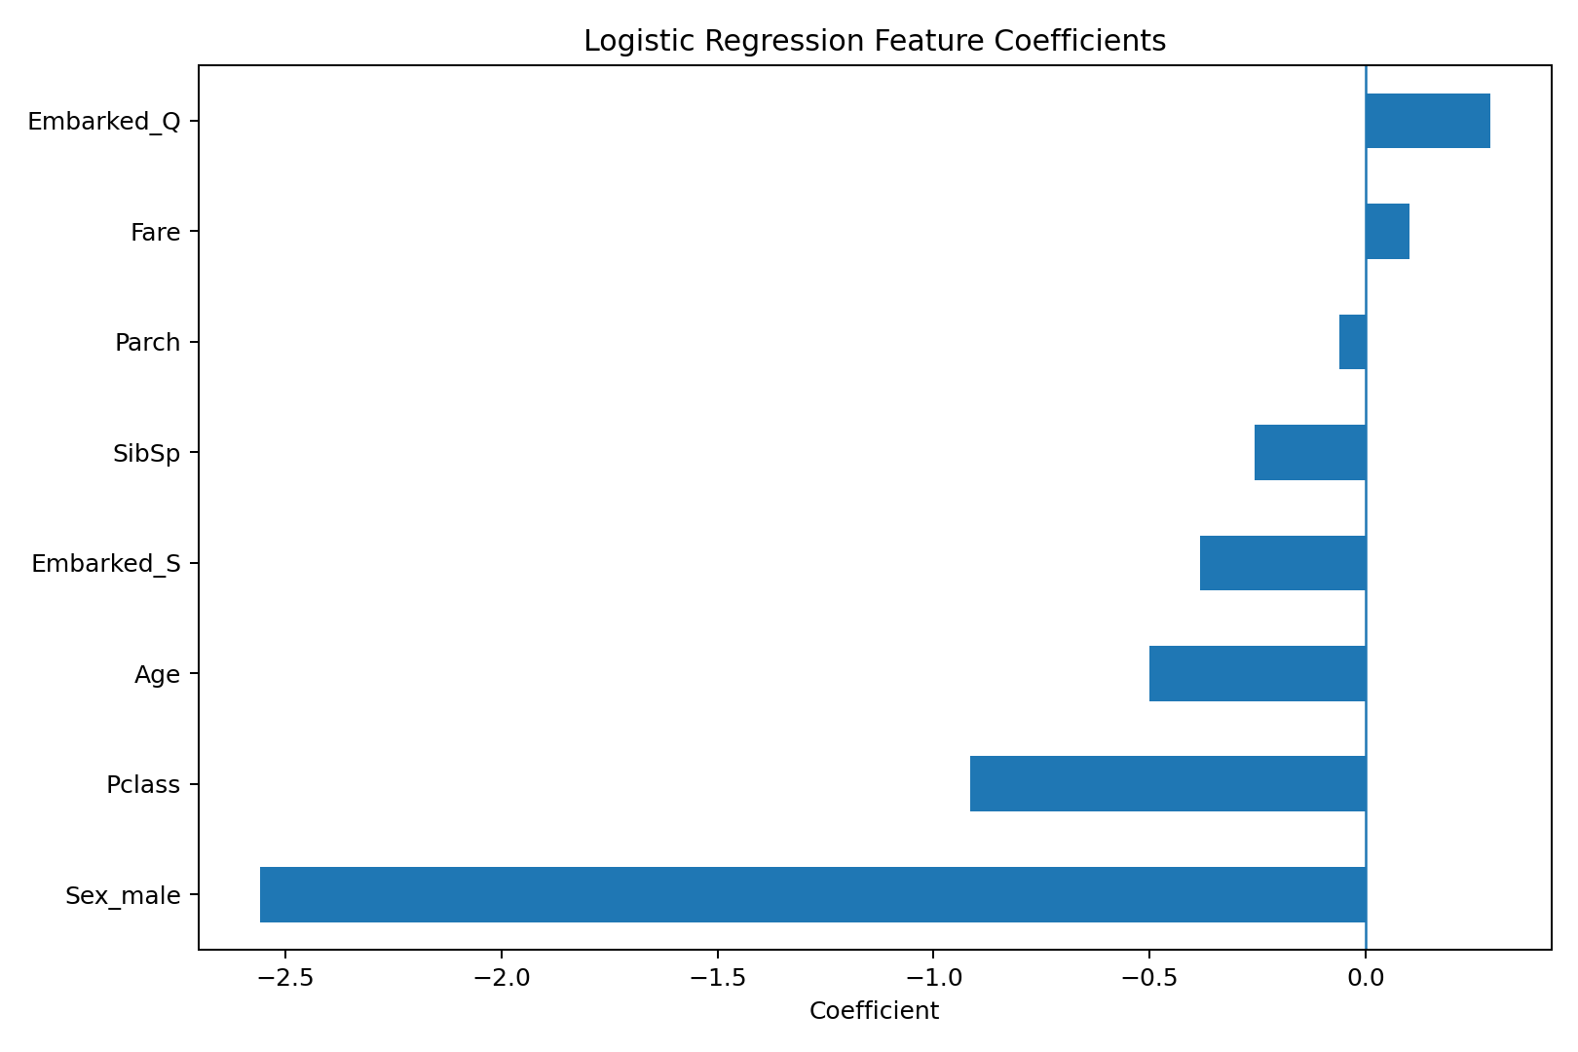
Figure 11. Logistic Regression coefficient directions.
Feature | Coefficient | Direction
Sex_male | -2.5598 | Negative
Pclass | -0.9158 | Negative
Age | -0.5009 | Negative
Embarked_S | -0.3835 | Negative
SibSp | -0.2577 | Negative
Parch | -0.0598 | Negative
Fare | 0.1017 | Positive
Embarked_Q | 0.2885 | Positive
The coefficient chart provides an interpretable view of how each transformed feature contributes to the model's decision boundary. Because the numerical features are standardized, coefficient magnitudes can be compared more meaningfully than when variables are measured on very different scales. Categorical coefficients are interpreted relative to their omitted reference categories.

16. Complete Python Implementation
# Week 4 – Titanic Survival Prediction
import pandas as pd
import numpy as np
from sklearn.model_selection import train_test_split, cross_val_score
from sklearn.compose import ColumnTransformer
from sklearn.pipeline import Pipeline
from sklearn.preprocessing import OneHotEncoder, StandardScaler
from sklearn.impute import SimpleImputer
from sklearn.linear_model import LogisticRegression
from sklearn.metrics import (
accuracy_score, precision_score, recall_score,
f1_score, confusion_matrix, classification_report,
roc_auc_score
)
df = pd.read_csv("titanic_train.csv")
features = ["Pclass", "Sex", "Age", "SibSp", "Parch", "Fare", "Embarked"]
X = df[features]
y = df["Survived"]
numeric_features = ["Pclass", "Age", "SibSp", "Parch", "Fare"]
categorical_features = ["Sex", "Embarked"]
preprocessor = ColumnTransformer([
("num", Pipeline([
("imputer", SimpleImputer(strategy="median")),
("scaler", StandardScaler())
]), numeric_features),
("cat", Pipeline([
("imputer", SimpleImputer(strategy="most_frequent")),
("onehot", OneHotEncoder(handle_unknown="ignore", drop="first"))
]), categorical_features)
])
model = Pipeline([
("preprocessor", preprocessor),
("classifier", LogisticRegression(max_iter=1000, random_state=42))
])
X_train, X_test, y_train, y_test = train_test_split(
X, y, test_size=0.20, stratify=y, random_state=42
)
model.fit(X_train, y_train)
y_pred = model.predict(X_test)
y_prob = model.predict_proba(X_test)[:, 1]
print("Accuracy:", accuracy_score(y_test, y_pred))
print("Precision:", precision_score(y_test, y_pred))
print("Recall:", recall_score(y_test, y_pred))
print("F1 Score:", f1_score(y_test, y_pred))
print("ROC-AUC:", roc_auc_score(y_test, y_prob))
print("Confusion Matrix:")
print(confusion_matrix(y_test, y_pred))
cv_scores = cross_val_score(
model, X_train, y_train, cv=5, scoring="accuracy"
)
print("CV Scores:", cv_scores)
print("Mean CV Accuracy:", cv_scores.mean())

17. Strengths of the Implemented Model
- Simple and interpretable baseline for binary classification.
- Uses a reproducible Scikit-learn pipeline.
- Handles missing numerical and categorical values systematically.
- Standardizes numerical variables before Logistic Regression.
- Uses one-hot encoding for categorical variables.
- Uses stratified train-test splitting to preserve class proportions.
- Uses five-fold cross-validation to assess stability.
- Provides several complementary evaluation metrics rather than relying only on accuracy.

18. Limitations
- The model is a linear classifier and may not capture complex non-linear interactions.
- Cabin information is excluded from the baseline because of high missingness.
- The dataset is historical and relatively small compared with modern machine-learning datasets.
- Accuracy alone does not fully describe class-specific performance.
- Some important passenger-level information may not be represented by the selected features.
- The model is intended for educational analysis and should not be treated as a real operational risk-prediction system.

19. Possible Improvements
- Compare Logistic Regression with Random Forest, Gradient Boosting and other tree-based classifiers.
- Engineer FamilySize = SibSp + Parch + 1.
- Create an IsAlone feature to distinguish solo travellers from passengers travelling with family.
- Extract passenger titles from Name and evaluate whether they improve predictive performance.
- Experiment with Cabin deck information after careful missing-value treatment.
- Tune Logistic Regression hyperparameters such as C and class_weight.
- Use GridSearchCV or RandomizedSearchCV with cross-validation.
- Compare ROC-AUC and precision-recall performance in addition to accuracy.
- Evaluate model calibration if predicted probabilities are used.
- Perform error analysis on false positives and false negatives.

20. Practical and Research Implications
The project demonstrates how a labelled historical dataset can be transformed into a supervised learning problem. The workflow is transferable to other binary classification tasks such as customer churn, loan default screening, equipment failure detection and medical risk classification, provided that the dataset and ethical requirements are appropriate.

21. Conclusion
The Week 4 supervised learning task was successfully implemented using the Titanic dataset and Logistic Regression. The workflow covered problem definition, dataset inspection, missing-value treatment, feature selection, categorical encoding, numerical standardization, stratified train-test splitting, model training, five-fold cross-validation and multi-metric evaluation.
The final baseline achieved 80.45% test accuracy, 79.31% precision, 66.67% recall and 72.44% F1-score, with ROC-AUC of 0.8435. The mean five-fold cross-validation accuracy was 79.64%. These results show that a relatively simple supervised learning model can capture useful patterns in passenger characteristics while also highlighting the need for stronger models and feature engineering when higher predictive performance is required.
Overall, the project provides a complete, reproducible and interpretable supervised learning implementation suitable for the Week 4 internship requirement.

22. References
- Kaggle – Titanic: Machine Learning from Disaster, Data and Data Dictionary.
- Scikit-learn – LogisticRegression documentation.
- Scikit-learn – train_test_split documentation.
- Scikit-learn – Pipeline and ColumnTransformer documentation.
- Scikit-learn – StandardScaler, SimpleImputer and OneHotEncoder documentation.
- Scikit-learn – classification metrics and cross-validation documentation.
- Pandas documentation – DataFrame operations and missing-value handling.
- Matplotlib documentation – plotting and visualization.
Primary dataset reference: https://www.kaggle.com/c/titanic/data
Kaggle describes Survived as the binary survival target and provides the Titanic data dictionary. The dataset used in this report contains the standard 891-row training set.

Appendix A – Execution Evidence
Appendix Figure A1. Dataset loading and inspection.

Appendix Figure A2. Missing-value analysis.

Appendix Figure A3. Feature engineering and split.

Appendix Figure A4. Model training.

Appendix Figure A5. Classification report.

Appendix Figure A6. Cross-validation output.

Appendix Figure A7. Evaluation metrics.

Appendix B – Supporting Visualizations
Appendix Figure B1. Target distribution.

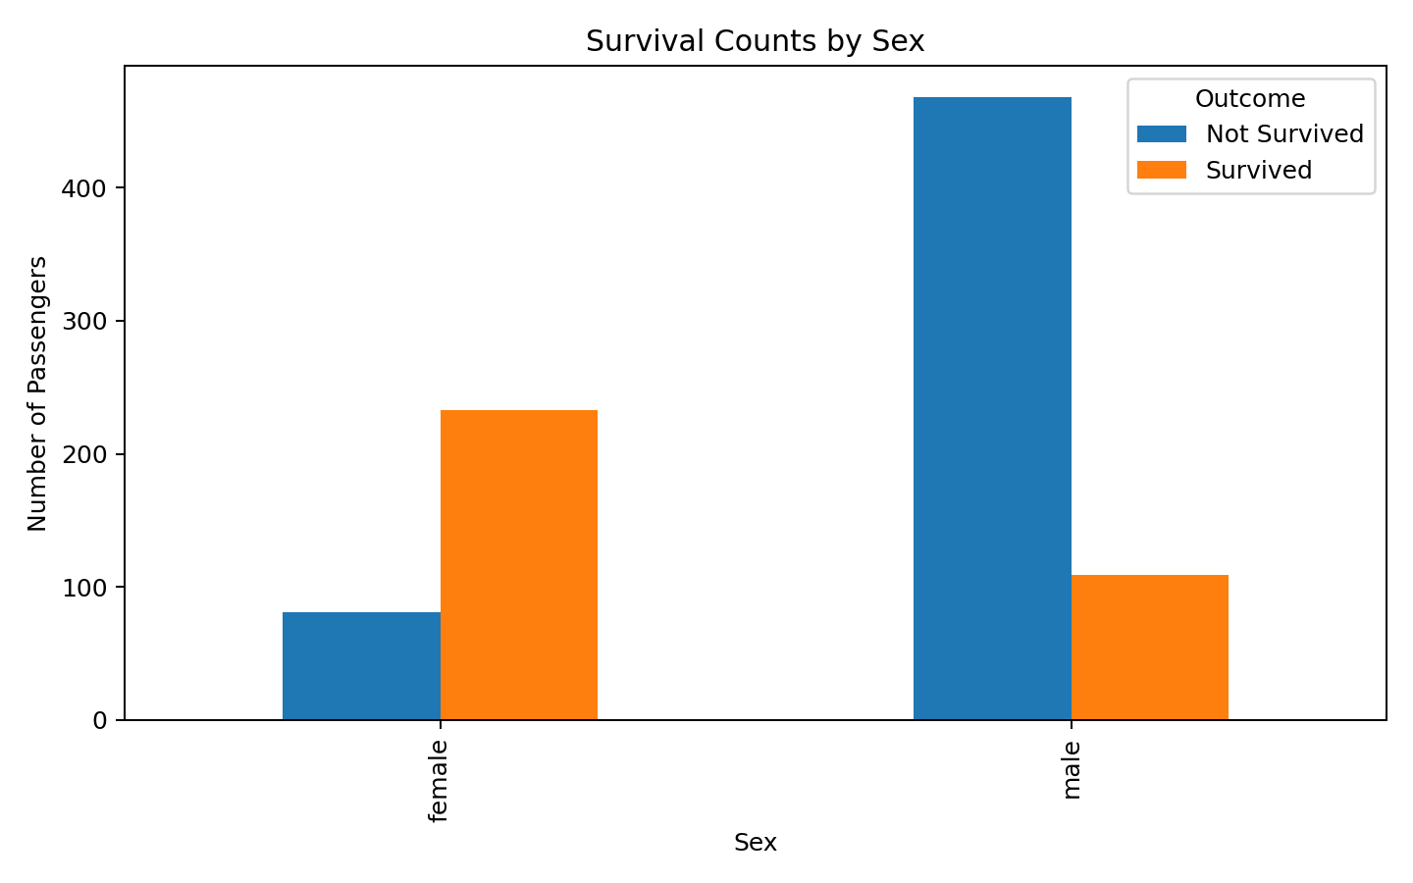
Appendix Figure B2. Survival counts by sex.

Appendix Figure B3. Confusion matrix.

Appendix Figure B4. Cross-validation accuracy.

Appendix Figure B5. Logistic Regression coefficients.

