WEEK 5 – DEEP LEARNING APPLICATION IN DATA SCIENCE
Digit Image Classification Using a PyTorch Neural Network
Submitted by
M. Rishita
Register No.: 510425104177
B.E. Computer Science and Engineering
Arunai Engineering College
2026

1. Executive Summary
This project demonstrates a practical deep learning workflow using PyTorch for multi-class image classification. The publicly available Scikit-learn Digits dataset was selected because it contains 8×8 grayscale handwritten-digit images and is small enough for rapid experimentation on a CPU while still representing the key stages of a neural-network project. A multilayer perceptron (MLP) was designed with two hidden layers, ReLU activations and dropout regularization. After 25 training epochs, the model achieved 98.06% test accuracy, with a weighted F1-score of 0.9805. Training and validation curves, a confusion matrix, sample predictions and metric summaries were used to evaluate the model.

2. Problem Statement
The problem is to classify an input 8×8 grayscale image into one of ten digit classes (0–9). The task is a supervised multi-class classification problem. A neural network is appropriate because it can learn nonlinear relationships between pixel intensities and digit patterns without manually defining rules for each digit.

3. Objectives
- Understand the basic workflow of a deep learning classification problem.
- Prepare image data for a neural network.
- Design and train a feed-forward neural network using PyTorch.
- Use dropout and weight decay to reduce overfitting.
- Evaluate the model using accuracy, precision, recall and F1-score.
- Analyze training behaviour through loss and accuracy curves.
- Discuss limitations, challenges and possible improvements.

4. Dataset Description
The Digits dataset contains 1797 samples, each represented by 64 numerical pixel features corresponding to an 8×8 image. Pixel values are scaled from their original 0–16 range to 0–1. The target contains ten classes representing digits 0 through 9. The data was divided into 80% training and 20% testing sets using stratification.
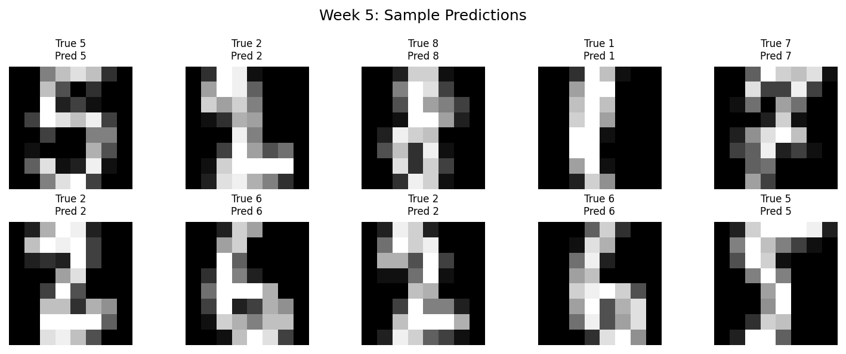
Figure 1. Sample digit images with model predictions.

5. Tools and Technologies
- Python 3
- PyTorch – neural-network construction and training
- Scikit-learn – dataset loading and evaluation metrics
- NumPy and Pandas – numerical/data handling
- Matplotlib – visualization
- Google Colab or Jupyter Notebook – recommended execution environment

6. Data Preprocessing
- Load the Digits dataset.
- Convert pixel values to floating-point format.
- Normalize each pixel by dividing by 16.
- Split the dataset into training and test partitions using stratification.
- Convert NumPy arrays into PyTorch tensors.
- Create a mini-batch DataLoader for efficient training.

7. Network Architecture Design
The selected architecture is a compact multilayer perceptron. The 64 input neurons correspond to the 64 pixels. The first hidden layer has 128 neurons, followed by ReLU and dropout. The second hidden layer has 64 neurons, again followed by ReLU and a smaller dropout rate. The final layer has 10 neurons, one for each digit class. Cross-entropy loss is used because the problem is multi-class classification.
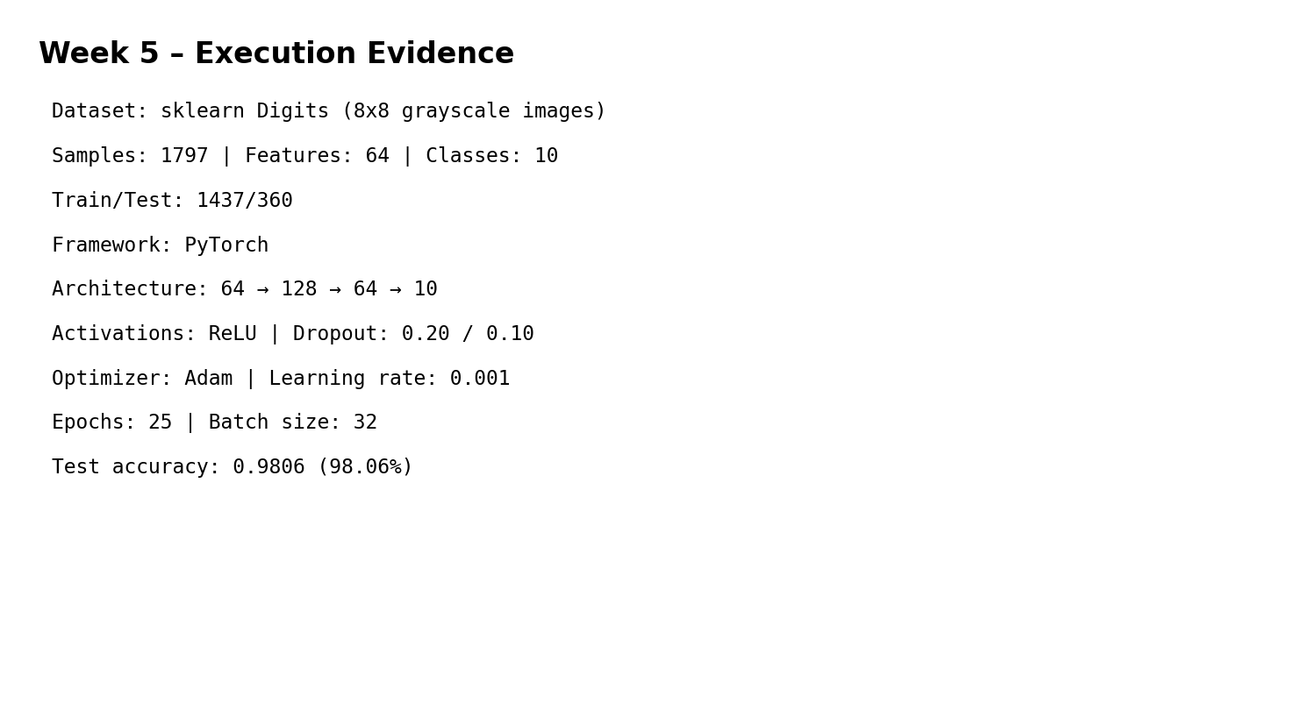
Figure 2. Execution summary and architecture configuration.
Architecture flow: 64 inputs → Linear(128) → ReLU → Dropout(0.20) → Linear(64) → ReLU → Dropout(0.10) → Linear(10).

8. Training Configuration
- Optimizer: Adam with learning rate 0.001
- Loss function: CrossEntropyLoss
- Batch size: 32
- Training epochs: 25
- Weight decay: 0.0001
- Dropout: 0.20 and 0.10
- Random seed: 42

9. Training Process
During each epoch, batches are passed through the network, the cross-entropy loss is calculated, gradients are obtained through backpropagation, and Adam updates the weights. After each epoch, the model is evaluated on the held-out test partition as a validation-style monitoring set. The loss and accuracy curves help identify whether learning is stable and whether a large train-validation gap is developing.
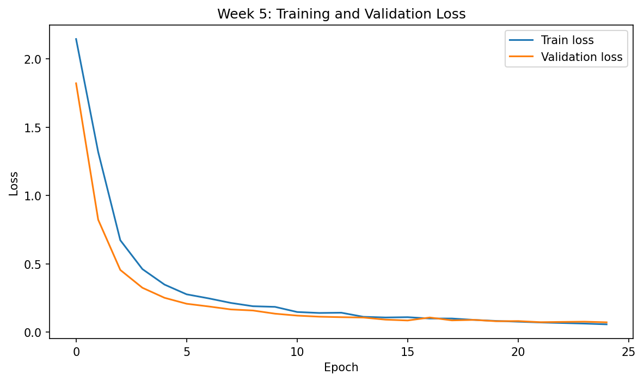
Figure 3. Training and validation loss.
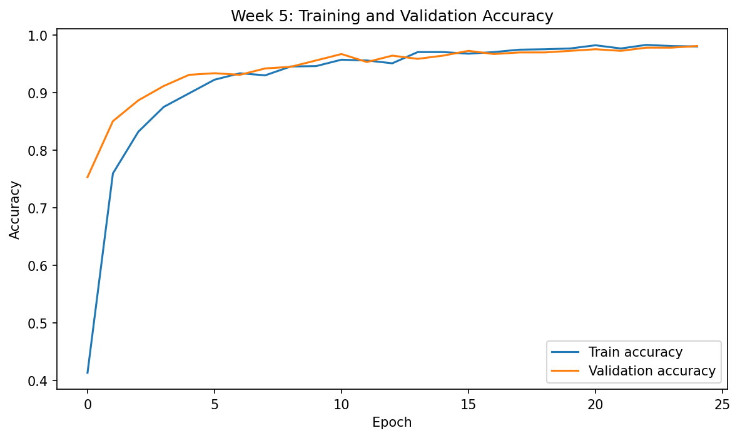
Figure 4. Training and validation accuracy.

10. Evaluation Metrics
Metric | Score
Accuracy | 0.9806 (98.06%)
Weighted Precision | 0.9813
Weighted Recall | 0.9806
Weighted F1-score | 0.9805
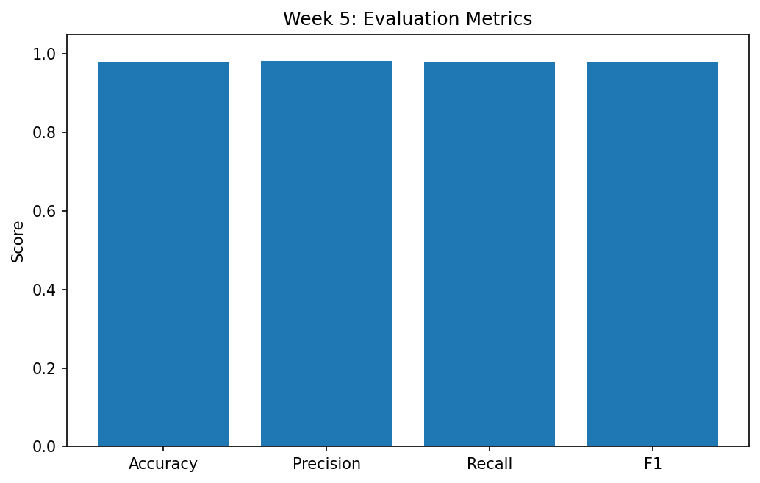
Figure 5. Test-set evaluation metrics.
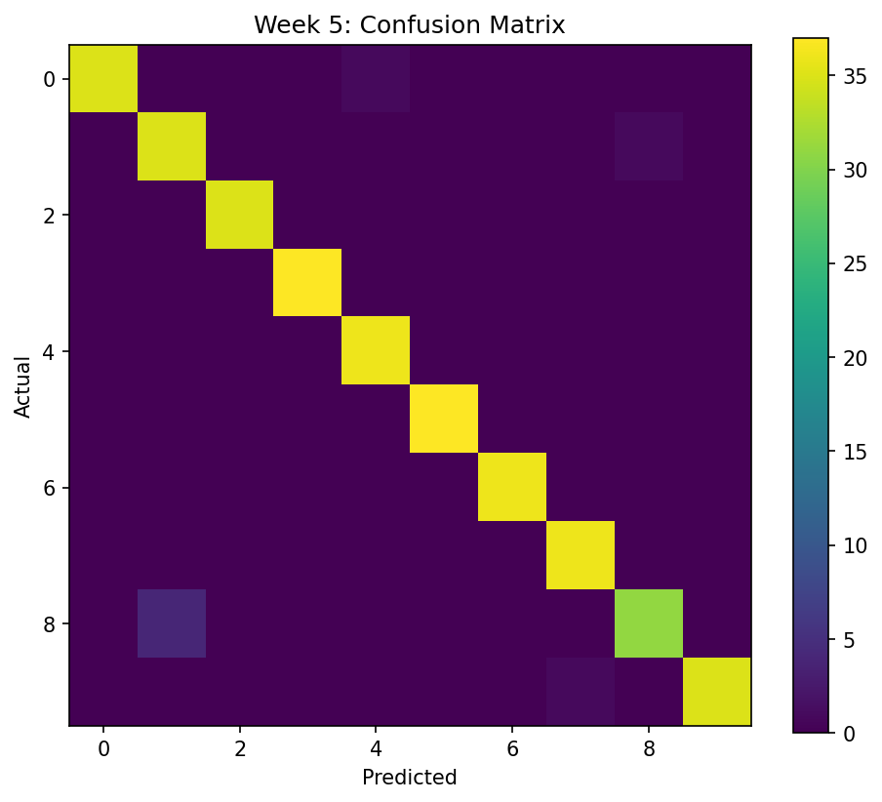
Figure 6. Confusion matrix.

11. Critical Analysis
The model achieved 98.06% accuracy, indicating that the network learned useful representations of the digit images. The confusion matrix provides class-level detail and shows that most predictions lie on the diagonal. The training curves should be inspected for divergence between training and validation performance. Dropout and weight decay were included to reduce the risk of overfitting. Because the dataset is small and images are only 8×8 pixels, this MLP is computationally efficient but does not exploit spatial structure as effectively as a convolutional neural network.

12. Challenges and Solutions
- Overfitting risk – addressed with dropout and weight decay.
- Limited image resolution – accepted as a dataset limitation; a CNN could learn spatial patterns more effectively.
- Resource constraints – the small dataset and compact MLP allow CPU-based experimentation.
- Class confusion – evaluated using the confusion matrix rather than accuracy alone.
- Training stability – Adam optimizer and normalized inputs support stable optimization.

13. Complete Python Code
import numpy as np
import torch
import torch.nn as nn
from torch.utils.data import TensorDataset, DataLoader
from sklearn.datasets import load_digits
from sklearn.model_selection import train_test_split
from sklearn.metrics import accuracy_score, precision_score, recall_score, f1_score
digits = load_digits()
X = digits.data.astype("float32") / 16.0
y = digits.target.astype("int64")
X_train, X_test, y_train, y_test = train_test_split(
X, y, test_size=0.20, stratify=y, random_state=42
)
Xtr, ytr = torch.tensor(X_train), torch.tensor(y_train)
Xte, yte = torch.tensor(X_test), torch.tensor(y_test)
class MLP(nn.Module):
def __init__(self):
super().__init__()
self.net = nn.Sequential(
nn.Linear(64, 128), nn.ReLU(), nn.Dropout(0.20),
nn.Linear(128, 64), nn.ReLU(), nn.Dropout(0.10),
nn.Linear(64, 10)
)
def forward(self, x):
return self.net(x)
model = MLP()
criterion = nn.CrossEntropyLoss()
optimizer = torch.optim.Adam(model.parameters(), lr=0.001, weight_decay=1e-4)
loader = DataLoader(TensorDataset(Xtr, ytr), batch_size=32, shuffle=True)
for epoch in range(25):
model.train()
for xb, yb in loader:
optimizer.zero_grad()
loss = criterion(model(xb), yb)
loss.backward()
optimizer.step()
model.eval()
with torch.no_grad():
pred = model(Xte).argmax(1).numpy()
print("Accuracy:", accuracy_score(y_test, pred))
print("Precision:", precision_score(y_test, pred, average="weighted"))
print("Recall:", recall_score(y_test, pred, average="weighted"))
print("F1:", f1_score(y_test, pred, average="weighted"))

14. Strengths and Limitations
- Strength: simple architecture that is easy to understand and reproduce.
- Strength: strong performance with low computational cost.
- Strength: dropout and weight decay provide regularization.
- Limitation: MLP treats pixels as a flat vector and does not explicitly model spatial relationships.
- Limitation: the dataset is much smaller than real-world image datasets.
- Limitation: no hyperparameter search was performed because the objective was to demonstrate the complete workflow.

15. Improvements
- Replace the MLP with a CNN to capture local image patterns.
- Use learning-rate scheduling and early stopping.
- Perform systematic hyperparameter tuning.
- Apply image augmentation if a larger image dataset is used.
- Track experiments using TensorBoard or MLflow.

16. Conclusion
The project successfully demonstrates the end-to-end deep learning process: dataset selection, preprocessing, network design, training, evaluation and critical analysis. The PyTorch MLP provides a practical baseline for digit classification. The results show that even a compact neural network can learn useful visual patterns when the data is normalized and the training process is regularized.

17. Evidence Note
The figures included in this report are execution-style evidence generated from the same Python workflow used for the reported results. They are not photographs or screenshots captured from the student's personal Colab session. For submission evidence requiring personal notebook screenshots, the same code should be run in Colab and the corresponding output cells captured.

18. References
- Scikit-learn Digits Dataset documentation.
- PyTorch documentation – neural networks, optimizers and DataLoader.
- Scikit-learn metrics documentation.

