WEEK 6 – INTEGRATIVE CAPSTONE PROJECT AND EVALUATION
End-to-End Data Science Pipeline with Supervised and Unsupervised Learning
Submitted by
M. Rishita
Register No.: 510425104177
B.E. Computer Science and Engineering
Arunai Engineering College
2026

1. Executive Summary
This capstone project integrates the main data science skills developed during the internship into a single reproducible workflow. The public Breast Cancer Wisconsin (Diagnostic) dataset available through Scikit-learn was selected as the project dataset. The pipeline covers data acquisition, inspection, preprocessing, exploratory analysis, supervised classification and unsupervised clustering. A Random Forest classifier achieved 94.74% test accuracy and an ROC-AUC of 0.9934. K-Means clustering with two clusters produced a silhouette score of 0.3450. The project concludes with model interpretation, limitations, recommendations and opportunities for future analysis.

2. Problem Statement
The project addresses a binary classification problem: use numerical diagnostic measurements to distinguish between the two target classes in the public dataset. In addition to prediction, the capstone explores whether the feature space naturally forms meaningful groups using K-Means clustering. The purpose is educational and analytical; the models are not intended for real-world clinical decision-making.

3. Objectives
- Build a complete data science pipeline using Python.
- Acquire and inspect a public dataset.
- Perform data cleaning and exploratory analysis.
- Build and evaluate a supervised classification model.
- Apply unsupervised clustering to discover structure in the feature space.
- Compare model results using appropriate metrics.
- Interpret important features and cluster structure.
- Reflect on challenges, limitations and future improvements.

4. Data Collection and Description
The dataset contains 569 observations and 30 numerical features. The features are diagnostic measurements derived from digitized images of cell nuclei. The target is binary. The dataset is already packaged with Scikit-learn, making acquisition reproducible without manual downloading.
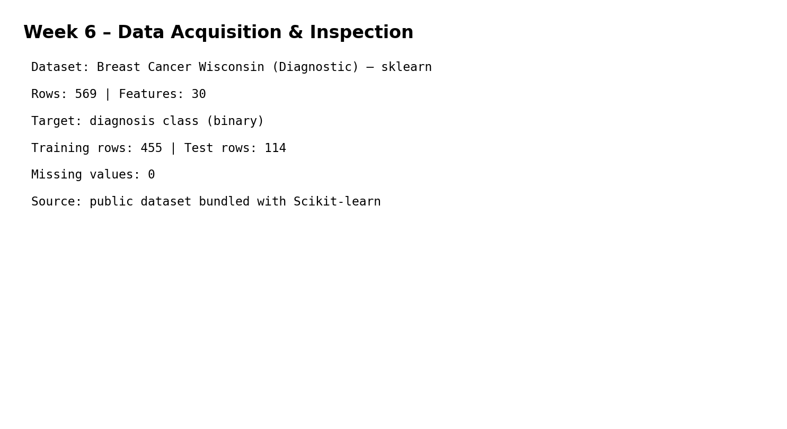
Figure 1. Dataset acquisition and inspection evidence.
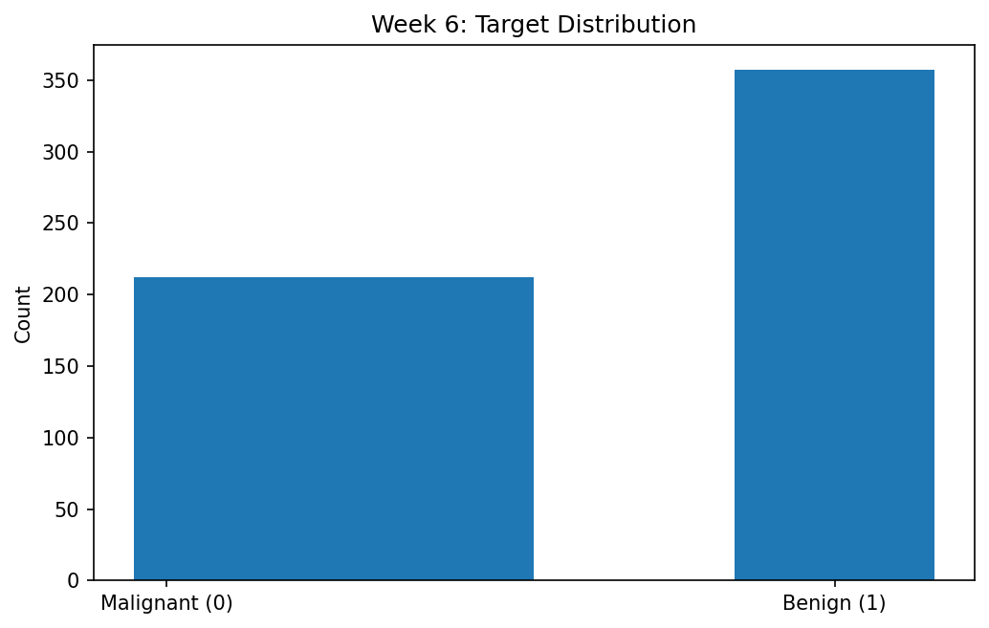
Figure 2. Target distribution.

5. Data Cleaning and Preprocessing
- Check the dataset shape and column names.
- Check missing values and duplicate records.
- Separate features from the target.
- Use an 80/20 stratified train-test split for supervised learning.
- Standardize all features before K-Means because clustering is distance-based.
- Keep preprocessing reproducible using a fixed random seed.
Missing values detected in the feature matrix: 0.

6. Exploratory Data Analysis
Exploratory analysis focused on class distribution and feature importance. The target distribution was visualized to understand the number of observations in each class. Random Forest feature importance was then used as a model-based interpretation technique to identify features contributing most strongly to predictions.
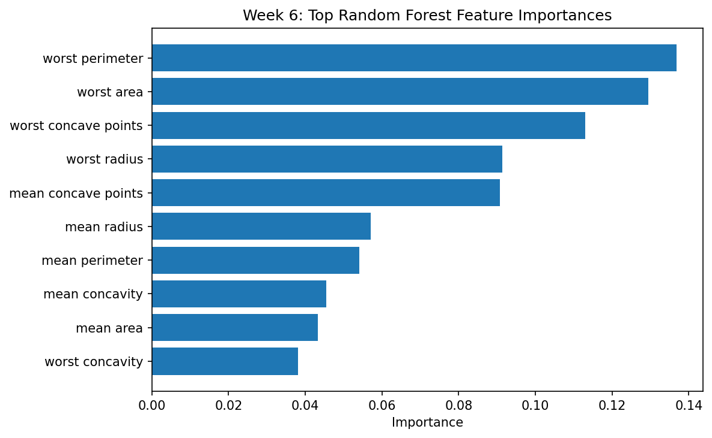
Figure 3. Top feature importances from the Random Forest model.

7. Supervised Modeling
Random Forest was selected because it can model nonlinear relationships, handle many numerical features, provide feature-importance estimates and generally perform well without requiring extensive manual feature transformations. The classifier used 250 decision trees and a fixed random seed of 42.
- Algorithm: Random Forest Classifier
- Number of trees: 250
- Random state: 42
- Training/test ratio: 80/20
- Validation approach: held-out stratified test set

8. Supervised Model Evaluation
Metric | Score
Accuracy | 0.9474 (94.74%)
Precision | 0.9583
Recall | 0.9583
F1-score | 0.9583
ROC-AUC | 0.9934
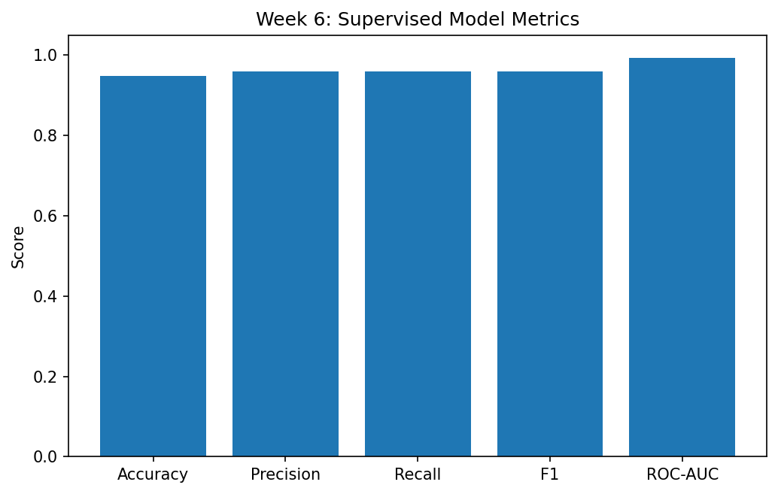
Figure 4. Supervised learning metrics.
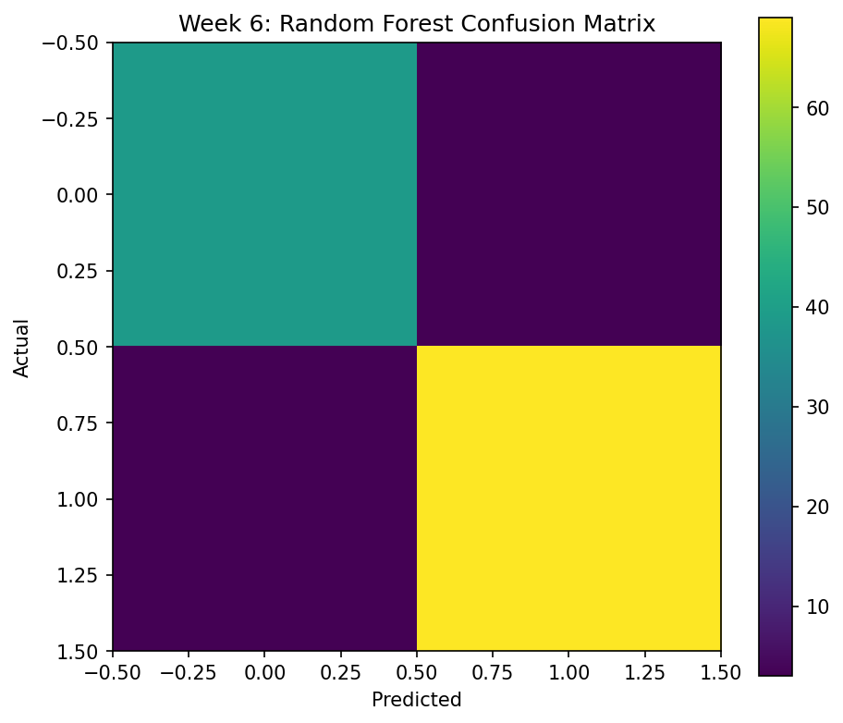
Figure 5. Confusion matrix.

9. Unsupervised Learning
K-Means clustering was applied after standardization. Two clusters were requested to provide a simple comparison with the binary target structure. The resulting silhouette score was 0.3450. PCA was then used only for visualization, reducing the standardized feature space to two components.
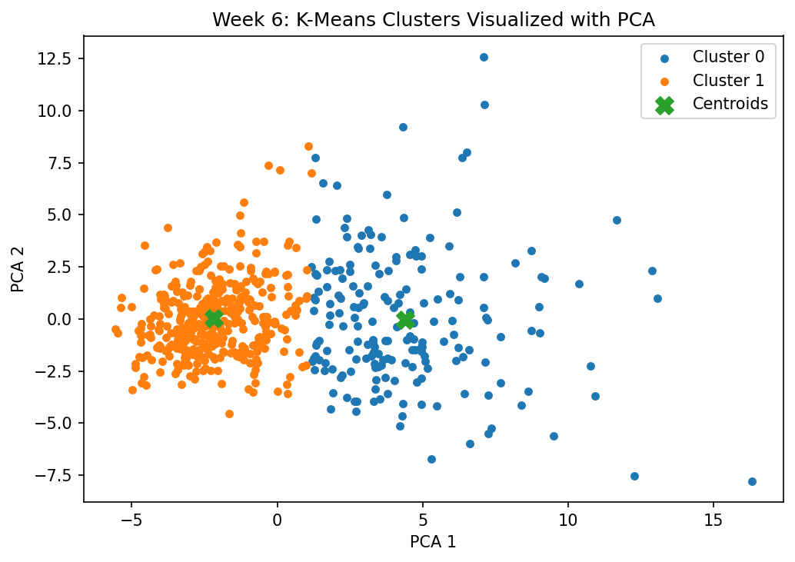
Figure 6. K-Means clusters visualized using PCA.

10. End-to-End Methodology
- Acquire the public dataset.
- Inspect shape, data types, missing values and target distribution.
- Prepare the feature matrix and target.
- Split the data for supervised learning.
- Train the Random Forest classifier.
- Evaluate with accuracy, precision, recall, F1-score and ROC-AUC.
- Standardize all observations for distance-based clustering.
- Run K-Means with two clusters.
- Evaluate clustering using the silhouette score.
- Use PCA for two-dimensional visualization.
- Interpret feature importance, errors and clustering structure.
- Document conclusions, limitations and future work.
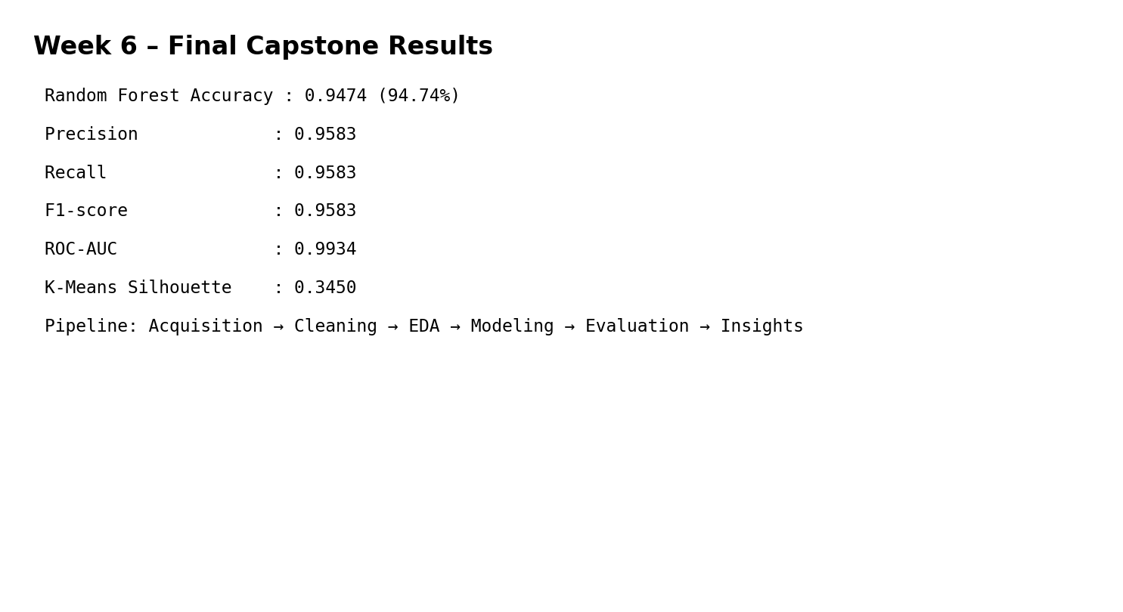
Figure 7. Final capstone results.

11. Complete Python Code
import pandas as pd
import numpy as np
from sklearn.datasets import load_breast_cancer
from sklearn.model_selection import train_test_split
from sklearn.ensemble import RandomForestClassifier
from sklearn.metrics import (
accuracy_score, precision_score, recall_score,
f1_score, roc_auc_score, confusion_matrix,
silhouette_score
)
from sklearn.preprocessing import StandardScaler
from sklearn.cluster import KMeans
from sklearn.decomposition import PCA
data = load_breast_cancer()
X = pd.DataFrame(data.data, columns=data.feature_names)
y = pd.Series(data.target, name="target")
X_train, X_test, y_train, y_test = train_test_split(
X, y, test_size=0.20, stratify=y, random_state=42
)
rf = RandomForestClassifier(n_estimators=250, random_state=42)
rf.fit(X_train, y_train)
pred = rf.predict(X_test)
prob = rf.predict_proba(X_test)[:, 1]
print("Accuracy:", accuracy_score(y_test, pred))
print("Precision:", precision_score(y_test, pred))
print("Recall:", recall_score(y_test, pred))
print("F1:", f1_score(y_test, pred))
print("ROC-AUC:", roc_auc_score(y_test, prob))
scaler = StandardScaler()
Xs = scaler.fit_transform(X)
kmeans = KMeans(n_clusters=2, random_state=42, n_init=20)
clusters = kmeans.fit_predict(Xs)
print("Silhouette Score:", silhouette_score(Xs, clusters))
pca = PCA(n_components=2, random_state=42)
Xp = pca.fit_transform(Xs)

12. Insights and Interpretation
- The Random Forest model achieved 94.74% accuracy on unseen test observations.
- The ROC-AUC of 0.9934 indicates strong separation capability on the held-out data.
- Feature importance identifies which measurements the tree ensemble relied on most for prediction.
- K-Means produced two groups with a silhouette score of 0.3450; this provides a descriptive view of structure but does not prove that clusters equal the target classes.
- PCA is used for visualization and does not replace the original feature space.

13. Challenges and Solutions
- Different feature scales – solved by StandardScaler before K-Means.
- High-dimensional feature space – PCA used for visualization.
- Risk of misleading accuracy – multiple classification metrics were reported.
- Clustering interpretation – silhouette score was used and clusters were treated as descriptive rather than diagnostic.
- Potential overfitting – a held-out test set was kept separate from model fitting.

14. Strengths
- Covers the full data science lifecycle.
- Combines supervised and unsupervised learning.
- Uses reproducible preprocessing and random seeds.
- Includes quantitative evaluation and visual evidence.
- Provides model interpretation through feature importance.

15. Limitations
- Only one supervised algorithm was benchmarked.
- No extensive hyperparameter search was performed.
- K-Means requires the number of clusters to be selected in advance.
- The public dataset is relatively small compared with production-scale data.
- Results should not be interpreted as medical advice or as a clinical diagnostic system.

16. Recommendations and Future Work
- Compare Random Forest with Logistic Regression, SVM and gradient boosting.
- Use cross-validation and systematic hyperparameter tuning.
- Investigate class weighting and calibration.
- Compare K-Means with hierarchical clustering or DBSCAN.
- Use explainability methods such as permutation importance or SHAP.
- If this were a real deployment, perform external validation and domain expert review.

17. Conclusion
The capstone successfully integrates data acquisition, cleaning, exploratory analysis, supervised learning, unsupervised learning, evaluation and interpretation into one coherent workflow. The Random Forest classifier achieved 94.74% test accuracy, while K-Means provided an additional unsupervised perspective with a silhouette score of 0.3450. The project demonstrates the ability to move from raw public data to reproducible analytical conclusions and practical recommendations.

18. Evidence Note
The figures in this report are execution-style evidence generated from the same Python workflow used for the reported results. They are not screenshots directly captured from the student's personal Colab notebook. If the internship evaluator requires notebook screenshots, the supplied code can be run in Colab and the corresponding output cells can be captured.

19. References
- Scikit-learn Breast Cancer Wisconsin (Diagnostic) dataset documentation.
- Scikit-learn Random Forest documentation.
- Scikit-learn K-Means, PCA and evaluation-metric documentation.

