**Delay Discounting**

Course name- PSY310: Lab in Psychology

Date- 04/11/2023

Name- Rishitaa Joshi

Enrollment no.- AU2120095

**GITHUB:**

**INTRODUCTION**

Delay discounting can be described as the tendency of person to discount the worth of the reward as the delay to receiving the same increases. This tendency states that people prefer smaller immediate rewards rather than bigger and delayed rewards. Delay discounting tasks can be used to study the individual differences and to quantify the level of impulsivity. The study of delay discounting is important because it has implications for understanding impulsive behaviour, self-control, addiction, and decision-making processes in general. Individuals with higher discount rates are more likely to engage in impulsive behaviours, such as unhealthy eating, substance abuse, and risky financial decisions. Understanding delay discounting can help researchers and policymakers develop strategies to promote healthier decision-making and impulse control.

Research studies show that various factors that influence a person’s tendency to discount delayed rewards differently. Some of the factors are personality traits such as conscientiousness and impulsivity can affect the delay discounting. Delay discounting is seen to increase with age. Which predicts that young people are more likely to choose immediate rewards and older people are more inclined to choose delayed but larger rewards. Research studies have also shown that people with higher cognitive abilities better memory and executive function, better perception abilities tend to have lower delay discounting rates.

**METHOD**

***Participant***

A total of four participants took part in the study. One participant was a student of the class, the other two were parents of the experimenter aged between 45-50 years and the last participant was a The participants had normal vision.

***Materials and procedure***

The following experiment was designed through using the python based software, PsychoPy. The student was provided with the video tutorials on how to redesign the experiment by the professor of the course. The materials used in order to design and conduct the experiment was the personal laptop of the student.

In the following experiment, in the beginning a fixation in the form of a polygon was added. After this the participants were faced with a situation where they had to choose between two rewards. For example, they were presented with a situation where they could either get a 11 GBP at that particular moment or obtain 30 GBP after 7 days. Here they choose whether they wished to gain the rewards at that moment or gain a larger amount of reward after a particular period of time.

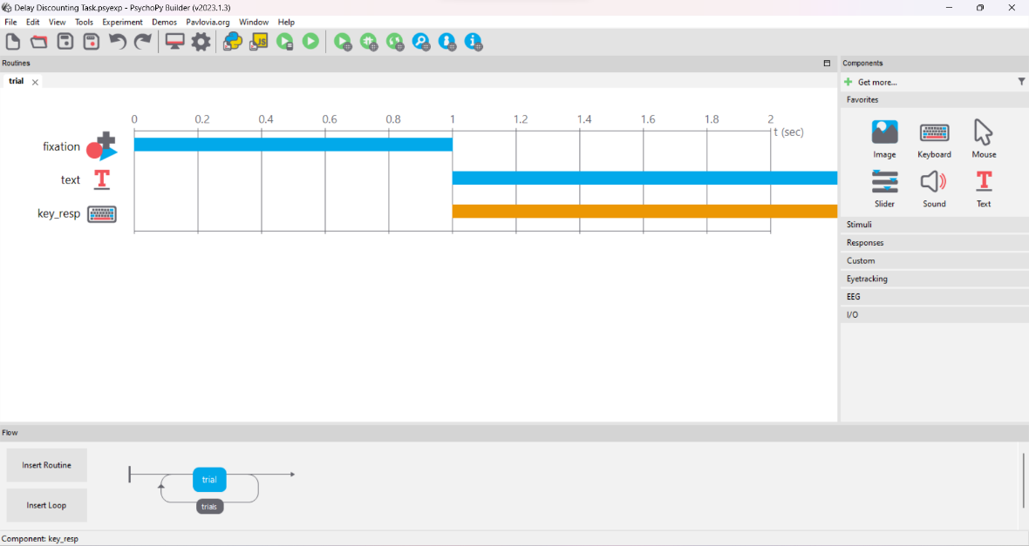

Figure- 1



Figure- 2

***Testing Conditions***

The 4 participants performed a total of 105 trials. It was made sure that the participants did not face any distractions from the environment. Participant performed the task without any breaks in between.

***Data Collection***

The data was automatically collected through PsychoPy in an excel file. The data was then refined to analyse the required the values efficiently

**RESULTS**

After conducting an analysis of the data gathered through psychopy, the following values were obtained. Three participants were found to be more focused on the larger and delayed rewards and just one participant was found to be impulsive and more interested in immediate rewards.

|  |  |  |
| --- | --- | --- |
| 0.05022 | 0.044382 | 0.044382 |
| 0.044019 | 0.044382 | 0.044382 |
| 0.044019 | 0.044382 | 0.044382 |
| 0.044019 | 0.044382 | 0.044382 |

**DISCUSSION**

Out of 4 participants, just one participant was found to be impulsive and focused on the immediate rewards. The data states that the other three participants were more focused on immediate and smaller rewards. Delay discounting can be considered to be an excellent marker for establishing individual differences in decision making processes. It can help in providing insight as to how to evaluate immediate and small rewards against delayed and larger rewards. This helps in representing their ability to delay gratification, evaluate and exercise self-control.

Delay discounting values has been found to predict and study various behaviours and outcomes. People with higher discount values are found to be more impulsive and risk takers whereas on the other side people with lower discount values are found to be more patient and focused on the larger rewards. Comprehending one’s discounting behaviour can aid in designing targeted interventions and treatments. One example of this would include interventions aimed at reducing delay discounting could be helpful with high discount rates, especially those struggling with addiction or impulse control disorders.

**REFERENCES**

Mehta, K., Pines, A., Adebimpe, A., Larsen, B., Bassett, D. S., Calkins, M. E., Baller, E., Gell, M., Patrick, L. M., Gur, R. E., Gur, R. C., Roalf, D. R., Romer, D., Wolf, D. H., Kable, J. W., & Satterthwaite, T. D. (2023). Individual Differences in Delay Discounting are Associated with Dorsal Prefrontal Cortex Connectivity in Youth. bioRxiv : the preprint server for biology, 2023.01.25.525577. <https://doi.org/10.1101/2023.01.25.525577>