**Intentional Binding**

Course name- PSY310: Lab in Psychology

Date- 30/10/2023

Name- Rishitaa Joshi

Enrollment no.- AU2120095

**GITHUB:**

**INTRODUCTION**

Intentional binding can be defined as the temporal attraction between a voluntary action and sensory consequence. Sense of agency is the feeling of being in control and generating one’s actions and their consequences. When we are performing an action, we are usually aware and in control of what we are doing, and we are also responsible for those actions and their effects. An example of sense of agency would include when we are picking up a cup. When we pick up a cup we are aware that we are performing this action. In the following experiment, sense of agency would be the awareness of the participant pressing the space bar after seeing the polygon, and being aware that they will hear a beep sound after they press the space key.

Intentional binding can be described to be a measure of sense of agency as it can demonstrate how our perception of time is influenced by the sense of agency. It shows that when a person is making an action, in this situation pressing the space bar, and then perceiving the consequence or effect, hearing the beep sound, the person perceives the delay between the action and the effect as being shorter than it actually is. Individuals often underestimate the delay between the action and their effect as being shorter and this underestimation occurs more frequently in self-generated actions which in results reinforces the sense of agency

**METHOD**

***Participant***

Only one participant took part in the study. The participant was a student of the Lab in Psychology. The participant had normal vision.

***Materials and procedure***

The experiment was designed by using a python based software, Psychopy. The experimenter was provided a video explaining how to design the visual grating task by the professor of the course. The materials used by the experimenter was their personal laptop.

In the beginning of the experiment a polygon in the shape of a circle was added. This would serve as a fixation. After this another polygon was added which was same in shape but differed in colour. This polygon was set to disappear only when the participant pressed the space key. When they pressed the key, the participant would hear a beep sound after a delay of either of 100ms, 400ms or 700ms. After the participant heard the beep they had to report the delay between the key press and the beep sound and then click the submit button after entering the value.

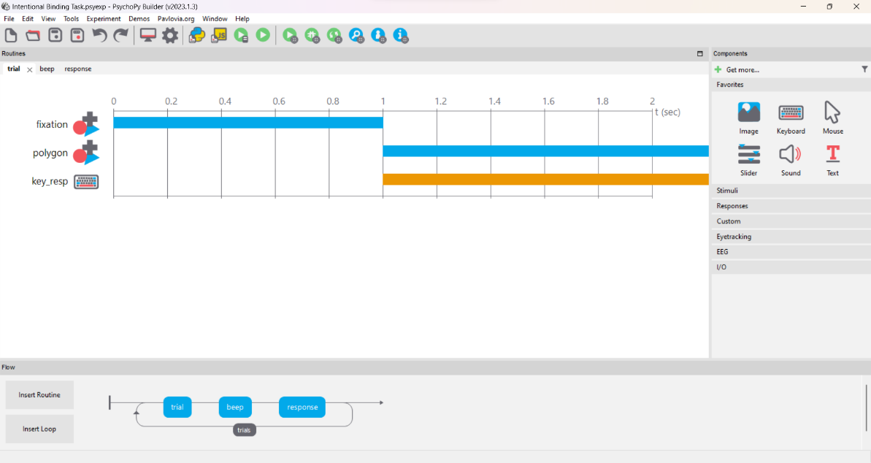

Figure-1

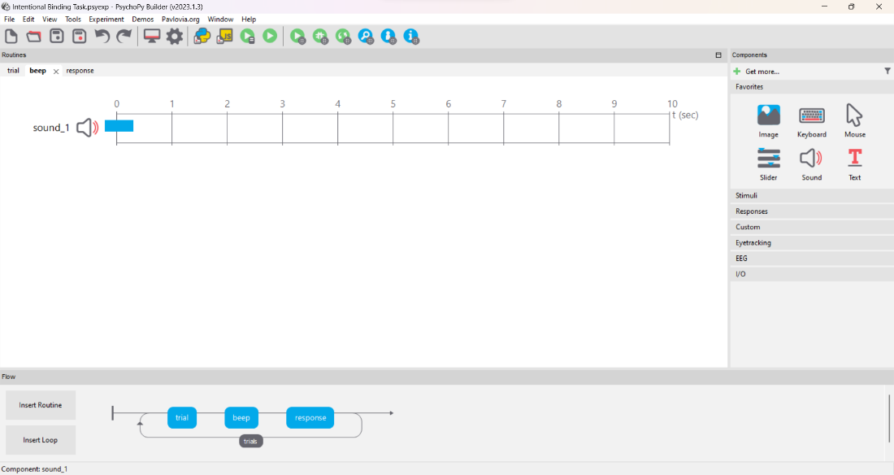

Figure-2

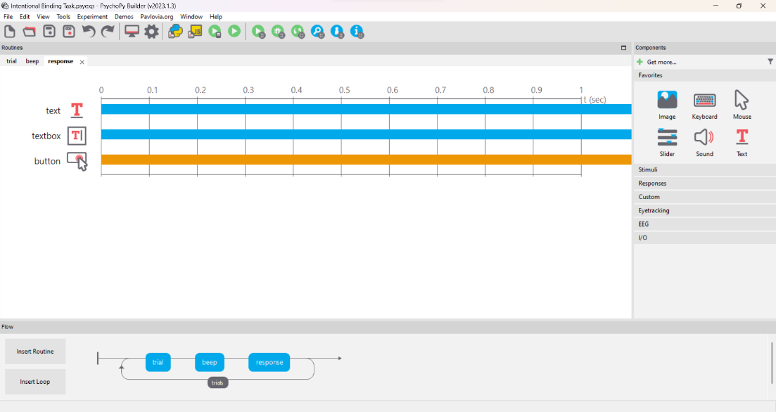 Figure-3



Figure-4

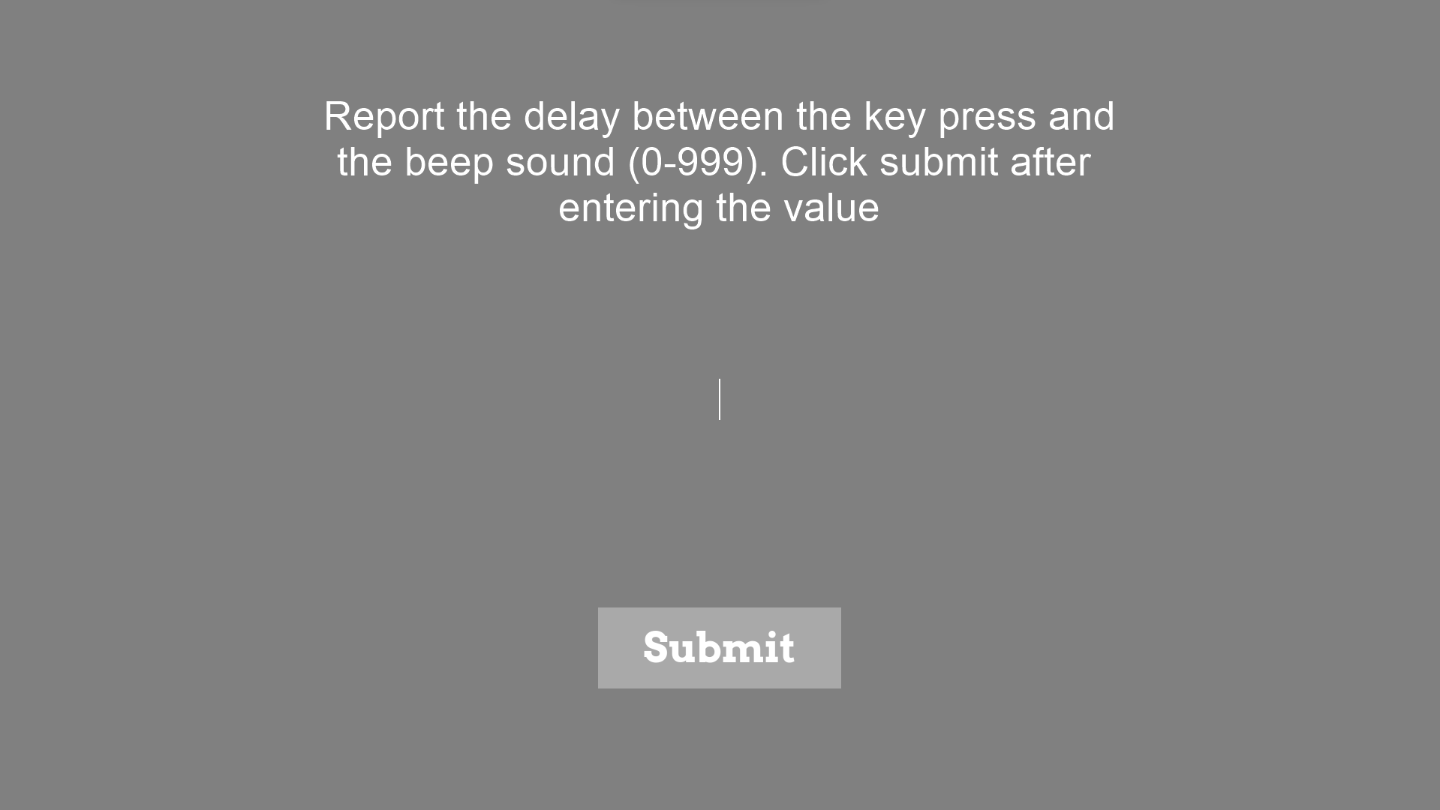

Figure- 5

***Testing Conditions***

The participants completed a total of 108 trials. It was made sure that the participant was able to hear the voice loudly and clearly and was not able to get distracted by the environment or any background noise. Participant performed the task without any breaks in between.

***Data Collection***

The data was automatically collected through PsychoPy in an excel file. The data was then refined to analyse the required the values efficiently

**RESULTS**

After conducting an analysis of the data gathered through psychopy, the average of the perceived delay by the participants for the expected condition when there was a short delay of 100ms was 222.2222, and for the unexpected condition was 300. The average of the expected condition when there was a delay of a 400ms was 311.1111 and for the unexpected condition was 433.3333. The average for the of the expected condition when there was a delay of 700ms 577.7778 and for the unexpected condition was 500.

|  |  |  |
| --- | --- | --- |
| **Column1** | **exp** | **unexp** |
| short | 222.2222 | 300 |
| medium | 311.1111 | 433.3333 |
| long | 577.7778 | 500 |

**DISCUSSION**

A thorough analysis of the data gathered was performed and the average of responses by the participants in the expected condition for the short, medium and long delay was 222.2222ms, 311.1111ms and 577.7778ms. The average of responses in the unexpected condition for the short, medium and long delay was 300ms, 433.3333ms and 500ms. From the data obtained it can be concluded that the participants took relatively long to recognise the amount of delay in the unexpected condition than compared to the expected condition. Using an implicit measure of sense of agency can have various benefits, such as it can help in the reduction of bias. As participants may not be ale to express their opinions about sense of agency consciously, using implicit measures can reduce these biases with the method of self-report. Another use of implicit measures is that it can produce more valid results and representation of an individual’s experiences. Although implicit measures of sense of agency provides a detailed and thorough insight, interpreting these measures often requires a nuanced understanding of the various psychological processes. If the data is not interpreted correctly, it can lead to false conclusions about the individuals’ sense of agency.

**REFERENCES**

Cavazzana, Annachiara, et al. “Intentional Binding Effect in Children: Insights from a New Paradigm.” *Frontiers in Human Neuroscience*, vol. 8, 2014. *Frontiers*, <https://www.frontiersin.org/articles/10.3389/fnhum.2014.00651>.

Moore, J. W., Middleton, D., Haggard, P., & Fletcher, P. C. (2012). Exploring implicit and explicit aspects of sense of agency. Consciousness and cognition, 21(4), 1748–1753. <https://doi.org/10.1016/j.concog.2012.10.005>

Dewey, J. A., & Knoblich, G. (2014). Do implicit and explicit measures of the sense of agency measure the same thing?. PloS one, 9(10), e110118. <https://doi.org/10.1371/journal.pone.0110118>