**Motor Sequence**

Course name- PSY310: Lab in Psychology

Date- 13/10/2023

Name- Rishitaa Joshi

Enrollment no.- AU2120095

**GITHUB:**

**Introduction**

Motor sequence task can be defined as an activity where a participant learns to perform series of coordinated movements or responses. These movements are usually in a particular order. Through such tasks we are able to gain a deeper understanding about learning and contingency. (Schmidt, J.R. (2012)) According to Schmidt, human contingency learning can be associated with operant conditioning, that is the observation that people tend to learn whichever response has the greatest probability of realizing a particular desired outcome. He considers contingency learning to the acquisition of implicit or explicit knowledge of statistical correlations between stimuli and/or responses. Contingency can be described as the relationship between particular movements and their outcomes. Contingency learning can be characterised with rapid acquisition speed. Participants can quickly form relationships of consistencies with each trial which results in faster responses. Contingency learning can also be used to gain more knowledge about the judgements of causal relations between the correlated stimuli.

**METHOD**

***Participant***

There was only one participant for this experiment. The participant was a student of the Lab in Psychology class. The participants had normal vision.

***Materials and procedure***

The experiment was designed by using a python based software, Psychopy. The experimenter was provided a video explaining how to design the visual grating task by the professor of the course. The materials used by the experimenter was their personal laptop.

In the beginning a polygon in the shape of a cross was added in the manner that it appeared after each individual trial. Following this, four polygons in the shape of rectangles were added which would be constant in all trials. After this, a polygon in the shape of a triangle was added whose position was set to change in each trial. The triangle was made to appear on top of the rectangle. In the end, a keyboard response was added where the participant had to press either z,x,c or v. The participants first performed sequential trials and then fully randomised trials.

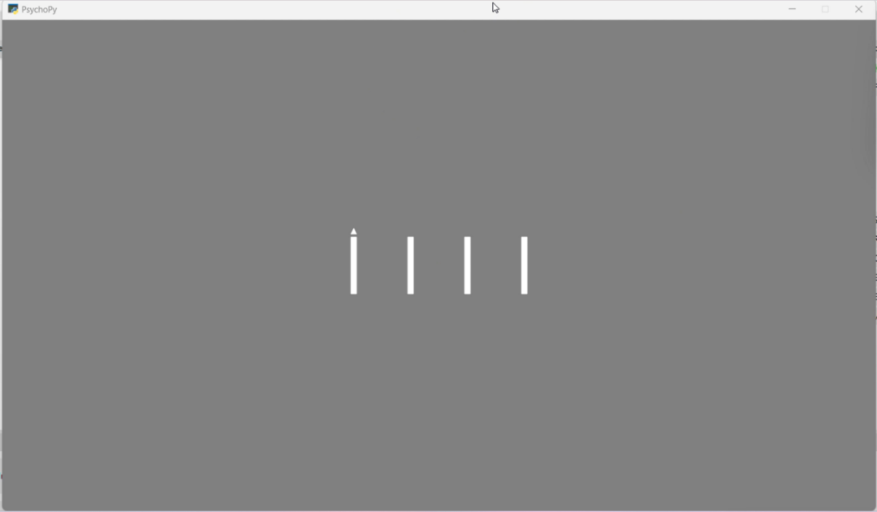

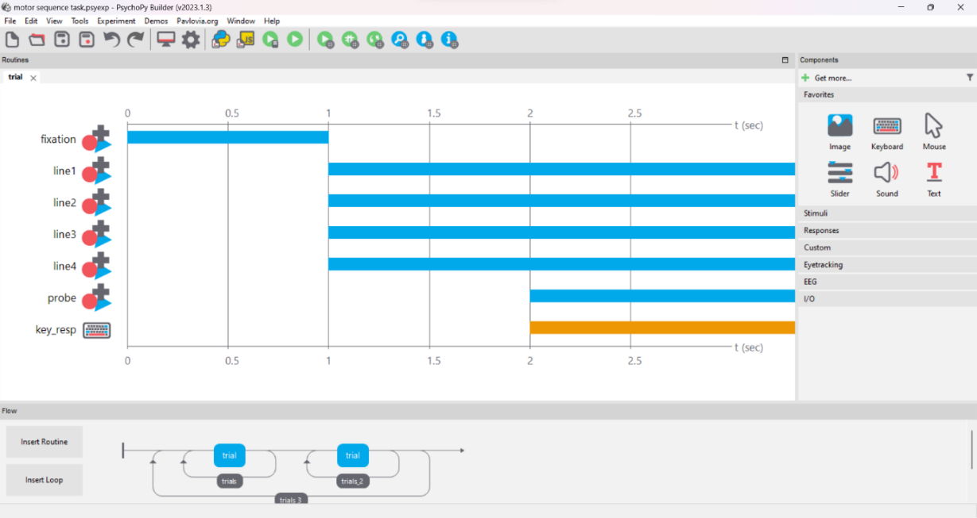

***Testing Conditions***

The participant performed a total of 400 trials from which 200 trials were from the sequence trials and 200 trials from the fully randomized trials. It was made sure that the participants were not able to get distracted by the environment. Participants performed the task without any breaks in between.

***Data Collection***

The data was automatically collected through PsychoPy in an excel file. The data was then refined to analyse the required the values efficiently

***Results***

After conducting an analysis of the gathered data of the participant, the average reaction time of the sequence trials was 0.521974 and the average reaction time of the fully randomized trials was 0.530133. Before conducting the analysis, the errors where the participants made incorrect responses were omitted in order to gain more accurate results.

**Figure-1**

**Figure-2**

**DISCUSSION**

A detailed analysis was performed on the data gathered. The 4 bin values for the sequence trials was found to be 0.575575, 0.621015, 0.464359 and 0.430007. the four bin values for the fully randomized trials were found to be 0.527121, 0.516144, 0.503094 and 0.56764. after obtaining these values a line chart was made which displayed the slope of both SEQRT and RANRT. It can be observed that the reaction time decreases gradually in the sequence trials which signifies that the participant slowly learns about the particular pattern of the trials which makes them react rapidly. Through the line chart it can be devised that the reaction time of randomized trials increases slightly as it takes more time for the participant to make the correct response. As the experiment will always the sequence trials first followed by the randomized trials or vice versa, a third loop can be added to randomize the occurrence of the first two loops. This can be useful when we wish to have multiple participants for the study. Counterbalancing can also be useful when we wish to have repeated measure design or a within subject design.

**REFERENCES**

Schmidt, J.R. (2012). Human Contingency Learning. In: Seel, N.M. (eds) Encyclopedia of the Sciences of Learning. Springer, Boston, MA. <https://doi.org/10.1007/978-1-4419-1428-6_646>

Schmidt, James. (2012). Human Contingency Learning. 10.1007/978-1-4419-1428-6_646.